The purpose of this assignment is to get familiar with Linux, compile an existing C/MPI program, modify it, execute it, obtain some timing data, and then analyze this data using the frameworks provided in Chapter 7 (performance analysis) of the Quinn textbook. First goto:

<https://github.com/pmodels/mpich/blob/master/examples/cpi.c>

and grab this (entire) C file (i.e. cpi.c)

Either put it on the CI project or local Linux / OSX / WSL install.

Compile it, and run it with mpirun:

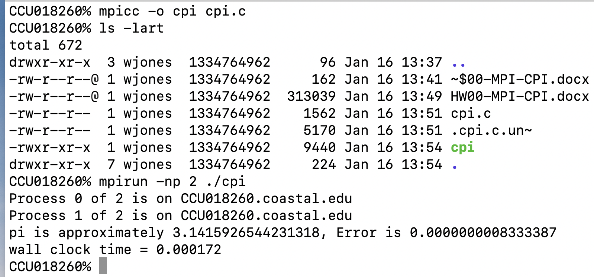



the ‘np’ means 2 processes.

Let’s increase the number of rectangles that it uses to perform the integration:



That takes slightly longer (note in green):

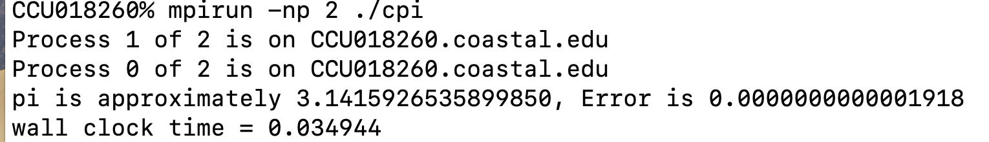



Let’s kick up n even larger:



Recompile and rerun:

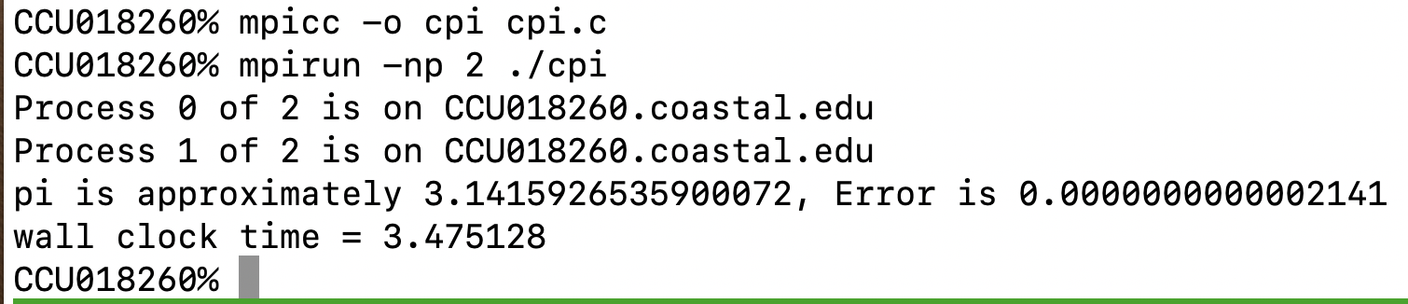



So, on 2 processes, with n = 1000000000, it takes 3.47 seconds on my Mac laptop.

What about with 1 process:

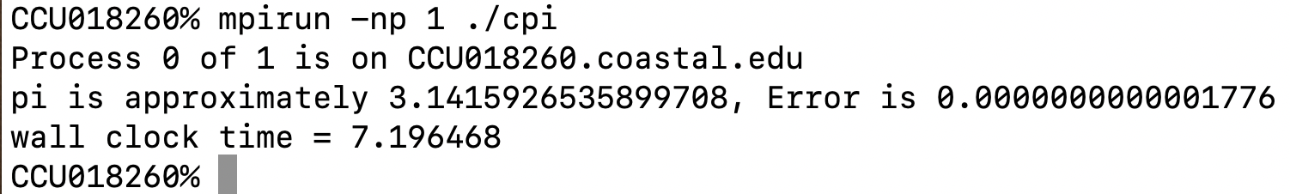



So with just 1 process, and n the same, it takes 7.196­ seconds.

So the empirical speedup on 2 (S2) processes is:

What about for 4 processes:

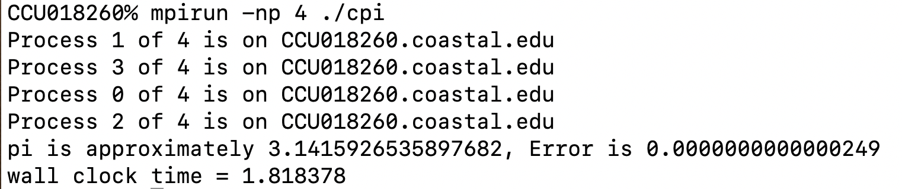



What about with 8 processes:

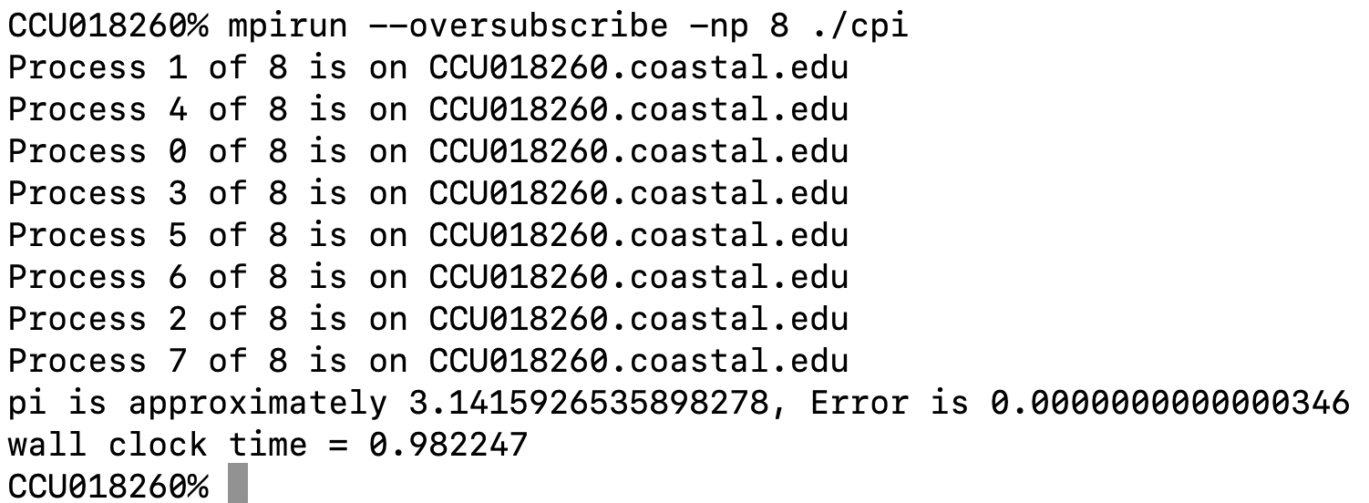



TODO:

Get this code, modify it to increase n, reproduce these same experiments. Then gather data (on your own machine, not the CI project), like how I did above, for this same size n, and for np of 1, 2, 3, 4, 5, 6, 7, 8, 9, 10, 11, 12.

Use your favorite graphing utility to plot the execution times, speedups and efficiencies with respect to (np), and get some graphs like these (this data is from a older machine, not my current laptop, hence the difference from the data above)

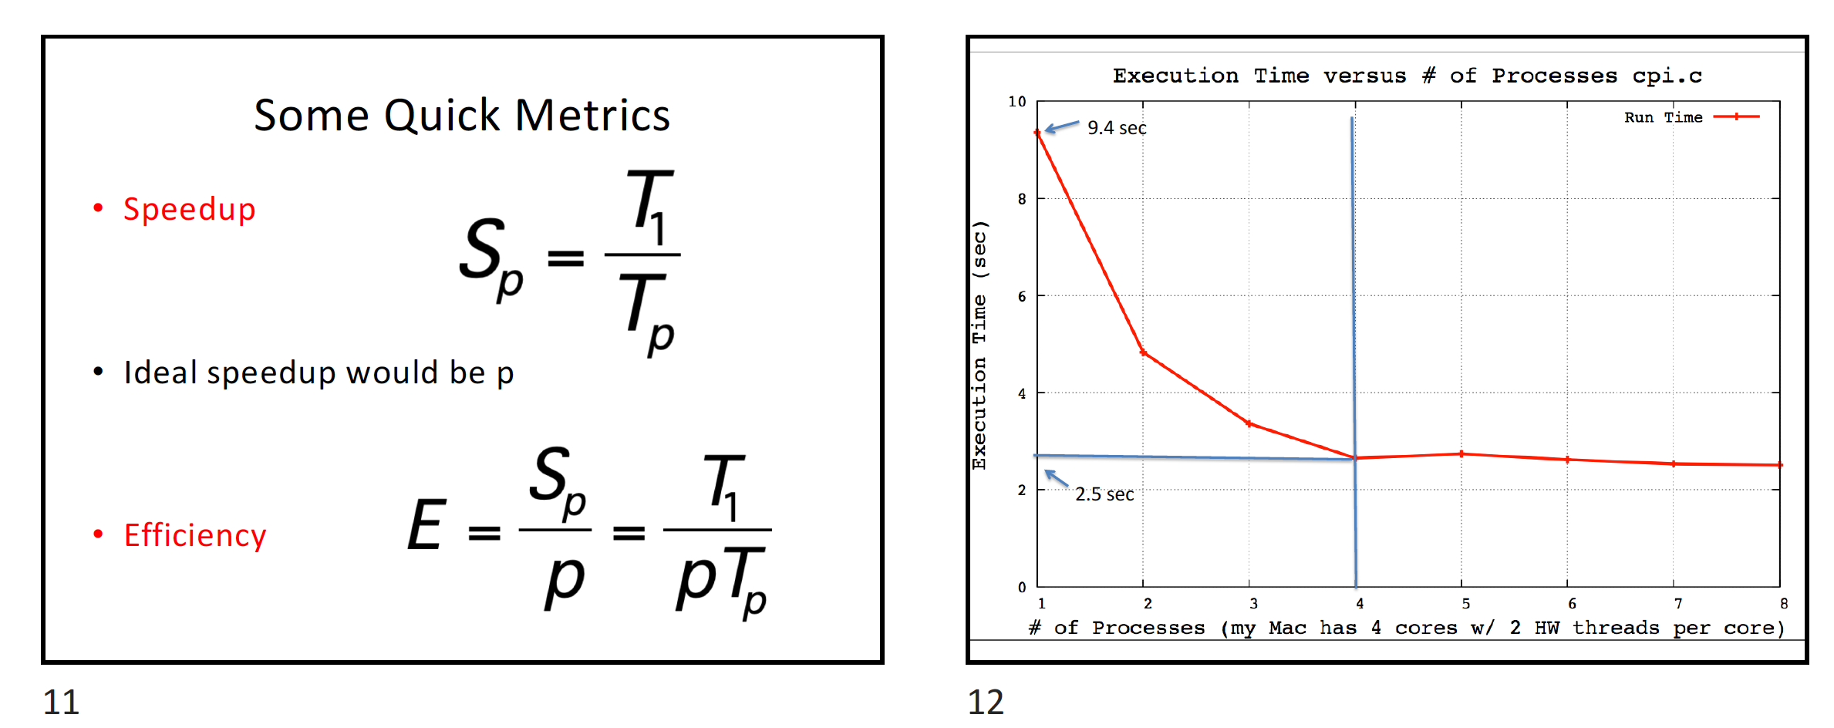

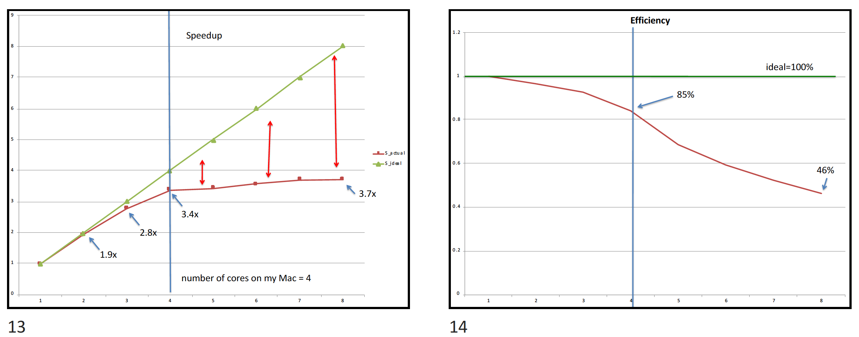

(these images are taken from the CalcPI.pptx in the Resources / QuinnSlides Zip file).

You may want to do this in a way so that you can just put new data right into the plotting program, so that it will be easy. (we’ll me modifying this, and doing more stuff with it).

Take the C file, and also a report (Word/PPTx or Excel / PPT, the source and final artifacts, and Zip together and submit into Moodle as a single file.