Using your completed HW MPI03, two additional programs, with a file listing like:

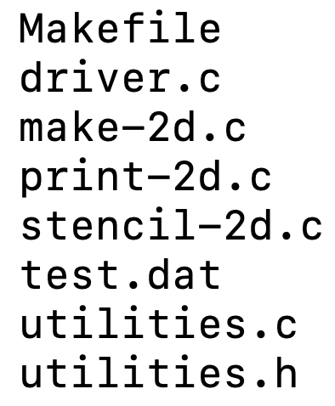



// make-2d usage: ./make-2d <rows> <cols> <output_file>

./make-2d 5 10 test2.dat

Contents of the matrix should be 0 to rows*cols-1, in row major order. For now, will change.

will create the exact same file that you started with. Must match same file format. You can test to see if they are the same by:

1. diffing them like: diff test.dat test2dat
2. using your prior print-2d to print it

// stencil-2 usage: ./stencil-2d <in_file> <out_file>

./stencil-2d test.dat processed.dat

stencil-2d will perform a 5-point stencil operation on the input data file, and will output the new 2d data file in a new file.

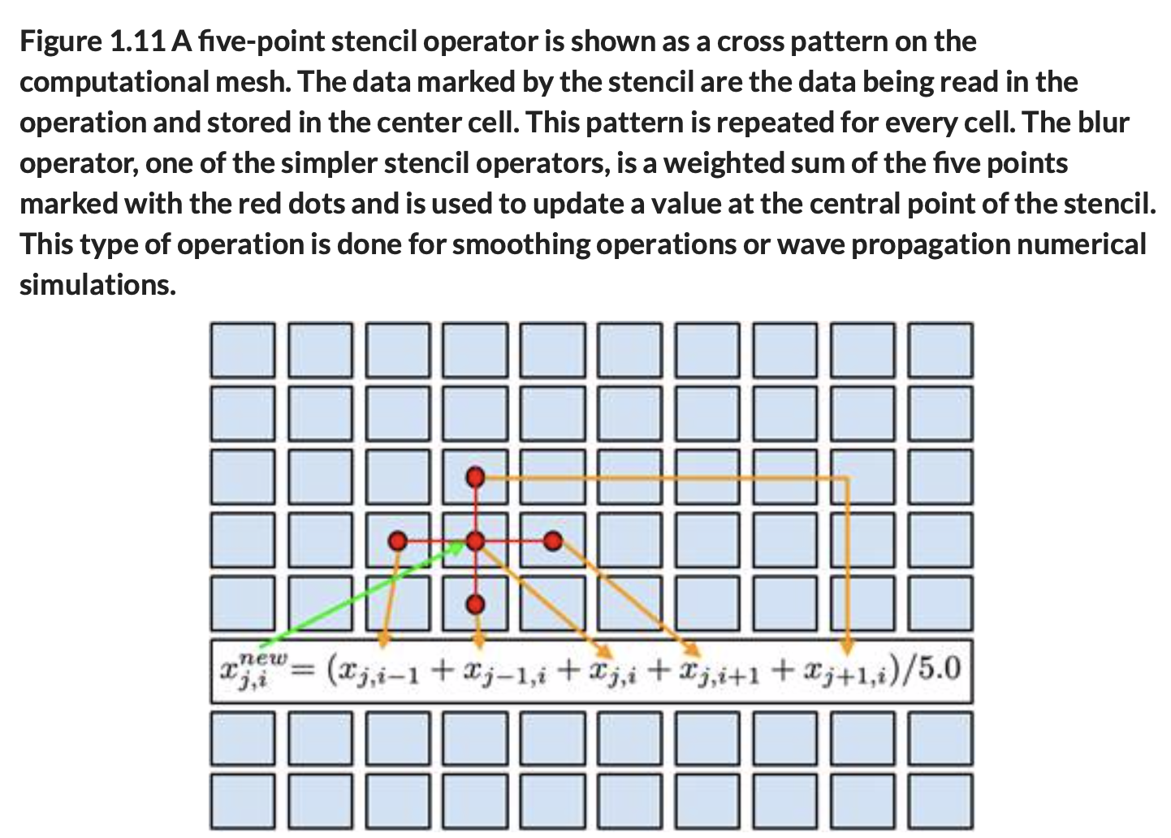

Stencil is not to be performed in-place. Should leverage existing utility functions, where possible.

Update the Makefile appropriately to handle these new programs.

**Submission to Moodle.**

Tar GZ the entire project directory (while being in the parent folder of the folder you’re trying to compress) up using:

**tar -czvf your_file_name.tar.gz ./the_folder_to_compress**

Submit to moodle.