In this assignment, we’re going to get used to doing file IO in C. Starting with the example from class today (starting exactly from there), you’ll have these files:

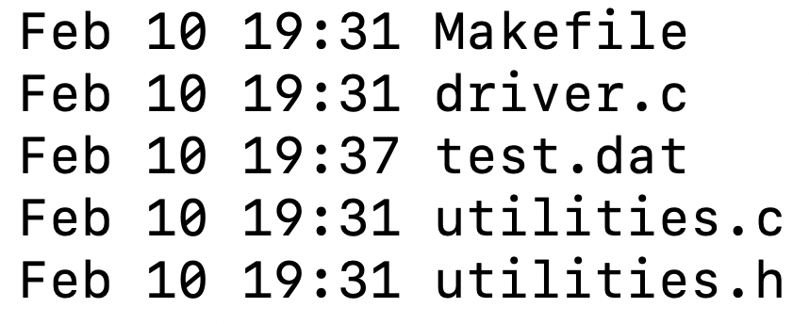



From Moodle, also grab the test.dat file, which you’ll be using as input to your program.

This file was created by writing two 32-bit integers to a file, representing the number of rows and columns of a 2D array, followed by the data of the 2d array, in row major order.

Create a new program called print-2d, and which resides in print-2d.c. You will execute the program like this:



In other words, you’ll write it so that you pass (via argv) the name of the input file. It will then print the contents of the file like this:

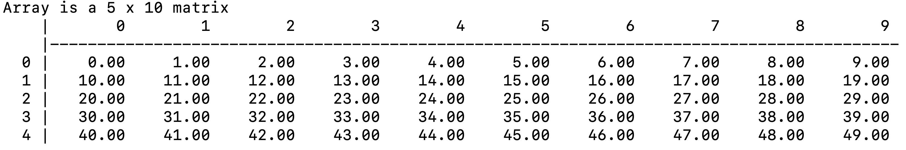

*(this is in fact the contents of the the test.dat file)*

This is important:

should structure your main() program like this:

main() {

// determine the dimensions of the 2d array of the input file (don’t hardcode 5x10 from // above, get this from the file

// call the allocation function discussed in class, to allocate space for the 2d array



// then read the 2d array out of the file and into the array.

// then print the contents of the array, by calling the print 2d from class:



(modify this to make the formatting look like mine)

}

Submission to Moodle.

Tar GZ the entire project directory up using:

**tar -czvf your_file_name.tar.gz ./the_folder_to_compress**

Submit to moodle.