Using your completed HW MPI03, two additional programs, with a file listing like:

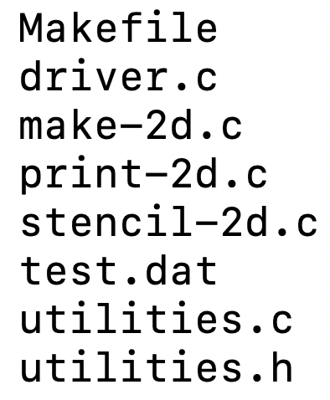



// make-2d usage: ./make-2d <rows> <cols> <output_file>

./make-2d 5 10 test2.dat

Contents of the matrix should be 1.0 in column 0 and cols-1, 0.0 otherwise.

This will create the initial / boundary conditions similar to discussed on Wikipedia at:

<https://en.wikipedia.org/wiki/Stencil_code>

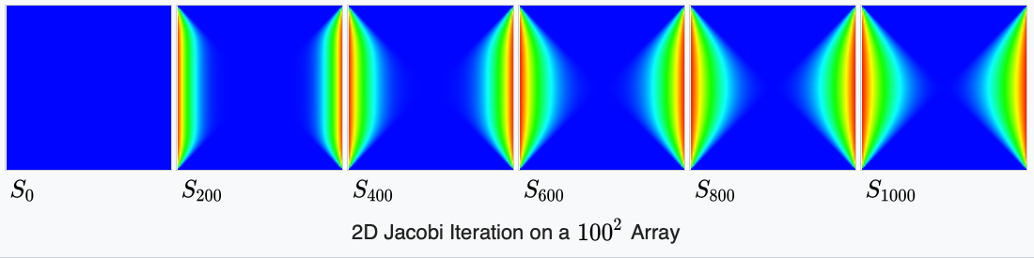

(see how the plate is ‘heating up’ in the center from the heat at the walls)

For example:

CCU018260% **./make-2d 5 8 ./initialPlate.dat**

CCU018260% **./print-2d ./initialPlate.dat**

./print-2d, ./initialPlate.dat,

reading in file: ./initialPlate.dat

1.00 0.00 0.00 0.00 0.00 0.00 0.00 1.00

1.00 0.00 0.00 0.00 0.00 0.00 0.00 1.00

1.00 0.00 0.00 0.00 0.00 0.00 0.00 1.00

1.00 0.00 0.00 0.00 0.00 0.00 0.00 1.00

1.00 0.00 0.00 0.00 0.00 0.00 0.00 1.00

CCU018260%

./stencil-2d test.dat processed.dat

Then, you’ll modify your prior stencil code, to work like this (note the change):

CCU018260% ./stencil-2d

usage: ./stencil-2d <num iterations> <input file> <final output>

stencil-2d will perform a 5-point stencil operation on the initial input data file, and will output the data from the final iteration into a file. (*for the time being, it will also print to the screen all intermediate iterations, later this will become a configurable parameter*).

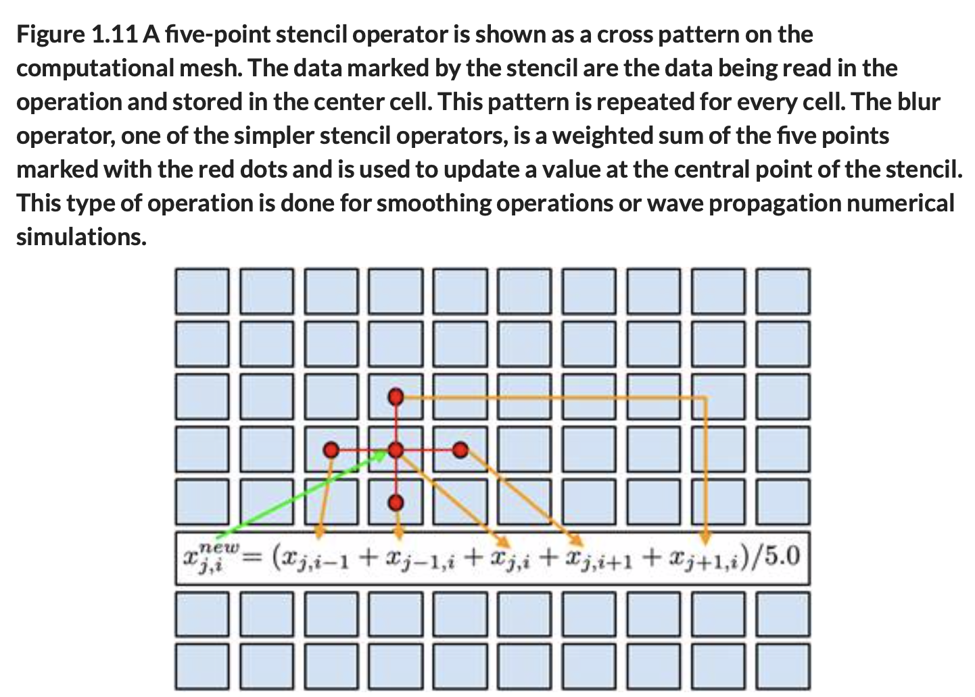

Stencil is not to be performed in-place. Should leverage existing utility functions, where possible.

Example execution:

CCU018260% ./stencil-2d 5 ./initialPlate.dat ./finalPlate.dat

1.00 0.00 0.00 0.00 0.00 0.00 0.00 1.00

1.00 0.00 0.00 0.00 0.00 0.00 0.00 1.00

1.00 0.00 0.00 0.00 0.00 0.00 0.00 1.00

1.00 0.00 0.00 0.00 0.00 0.00 0.00 1.00

1.00 0.00 0.00 0.00 0.00 0.00 0.00 1.00

*(this is initial data, before the first iteration)*

1.00 0.00 0.00 0.00 0.00 0.00 0.00 1.00

1.00 0.20 0.00 0.00 0.00 0.00 0.20 1.00

1.00 0.20 0.00 0.00 0.00 0.00 0.20 1.00

1.00 0.20 0.00 0.00 0.00 0.00 0.20 1.00

1.00 0.00 0.00 0.00 0.00 0.00 0.00 1.00

1.00 0.00 0.00 0.00 0.00 0.00 0.00 1.00

1.00 0.28 0.04 0.00 0.00 0.04 0.28 1.00

1.00 0.32 0.04 0.00 0.00 0.04 0.32 1.00

1.00 0.28 0.04 0.00 0.00 0.04 0.28 1.00

1.00 0.00 0.00 0.00 0.00 0.00 0.00 1.00

1.00 0.00 0.00 0.00 0.00 0.00 0.00 1.00

1.00 0.33 0.07 0.01 0.01 0.07 0.33 1.00

1.00 0.38 0.09 0.01 0.01 0.09 0.38 1.00

1.00 0.33 0.07 0.01 0.01 0.07 0.33 1.00

1.00 0.00 0.00 0.00 0.00 0.00 0.00 1.00

1.00 0.00 0.00 0.00 0.00 0.00 0.00 1.00

1.00 0.36 0.10 0.02 0.02 0.10 0.36 1.00

1.00 0.43 0.12 0.02 0.02 0.12 0.43 1.00

1.00 0.36 0.10 0.02 0.02 0.10 0.36 1.00

1.00 0.00 0.00 0.00 0.00 0.00 0.00 1.00

**1.00 0.00 0.00 0.00 0.00 0.00 0.00 1.00**

**1.00 0.38 0.12 0.03 0.03 0.12 0.38 1.00**

**1.00 0.45 0.15 0.04 0.04 0.15 0.45 1.00**

**1.00 0.38 0.12 0.03 0.03 0.12 0.38 1.00**

**1.00 0.00 0.00 0.00 0.00 0.00 0.00 1.00**

*(this is the final iteration, of the 5 specified)*

CCU018260% ./print-2d ./finalPlate.dat

./print-2d, ./finalPlate.dat,

reading in file: ./finalPlate.dat

**1.00 0.00 0.00 0.00 0.00 0.00 0.00 1.00**

**1.00 0.38 0.12 0.03 0.03 0.12 0.38 1.00**

**1.00 0.45 0.15 0.04 0.04 0.15 0.45 1.00**

**1.00 0.38 0.12 0.03 0.03 0.12 0.38 1.00**

**1.00 0.00 0.00 0.00 0.00 0.00 0.00 1.00**

CCU018260%

As you can see, the plate is “heating up” in the center, as the heat comes in from the two left / right boundary walls.

Update the Makefile appropriately to handle these new programs.

**Submission to Moodle.**

Tar GZ the entire project directory (while being in the parent folder of the folder you’re trying to compress) up using:

**tar -czvf your_file_name.tar.gz ./the_folder_to_compress**

Submit to moodle.