In this assignment, you will use the Monte Carlo Method perform the following calculation:

$$\int_{a}^{b}{f\left(x\right)dx}$$

The function f(x) will be defined at the top of your program as follows:

double f(double x) {

return x*x; // we should be able to change this

}

You will use drand48() to provide your pseudorandom number sequence. You will seed it properly.

The CLI (commandline interface) for the sequential code will be as follows:

./mc-integration-serial <a> <b> <n>

where a and b are the bounds of integration above, and n is the total number of (xi,yi) points generated.

Running this command will report to the console the a single line:

a b n approximation_of_integration exec_time

Where exec_time is the execution time of the program in seconds. Use the linked timer.h

file that I have provided in Moodle. Here’s the basic idea:

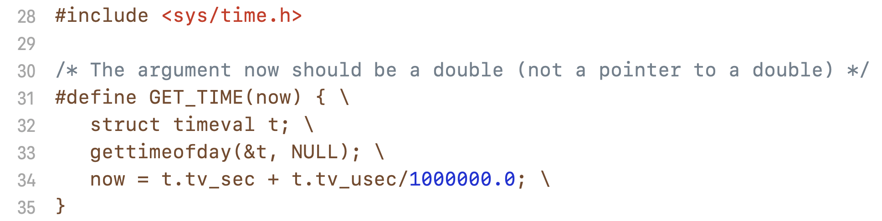

Just include the timer.h file, and call it from your program like this:

double start_time, end_time, elapsed_time;

GET_TIME(start_time);

// code you want to time

GET_TIME(end_time);

elapsed_time = end_time – start_time;

*(as a side note, it is an interesting endeavor to see how this macro works)*

You will use this utility to observe the behavior of using larger and larger values of n. Exact Details TBD in class.

You will then develop a parallel version using MPI that will adhere to the following:

mpirun -np <p> ./mc-integration-parallel <a> <b> <n>

to do the same thing, but dividing the workload among the <p> processes. Only the main process should produce any output, and the output it produces should be the same as before, except with <p> also written out.

a b n approximation_of_integration exec_time p

You will then use COMET / XSEDE to test out the performance of this code, for 3 different sizes of n, and for a number of processes that goes from 1, 2, 4, 8, 16, and finally 24. I want tables and plots of the data for the time, speedup and efficiency.

Make sure that the X axis has 1, 2, 4, 8, 16 and 24 spread out linearly (i.e. the space between the tick marks for 4 and 8 should be twice as much as the space between the 2 and 4 tick marks. Also, 24 should be spaced out appropriately. In other words, I want both the X and Y axis to be linear. I noticed that some folks didn’t have this back in their reports / plots at the beginning of the course.

You will include all this in your **report**, and also your report will discuss Monte Carlo, what you did, how it works, and also a comparison for this numerical integration technique to an analytical solution for the same f(x)’s across the same intervals. And demonstrate how much error there is between the two, for 2 to 3 different values of n.

**Submission to Moodle.**

Tar GZ the entire project directory (while being in the parent folder of the folder you’re trying to compress) up using:

**tar -czvf your_file_name.tar.gz ./the_folder_to_compress**

Submit to moodle.