You're Invited to Starfire's

10th Annual Tai Chi Adventure

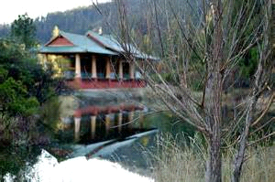

This year's adventure will take place in Northern California at the Chagdud Gonpa Tibetan Buddhist retreat center. This is an opportunity to deepen your Tai Chi practice in a serene, rural setting in the Trinity Alps. In addition to Tai Chi there will be opportunities for hiking, rafting, and learning Tibetan meditation.

 

As always, the price includes: Comfortable lodging, 3 daily gourmet meals with vegetarian options, 3 daily Tai Chi sessions, and optional meditation sessions. One surprise activity (after all this is an adventure) and the company of a friendly group of fellow tai chi players.

**Location:** Chagdud Gonpa Rigdzin Ling

341 Red Hill Rd Junction City, 15 miles West of Weaverville California

**Dates:** October 21 - 26, 2016, or Oct 21 - 23 (weekend option).

**Cost:**  $600 all inclusive (6 days/5 nights)

$300 (Fri, Sat, Sun option)

**Discounts:** 10 % off for early sign up!

20 % off for new tai chi guests

30 % off for non tai chi guests

**Contact:** Starfire at (510) 260-4493, or starfire88@netzero.net, or [www.Starfire.Org](http://www.Starfire.Org)