Activate the Major Incident Plugin

1. Navigate to System Definition > Plugins
2. Search for Incident Management - Major Incident Management

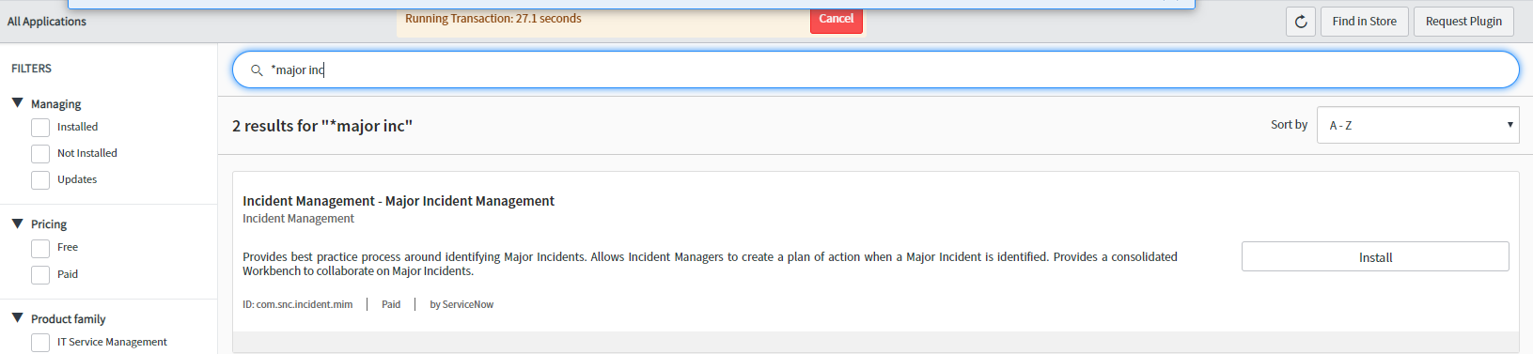

1. Click on Activate/Repair

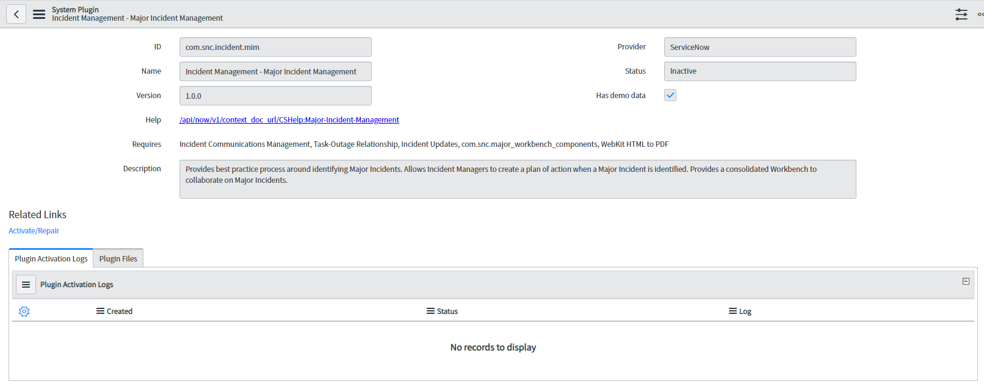

1. A popup will appear, this plugin will activate other required plugins. For reference you can check the Load demo data box. Click on Activate

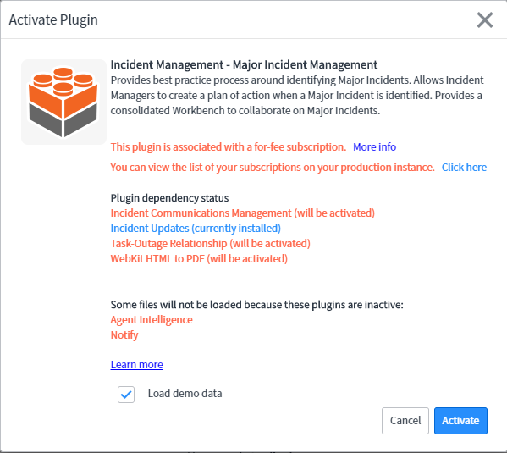

1. Wait for the plugin to activate, it will take a bit. Click on Close & Reload Form after you get the success message

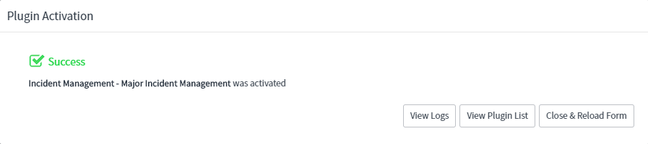

1. You have successfully activated Major Incident Management in your instance

Major Incident Overview (Dashboard)

1. Navigate to Incident > Major Incident > Overview
2. Click through the tabs to familiarize yourself with the contents of each (fairly obvious as to the content displayed)
3. Under the Major Incident Candidates tab you should see 2 if you loaded demo data during the plugin activation

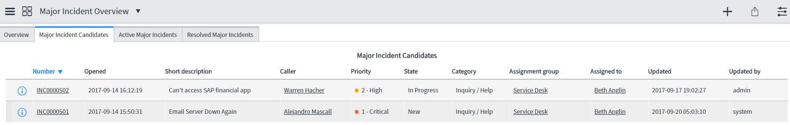

Configure Major Incident Properties

1. Expose the Application picker in the header by clicking on the gear icon in the upper right-hand side of the screen
2. In the popup select Developer and toggle on Show application picker in header and Show update set picker in header, then close the window

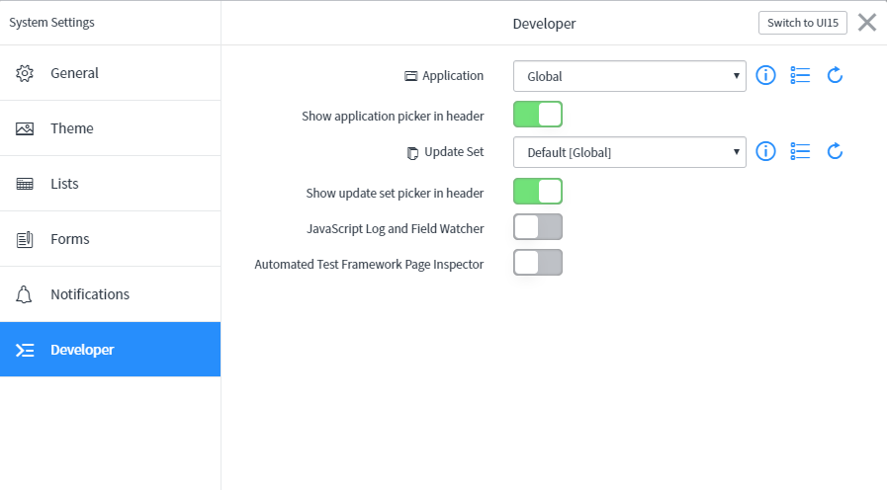

1. In the application picker, select Major Incident Management
2. If you want to migrate the updates you will be making be sure to set up a local update set and select it in the update set picker
3. Navigate to System Security > Users and Groups > Groups
4. Click on New to create new group (in reality, you may already have an Outage Managers group here we are creating one for demonstration purposes)
5. Enter Outage Managers into the Name field and then click on the menu icon and select Save.
6. After the screen refreshes, select the roles tab and click on Edit
7. Add the itil, communication_manager, and major_incident_manager roles and then click on Save

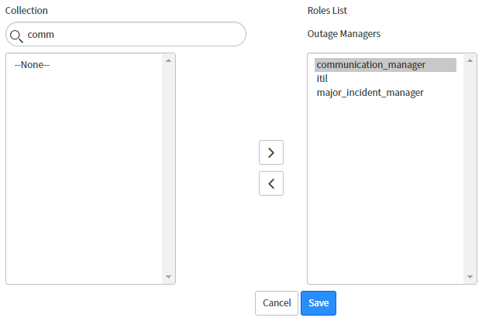

1. Select the group members tab and click on Edit. Add at least three members to the group for the demo the users don’t matter
2. Click on the menu icon on the top of the form and select Copy sys_id
3. Type major into the filter navigator and then select Incident > Administration > Major Incident Properties
4. Paste the copied sys_id into the field under “The sys_id of the group for Major Incident assignment at the time of proposal and promotion”, then click on Save

Configure Major Incident Trigger Rules

1. Navigate to Incident > Administration > Major Incident Trigger Rules
2. In the list header click on New
3. Fill in the following fields
   1. Name – Short description contains Outage
   2. Execution Order – 400
   3. Condition – Short description > contains > outage
4. Click on Submit

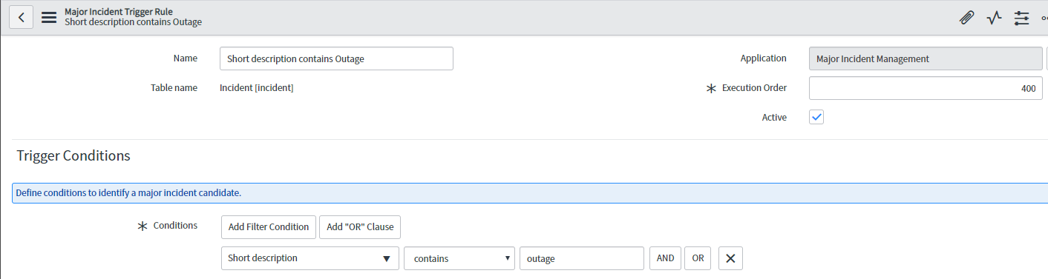

Configure Communication Plan Definitions

1. Navigate to Incident > Administration > Communication Plan Definitions
2. Select the communication plan with the name Technical Communications where the condition includes Priority = 1
3. Review the contents of the plan and how to set them up using the condition builder
4. Select the Communication Task Definitions tab in the related list if it’s not selected already and click on Initial Technical Communication

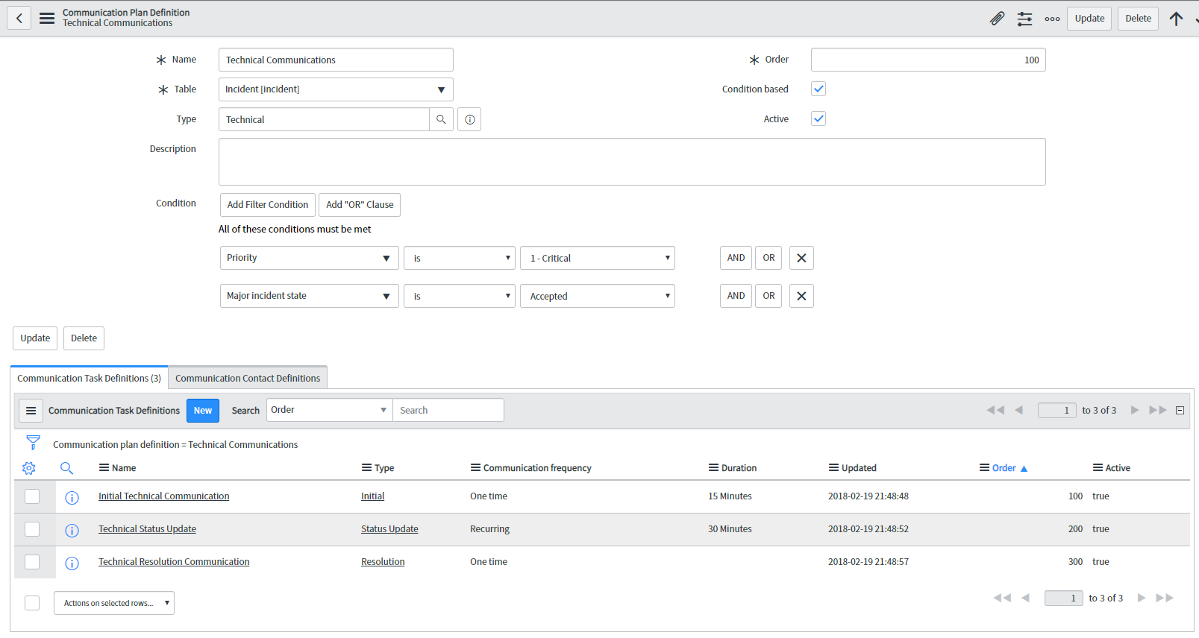

1. Click on E-mail in the Communication Channel Definitions section

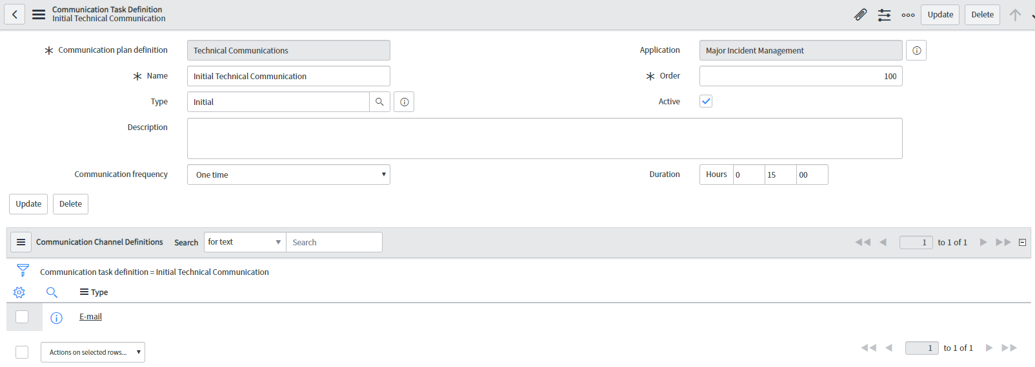

1. Click the lookup icon on the Email client template field select Initial Communication (Technical) and then click on Update
2. Navigate back to the Communication Plan Definition and repeat the process above to assign an email template to each task definition
3. Select the Communication Contact Definitions tab in the related list of the Communication Plan Definition and click on New
4. Enter the following
   1. Type = Group
   2. Group = Incident Management
5. Click on submit
6. At this point you would do the same for all the other Communication Plan Definitions you plan on using but we’ll only do this one for this demo

Create an On-Call Schedule for Outage Managers Group

1. Navigate to On-Call Scheduling > Create New Schedule
2. Under the Basic Info Chevron enter the following
   1. Which Group does this Schedule apply to? = Outage Managers
   2. What would you like your Schedule's name to be? = Outage Managers
   3. When would you like your new Schedule to begin? = Today
3. Click Next
4. Under the Schedule definition chevron enter the following
   1. Would you like to use an existing schedule? = Yes
   2. https://dev49501.service-now.com/images/s.gifxWhat type of Schedule would you like to use? = 24 x 7
5. Click Next
6. Under the Configure Rotations and Escalations chevron enter the following
   1. How many Duty rotations are there in your On-Call Schedule? = 1
   2. Which Members would you like to be in your Schedule? = Move all to right
   3. Day of Rotation = Monday
   4. Leave all the rest set to defaults but review if you aren’t familiar with this module.
7. Click Next
8. Click Next under the On-Call Group Settings chevron
9. Click Next under the Notification settings chevron.

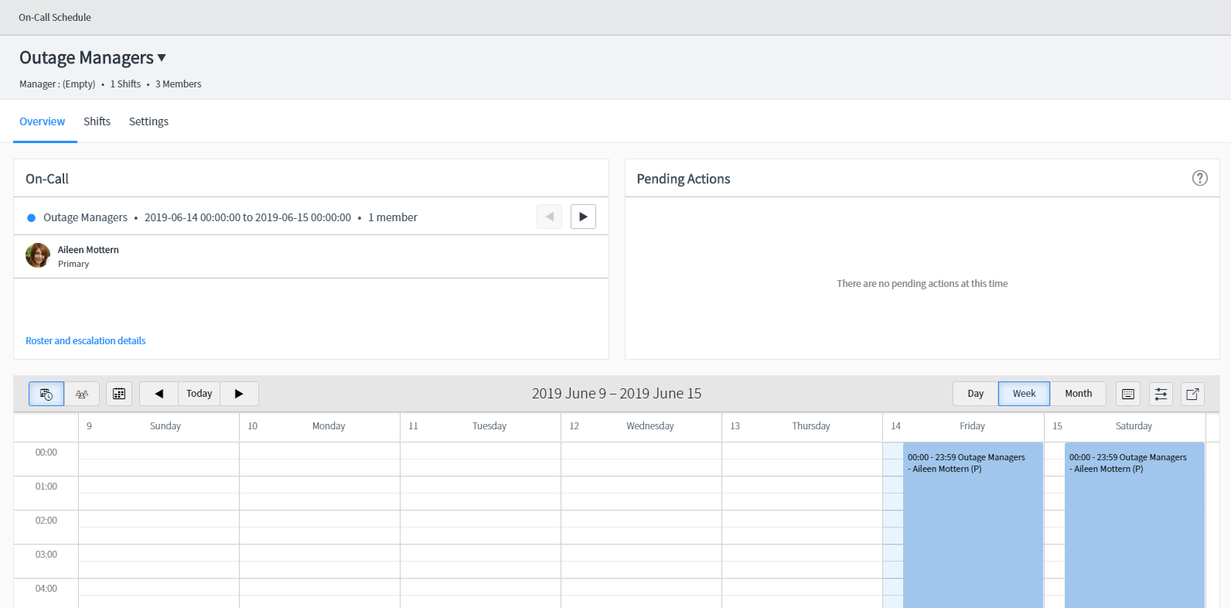

1. Navigate to Incident > Open and click on any open Incident
2. Click on the menu and select Configure > Business Rules
3. Search for Name = Major
4. Set Major incident assignment rule to Active = false
5. Click on a column header and select Import XML and import the file MIM assignment rule and the file Close ICT Updates

Use it!

1. Impersonate a user without the major_incident_manager role
2. Navigate to any open Incident
3. Copy the Incident number using Ctrl + C
4. Right click on the Incident header
5. You can see that you have option to Propose Major Incident
6. Impersonate a user you added to the Outage Managers group
7. Search for the copied Incident using search
8. Right click on the Incident header
9. You can see that you have option to Propose Major Incident and to directly Promote to Major Incident
10. Navigate to Incident > Major Incidents > Candidates – Make not of any you see in here. They are Incidents that were manually proposed or met any trigger rules above
11. Create a new incident by clicking on Create New under Incident
12. Fill in required fields as needed, be sure to set Impact to High and Urgency to High and make sure the word outage is included in your short description and save it.
13. Navigate to Incident > Major Incidents Candidates – your new incident should show up here
14. We will also propose a Major Incident by navigating to open incidents, search for incidents where Major incident state = (empty) and select one.
15. Right click on the header of the Incident and select Propose Major Incident
16. Enter Work Notes and Business Impact then click on Propose
17. You will see a message that your record has been proposed as a major incident candidate
18. Navigate to Major Incidents > Overview and click on the Major Incident Candidates tab
19. Open the Incident you just proposed
20. Make sure you are impersonating a user that is a member of the Outage Managers group and make note of the Assignment group and Assigned to fields
21. Right click on the Incident header and you will see options to Promote to Major Incident or to Reject Major Incident Candidate. Guess how they work? 😊 Select Promote to Major Incident
22. Enter work notes and update Business Impact if needed (note you have the business impact pull into email templates for messages if you want) then click Promote
23. You will see a message that your record has been promoted to a major incident and Assignment Group has been updated to Outage Managers and Assigned to has been updated to the outage manager who is on call
24. Click on View Workbench in the header and you will see a new view!

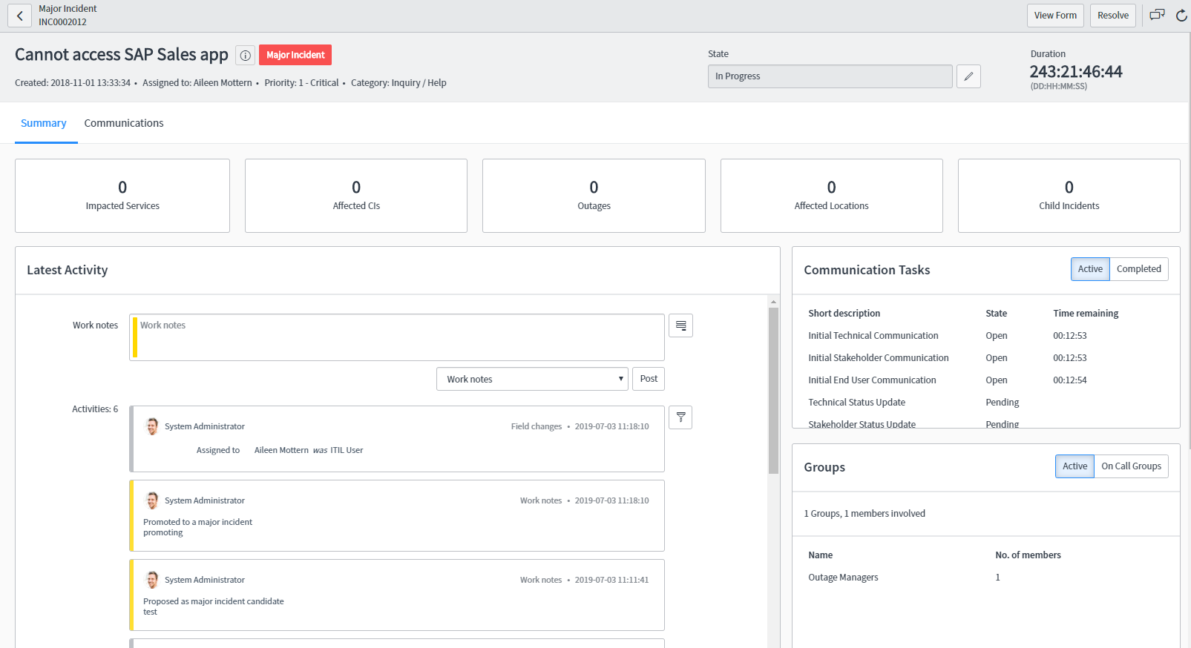

1. Review the fields you see including the Communication tasks countdown
2. Click on the Communications tab
3. Check out the options under Groups (notify would be available if you have it)
4. You can see your Communication tasks here, start with clicking the Send button on the Initial Technical Communication – It will bring up a standard template we designated previously. You can update any of the info you want then click on Send.
5. You can now see the Initial Technical Communication is complete and it progresses to Technical Status update with a new countdown started, that countdown will recur until you either close the task by clicking the vertical ellipses and selecting either End Task or Snooze or resolve the Incident
6. Click on Resolve – enter resolution code and resolution notes
7. All update communication tasks should close and you can now send the Resolution communications
8. You will also see the Post Incident Report section is now visible – explore it and after you fill in some info click on View Complete Report – from there you can download a PDF to distribute if needed
9. Note these Incidents don’t close after 24 hours (or your settings) like normal incident do, so they can be tracked for Post Incident/Root Cause Analysis