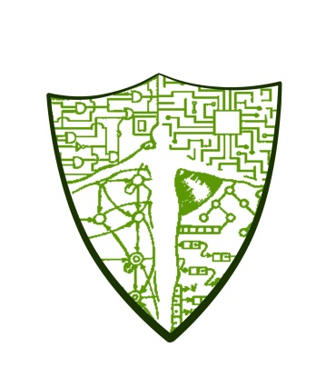

**Computer Science Guild**

University of the Philippines Cebu

Gorordo Ave., Lahug, Cebu City

upcsg.upcebu@gmail.com

6 April 2016

Senior Supt. Benjamin Santos Jr.

City Director

Cebu City Police Office

Dear Mr. Santos:

Greetings form UP Computer Science Guild!

The UP Computer Science Guild (UPCSG) is a course based organization in the University of the Philippines Cebu. The organization focuses on helping the members develop into well-rounded young professionals, more importantly, mold their careers as Computer Scientists in order to be of help to the world in general and to the Philippines in particular.

One of our activities as an organization is the Outreach Program. We wish to invite your policemen to participate in this 2-day session for us to help them have a better grasp on basic computer skills using Microsoft Office. This will be a great opportunity for our policemen to learn efficient document and report making which we know are of utmost importance within police offices. Attached is the framework, schedules and outlines for the said event.

Please email us at [upcsg.upcebu@gmail.com](mailto:upcsg.upcebu@gmail.com) for questions, inquiries and to confirm your police officers’ participation in the program together with the list of police officers that may participate in the program.

We hope to hear you on or before 10 April 2016.

We are looking forward for your approval.

Sincerely Yours,

**Arvin S. Arbuis**

Project Head, SY 2015-2016

Outreach Program

Mobile: +639330612892

E-mail: [asarbuis@up.edu.ph](mailto:asarbuis@up.edu.ph)

Noted by:

**Kurt Junshean P. Espinosa Sram J Isle L. Santillan**

Adviser, SY 2015-2016 Co-Project Head, SY 2015-2016

UP Computer Science Guild Outreach Program

Mobile: +639428647438

Email: [sjisantillan@gmail.com](mailto:sjisantillan@gmail.com)

**Arnold Joseph Caesar P. Esteban**

President, SY 2015-2016

UP Computer Science Guild