Lingwistyka Matematyczna – labolatorium

Zadanie 2

Jacek Kuliś

221476

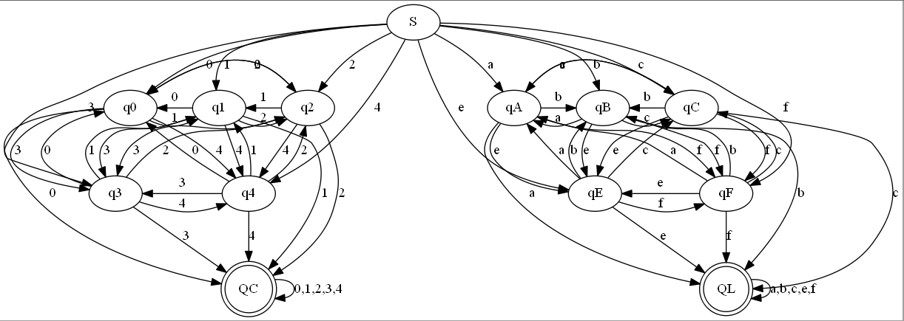

|  |  |  |  |  |  |  |  |  |  |  |
| --- | --- | --- | --- | --- | --- | --- | --- | --- | --- | --- |
|  | 0 | 1 | 2 | 3 | 4 | a | b | c | e | f |
| S | q0 | q1 | q2 | q3 | q4 | qA | qB | qC | qE | qF |
| q0 | **QC** | q1 | q2 | q3 | q4 | - | - | - | - | - |
| q1 | q0 | **QC** | q2 | q3 | q4 | - | - | - | - | - |
| q2 | q0 | q1 | **QC** | q3 | q4 | - | - | - | - | - |
| q3 | q0 | q1 | q2 | **QC** | q4 | - | - | - | - | - |
| q4 | q0 | q1 | q2 | q3 | **QC** | - | - | - | - | - |
| qA | - | - | - | - | - | **QL** | qB | qC | qE | qF |
| qB | - | - | - | - | - | qA | **QL** | qC | qE | qF |
| qC | - | - | - | - | - | qA | qB | **QL** | qE | qF |
| qE | - | - | - | - | - | qA | qB | qC | **QL** | qF |
| qF | - | - | - | - | - | qA | qB | qC | qE | **QL** |
| **QC** | **-** | **QC** | **QC** | **QC** | **QC** | - | - | - | - | - |
| **QL** | - | **-** | **-** | **-** | **-** | **QL** | **QL** | **QL** | **QL** | **QL** |