**Conversation System**

# Flow chart

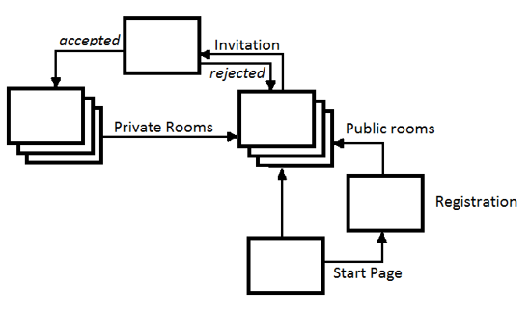

# Actors

|  |  |
| --- | --- |
| Name | Description |
| Registered user | User who passed registration |
| Unregistered user | User who did not pass the registration |
| Generic user | User who has the same permissions no matter whether registered or unregistered |

# Use case index

|  |  |  |  |
| --- | --- | --- | --- |
| Use Case ID | Use Case Name | Actor | Priority |
| 1 | Start Page | Unregistered user | 1 |
| 2 | Registration | Unregistered user | 1 |
| 3 | Conversation in public rooms | Generic user | 1 |
| 4 | Invite to private conversation another user | Generic user | 1 |
| 5 | Accepting/rejecting invitation | Generic user | 1 |

# Use cases

## 4.1 Start Page

Id: Use case 1

Name: Start page

Primary actor: Unregistered user

Basic flow: On this page user decide whether want use the application as registered user or unregistered user. If user want use application as registered user and click the proper button, will be redirect to registration page. If user want use application as unregistered user and click the proper button, will be redirect to public rooms.

4.2 Registration

Id: Use case 2

Name: Registration

Primary actor: Unregistered user

Basic Flow: On this page user should enter login and password in order to use the application as registered user. After entered all needed values and submitted the form user will be redirect to page which contains public rooms.

Exception flow: If values for required fields will not be provided or will not be valid than user can not move to the next page.

4.3 Conversation in public rooms

Id: Use case 3

Name: Conversation in public rooms

Primary actor: Generic user

Basic Flow: On this page users can take part in conversation with other people in the public rooms.

4.4 Invite to the private conversation another users

Id: Use case 4

Name: Invite to the private conversation another users

Primary actor: Generic user

Basic Flow: From this page user can invite another users to private conversation. If invited user accept the invitation then he/she will be able to take part in conversation. In situation when user rejected the invitation than he/she will not be able to participate in the conversation.

4.5 Accepting/rejecting invitation

Id: Use case 5

Name: Accepting/rejecting invitation

Primary actor: Generic user

Basic Flow: If user is invited to private conversation, he/she will see information about invitation. In this situation user has two options. First of all, if user accepts the invitation then he/she will be redirect to new window and will be able to take part in private conversation. Secondly, if user rejected the invitation then will not be able to take part in private conversation. What is more, the new window will not be opened.