Jacek Radajewski
Student number: 43612772
BIOL3014 – Advanced Bioinformatics
Practical 0

Exercise 1

Code
'''
Created on 30/07/2014

@author: s4361277
'''

my_aa = "Z"
#my_aa = "W"
my_aacodes = {'Y':'TYR', 'F':'PHE', 'C':'CYS', 'V':'VAL', 'H':'HIS', 'L':'LEU', \
'D':'ASP', 'A':'ALA', 'S':'SER', 'E':'GLU', 'W':'TRP', 'P':'PRO', \
'I':'ILE', 'R':'ARG', 'K':'LYS', 'N':'ASN', 'M':'MET', 'T':'THR', \
'G':'GLY', 'Q':'GLN'}

print "The provided letter is ", my_aa
if my_aa in my_aacodes:
print "This letter is in the list, it corresponds to the amino acid", \
my_aacodes.get(my_aa)
else:
print "This letter is not in the list and therefore does not correspond "\
+ "to an amino acid"

Output
Output shown for my_aa set to 'W' and 'Z'
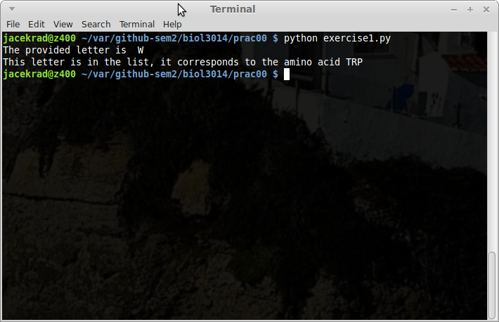
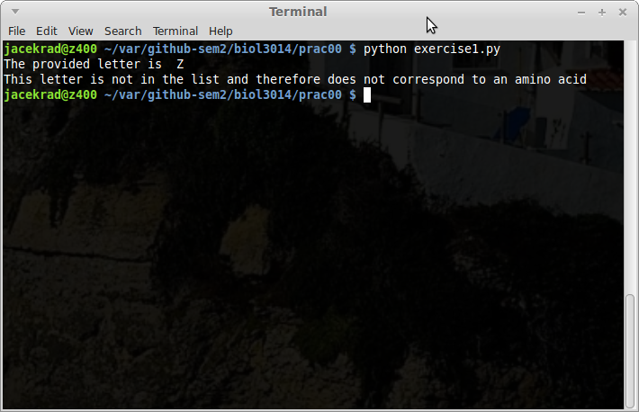

Exercise 2

Part 1
When mySequence = ["M","H","K","L"] is replaced with mySequence = "MHKL" the program executes the same as before because in the first case the line
for myaa in mySequence:
iterates over characters in a list and in the latter case over the same characters in a string.

Part 2

Code
'''
Created on 30/07/2014

@author: s4361277
'''
myHydrophobics = "FLIMVPAWG"
mySequence = "MHKL"
mySequenceHydro = ""
for myaa in mySequence:
#print "The amino acids is", myaa
if myaa in myHydrophobics:
mySequenceHydro += "*"
# print " It is hydrophobic"
else:
mySequenceHydro += " "
print mySequence
print mySequenceHydro

Output
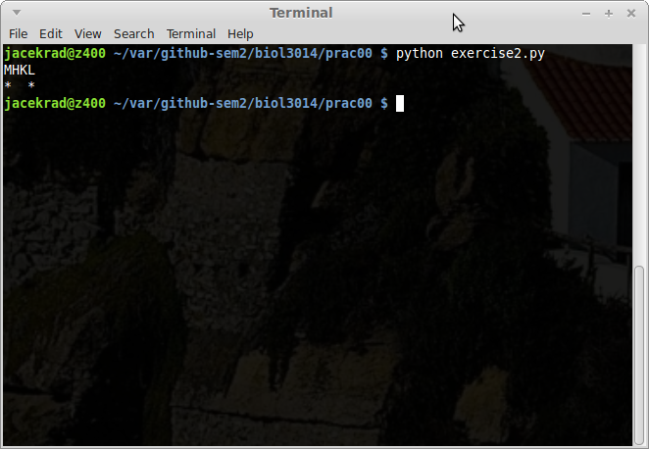

Part 3

Code
'''
Created on 30/07/2014

@author: s4361277
'''
myHydrophobics = "FLIMVPAWG"
mySequence = "MCGTEGPNFYVPFSNKTGVVRSPFEAPQYYLAEPWQFSMLAAYMFLLIMLGFPIN"\
+ "FLTLYVTVQHKKLRTPLNYILLNLAVADLFMVFGGFTTTLYTSLHGYFVFGPTGCNLEGFFA"\
+ "TLGGEIALWSLVVLAIERYVVVCKPMSNFRFGENHAIMGVAFTWVMALACAAPPLVGWSRYI"\
+ "PEGMQCSCGIDYYTPHEETNNESFVIYMFVVHFIIPLIVIFFCYGQLVFTVKEAAAQQQESA"\
+ "TTQKAEKEVTRMVIIMVIAFLICWLPYAGVAFYIFTHQGSCFGPIFMTIPAFFAKTSAVYNP"\
+ "VIYIMMNKQFRNCMVTTLCCGKNPLGDDEASTTVSKTETSQVAPA"
mySequenceHydro = ""
for myaa in mySequence:
#print "The amino acids is", myaa
if myaa in myHydrophobics:
mySequenceHydro += "*"
else:
mySequenceHydro += " "
print mySequence
print mySequenceHydro

Output
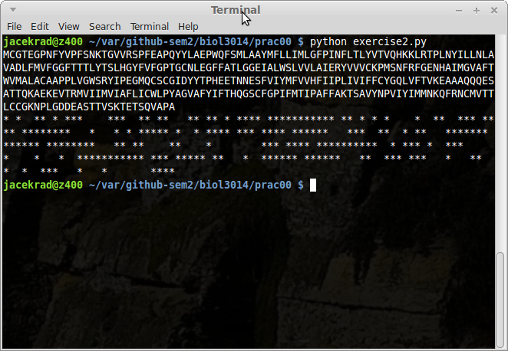

Exercise 3
The two possible outputs are True or False. Documented function shown below:
'''
Created on 30/07/2014

@author: s4361277
'''
def myIsDNA (mySeq):
'''
This function returns True iff mySeq consists entirely of DNA letters or
more specifically mySeq does not contain any of the following letters:
QWERYUIOPSDFHJKLZXVBNM. Function returns False otherwise.
'''
# list of non-DNA letters
myNonDNA = "QWERYUIOPSDFHJKLZXVBNM"

# iterate over the non-DNA letters
for myAA in myNonDNA:

# check if the non-DNA letter is contained in our sequence
# and if it is then return False
if myAA in mySeq:
return False

# finished iterating over the non-DNA letter and have not returned False yet so return True as mySeq IS DNA
return True

# call the function
print myIsDNA("GTTCGACCA")

Output
