Jacek Radajewski
Student number: 43612772
SCIE2100 Prac 9

Exercise 1

Exercise 2
In order to get the number of promoters I have simply loaded the FASTA file and counted how many were in it:
'''
Created on 27/05/2014

@author: s4361277
'''
from sequence import *

promoters = readFastaFile("yeast_promoters.fa", DNA_Alphabet)

print "There are", len(promoters), "promoters"

Running the program we get the result of 5880 promoters.

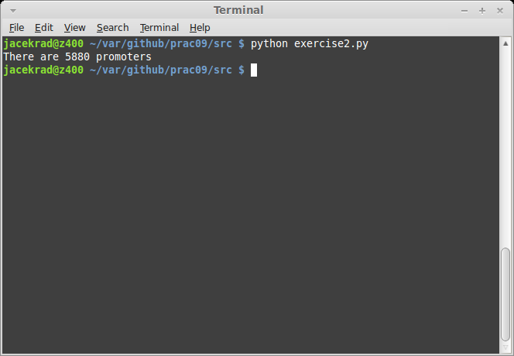
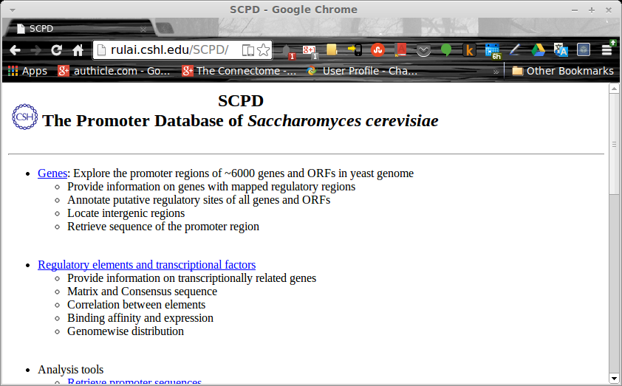

Exercise 3

Code
'''
Created on 27/05/2014

@author: s4361277
'''
from sequence import *

z = readMultiCount("abf1.jaspar")
pwm = PWM(z)
letters = ['A', 'C', 'G', 'T']
print pwm

print "PWM 10'th column"
for i in range(0, 4):
print letters[i], pwm.m[i][9]

Output
PWM 10'th column
A 0.514898949154
C -25.3284360229
G 0.844378150284
T -25.3284360229

Exercise 4

Exercise 5

Exercise 6
There are 9275 probes and 8714 genes in GDS3198.soft. Please see the code below.

Code
'''
Created on 27/05/2014

@author: s4361277
'''
import genome

g1 = genome.readGEOFile('GDS3198.soft', id_column = 0)
g2 = genome.readGEOFile('GDS3198.soft', id_column = 1)

print "GDS3198.soft contains", len(g1.getGenes()), "probes"
print "GDS3198.soft contains", len(g2.getGenes()), "genes"

Execution
Data set GDS3198 contains 9275 genes
Data set has 13 null-values
Data set GDS3198 contains 8714 genes
Data set has 13 null-values
GDS3198.soft contains 9275 probes
GDS3198.soft contains 8714 genes

Exercise 7
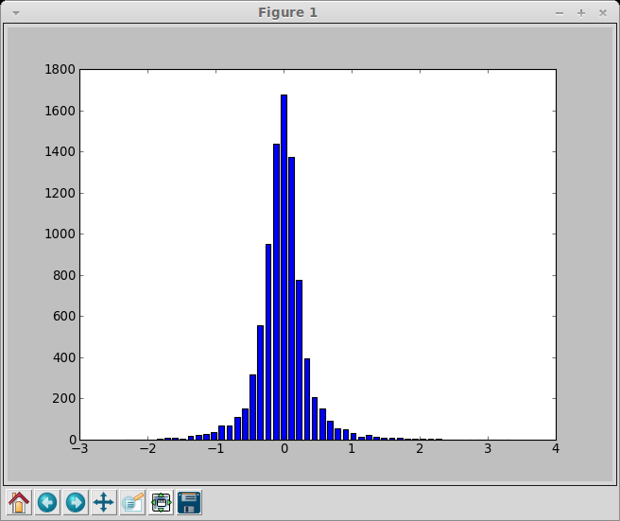

Exercise 8

Exercise 9

Exercise 10

Exercise 11

Exercise 12

