Jacek Radajewski
SCIE2100 Prac 4

Questions 1 & 2

Q1
Time taken to run the triplet alignment was approximately 0.62 seconds. Pairwise alignment on the other hand completed in 0.005 seconds.

Q2
In this question we have doubled the sequence length and it has taken 4.74 seconds to calculate the global alignment of the triplet. The time taken to execute the algorithm has increased by 4.74 / 0.62 which is around 7.65. In triplet alignment we are processing a three dimensional matrix so by increasing the the length of our sequence by a factor of 2 we increase the total number of the cells in the matrix by a factor of 2³ = 8. The actual increase in execution time was 7.65.
The performance of the algorithm is O(n³).
I have written code which calculates the execution time for computing triplet global alignment for sequences of length from n to 10n. These were graphed next to expected execution times and shown below. The expected calculations for 2 <= n <= 10 is based on n=1.

Code
'''
Created on 15/04/2014

@author: s4361277
'''
from sequence import *
import time

seqA1 = Sequence("AGCGCGATTATATAAGACGGACGGCTAAAG")
seqB1 = Sequence("AGCGGATATTTATATCGCACGACGACTACG")
seqC1 = Sequence("GGATCGATTATATAGCCTGGACGAGACATG")

seqA2 = Sequence("AGCGCGATTATATAAGACGGACGAGACGACAGCGCGATAGACGAGACGGACGAGACGACT")
seqB2 = Sequence("GGATCGATTATATAGCCTGGACGAGACATGGGATCGAAGACGACCTGGACGAGACATGAC")
seqC2 = Sequence("AGCGGATATTTATATCGCACGACGACTACGAGCGGAAGACGAGTTTCGCACGACACTACG")

matrix = readSubstMatrix("dna.matrix", DNA_Alphabet)

print "pairwise align of short sequences (Q1)"
start_time = time.time()
alignGlobal(seqA1, seqB1, matrix, -1)
end_time = time.time()
print("Elapsed time was %g seconds" % (end_time - start_time))

print "triplet align of short sequences (Q1) ..."
start_time = time.time()
tripletAlignGlobal(seqA1, seqB1, seqC1, matrix, -1)
end_time = time.time()
print("Elapsed time was %g seconds" % (end_time - start_time))

print "triplet align of long sequences (Q2) ..."
start_time = time.time()
tripletAlignGlobal(seqA2, seqB2, seqC2, matrix, -1)
end_time = time.time()
print("Elapsed time was %g seconds" % (end_time - start_time))

# the following code provides a more detailed analysis of algorithm time
# the output was use to genmerate a comparison graph of expected vs real
# execution times

print "triplet align: time vs sequence length (Q2) ..."
sequence_string_fragment_1 = "AGCGCGATTATATAAGACGGACGGCTAAAG"
sequence_string_fragment_2 = "AGCGGATATTTATATCGCACGACGACTACG"
sequence_string_fragment_3 = "GGATCGATTATATAGCCTGGACGAGACATG"

sequence_string_1 = ""
sequence_string_2 = ""
sequence_string_3 = ""

for length_multiplier in range(1, 11):
sequence_string_1 += sequence_string_fragment_1
sequence_string_2 += sequence_string_fragment_2
sequence_string_3 += sequence_string_fragment_3
start_time = time.time()
tripletAlignGlobal(Sequence(sequence_string_1), Sequence(sequence_string_2),
Sequence(sequence_string_3), matrix, -1)
end_time = time.time()
# output produced can be redirected into a CSV file
print length_multiplier, ",", end_time - start_time

Execution
Screen shot below shows the execution of the code for questions 1 and 2.

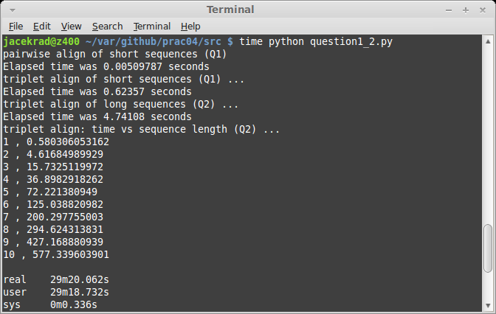

Question 4

a, b & c
All of the sequences in this alignment are from the highly conserved FOXP2 gene. One could conclude for the alignment to be reasonable if the conserved regions are visible in the HTML output. Looking at the HTML representation of the alignment (see below) we can clearly see with the exception of the “unknown” sequence all sequences are highly conserved with many regions identical or almost identical. It can be said

Alignment
The screen grabs are shown. First is of the head of the alignment and the second show full length of the alignment.

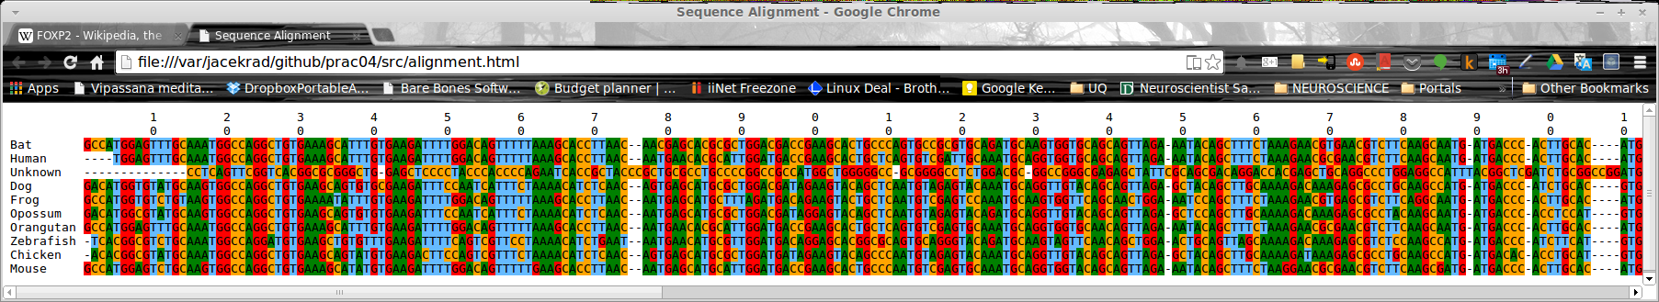

Code

'''
Created on 15/04/2014

@author: s4361277
'''
from sequence import *
import time

multi_align_sequences = readFastaFile("multiAlign.fasta", DNA_Alphabet)

start_time = time.time()
alignment = runClustal(multi_align_sequences)
end_time = time.time()
print("Elapsed time was %g seconds" % (end_time - start_time))

alignment.writeClustal("multiAlign.aln")
alignment.writeHTML("alignment.html")

Question 6
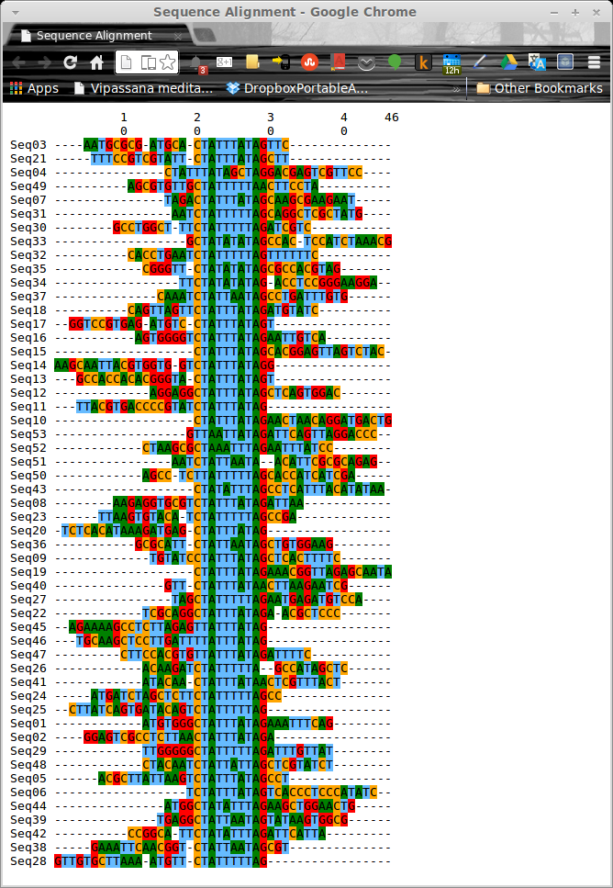

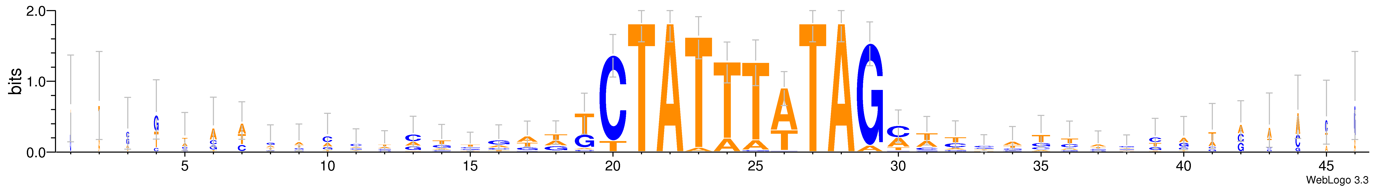
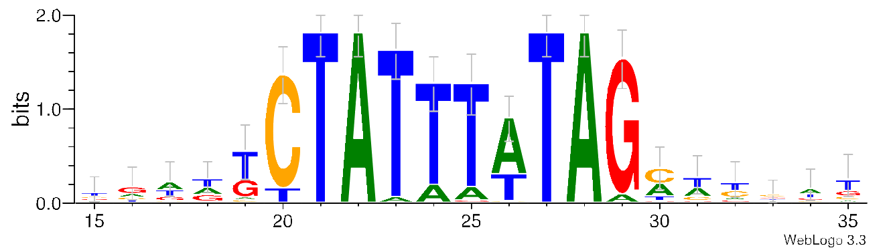

Question 7
Consensus sequence: CTATTTATAG
Regular expression: [CT]TA[TA]{5}AG

