Jacek Radajewski
Student number: 43612772
SCIE2100 Prac 8

Question 5
The sequence chose was the 1EVH:
SEQSICQARAAVMVYDDANKKWVPAGGSTGFSRVHIYHHTGNNTFRVVGRKIQDHQVVIN
CAIPKGLKYNQATQTFHQWRDARQVYGLNFGSKEDANVFASAMMHALEVLN

from the sstr3.fa file we can inspect the predicted secondary structure:
CEEEEEEEEEEEEEEECCCCEEEEHHHCCCCEEEEEEEECCCCEEEEEEEECCCCCEEEE
EEECCCCCCECCCCCEEEEECCCCEEEEEECCHHHHHHHHHHHHHHHHHHC

The accuracy was calculated at 61%. This was obtained by counting matches and dividing them by the total number of residues. A successful match was when expected and actual were both alpha helix or expected and actual were both beta sheets or when expected and actual were both neither an alpha helix or beta sheet.

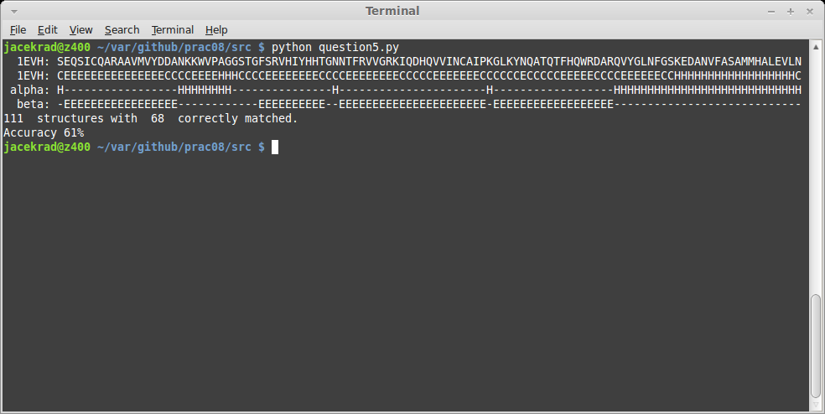

JMOL structure view
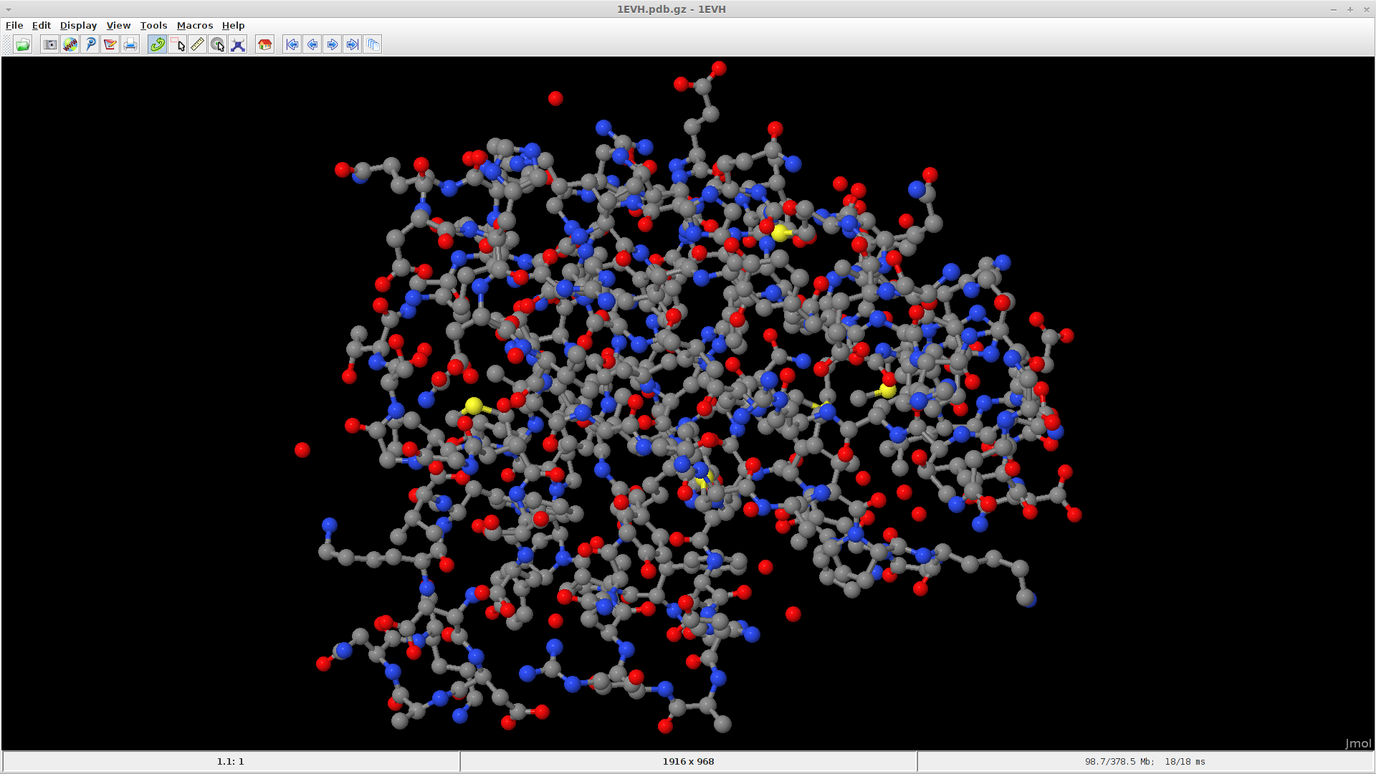

Code
'''
Created on 20/05/2014
prac08 question 5

@author: s4361277
'''
from sequence import *
from symbol import *
from sstruct import *

# read both protein and structure sequences into lists
proteins = readFastaFile("prot2.fa", Protein_Alphabet)
structures = readFastaFile("sstr3.fa", DSSP3_Alphabet)

# store protein and structure sequences in dictionary for easy retrieval
protein_map = {}
structure_map = {}

for protein in proteins:
protein_map.update({protein.name:protein})

for structure in structures:
structure_map.update({structure.name:structure})

protein = protein_map.get("1EVH")
structure = structure_map.get("1EVH")

alpha = getScores(protein, 0)
calls_a1 = markCountAbove(alpha, width=6, call_cnt=4)

alpha = getScores(protein, 0) # values from column 0
beta = getScores(protein, 1) # values from column 1

calls_a1 = markCountAbove(alpha, width=6, call_cnt=4)
calls_a2 = extendDownstream(alpha, calls_a1, width=4)
calls_a3 = extendUpstream(alpha, calls_a2, width=4)

calls_b1 = markCountAbove(beta, width=5, call_cnt=3)
calls_b2 = extendDownstream(beta, calls_b1, width=4)
calls_b3 = extendUpstream(beta, calls_b2, width=4)

avg_a = calcRegionAverage(alpha, calls_a3)
avg_b = calcRegionAverage(beta, calls_b3)

diff_a = [avg_a[i] - avg_b[i] for i in range(len(avg_a))]
diff_b = [avg_b[i] - avg_a[i] for i in range(len(avg_a))]

calls_a4 = checkSupport(calls_a3, diff_a)
calls_b4 = checkSupport(calls_b3, diff_b)

# print the sequence, structure from file and calculated alpha helix
# and beta sheet structures
print " ", protein
print " ", structure
print " alpha:", makesstr(calls_a4, 'H')
print " beta:", makesstr(calls_b4, 'E')

# to check the accuracy we simply compare our prediction to the one
# obtained from sstr3.fa

position = 0
match_count = 0
for element in structure.sequence:
if element == "H" and calls_a4[position]:
match_count += 1 # matched alpha helix
if element == "E" and calls_b4[position]:
match_count += 1 # matched beta sheet
if element != "H" and element !="E" and not(calls_a4[position]) and not(calls_b4[position]):
match_count += 1 # matched other
position += 1

print position, " structures with ", match_count, " correctly matched."
print "Accuracy %d%%" % ((float(match_count) / position) * 100)

Secondary structure from Protein Data Bank
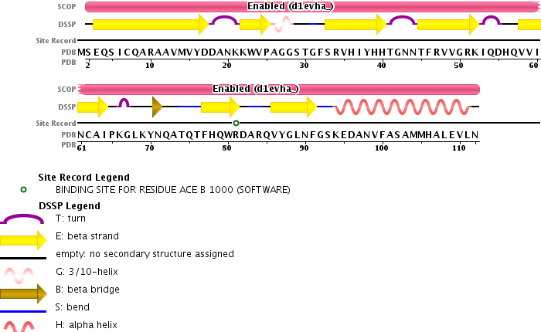

Question 7
Baseline for a 3-class secondary structure (eg. Alpha helix, beta sheet and random coil) is the probability of random guessing a structure. Since we have 3 potential types our guess probability would be 1/3 or 33%. This means that if our prediction algorithm success rate should be compared to that of 33% baseline.

Question 8

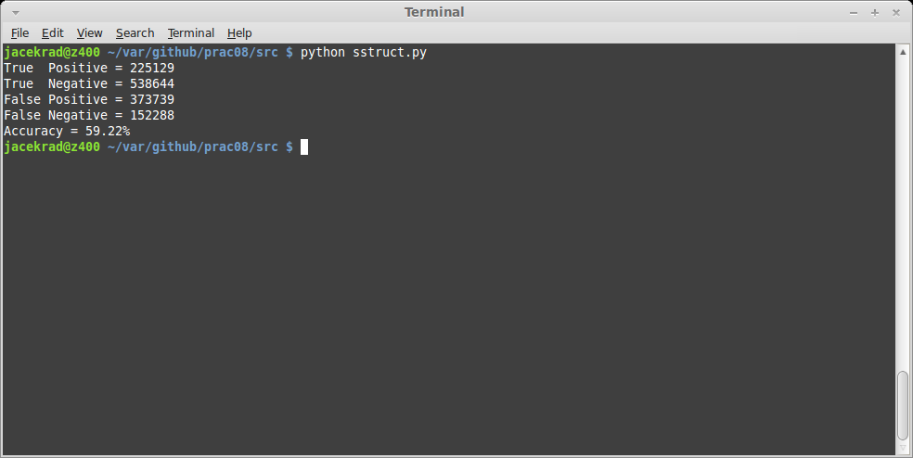

Question 9

