Jacek Radajewski (43612772)
SCIE2100 Prac 3
14/04/2014

Question 1

def alignGlobal(seqA, seqB, substMatrix, gap=-1):

.
.
.

# ~~~~~~~~~~~~~~~~~~~~~~~~~~~~~~~~~~~~~~~~~~~~~~~~~~~~~~~~~~~~~~~~~~~~~~~~~~~~~~~~~~~~
# starting at the bottom right hand corner of the matrix trace back to the origin 0,0
while i > 0 and j > 0:
# ~~~~~~~~~~~~~~~~~~~~~~~~~~~~~~~~~~~~~~~~~~~~~~~~~~~~~~~~~~~~~~~~~~~~~~~~~~~~~~~~~~~~
if S[i, j] == S[i - 1, j] + gap:
alignA = seqA[i - 1] + alignA
alignB = "-" + alignB
i -= 1
elif S[i, j] == S[i, j - 1] + gap:
# Got here by a gap in sequence A (go left)
alignA = "-" + alignA
alignB = seqB[j - 1] + alignB
j -= 1
else:
# Got here by aligning the bases (go diagonally)
alignA = seqA[i - 1] + alignA
alignB = seqB[j - 1] + alignB
i -= 1
j -= 1
# Fill in the rest of the alignment if it begins with gaps
# (i.e., traceback all the way to S[0, 0])
while i > 0:
# Go up
alignA = seqA[i - 1] + alignA
alignB = "-" + alignB
i -= 1
while j > 0:
# Go left
alignA = "-" + alignA
alignB = seqB[j - 1] + alignB
j -= 1
alignment = Alignment([Sequence(alignA, seqA.alphabet, seqA.name, gappy=True), Sequence(alignB, seqB.alphabet, seqB.name, gappy=True)])
alignment.gap_penalty = gap # save the gap for future analysis
return alignment

Question 2
def alignLocal(seqA, seqB, substMatrix, gap=-1):
.
.
.
# Stop when we hit the beginning of at least one sequence
# Local: also stop when we hit a score 0
while i > 0 and j > 0 and S[i, j] > 0:
# ~~~~~~~~~~~~~~~~~~~~~~~~~~~~~~~~~~~~~~~~~~~~~~~~~~~~~~~~~~~~~~~~~~~~~~~~~~~~~~~~~~~~
if S[i, j] == S[i - 1, j] + gap:
alignA = seqA[i - 1] + alignA
alignB = "-" + alignB
i -= 1
elif S[i, j] == S[i, j - 1] + gap:
alignA = "-" + alignA
alignB = seqB[j - 1] + alignB
j -= 1
# ~~~~~~~~~~~~~~~~~~~~~~~~~~~~~~~~~~~~~~~~~~~~~~~~~~~~~~~~~~~~~~~~~~~~~~~~~~~~~~~~~~~~
else:
# Got here by aligning the bases (go diagonally)
alignA = seqA[i - 1] + alignA
alignB = seqB[j - 1] + alignB
i -= 1
j -= 1
return Alignment([Sequence(alignA, seqA.alphabet, seqA.name, gappy=True), Sequence(alignB, seqB.alphabet, seqB.name, gappy=True)])

Question 3
Two differences between Needleman-Wunsch global and Smith-Waterman local alignments and their corresponding python implementation differences are described below.

Negative scores
One way that Smith-Waterman local alignment is different to Needleman-Wunsch global alignment is that it rejects negative scores. This difference is implemented in the code by adding 0 to the list from which we select the maximum as shown in the code below.

Global
S[i, j] = max([match, delete, insert])

Local
S[i, j] = max([match, delete, insert, 0])

Traceback start position

Global
Needleman-Wunsch traceback starts at the bottom-right-hand corned of the matrix ie last element. The code for obtaining the traceback starting point coordinates is shown below.
i = lenA
j = lenB

Furthermore the following code applies only to global alignment as local alignment would never start with a gap
# Fill in the rest of the alignment if it begins with gaps
# (i.e., traceback all the way to S[0, 0])
while i > 0:
# Go up
# ~~~~~~~~~~~~~~~~~~~~~~~~~~~~~~~~~~~~~~~~~~~~~~~~~~~~~~~~~~~~~~~~~~~~~~~~~~~~~~~~~~~~
alignA = seqA[i - 1] + alignA
alignB = "-" + alignB
# ~~~~~~~~~~~~~~~~~~~~~~~~~~~~~~~~~~~~~~~~~~~~~~~~~~~~~~~~~~~~~~~~~~~~~~~~~~~~~~~~~~~~
i = i - 1
while j > 0:
# Go left
# ~~~~~~~~~~~~~~~~~~~~~~~~~~~~~~~~~~~~~~~~~~~~~~~~~~~~~~~~~~~~~~~~~~~~~~~~~~~~~~~~~~~~
alignA = "-" + alignA
alignB = seqB[j - 1] + alignB
# ~~~~~~~~~~~~~~~~~~~~~~~~~~~~~~~~~~~~~~~~~~~~~~~~~~~~~~~~~~~~~~~~~~~~~~~~~~~~~~~~~~~~
j = j - 1

Local
Unlike Needleman-Wunsch global alignment, Smith-Waterman traceback does not start at the 'end', bottom-right corner of the matrix. Instead, local alignment traceback starts at the highest score. The coordinates of the highest score are obtained by the following code:
i = 0
j = 0
for ii in range(1, lenA + 1):
for jj in range(1, lenB + 1):
if S[ii, jj] > S[i, j]:
i = ii
j = jj

Question 7

Analysis of the HQ659871.1 and JX416721.1 alignments
In order to complete questions 5, 6 & 7 of the practical I have performed local and global alignments using five different matrices and gap penalties ranginng from -1 to -19. Furthermore, the above analysis was performed for all three reading frames with a seperate output file generated for each reading frame.

The approach was to iterate over the matrices and gaps as described above and collate all of the resulting alignments so they can be displayed together, on a single HTML page, for easy comparison. This was done by generating the output of all collated alignments and transforming the result into HTML using a XSLT stylesheet. Single HTML file contained results for various matrices and gap penalties used, but seperate files were used for local and global alignments as well as different reading frames.

In order to aid the analysis of the alignments start codons (including alternative) AUG, GUG and UUG were highlighted green, stop codons UAG, UGA and UAA were highlighted blue and gaps were highlighted red

Below is the listing of the main part of question 7 with the rest of the supporting code in Appendix B.

'''
Created on 08/04/2014

@author: s4361277
question 7
'''
from sequence import *
from alignments import AlignmentCollection, AlignmentThread

HQ659871_1 = getSequence("HQ659871.1", "genbank")
JX416721_1 = getSequence("JX416721.1", "genbank")

matrix_names = ["dna.matrix", "dna.matrix2", "dna.matrix3", "dna.matrix4", "dna.matrix.unknown"]

# list of matrices though which we shall iterate to obtain various alignments
matrices = []
for matrix_name in matrix_names:
matrix = readSubstMatrix(matrix_name, DNA_Alphabet)
print "Adding matrix: " + matrix_name + "\n", matrix
matrices.append(matrix)

local_alignments = AlignmentCollection("question 7 local")
global_alignments = AlignmentCollection("question 7 global")

print "number of cells in alignment matrix = ", len(HQ659871_1) * len(JX416721_1)

threads = []

print "HQ659871_1 = ", len(HQ659871_1)
print "JX416721_1 = ", len(JX416721_1)

for matrix in matrices:
print "processing matrix:", matrix.name
for gap_penalty in range(-1, -20, -1):
local_alignments.add_alignment(alignLocal(HQ659871_1, JX416721_1, matrix, gap_penalty))
global_alignments.add_alignment(alignGlobal(HQ659871_1, JX416721_1, matrix, gap_penalty))

local_alignments.dump_xml_and_html("question_7_local_alignments")
global_alignments.dump_xml_and_html("question_7_global_alignments")

The five matrices used in the analysis were:

dna.matrix - original supplied matrix
A 6
C -5 6
G -1 -5 6
T -5 -1 -5 6
A C G T

dna.matrix2 - slight increase to the most negative scores
A 6
C -4 6
G -1 -4 6
T -4 -1 -4 6
A C G T

dna.matrix3 – slignificant increase to the most negative scores
A 6
C -2 6
G -1 -2 6
T -2 -1 -2 6
A C G T

matrix: dna.matrix4 - all negative scores are equal
A 6
C -3 6
G -3 -3 6
T -3 -3 -3 6
A C G T

dna.matrix.unknown - found on various sites including wikipedia
A 10
C -3 9
G -1 -5 7
T -4 0 -3 8
A C G T

part a
In order to globally align two sequences of length m and n, a m+1 x n+1 matrix needs to be constructed m x n cells evaluated using the algorithm. Our sequences have lengths: HQ659871_1: 1497 and JX416721_1: 1565 which generates a matrix with 2342805 + 1297 + 1565 + 1 cells. The size of this matrix determines the significant overall wall clock time of running the alignment. Below is a screen shot of running global and local algorithms for 5 different substitution matrices and 19 different gap penalties. The wall clock time of the full analysis was 45:37 with the CPU time only a few seconds less showing that almost all of the time was spent calculating.

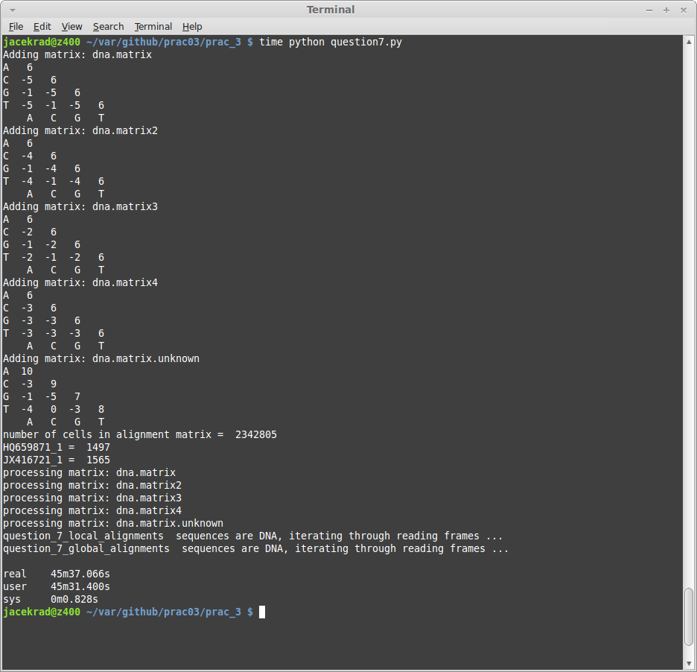

part b
Screen shots below shows multiple alignments of the two sequences, all using the default (supplied) substitution matrix (dna.matrix), various gap penalties and read frame 0. First screen shot show global alignments and the second shows local.

part c

Question 10
Question 10 was processed in a manner similar to that of question 7. The following is the code:
'''
Created on 08/04/2014

@author: s4361277
'''
from sequence import *
from alignments import AlignmentCollection, AlignmentThread
import util

p08684_filename="p08884.fasta"
q16802_filename="q16802.fasta"

# question 8
util.searchAndSave("P08684", p08684_filename)
util.searchAndSave("Q16802", q16802_filename)

matrix_names = ["blosum62.matrix", "p450.matrix"]

# list of matrices though which we shall iterate to obtain various alignments
matrices = []
for matrix_name in matrix_names:
matrix = readSubstMatrix(matrix_name, Protein_Alphabet)
print "Adding matrix: " + matrix_name + "\n", matrix
matrices.append(matrix)

# read our residue sequences from FASTAs
P08684 = readFastaFile(p08684_filename)[0]
Q16802 = readFastaFile(q16802_filename)[0]

local_alignments = AlignmentCollection("question 7 local")
global_alignments = AlignmentCollection("question 7 global")

for matrix in matrices:
print "processing matrix:", matrix.name
for gap_penalty in range(-1, -20, -1):
local_alignments.add_alignment(alignLocal(P08684, Q16802, matrix, gap_penalty))
global_alignments.add_alignment(alignGlobal(P08684, Q16802, matrix, gap_penalty))

local_alignments.dump_xml_and_html("question_10_local_alignments")
global_alignments.dump_xml_and_html("question_10_global_alignments")

Appendix A – Unit tests for Questions 1 & 2
'''
Created on 08/04/2014

@author: s4361277
unit tests:
prac 3
questions 1 & 2
'''
import unittest

from sequence import Sequence, Protein_Alphabet, readSubstMatrix, alignGlobal, alignLocal

class SequenceTest(unittest.TestCase):

def setUp(self):
self.seqA = Sequence("THISLINE", Protein_Alphabet, name="SeqA")
self.seqB = Sequence("ISALIGNED", Protein_Alphabet, name="SeqB")
self.blosum62_matrix = readSubstMatrix("blosum62.matrix", Protein_Alphabet)

def tearDown(self):
pass

def testQuestion1_8(self):
""" test question 1; global alignment with a gap penalty of -8 """
aln_global_8 = alignGlobal(self.seqA, self.seqB, self.blosum62_matrix, -8)
expected1 = aln_global_8.seqs[0].getSeqString()
expected2 = aln_global_8.seqs[1].getSeqString()
self.assertEquals("THISLINE-", expected1)
self.assertEquals("ISALIGNED", expected2)

def testQuestion1_4(self):
""" test question 1; global alignment with a gap penalty of -4 """
aln_global_4 = alignGlobal(self.seqA, self.seqB, self.blosum62_matrix, -4)
expected1 = aln_global_4.seqs[0].getSeqString()
expected2 = aln_global_4.seqs[1].getSeqString()
self.assertEquals("THIS-LI-NE-", expected1)
self.assertEquals("--ISALIGNED", expected2)

def testQuestion2_8(self):
""" test question 2; local alignment with a gap penalty of -8 """
aln_local_8 = alignLocal(self.seqA, self.seqB, self.blosum62_matrix, -8)
expected1 = aln_local_8.seqs[0].getSeqString()
expected2 = aln_local_8.seqs[1].getSeqString()
self.assertEquals("SLI-NE", expected1)
self.assertEquals("ALIGNE", expected2)

def testQuestion2_4(self):
""" test question 2; local alignment with a gap penalty of -4 """
aln_local_4 = alignLocal(self.seqA, self.seqB, self.blosum62_matrix, -4)
expected1 = aln_local_4.seqs[0].getSeqString()
expected2 = aln_local_4.seqs[1].getSeqString()
self.assertEquals("IS-LI-NE", expected1)
self.assertEquals("ISALIGNE", expected2)

if __name__ == "__main__":
#import sys;sys.argv = ['', 'Test.testName']
unittest.main()

Appendinx B.1 – Alignment.toXML()
def toXML(self, reading_frame = 0):
""" Attempt to dump an XML representation of this alignment
"""

xml = ""

# output reading from for DNA alphabets only
if self.alphabet == DNA_Alphabet:
xml += "<sequence-alignment gap-penalty=\"" + str(self.gap_penalty) + "\"" \
+ " matrix-name=\"" + str(self.matrix_name) + "\"" \
+ " reading-frame=\"" + str(reading_frame) + "\">"
else:
xml += "<sequence-alignment gap-penalty=\"" + str(self.gap_penalty) + "\"" \
+ " matrix-name=\"" + str(self.matrix_name) + "\">"
xml += "<sequences>\n"
maxNameLength = self.getnamelen()
xml += ''.ljust(maxNameLength) + ' '
for sequence in self.seqs:
xml += "<sequence>\n"
xml += "<name>" + sequence.name.ljust(maxNameLength) + "</name>\n"
seq_length = len(sequence)
position = 0
sof = False # start of frame flag
for sym in sequence:
if ((position - reading_frame) % 3) == 0:
sof = True
else:
sof = False
if sym == '-':
xml += "<GAP/>"
elif sof and seq_length > (position + 2) and \
sym == 'A' and sequence[position + 1] == 'T' and sequence[position + 2] == 'G':
xml += "<" + sym + " codon=\"start\" />"
elif sof and seq_length > (position + 2) and \
sym == 'G' and sequence[position + 1] == 'T' and sequence[position + 2] == 'G':
xml += "<" + sym + " codon=\"start\" />"
elif sof and seq_length > (position + 2) and \
sym == 'T' and sequence[position + 1] == 'T' and sequence[position + 2] == 'G':
xml += "<" + sym + " codon=\"start\" />"
elif sof and seq_length > (position + 2) and \
sym == 'T' and sequence[position + 1] == 'A' and sequence[position + 2] == 'G':
xml += "<" + sym + " codon=\"stop\" />"
elif sof and seq_length > (position + 2) and \
sym == 'T' and sequence[position + 1] == 'G' and sequence[position + 2] == 'A':
xml += "<" + sym + " codon=\"stop\" />"
elif sof and seq_length > (position + 2) and \
sym == 'T' and sequence[position + 1] == 'A' and sequence[position + 2] == 'A':
xml += "<" + sym + " codon=\"stop\" />"
else:
xml += "<" + sym + "/>"
position += 1
xml += "</sequence>\n"
xml += "</sequences></sequence-alignment>\n"
return xml

Appending B.2 – alignments.py
'''
Created on 12/04/2014

@author: jacekrad
'''

from lxml import etree
import threading as thread
from sequence import *

class AlignmentCollection():
'''
simple collection of multiple alignments
main purpose of this class is to allow us to compare multiple alignments
with each other analysing gaps etc
'''

def __init__(self, name):
'''
Constructor
'''
self.name = name
self.alignments = []
self.is_dna = False

def add_alignment(self, alignment):
""" append an alignment to this collection """
self.alignments.append(alignment)

def toXML(self, reading_frame = 0):
""" return XML representation of this collection of alignments """
if self.is_dna:
xml = "<alignments name=\"" + self.name + "\" reading_frame=\"" + str(reading_frame) + "\">\n"
else:
xml = "<alignments name=\"" + self.name + "\">\n"
for alignment in self.alignments:
xml += alignment.toXML(reading_frame = reading_frame)
xml += "</alignments>\n"
return xml

def dump_xml_and_html(self, prefix = "output"):
""" dump raw XML representation of these alignments as well as
transformed into HTML output into files named by the prefix """

# if these are alignments of DNA then we generate 3 of each,
# one per reading frame
if self.alignments[0].seqs[0].alphabet == DNA_Alphabet:
self.is_dna = True

if self.is_dna:
print prefix, " sequences are DNA, iterating through reading frames ..."
for reading_frame in range(0, 3):
xml_filename = prefix + "_reading_frame_" + str(reading_frame) + ".xml"
html_filename = prefix + "_reading_frame_" + str(reading_frame)+ ".html"
xslt_filename = "alignments_html.xsl"
# dump XML
open(xml_filename, "w").write(self.toXML(reading_frame))
#dump HTML
open(html_filename, "w").write(self.transform(xml_filename, xslt_filename))

else:
xml_filename = prefix + ".xml"
html_filename = prefix + ".html"
xslt_filename = "alignments_html.xsl"
# dump XML
open(xml_filename, "w").write(self.toXML())
#dump HTML
open(html_filename, "w").write(self.transform(xml_filename, xslt_filename))

def transform(self, xmlPath, xslPath):
xslRoot = etree.fromstring(open(xslPath).read())
transform = etree.XSLT(xslRoot)
xmlRoot = etree.fromstring(open(xmlPath).read())
transRoot = transform(xmlRoot)
return etree.tostring(transRoot)

class AlignmentThread (thread.Thread):

def __init__(self, HQ659871_1, JX416721_1, matrix_filename, gap_penalty, alphabet = DNA_Alphabet):
thread.Thread.__init__(self)
self.seqA = HQ659871_1
self.seqB = JX416721_1
self.matrix = readSubstMatrix(matrix_filename, alphabet)
self.gap_penalty = gap_penalty
self.result_alignment = None

def run(self):
print "Starting " + self.name
self.result_alignment = alignGlobal(self.seqA, self.seqB, self.matrix, self.gap_penalty)
print self.name, " completed"

Appendix B.3 alignments_html.xsl
<?xml version="1.0" encoding="UTF-8"?>
<xsl:stylesheet xmlns:xsl="http://www.w3.org/1999/XSL/Transform"
xmlns:xs="http://www.w3.org/2001/XMLSchema" exclude-result-prefixes="xs" version="2.0">

<xsl:output method="xhtml" encoding="UTF-8" indent="yes"/>

<xsl:template match="/">
<html>
<head>
<link href="alignments.css" rel="stylesheet" type="text/css"/>
<title>
<xsl:value-of select="alignments/@name"/>
</title>
</head>
<body>
<table>
<xsl:apply-templates select="alignments/sequence-alignment"/>
</table>
</body>
</html>
</xsl:template>

<xsl:template match="sequence-alignment">
<tbody class="alignment">
<tr>
<th class="desc">
<xsl:if test="@reading-frame">
<xsl:text>Frame: </xsl:text>
<xsl:value-of select="@reading-frame"/>
<xsl:text>;</xsl:text>
</xsl:if>
<xsl:value-of select="@matrix-name"/>
</th>
<xsl:for-each select="sequences/sequence[1]/node()">
<th>
<xsl:value-of select="floor((position() mod 1000) div 100)"/>
</th>
</xsl:for-each>
</tr>
<tr>
<th class="desc">penalty = <xsl:value-of select="@gap-penalty"/></th>
<xsl:for-each select="sequences/sequence[1]/node()">
<th>
<xsl:value-of select="floor((position() mod 100) div 10)"/>
</th>
</xsl:for-each>
</tr>
<tr>
<th class="desc"><xsl:value-of select="count(.//GAP)"/> gaps.</th>
<xsl:for-each select="sequences/sequence[1]/node()">
<th>
<xsl:value-of select="position() mod 10"/>
</th>
</xsl:for-each>
</tr>
<xsl:for-each select="sequences/sequence">
<tr class="alignment">
<td class="seq_name">
<xsl:value-of select="name"/>
</td>
<xsl:apply-templates select="node()[local-name() != 'name']"/>
</tr>
</xsl:for-each>
</tbody>
</xsl:template>

<xsl:template match="GAP">
<td class="gap alignment">-</td>
</xsl:template>

<xsl:template match="A[@codon = 'start']">
<td class="atg_codon">A</td>
</xsl:template>

<xsl:template match="T[@codon = 'start']">
<td class="atg_codon">T</td>
</xsl:template>

<xsl:template match="G[@codon = 'start']">
<td class="atg_codon">G</td>
</xsl:template>

<xsl:template match="T[preceding-sibling::node()[1][@codon = 'start']]">
<td class="atg_codon">T</td>
</xsl:template>

<xsl:template match="G[preceding-sibling::node()[2][@codon = 'start']]">
<td class="atg_codon">G</td>
</xsl:template>

<xsl:template match="T[@codon = 'stop']">
<td class="stop_codon">T</td>
</xsl:template>

<xsl:template match="A[preceding-sibling::node()[1][@codon = 'stop']]">
<td class="stop_codon">A</td>
</xsl:template>

<xsl:template match="A[preceding-sibling::node()[2][@codon = 'stop']]">
<td class="stop_codon">A</td>
</xsl:template>

<xsl:template match="G[preceding-sibling::node()[1][@codon = 'stop']]">
<td class="stop_codon">G</td>
</xsl:template>

<xsl:template match="G[preceding-sibling::node()[2][@codon = 'stop']]">
<td class="stop_codon">G</td>
</xsl:template>

<xsl:template match="M">
<td class="atg_codon">M</td>
</xsl:template>

<!-- fallback match of non-special letters -->
<xsl:template match="A | B| C | D | E | F | G | H | I | J | K | L | N | O | P | Q | R | S| T | U | V | X | Y | Z">
<td class="alignment">
<xsl:value-of select="local-name()"/>
</td>
</xsl:template>

</xsl:stylesheet>

Appendix B.4 – alignment.css

td {
font-family:monospace;
border:1px solid #CCC;
}

th {
font-family:monospace;
font-size:smaller;
color:#DDD;
}

.desc {
color: blue;
text-align:left;
}

.gap {
background-color:#FF8888;
}

.atg_codon {
background-color:#00FF00;
}

.stop_codon {
background-color:#0000FF;
}

.seq_name {
font-weight:bold;
}

.alignment {}

