A detailed page outlining the project scope, objectives, data sources, and features.

problem statement

========

Ngee Ann Polytechnic admits students through various admission exercises. However, the admissions team faces a significant challenge in managing the high volume of daily inquiries, which often exceed 100 per day. With a small team of only two service representatives, response times are slow, leading to delays in addressing students' questions. The majority of these inquiries revolve around understanding course content and exploring potential career paths after graduation. This influx of inquiries strains the resources available and hinders the ability to provide timely and effective guidance to prospective students, impacting the overall admissions experience.

project scope

===============

To streamline the course coaching process and improve the efficiency of the customer service team, we propose the development of an internal application powered by a Large Language Model (LLM). This application will serve as a bot to reply public enquiries related to course coaching.

Enquirer can input their queries related to course to the LLM. The model will process these inputs and click submit button.

The LLM will then assess and provide a clear, text-based explanation or justification for each enquiry, referring to the relevant client information.

objectives

=============

The app will display guidance for the course related to course description, skill acquire or future career that graduant can pursue, including references to relevant course-specific data.

data sources

=============

a json file related to the course coaching detail.

Impact

=============

-Reduce the time spent handling public inquiries, allowing service representatives to focus on more high-value tasks

-we estimate the app will be used by 4000 of public enquirer, with about 100-200 inquiries per day.

methodology

==============

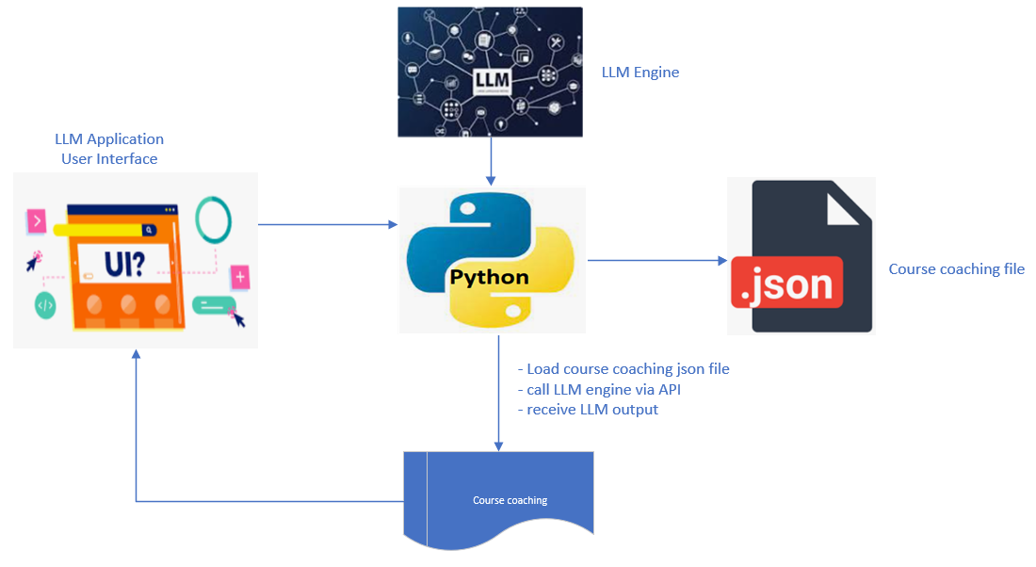

**About chatbot 1**

Welcome to Ngee Ann Polytechnic Course Coaching Chatbot!

Hello! I'm your friendly Course Coaching Assistant, here to help you navigate the wide array of courses offered at Ngee Ann Polytechnic. Whether you're a prospective student or someone looking to learn more about a specific program, I'm here to provide you with all the information you need.

What I Can Do For You:

* Course Information: Get detailed information about various diploma courses, degrees, and specializations offered at Ngee Ann Polytechnic.
* Admission Details: Learn about the admission process, eligibility requirements, and key deadlines.
* Course Schedule: Find out about class timings, terms, and session dates.
* Campus Facilities: Curious about campus life, student services, or facilities? I’ve got you covered!
* Application Help: Need assistance with submitting your application or documents? Let me guide you through the steps.
* Career Pathways: Wondering how a specific course can shape your career? I can share career paths, internships, and job opportunities that are associated with your chosen field.
* Course Prerequisites: Get information about entry requirements for specific courses or how to prepare before joining.
* General Inquiries: Have other questions? Ask me anything and I’ll provide you with the information you need!

How It Works:

1. Ask Away: Just type your question, and I'll find the best possible answer for you.
2. Instant Responses: No waiting, no hassle! Get quick answers on the go.
3. Easy Navigation: If you're looking for something specific, just let me know and I'll point you in the right direction.

I’m here 24/7, ready to assist you in making the best decisions about your education journey at Ngee Ann Polytechnic.

Let’s get started! How can I assist you today?