EXP:4 7 SEGMENT DISPLAY USING AT89C51 USING PROTEUS
AIM:
To write an assembly language program for 7 Segment Display Using AT89C51 using Keil
and Proteus
SOFTWARE REQUIRED:
Proteus 8 software.
PROGRAM:
ORG 000H
UP:MOV P2,#0C0H
ACALL DELAY
MOV P2,#0F9H
ACALL DELAY
MOV P2,#0A4H
ACALL DELAY
MOV P2,#0Bон
ACALL DELAY
MOV P2,#99H
ACALL DELAY
MOV P2,#92H
ACALL DELAY
MOV P2,#82H
ACALL DELAY
MOV P2,#0F8H
ACALL DELAY
MOV P2, #80H
ACALL DELAY
MOV P2,#90H
ACALL DELAY
DELAY: MOV R5,#10
HI:MOV R4,#180
H2:MOV R3,#255
H3:DJNZ R3,H3
DJNZ R4.H2
DJNZ RS.HI
RET
END
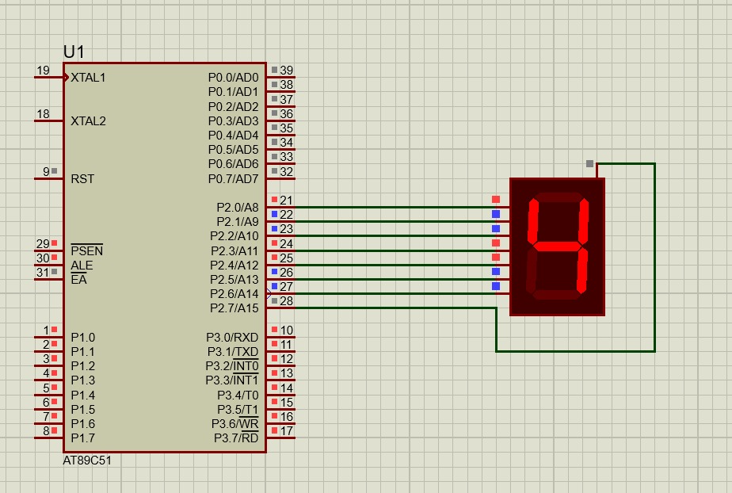

RESULT:
Thus the program has been successfully verified and executed.

