ASSIGNMENT-2

1. Write a program to find the number of special characters in the given statement

Sample Input:

Given statement: Modi Birthday @ September 17, #&$% is the wishes code for him.

Sample Output:

Number of special Characters: 5

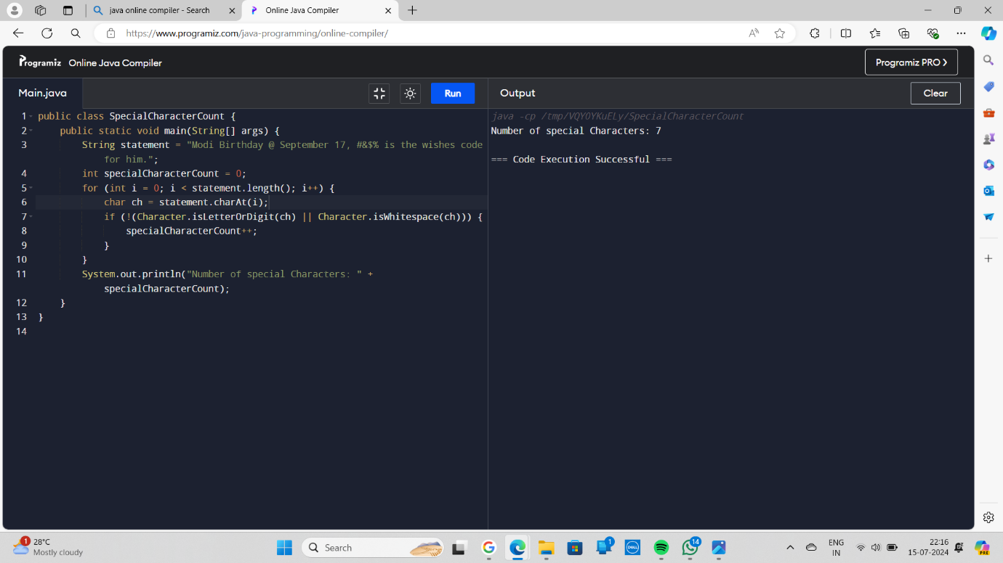

2.Write a program to enter the marks of a student in four subjects. Then calculate the total and aggregate, display the grade obtained by the student. If the student scores an aggregate greater than 75%, then the grade is Distinction. If aggregate is 60>= and <75, then the grade is First Division. If aggregate is 50 >= and <60, then the grade is Second Division. If aggregate is 40>= and <50, then the grade is Third Division. Else the grade is Fail

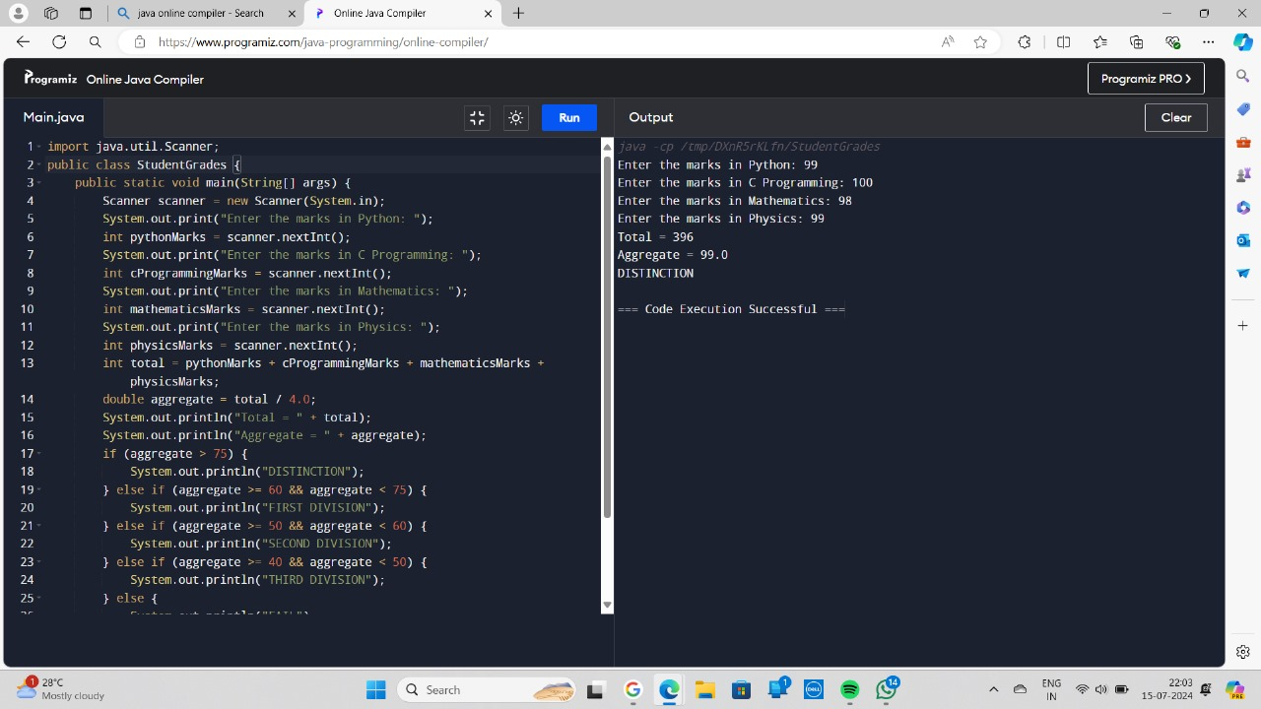

3.Write a program to calculate tax given the following conditions:

a. If income is less than or equal to 1,50,000 then no tax

b. If taxable income is 1,50,001 – 3,00,000 the charge 10% tax

c. If taxable income is 3,00,001 – 5,00,000 the charge 20% tax

d. If taxable income is above 5,00,001 then charge 30% tax

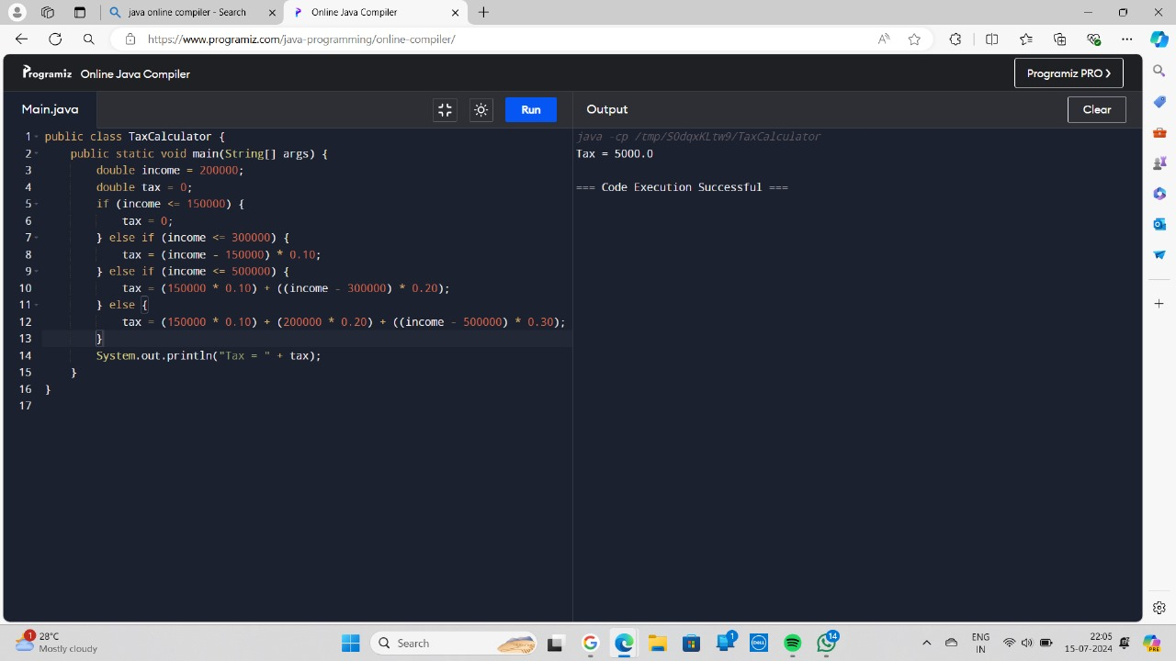

4. Write a program to print the first n perfect numbers. (Hint Perfect number means a positive integer that is equal to the sum of its proper divisors)

Sample Input:

N = 3

Sample Output:

First 3 perfect numbers are: 6 , 28 , 496

Test Cases:

1. N = 0

2. N = 5

3. N = -2

4. N = -5

5. N = 0.2

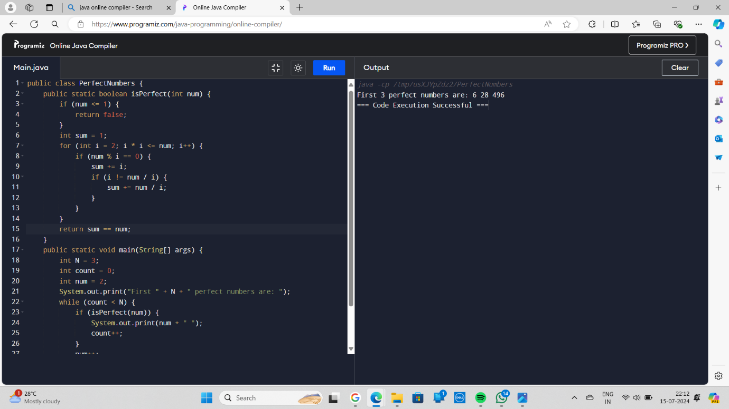

5. Write a Program to Find the Nth Largest Number in a array.

Sample Input:

List : {14, 67, 48, 23, 5, 62}

N = 4

Sample Output:

4th Largest number: 23

