NDIS Cost Growth, Policy Options & Fiscal Risk

  - How does participant growth, average plan costs, and policy levers affect the long-term fiscal sustainability of the NDIS under alternative scenarios?

Table of Contents
Purpose 2
Data and Methodology 2
Key Assumptions 2
Key Findings 3
Scenario Analysis 4
Policy Implications 6
Uncertainties and Limitations 6

Purpose
This report assesses the medium-term fiscal sustainability of the NDIS scheme through modelling alternative participant growth and cost scenarios. This analysis will provide insight into the impacts of the tightening eligibility reform, as well as potential economic and demographic scenarios on the NDIS.

Key Findings
- Under baseline assumptions, total NDIS budgeting costs grow materially over the next 15 years, driven primarily by increases in average plan cost rather than participant growth. Hence, mitigating costs may be more influential to the NDIS’ sustainability than eligibility reforms. This can be inferred from the figure below.
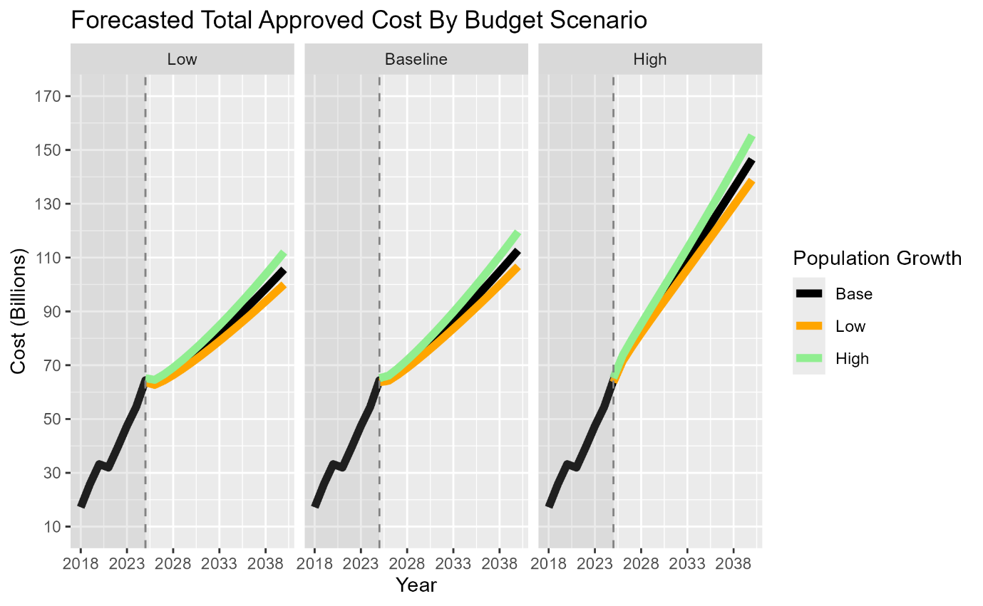
- The propensity for extreme annualised member budget increases is larger than conservative budget increases. This raises concerns for future sustainability through the high likelihood of increased financial constraint.
- Participant utilisation of annualised budgets is projected to increase, which is directly due to forecasted payments increasing relative to budgeting costs. WHAT DOES THIS MEAN?
- With no eligibility reforms, under the base case scenario, members under the age of 20 responsible for more budget plan costs than other age groups, with cost growth in this area being more pronounced as well. This may be evidence that an eligibility tightening reform on this cohort may greatly reduce costs. This is demonstrated in the figure below.
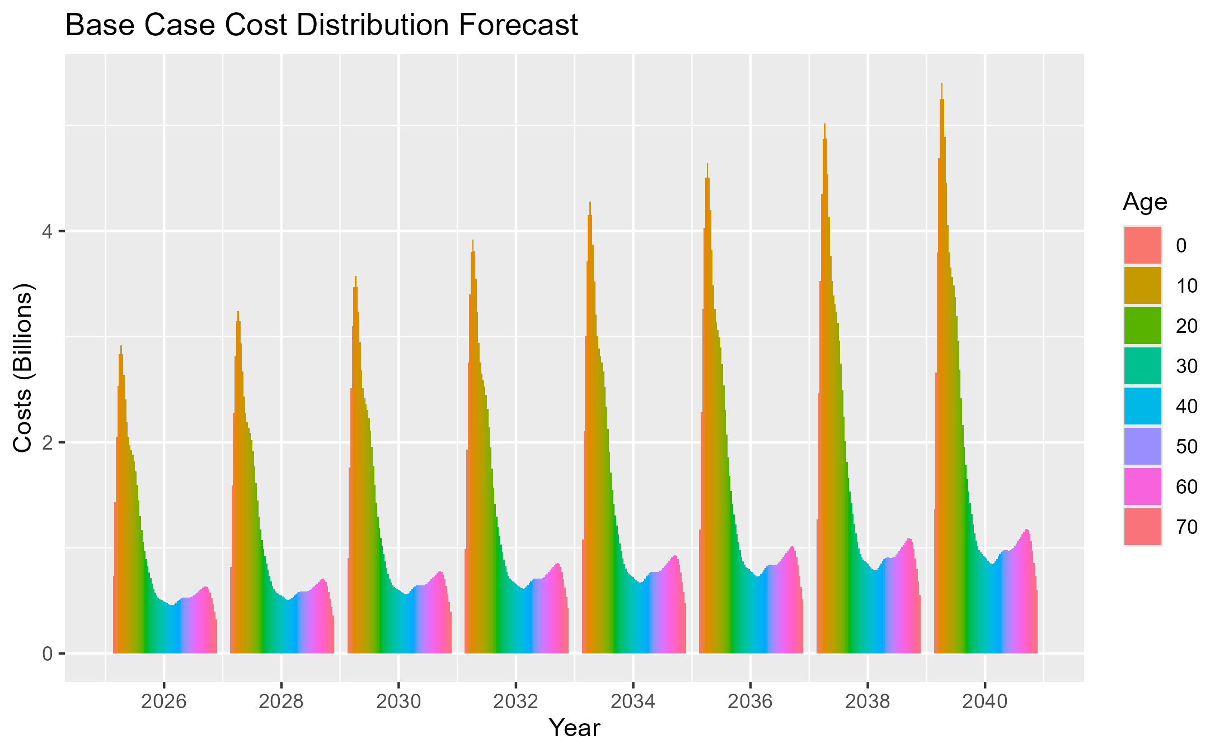

Scenario Analysis
- Status-quo scenario:
The status quo scenario is modelled under baseline population, average budget and average payments growth. Total participants are forecasted to increase by 20% over the next 15 years to approximately 900,000, total services budget by 96% to $126 billion, total payments by 99% to $100 billion, and utilisation has only increased by 1%.
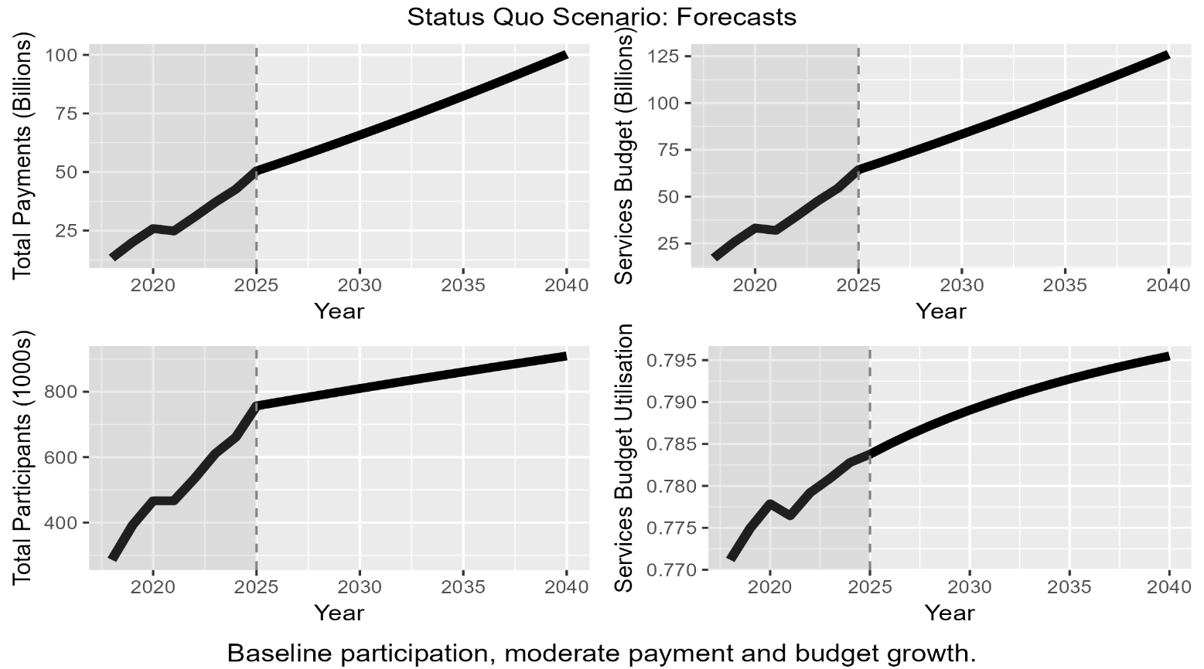
- Adverse scenario:
The adverse scenario is modelled under high participation growth, high budget growth and high payment growth. This scenario represents a scenario where services costs increase drastically, along with huge demand spikes. Total participation is forecasted to increase by 26% over the coming 15 years to approximately 960,000, total services budget by 140% to $155 billion, total payments by 109% to $131 billion and utilisation to decrease by 12% to 84%.
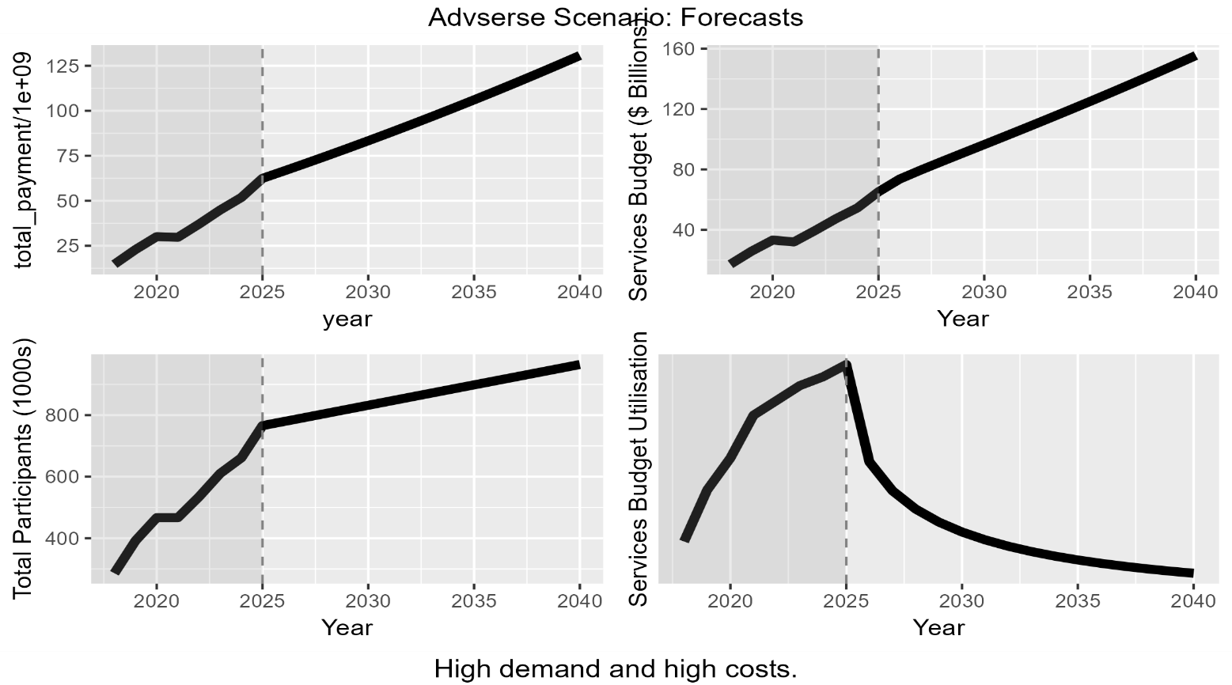

- Reform scenario:
Under the eligibility reform scenario, the payments and budget are modelled with moderate growth. The under 10 years old members group are modelled to decrease in size, in response to a tightening reform in children’s eligibility. This results in fewer children in the scheme long term compared to the base case, with a short-term shrinking in size as existing members age out of the group, and fewer children enter the scheme.
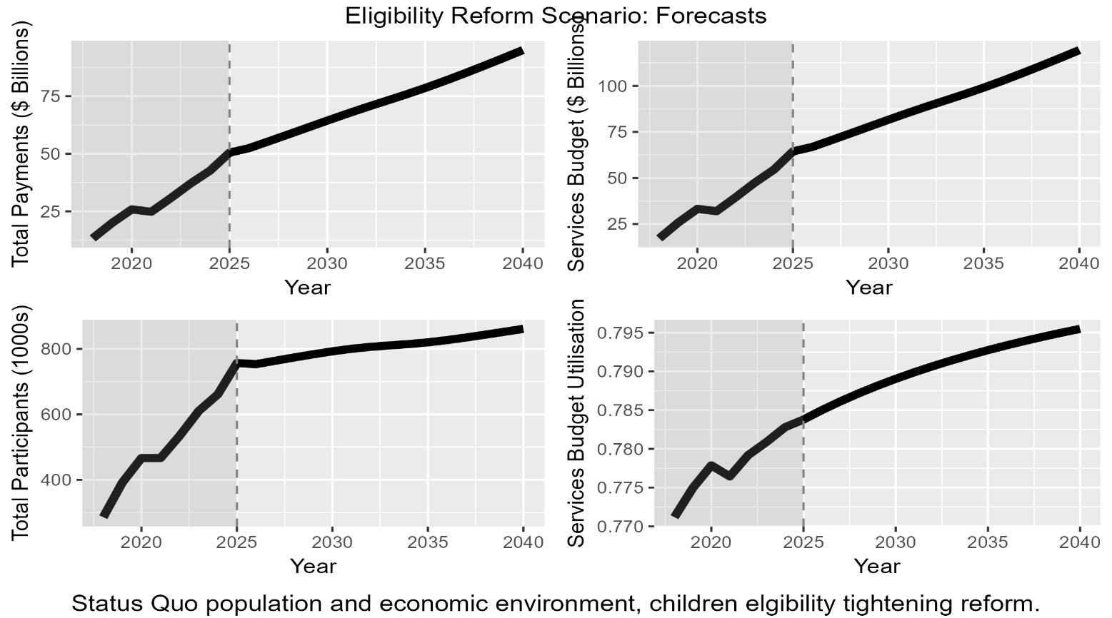

Policy Implications
The tightening of the policy reform in the medium-term, as discussed, showed minimal improvements to the scheme’s future financial burden. Despite the population distribution being influenced materially in comparison to the base case (Appendix C), the effects of this change produced negligible cost reduction.

Uncertainties and Limitations
The results in this report are indicative only and rely on publicly available data from the post-2018 period. To reiterate the underlying assumptions, data simplifications and limitations diminish the accuracy of longer-term projections, as longer horizons are also subject to policy and behavioral uncertainties.

Appendix

Appendix A – Methodology
The data for this report was sourced from the NDIS quarterly reports, ABS population projections and the ABS quarterly population estimates.
The data was first ingested, cleaned and wrangled ready for analysis and modelling. Population projections were combined with age distributions and NDIS participation rates to forecast the active members in the scheme. Participation rates were smoothed and normalised using spline interpolation, and the population distribution was smoothed and normalised using Lowess curves to reduce noise. The assumptions here are that these will capture the general shape of the distributions better.
Average annualised planned budgets were forecasted using ARIMA(0,1,0) models, likewise for payments per participant which further incorporating the annualised budget as an input.
These forecasts produced baseline, conservative and extreme outputs alike, which were used for scenario analysis for baseline, high pressure, adverse and reformed eligibility states. The projection horizon is medium-term at 15 years (2026-2040).

Appendix B – Key Assumptions
- Overall Participation Growth:
Converges to the national population growth, forecasted by the ABS. This assumption provides modelling simplicity, which is necessary for interpretability and accuracy due to scarce historical data. It is well justified as for medium-term projections, significant shocks to disability rates are assumed to be minimal and the prevalence of natural born conditions is unlikely to change. This goes against the data, as its explosive growth likely occurred to meet existing demand, rather than demonstrating a long term trend.
- Age Distribution:
For simplicity, the age distribution will remain fixed at the most recent ABS quarterly estimate in Q3 2025. This can be justified by the data demonstrating quite a constant distribution and the medium-term projection horizon. This disregards any mortality, fertility and migration assumptions, which would be required for a more accurate model. Further iterations of this report will incorporate these variables in its analysis.
- Gender Distribution:
Gender is assumed to be evenly distributed across Male and Female for simplicity. The differences are negligible for this analysis, as fertility, mortality and migration are already disregarded, and average costs across all participants are applied.
- Participation Rates:
These rates are fixed at the 2025 levels for all baseline scenarios. The policy reform, however, alters this assumption by design.
- Budget and Payment Modelling:
Both are modelled using ARIMA(0,1,0) relationships. In short, the change in average annualised budgets and payments are modelled with time rather than the values themselves. The payments are modelled with the forecasted budget values as an input, under the assumption that participant payments likely increase as access to services increases.
- Participant States
This forecast only considers members to be active in the NDIS scheme, or inactive. This assumes all entrants represent equivalent attributes in the models.

Appendix C – Additional Charts

Baseline vs Reform Population Distributions
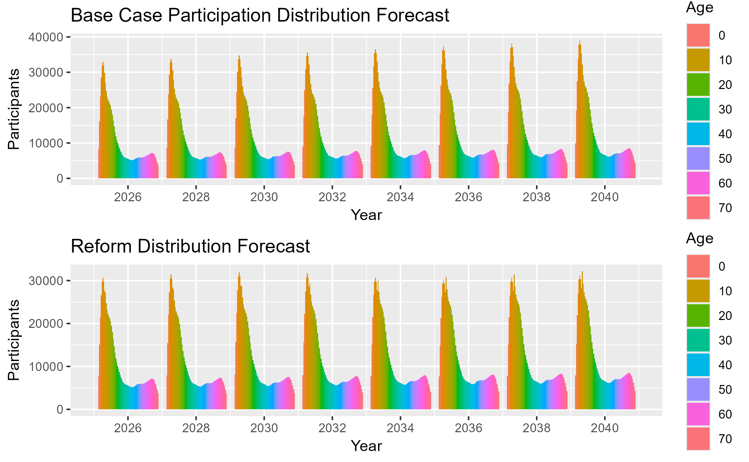

Population Projection (ABS)
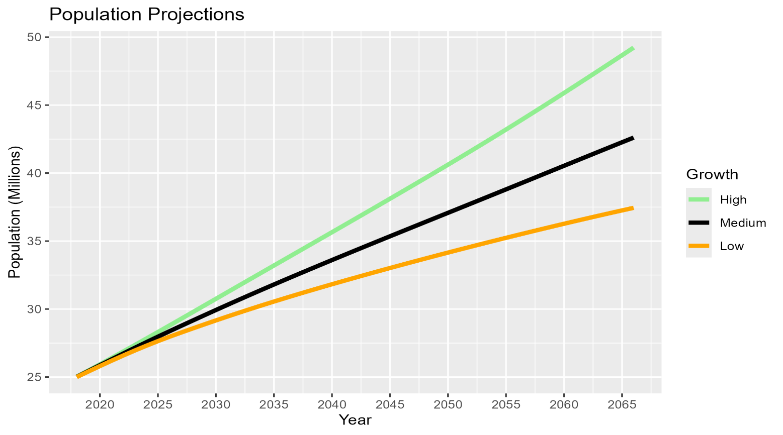

Raw Historical Participation Rates
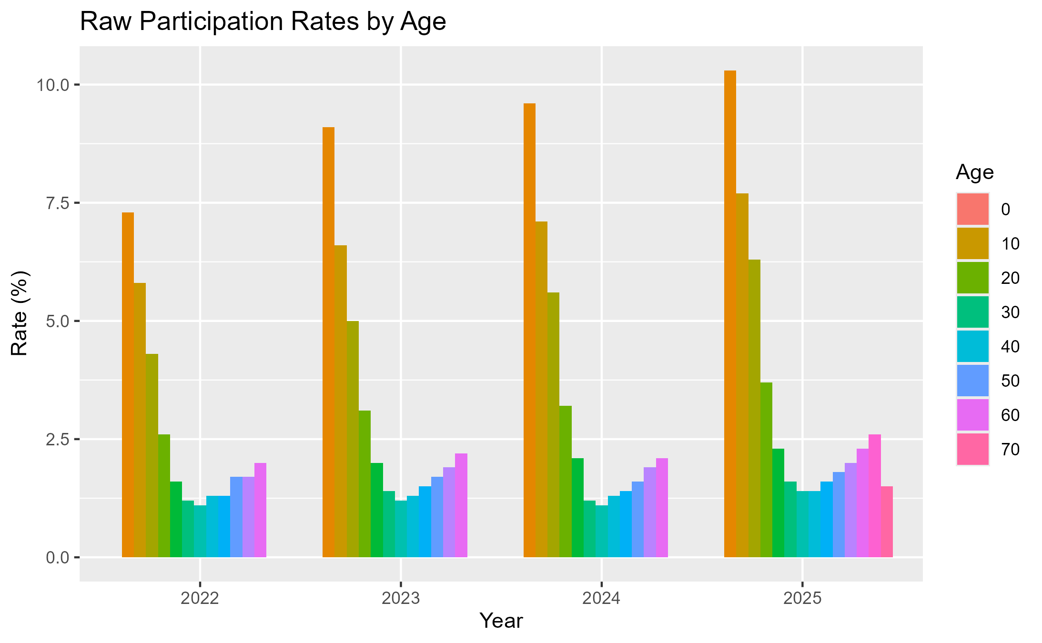

Historical Average Budget and Participants
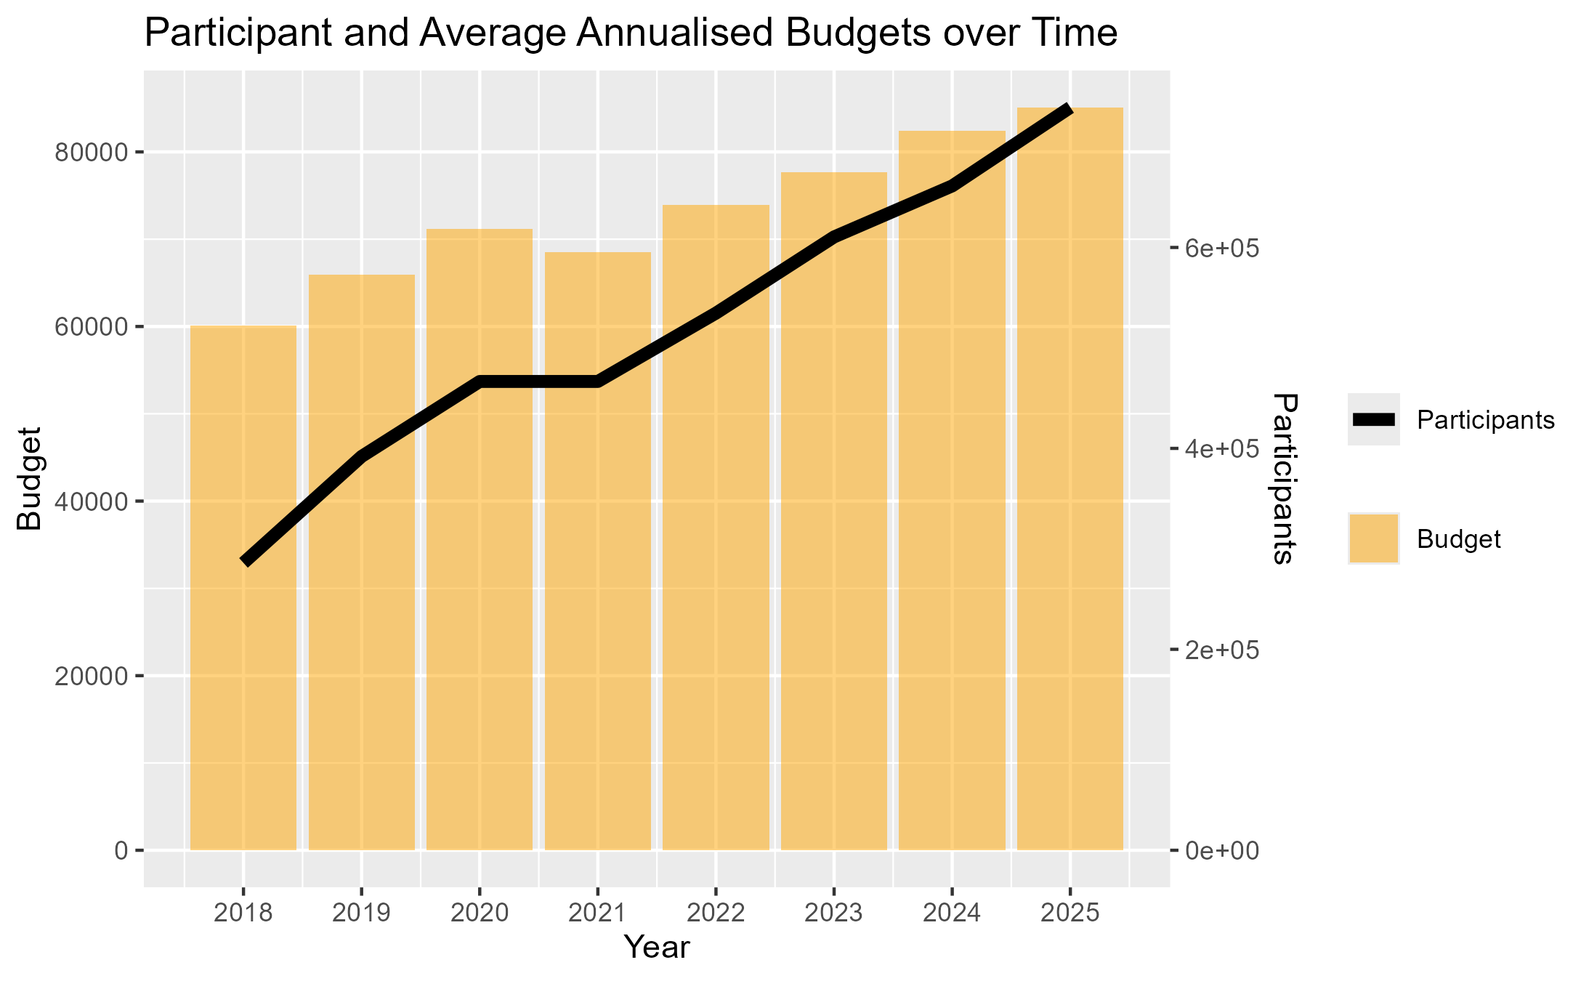

Historical Average Payments
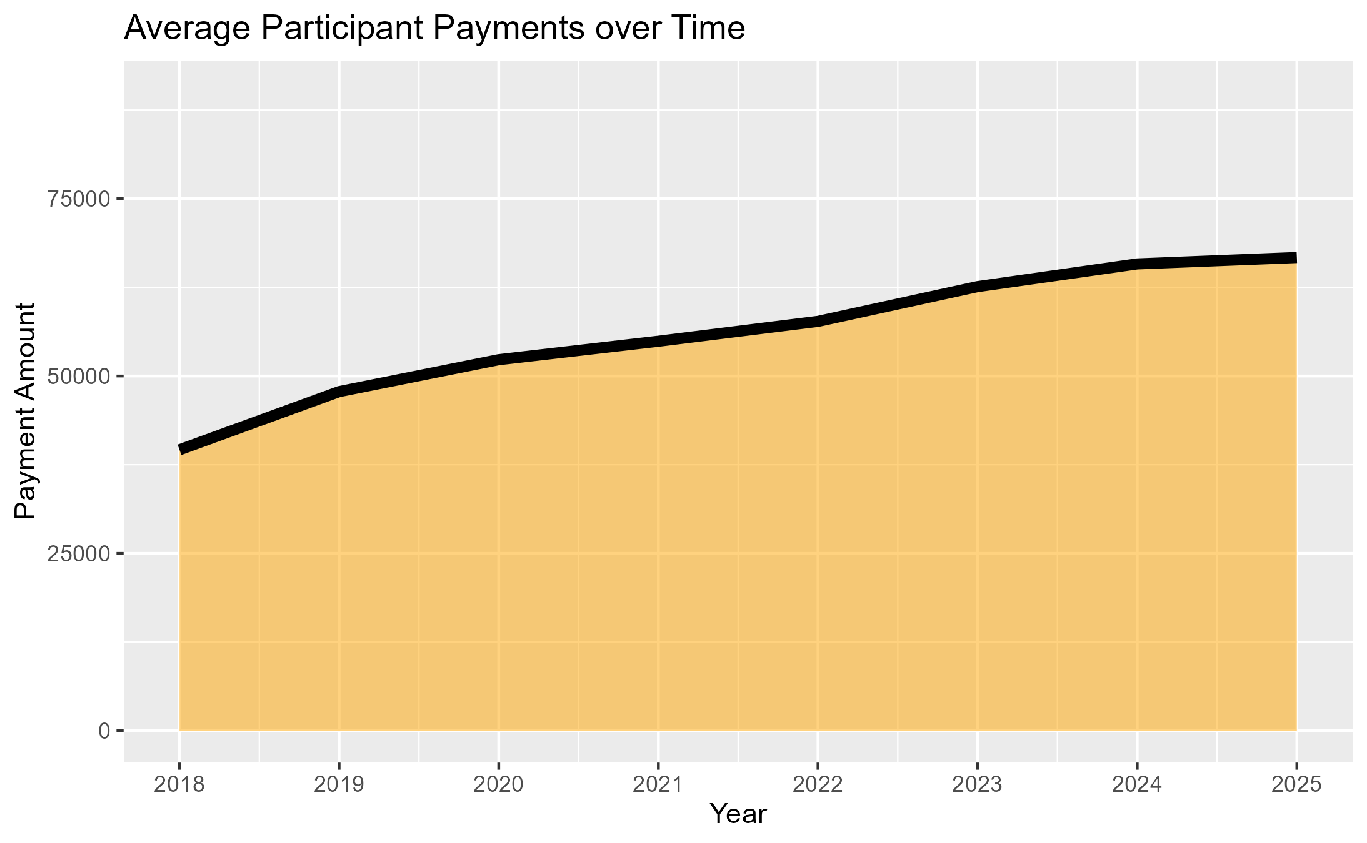

Historical Average Budget Utilisation
