Individual Report - Kaixiang Sheng
Facial Recognition with Emotion and Liveness
1. Individual Contributions
My main contributions were metric-learning face verification, anti-spoofing / liveness detection, and glasses detection as an individual innovative feature. I implemented training, evaluation, comparison, and integration wrappers for these modules, then selected the final models based on shared test-set performance and real-time webcam behaviour.
- Metric learning recognition: trained and compared four Kaixiang models, built gallery-based recognition, and tested Euclidean and cosine verification.
- Anti-spoofing: trained MobileNetV2 and EfficientNetB0 binary liveness classifiers and tuned webcam integration thresholds.
- Innovation: developed an independent glasses detection module for additional user appearance metadata.
2. Datasets and Evaluation Protocol
The supplied 11-785 Face Verification dataset was initially tested, but smoke tests were not stable enough for robust metric recognition. The project specification allows additional data sources, so I used public datasets and kept identity-disjoint or class-balanced local splits.
- Metric recognition dataset: VGGFace2, https://www.kaggle.com/datasets/hearfool/vggface2. Local split: 480 training identities, 30 validation identities, and 30 test identities. Final evaluation used datasets/recognition/test with 1200 verification pairs.
- Liveness dataset: LCC-FASD, https://www.kaggle.com/datasets/faber24/lcc-fasd. It was arranged into real/spoof folders with an approximately 5:1:1 train/validation/test split. Final evaluation used 200 test images: 100 real and 100 spoof.
- Glasses dataset: local datasets/glasses split into with_glasses and without_glasses. Final test set contained 3376 images.
3. Key Methods
All models used transfer learning with further task-specific training, not fully pre-trained models directly. For metric recognition, I compared contrastive Siamese models and batch-hard triplet models. The models used 224 x 224 RGB crops, ImageNet normalization, L2-normalized embeddings, and threshold-based verification.
- Contrastive models: Siamese ResNet18 and Siamese MobileNetV2, contrastive loss, batch size 16, 5 head epochs + 15 fine-tuning epochs, 3000 pairs per epoch, head LR 1e-3, fine-tune LR 1e-4.
- Triplet models: Triplet ResNet18 and Triplet MobileNetV2 with P=8 identities and K=4 images per identity. Triplet ResNet18 used margin 0.3; Triplet MobileNetV2 used margin 0.2 for the final run.
- Liveness models: MobileNetV2 and EfficientNetB0 with custom binary heads, binary cross-entropy, 5 head epochs + 15 fine-tuning epochs, early stopping, and final-block fine-tuning.
- Glasses models: MobileNetV2 and EfficientNetB0 with binary heads, BCEWithLogitsLoss, class weighting, 3 head epochs + 8 fine-tuning epochs, and limited training samples per class for runtime control.
4. Results
4.1 Metric Learning Recognition
Model | Loss | Euc AUC | Euc Acc | Euc F1 | Cos AUC | FPS
Contrastive ResNet18 | Contrastive | 0.8375 | 0.7708 | 0.7703 | 0.8375 | 15.55
Contrastive MobileNetV2 | Contrastive | 0.7739 | 0.7142 | 0.7491 | 0.7739 | 29.33
Triplet ResNet18 | Triplet | 0.8880 | 0.8092 | 0.8044 | 0.8883 | 16.75
Triplet MobileNetV2 | Triplet | 0.7794 | 0.7192 | 0.7310 | 0.7791 | 29.82
Triplet ResNet18 achieved the best recognition result and was selected for final deployment.
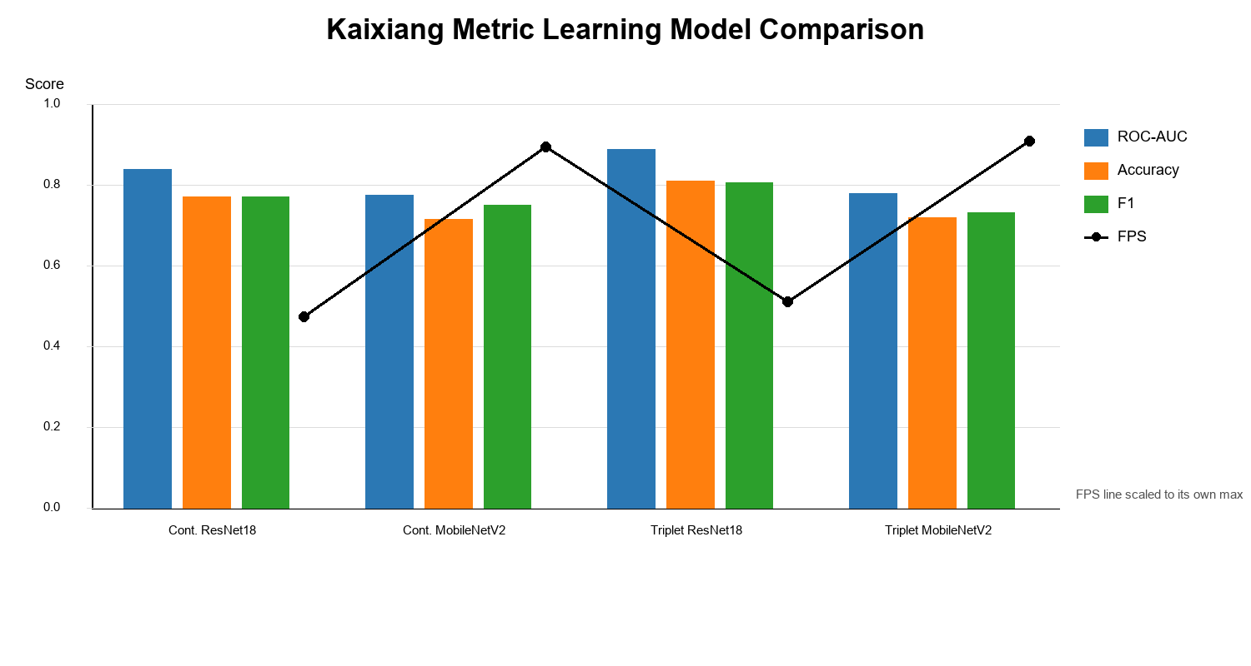 | 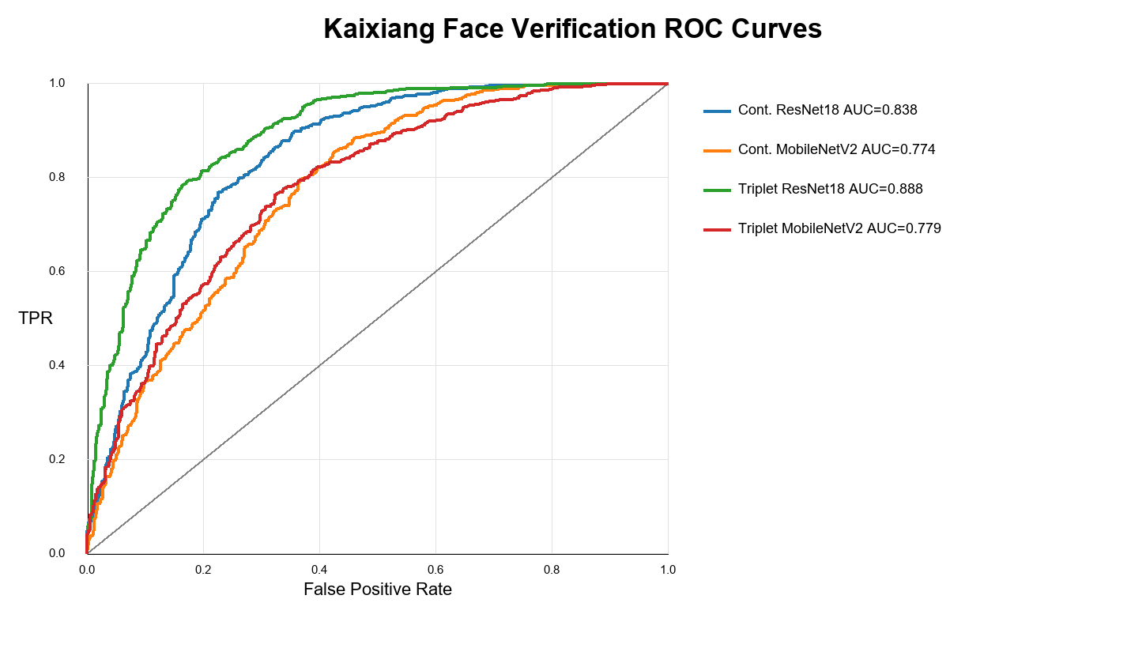
Figure 1. Kaixiang metric model comparison. | Figure 2. ROC curves for my four metric models.
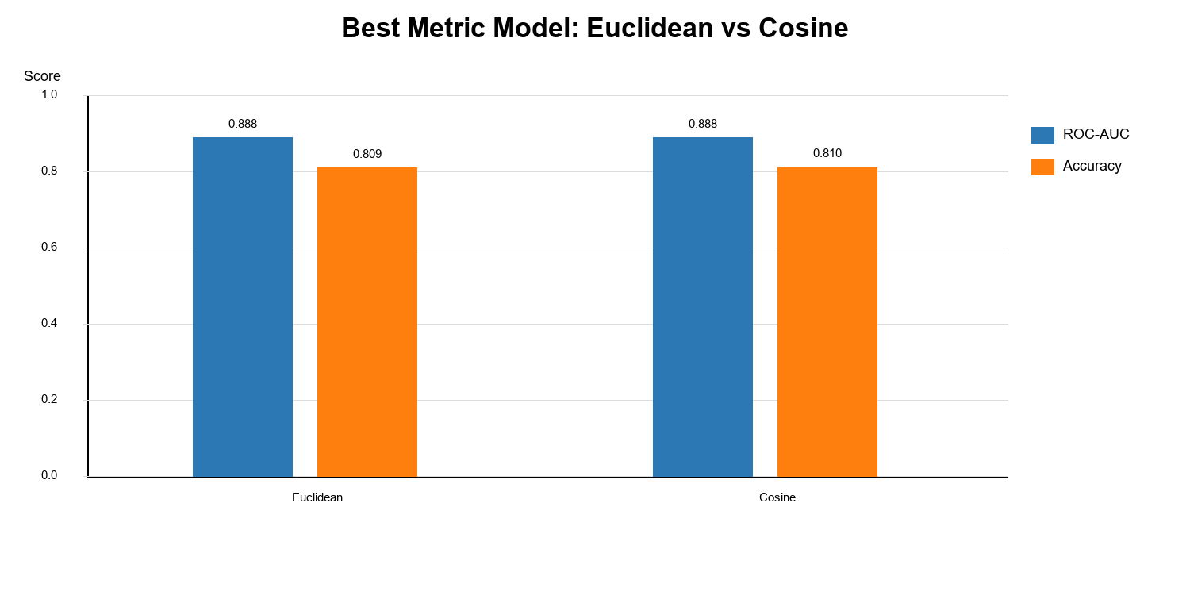 | 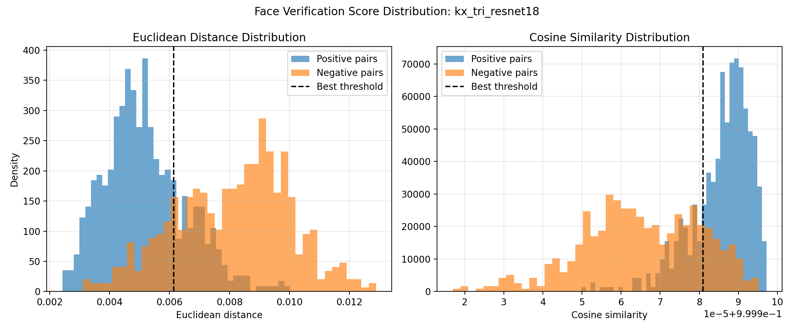
Figure 3. Euclidean vs cosine on the best model. | Figure 4. Positive/negative score distribution.
4.2 Anti-Spoofing / Liveness Detection
Model | AUC | Acc | F1 | Precision | Recall | FPS
MobileNetV2 + binary head | 0.9447 | 0.8750 | 0.8756 | 0.8713 | 0.8800 | 37.62
EfficientNetB0 + binary head | 0.9724 | 0.9150 | 0.9128 | 0.9368 | 0.8900 | 30.92
EfficientNetB0 was selected because it achieved the strongest ROC-AUC, accuracy, and F1-score.
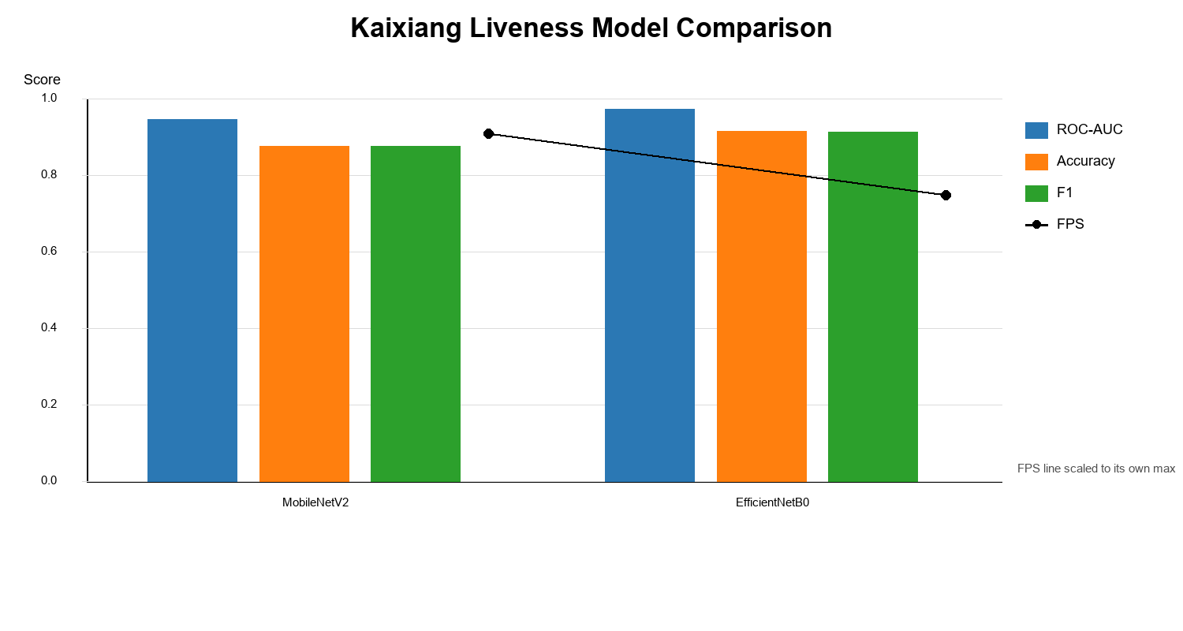 | 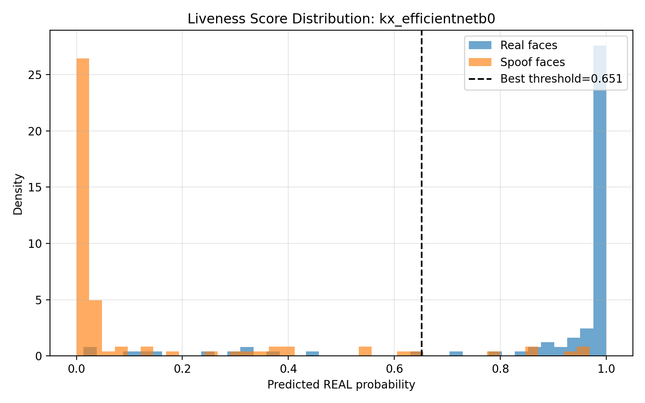
Figure 5. Kaixiang liveness model comparison. | Figure 6. EfficientNetB0 score distribution.
4.3 Innovative Feature: Glasses Detection
Glasses detection was added as an independent innovative feature. It predicts whether the detected user is wearing glasses and can provide extra appearance information during attendance. The feature is separate from recognition and liveness detection.
Model | Acc | Precision | Recall | F1 | FPS
MobileNetV2 + binary head | 0.9932 | 0.9892 | 0.9942 | 0.9917 | 119.12
EfficientNetB0 + binary head | 0.9923 | 0.9884 | 0.9927 | 0.9906 | 103.52
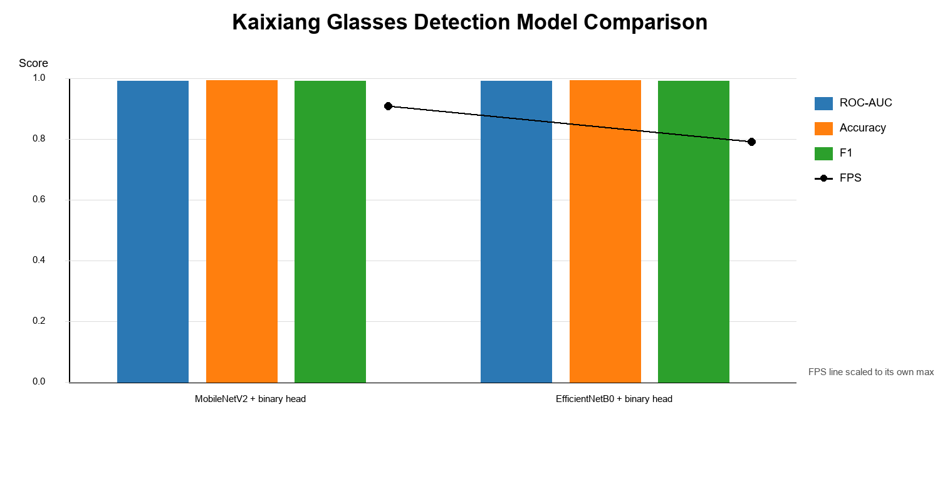 | 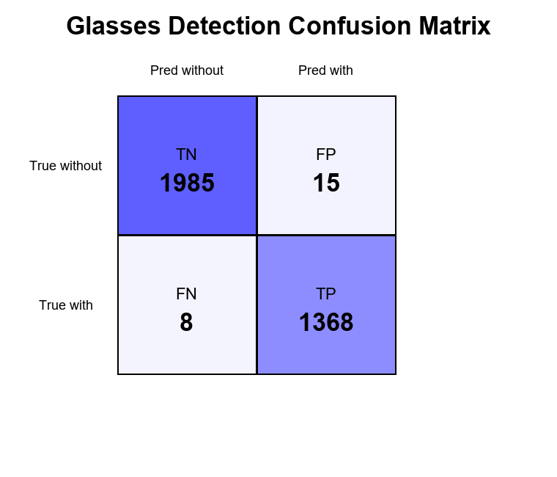
Figure 7. Glasses model comparison. | Figure 8. Final glasses confusion matrix.
5. Challenges and Resolutions
- Dataset stability: the original verification dataset did not generalise well in smoke tests, so I used VGGFace2 and identity-disjoint train/validation/test splits.
- Model compliance: to satisfy the rule against fully pre-trained models, all final models replaced the classification head and were further trained or fine-tuned.
- Webcam recognition instability: similar-looking identities caused small embedding gaps, so I used thresholding, ambiguity rejection, gallery embeddings, and temporal smoothing in integration testing.
- Liveness false acceptance: tight face crops sometimes missed spoof context, so I tested expanded liveness crops and adjusted the decision threshold for better real-world behaviour.
6. Final Reflection
Overall, Triplet ResNet18 was the strongest metric-learning model, EfficientNetB0 was the strongest liveness model, and MobileNetV2 was the best glasses model. The main lesson was that good offline AUC does not always guarantee stable webcam behaviour, so final integration required both quantitative evaluation and real-time testing under practical lighting, crop, and identity-similarity conditions.

