Template | Status | Notes
Assignments.Initializer | Keep (Revise) | Emit only when assignments exist; drop partial if not needed.
Elements.Initializer | Keep (Revise) | Ensure ParameterType includes []; guard against empty elements.
Registry | Keep (Revise) | Drop partial if unused; emit only if instances exist.
Registry.Member | Revise / Possibly Eliminate | Keep only if fields are needed; may be redundant.
Registry.Accessors | Keep | Core to dual accessor pattern; ensure interface vs class typing.
Registry.Create | Keep (Revise) | Ensure it wires elements correctly; no duplication with assignments.

----------------------
Registry | Keep (Revise) | Aggregate orchestration (CreateAll, InitializeAllAsync) | Drop partial if unused; emit only if instances exist.
Registry.Accessors | Keep (Revise) | Declares backing fields, external interface getters, internal concrete getters, and register methods | Core to dual accessor pattern. Consider folding InstanceField here for simplicity.
Registry.InstanceFactory (new, replaces Registry.Member) | Keep (Revise) | Per-instance creation logic (element-driven vs assignment-driven) | Eliminates duplication. Descriptive name clarifies purpose.
Assignments.Initializer | Keep (Revise) | Async initialization of assignment-driven instances | Emit only when assignments exist and InitializerName is set. Drop partial unless needed.
Elements.Initializer | Keep (Revise) | Builds arrays or single elements for element-driven instances | Ensure ParameterType includes [] when IsArray is true. Guard against empty elements.
Registry.Member | Eliminate | Previously mixed fields + creation logic | Superseded by Accessors + InstanceFactory split.

--------------------
he consolidated summary table of all templates we’ve reviewed, with their current audit status:
🔹 Template Audit Summary
Template Name | Status | Notes / Key Revisions
Assignments.Initializer | Keep (Revise) | Expanded comments, confirm async initializer contract, ensure DTO-driven assignment resolution.
Elements.Initializer | Keep (Revise) | Add guard for empty elements, clarify array typing, expand comments, use partial.
Registry.Accessors | Keep (Revise) | Expanded comments, clarify dual accessor rationale, keep partial, improve readability.
Registry | Keep (Revise) | Expanded comments explaining sync vs async phases, optional error handling.
Registry.InstanceFactory | Keep (Revise) | Use partial, expand comments on element vs assignment-driven creation.
NamedInstanceAccessor.Class | Keep (Revise) | Add partial, improve exception clarity, expand comments on dynamic resolution.
NamedInstanceAccessor.Function | Keep (Revise) | Add guard for GetService, expand comments, keep provenance annotation.
NamedInstanceAccessor.Function.Initializer | Keep (Revise) | Remove brittle dynamic, enforce strongly typed initializer, expand comments.
NamedInstanceAccessor.Function.NamedInstanceArray | Keep (Revise) | Add null guard for service resolution, expand comments, keep partial.
PrimitiveArray | Keep (Revise) | Expand comments, clarify plural naming, ensure pipeline enforces valid members.
PrimitiveArray.InnerMembers | Keep (Revise) | Clarify fragment role, add {{GeneratedHeader}}, expand comments.
PrimitiveArray.Member | Keep (Revise) | Add namespace wrapper, expand comments, clarify fragment role, add header.
Registration.Fragment | Keep (Revise) | Emit lifetime calls directly, add error handling, expand comments.
Registration | Keep (Revise) | Expanded comments, clarify usage in DI, ensure header consistency.
Registry.InstanceField | Keep (Revise)
------------
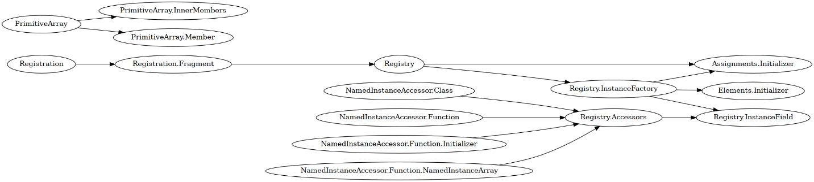
---------------
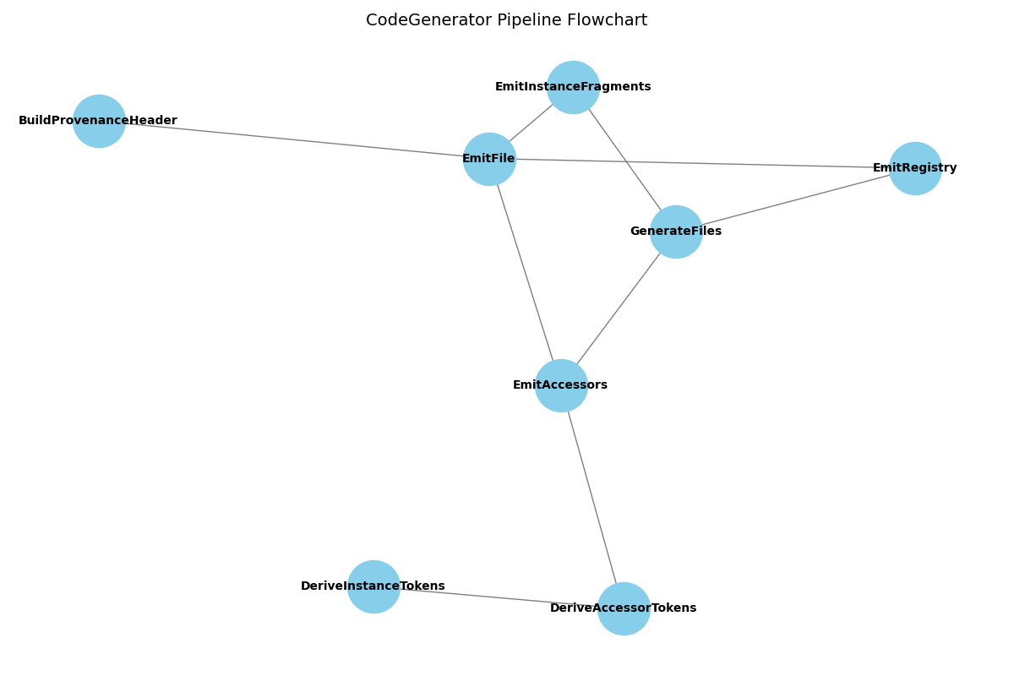
---------------------
Here’s the flowchart of your refactored CodeGenerator pipeline, showing how each helper method interacts:
🔹 Flowchart: CodeGenerator Pipeline
mermaid
flowchart TD

A[GenerateFiles] --> B[EmitRegistry]
A --> C[EmitAccessors]
A --> D[EmitInstanceFragments]

B --> E[EmitFile]
C --> F[DeriveAccessorTokens]
F --> G[DeriveInstanceTokens]
C --> E
D --> E

E --> H[BuildProvenanceHeader]
🔹 Explanation of Flow
- GenerateFiles orchestrates everything:
  - Calls EmitRegistry → emits the aggregate registry file.
  - Calls EmitAccessors → builds accessor tokens and emits accessors file.
  - Iterates instances → EmitInstanceFragments for per-instance files.
- EmitFile is the central funnel:
  - Every file emission passes through it.
  - It always prepends provenance via BuildProvenanceHeader.
- DeriveAccessorTokens builds metadata for accessors:
  - Delegates per-instance logic to DeriveInstanceTokens.
🔹 Why this is powerful
- Single funnel for file emission → provenance consistency guaranteed.
- Separation of concerns → registry, accessors, and fragments are modular.
- Extensible pipeline → adding new fragment types or provenance rules is straightforward.
- Onboarding clarity → maintainers can follow the flowchart to understand execution order.
✅ With this flowchart, you now have both the code and the visual architecture of your generator.
Would you like me to now create a runtime walkthrough narrative — a “story of execution” showing how a single named instance flows through this pipeline from definition → expando → template → emitted file?

