SAUDI ARABIA · 2010–2025

Population, Faith & the Post-Oil Economy
The Kingdom's population grew 47% in fourteen years, driven mostly by foreign labor migration that rises and falls with domestic labor policy — while the economy has begun, measurably, to grow around oil rather than because of it.
Compiled July 2026

Metric | Value | Change
Population, 2024 | 35.30M | +47.2% since 2010
Non-Saudi share, 2024 | 44.4% | up from 41.4% in 2010
Riyadh (city, 2022 census) | 6.92M | +33.5% since 2010
Non-oil share of GDP | ~54% | record high, per GASTAT
Real GDP growth, 2025 | +4.5% | accelerating from +2.7% in 2024

01 — Population
Mid-year population by nationality, 2010–2024. The 2016–2019 dip is almost entirely non-Saudi: Nitaqat “Saudization” quotas and a new expatriate dependent levy pushed foreign residents to leave faster than new ones arrived. GASTAT had not yet published a mid-2025 estimate at time of writing.
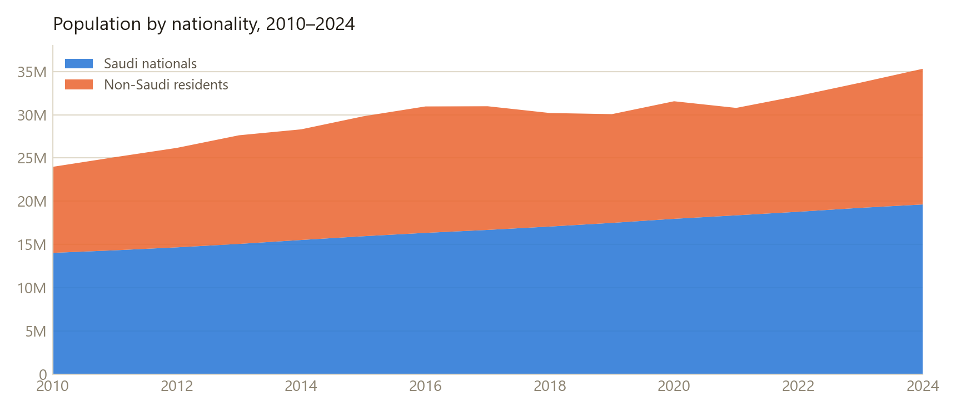
2017–2019: non-Saudi population fell from 14.60M to 12.56M (–14%) amid Saudization drives, before rebounding as construction and giga-project hiring resumed.
Population by nationality, 2010–2024
Year | Saudi nationals | Non-Saudi residents | Total | Non-Saudi share
2010 | 14,046,164 | 9,932,323 | 23,978,487 | 41.4%
2011 | 14,342,129 | 10,749,738 | 25,091,867 | 42.8%
2012 | 14,683,546 | 11,485,315 | 26,168,861 | 43.9%
2013 | 15,079,401 | 12,544,603 | 27,624,004 | 45.4%
2014 | 15,535,036 | 12,774,237 | 28,309,273 | 45.1%
2015 | 15,968,071 | 13,848,311 | 29,816,382 | 46.4%
2016 | 16,355,312 | 14,598,886 | 30,954,198 | 47.2%
2017 | 16,696,980 | 14,280,375 | 30,977,355 | 46.1%
2018 | 17,085,636 | 13,110,645 | 30,196,281 | 43.4%
2019 | 17,507,171 | 12,556,628 | 30,063,799 | 41.8%
2020 | 17,978,587 | 13,573,923 | 31,552,510 | 43.0%
2021 | 18,380,669 | 12,403,714 | 30,784,383 | 40.3%
2022 | 18,792,262 | 13,382,962 | 32,175,224 | 41.6%
2023 | 19,245,929 | 14,456,802 | 33,702,731 | 42.9%
2024 | 19,635,258 | 15,665,022 | 35,300,280 | 44.4%

02 — Cities & Regions
Saudi Arabia has run two full population censuses this period — 2010 and 2022 — so city-level figures exist only at those two points; there is no official annual series per city. Ranked by 2022 population.
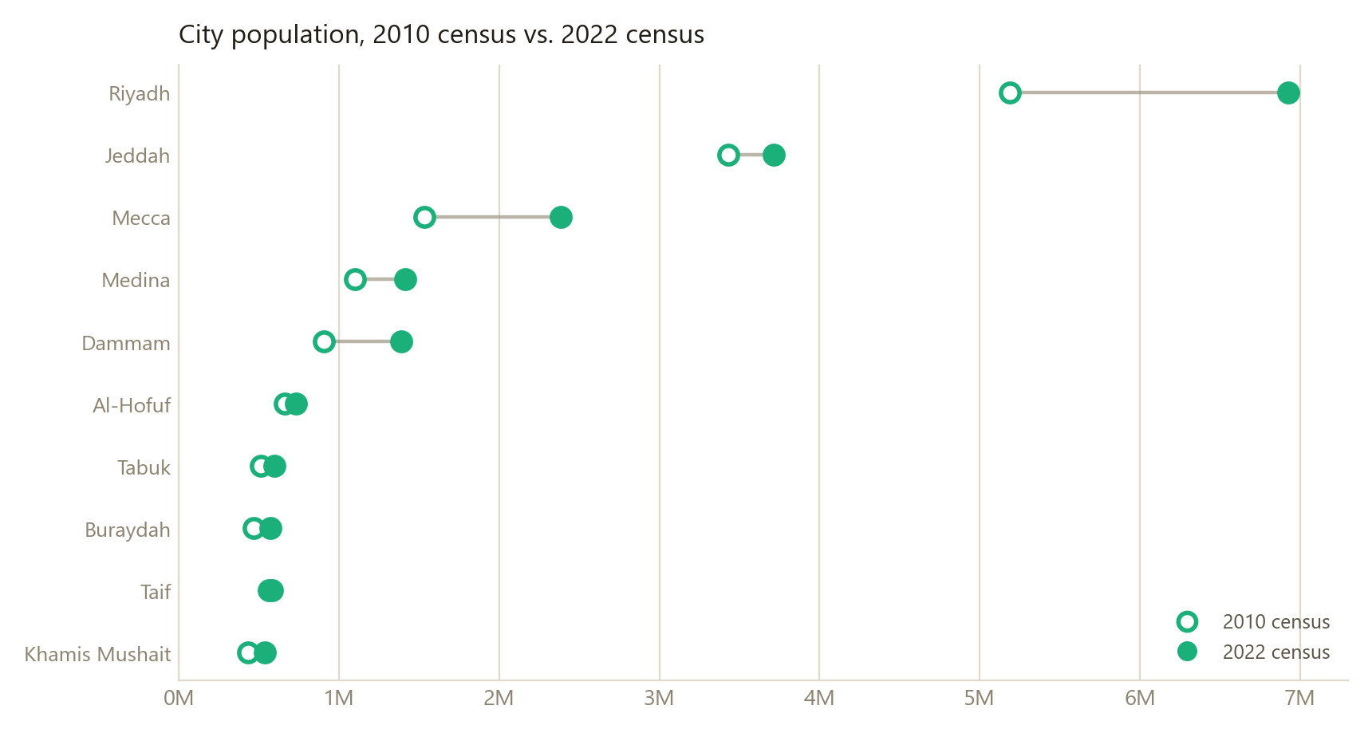
City population, 2010 vs. 2022 census
City | 2010 census | 2022 census | CAGR
Riyadh | 5,188,286 | 6,924,566 | +2.43%/yr
Jeddah | 3,430,697 | 3,712,917 | +0.66%/yr
Mecca | 1,534,731 | 2,385,509 | +3.74%/yr
Medina | 1,100,093 | 1,411,599 | +2.10%/yr
Dammam | 903,312 | 1,386,166 | +3.63%/yr
Al-Hofuf | 660,788 | 729,606 | +0.83%/yr
Tabuk | 512,629 | 594,350 | +1.24%/yr
Buraydah | 467,410 | 571,169 | +1.68%/yr
Taif | 579,970 | 563,282 | -0.24%/yr
Khamis Mushait | 430,828 | 535,065 | +1.82%/yr

Foreign-resident share by region, 2022
Riyadh and Makkah regions — home to Riyadh, Jeddah, Mecca and Taif — carry the highest non-Saudi shares, close to half their population. The thirteen regions hold 32.18M people between them.
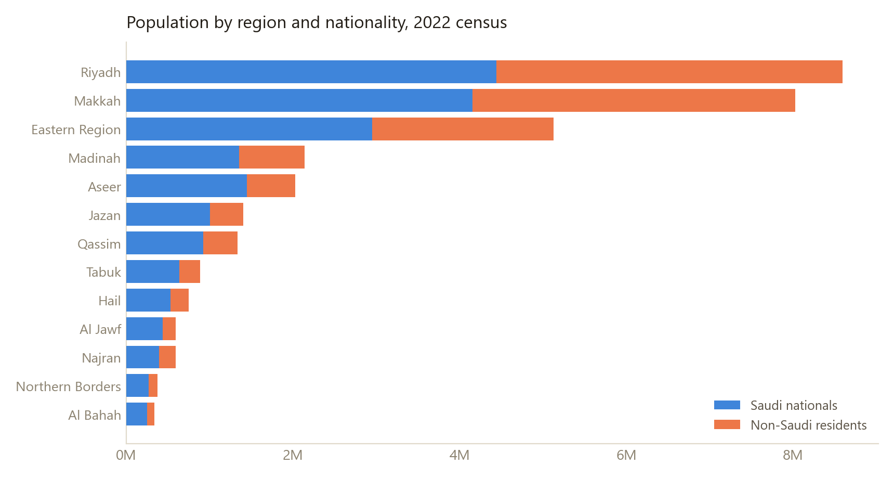
Population by region and nationality, 2022 census
Region | Saudi | Non-Saudi | Total | Non-Saudi share
Riyadh | 4,439,210 | 4,152,538 | 8,591,748 | 48.3%
Makkah | 4,153,723 | 3,867,740 | 8,021,463 | 48.2%
Eastern Region | 2,949,854 | 2,175,400 | 5,125,254 | 42.4%
Madinah | 1,352,146 | 785,837 | 2,137,983 | 36.8%
Aseer | 1,444,688 | 579,597 | 2,024,285 | 28.6%
Jazan | 1,002,779 | 402,218 | 1,404,997 | 28.6%
Qassim | 926,490 | 409,689 | 1,336,179 | 30.7%
Tabuk | 637,601 | 248,435 | 886,036 | 28.0%
Hail | 527,885 | 218,521 | 746,406 | 29.3%
Al Jawf | 440,264 | 155,558 | 595,822 | 26.1%
Najran | 394,976 | 197,324 | 592,300 | 33.3%
Northern Borders | 271,358 | 102,219 | 373,577 | 27.4%
Al Bahah | 251,288 | 87,886 | 339,174 | 25.9%

03 — Faith
Saudi Arabia's census does not ask about religion, so no official breakdown exists. The figures below are third-party demographic estimates (Pew Research / ARDA-style modeling), shown as an approximate picture rather than a census fact.
~93% of residents are estimated to be Muslim
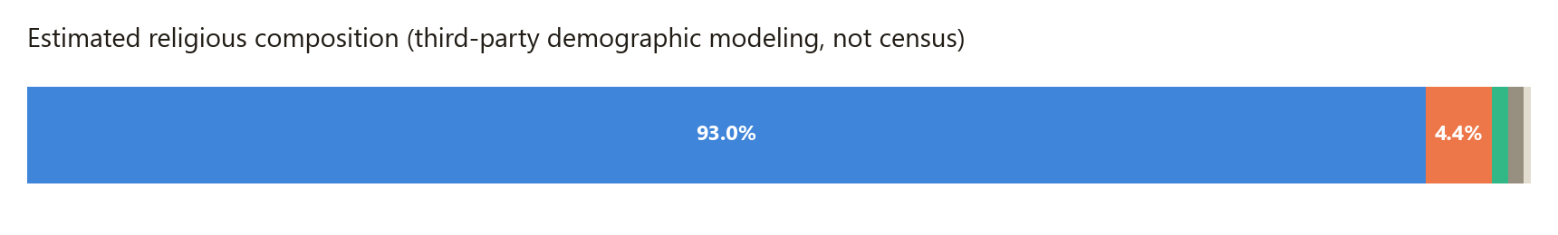
Group | Estimated share
Muslim | 93.0%
Christian | 4.4%
Hindu | 1.1%
Unaffiliated | 0.7%
Folk / traditional | 0.3%
Other (incl. Buddhist) | 0.5%
Among Saudi citizens specifically, an estimated 85–90% are Sunni and 10–15% Shia (mostly Twelver, concentrated in the Eastern Province), plus small Ismaili and Zaydi communities. Nearly all Christians, Hindus and Buddhists in the Kingdom are foreign workers on residency permits, not citizens — Hindu residents in particular track closely with the South Asian labor migration visible in the regional table above.

04 — Economic Development
Annual real GDP growth, 2010–2025. Swings before 2021 track oil output and price almost one-for-one; growth since 2023 leans increasingly on non-oil activity — construction, tourism and logistics — a deliberate Vision 2030 target rather than a market accident.
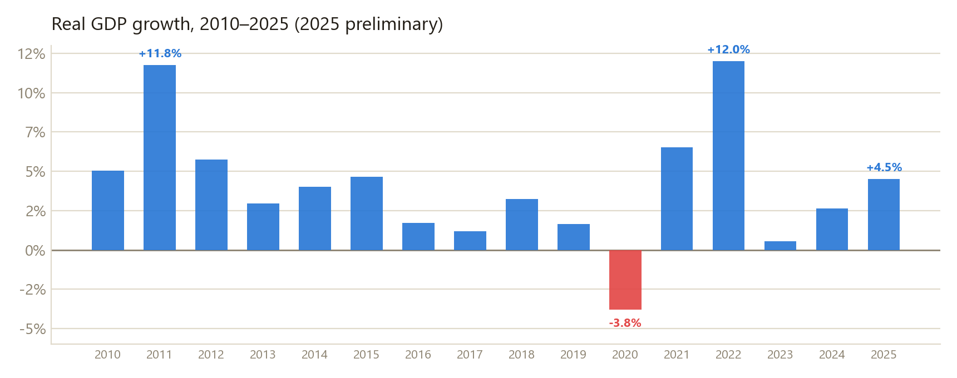
Real GDP growth, 2010–2025
Year | Real GDP growth
2010 | +5.04%
2011 | +11.76%
2012 | +5.76%
2013 | +2.95%
2014 | +4.02%
2015 | +4.66%
2016 | +1.70%
2017 | +1.18%
2018 | +3.23%
2019 | +1.65%
2020 | -3.80%
2021 | +6.52%
2022 | +12.00%
2023 | +0.54%
2024 | +2.65%
2025 | +4.50% *
* 2025 is a GASTAT preliminary national-accounts figure; 2010–2024 are World Bank series (NY.GDP.MKTP.KD.ZG).

Vision 2030 — selected indicators
Indicator | Figure
Inbound tourism, 2025 | ~122M visitors — original 2030 target (100M) reached 7 years early; goal raised to 150M
FDI inflows, Q1 2025 | +44% YoY (SAR 22.2bn)
NEOM giga-project | ~100,000 jobs created; ~$10bn FDI attracted
Vision 2030 initiatives | ~85% reported complete or on track; 2025–2030 termed “full delivery” phase

Sources
- General Authority for Statistics, Saudi Arabia (GASTAT) — Census 2010 & 2022, mid-year population estimates, national accounts / GDP releases.
- Gulf Labour Markets, Migration and Population Programme (GLMM), gulfmigration.grc.net — compiled tabulations of GASTAT population-by-nationality and by-region data, 2010–2024.
- World Bank national accounts data, indicator NY.GDP.MKTP.KD.ZG, 2010–2024.
- Trading Economics & GASTAT national accounts releases, 2025 preliminary growth figures.
- Third-party religious demographic estimates (Pew Research Center / Association of Religion Data Archives methodology, as aggregated by public demographic reference sites) — not derived from an official census.
- Vision 2030 progress figures: Saudi state media (SPA), GASTAT quarterly releases, and 2025 press coverage of tourism, FDI and giga-project statistics.

Caveats worth keeping in mind: city-level population is only ever as fresh as the last census (2022) — there is no official annual city series, so the 2010→2022 comparison is the finest-grained, honest view available. Regional (not city) breakdowns are annual through 2022 only, since the 2022 census reset the series. Religion is modeled, not measured. The 2025 population figure is omitted because GASTAT had not published it as of this writing.

