**Response Time Analysis and Prediction**

*Project report submitted in partial fulfillment*

*of the requirements for the degree of*

*Bachelor of Technology*

*in*

*Computer Science and Engineering*

*By*

***Shivam Sharma (15ucs130)***

***Vivek Kumar (15ucs162)***

*Under Guidance of*

***Vikas Bajpai***



**Department of Computer Science and Engineering**

**The LNM Institute of Information Technology, Jaipur**

**May 2018**

Copyright c The LNMIIT 2017

All Rights Reserved

**DECLARATION**

We hereby certify that,

a) the work contained in this report is original and has been done by me under the guidance of my supervisor(s).

b) the work has not been submitted to any other Institute for any degree or

diploma.

c) I have followed the guidelines provided by the Institute in preparing the report.

d) I have conformed to the norms and guidelines given in the Ethical Code of

Conduct of the Institute.

e) Whenever I have used materials (data, theoretical analysis, figures, and text)

from other sources, I have given due credit to them by citing them in the text

of the report and giving their details in the references. Further, I have taken

permission from the copyright owners of the sources, whenever necessary.

(Signature of the Student)

Date:

17-05-2018

**CERTIFICATE**

This is to certify that the Dissertation Report entitled, “**Response Time Analysis and Prediction**” submitted

by Mr “**Shivam Sharma**” and Mr “**Vivek Kumar**” to LNMIIT, Jaipur.

India, is a record of bonafide Project work carried out by him under my/our

supervision and guidance and is worthy of consideration for the award of the degree of Bachelor of Technology in Computer Science Engineering of the Institute.

Name of the Supervisor

(Signature)

Department of

LNM Institute of Information Technology

Jaipur

Date:

17-05-2018

**ACKNOWLEDGMENT**

This document is prepared by the inspiration received from Professor “**Vikas Bajpai**”,

Head, and Department of CSE. Many colleagues at LNMIIT have carefully read and improved the document; their contributions are gratefully acknowledged.

Student Name and Roll Number

**Abstract**

In this project we have taken out the data of the response time for 100 websites. We have used open source websites for this project. We have used localhost server as the hosting server so that the response time does not gets affected by the internet speed. We have used Badboy a website testing software. We have made several iterations of the flow path . Taking different paths in different websites so as to collect random data. Taking out iterations consisting of 1, 20 and 30 sets of iterations . Taking out the Response time graph of the 20 and 30 iterations.

We used XAMPP and WAMP software to host the websites and calculated response time using Badboy. It took us 3 months to do this work .We downloaded an average of 1500 websites in the process. With the probability of success was 1/15 . But in the end we were able to take out the data . We will try to automate the task by using automation code. The data collected right now will be used for the prediction of the response time of Important Websites which is our future goal

More details about the project can be found here –

<https://github.com/jack17529/ResponseTimeAnalysis>

**TABLE OF CONTENTS**

DECLARATION ................................................................................................... ii

CERTIFICATE ..................................................................................................... iii

ACKNOWLEDGEMENTS .................................................................................. iv

ABSTRACT........................................................................................................... v

CHAPTER 1 (INTRODUCTION)........................................................................ 2

CHAPTER 2 (Response Time ) …………........................................................... 3

2.1 What is Response Time ?................................................................................ 3

2.2 Calculating Response Time …........................................................................ 3

2.3 Usage/Importance ........................................................................................... 4

CHAPTER 3 (Our Work) …………………......................................................... 5

3.1 Week Activity..………..……………………….............................................. 5

CHAPTER 4 (CONCLUSIONS AND RESULTS).….......................................... 10

4.1 Future Scope ………………………………………………………………… 10

BIBLIOGRAPHY................................................................................................... 11

**Chapter-1**

***Introduction***

The smaller the response time the better is the Website’s economy.When we talk about E-Commerce the first thing that comes into our mind is the money made by the E-Commerce websites. All big companies like Amazon, Flipcart etc put a lot of money to check that the response time of the website remains small at all the time of a day.

The smaller the response time the smaller is the time taken to get from one request to other request , thus more people will stay on the site. Which help converting a viewer into a customer. Hence directly affecting the sales of the products in a shopping website.

**Chapter-2**

***Response Time***

**2.1 What is Response Time ?**

Response time refers to the amount of time Enterprise Server takes to return the results of a request to the user. The time it takes to perform a HTTP GET to the specified URL. The faster the response time, the more requests per minute are being processed. However, as the number of users on the system increases, the response time starts to increase as well, even though the number of requests per minute declines.

Response time is commonly considered to be the amount of time that passes between when the user requests the first byte of information until the last byte of every image, style sheet or java file scripts are delivered to them.

It consists of 3 parts –

1. Time to first byte
2. Time to receive headers
3. Time to load HTML of the site

**2.2 Calculating Response Time**

We are trying to calculate the response time at the peak load point , because after the peak load point the calculations of the response time becomes inaccurate.

The request per minute are inversely proportional to the response time. The sharper the decline in requests per minute, the steeper the increase in response time.

The formula used to calculate the response time is -

Tresponse = **n/r -** Tthink

where

* **n** is the number of concurrent users
* **r** is the number requests per second the server receives
* Tthink is the average think time (in seconds)

To obtain an accurate response time result, always include think time in the equation . The time of the peak load is treated as the bottleneck of this experiment thus we have calculated it at the peak load.

**2.3 Usage / Importance**

Everyone in the business world understands that the importance of having fast response time of websites. The more time a customer spends on your website the more likely he/she is to spend money .The behavior of the website should influence the users to spend more time on the website.

Response time is critical to influencing buying behavior . The performance of your website is directly related to the level of your business skills. Checking the website performance the way in which customers will see , is what matters the most .

There are various tools to measure the response time –

1. Selenium.
2. JMeter
3. Badboy

**Chapter – 3**

***Our Work***

**In the first week** , we did a good research on what does response time mean , we checked several definitions of it on the internet. We did calculations of the response time with the formula.

**In the second week**, we read research papers to know what is the current trend on the research happening on the topic.

**In the third week** , we were asked to host 10 websites locally. So we first learnt how to use local servers to host your website then we tried XAMPP and WAMP. These are the most popular servers to host your website locally for windows users .We learnt how to host websites locally. We struggled in finding self hosting websites on the internet.

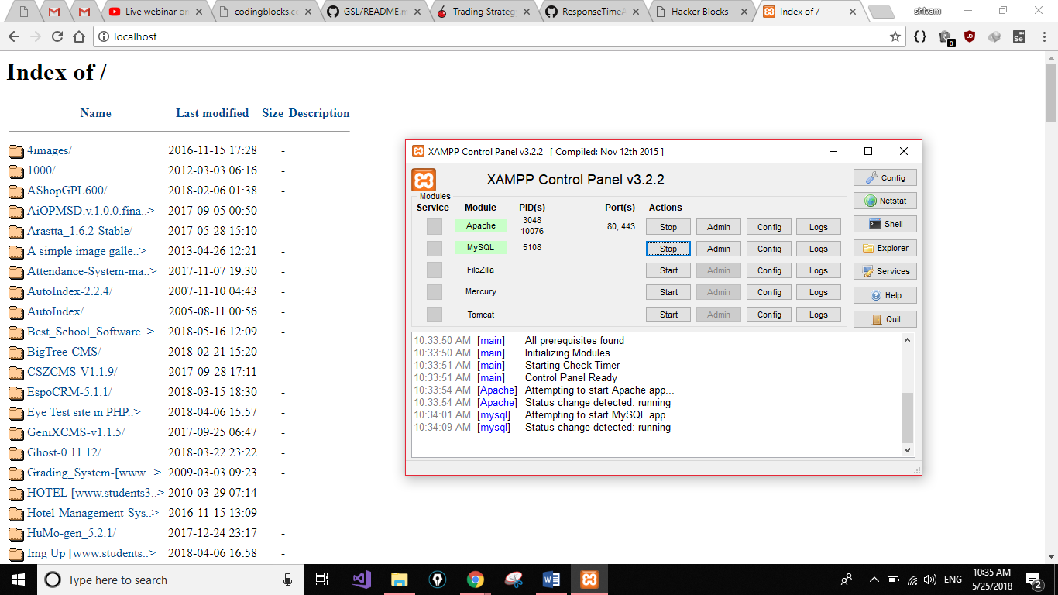

**In the fourth week**, we were asked to find the software to calculate response time , we tried different softwares including Selinum , JMeter . Shivam used the Selinum to find the response time and even automated the task , Vivek calculated the response time with JMeter.

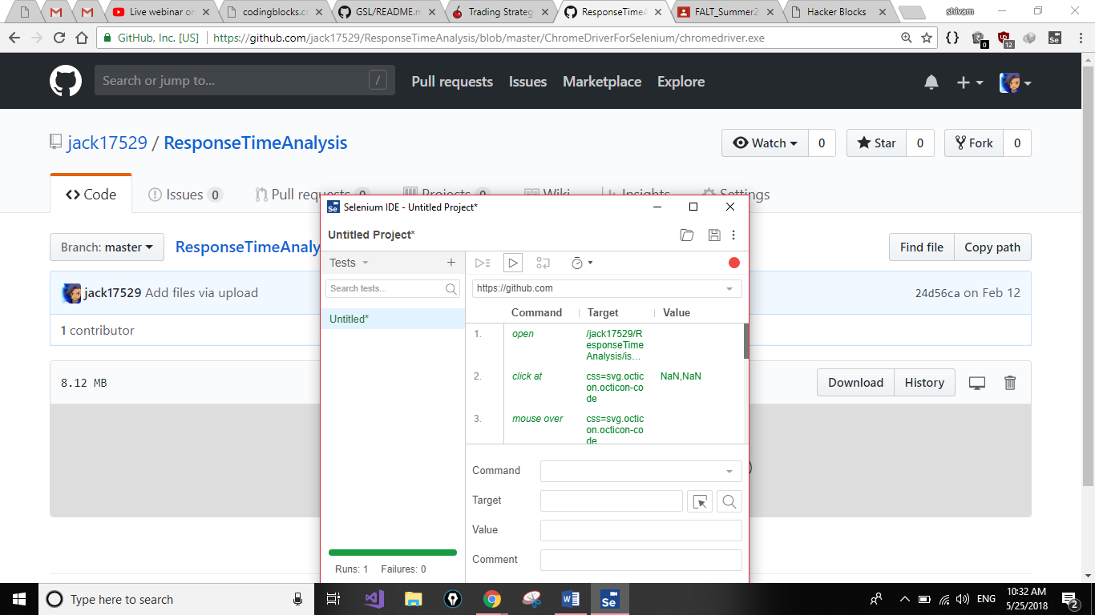

**In the fifth week**, we were told that we are not on the right track and have to bring data of 20 websites , then we used Badboy to calculate the response time of the websites that we collected. Most of the websites gave Php version error , we tested over a 100 websites yet only 20 worked . We brought both the data of the websites of 1,20,50 iterations and graphs. We even showed the DFD of the websites . After a lot of struggle our work was approved.



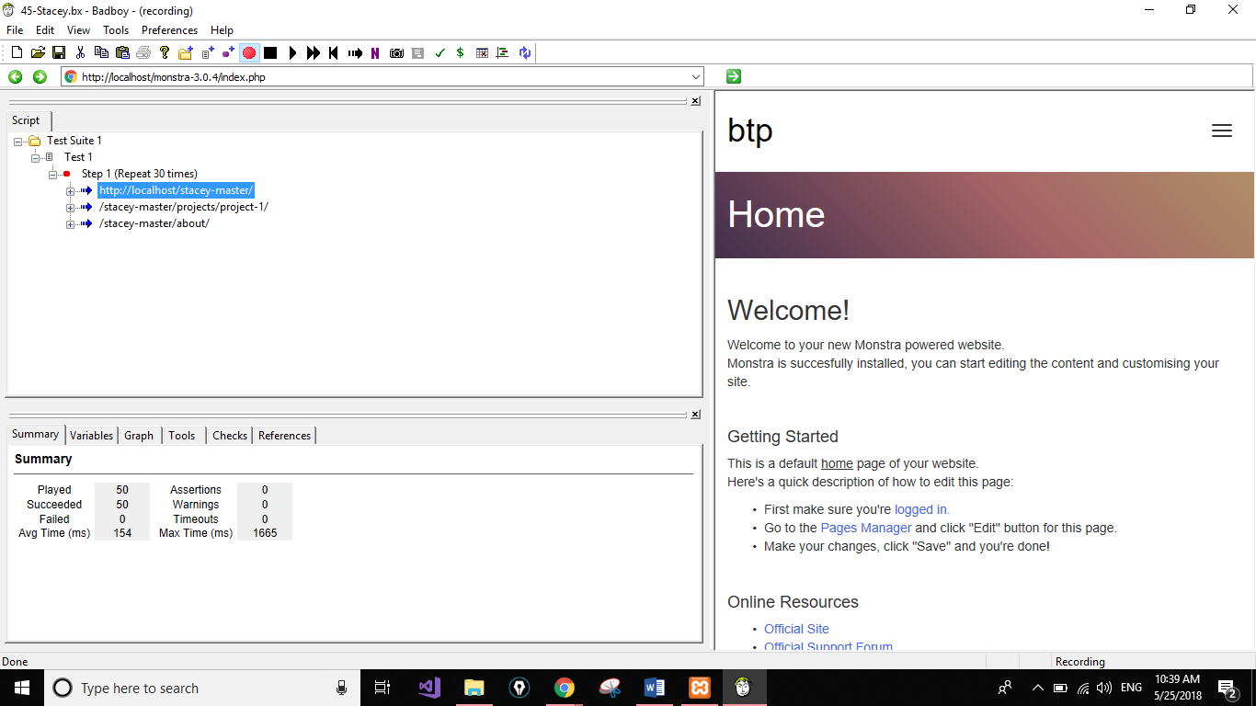

**In the sixth week**, we were told to collect the data of 50 websites . At this time Vivek was not present in LNMIIT and Shivam was struggling to collect the data alone , and thus we mailed for time extension. But somehow it took us 2 weeks to collect the data.

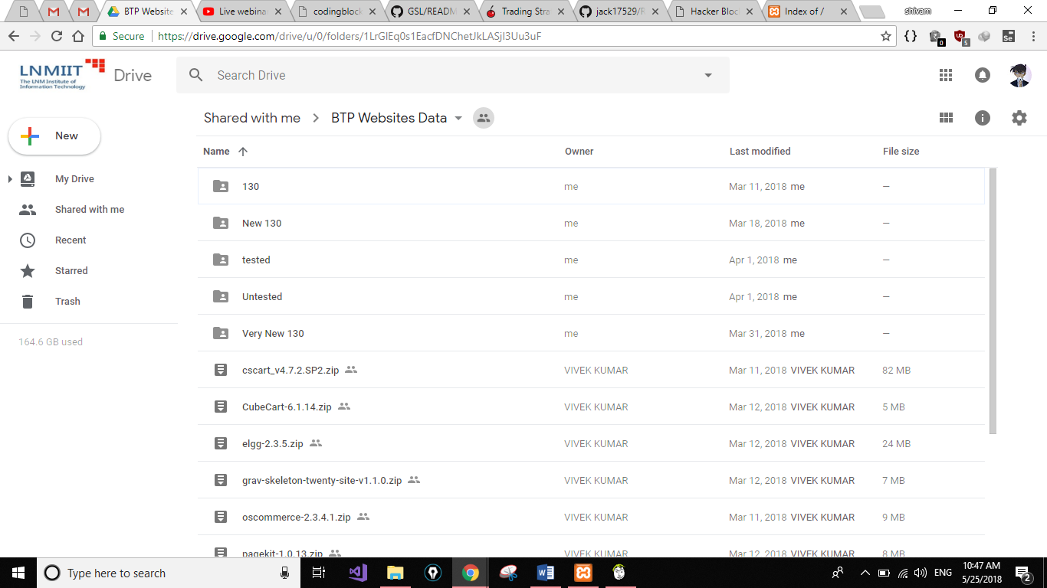

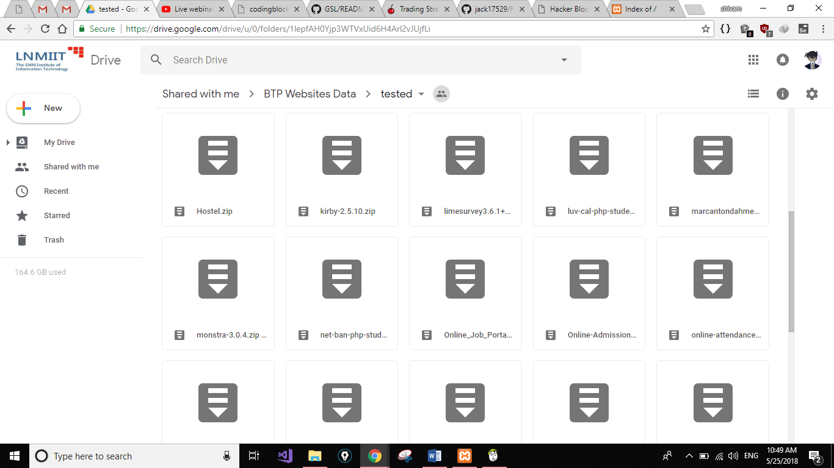

**In the eighth week** , we were asked to collect data for 100 websites and were given full time until the semester ends to complete the work. We struggled really hard during this time , but somehow in the end we were able to fetch the data along with the graphs.

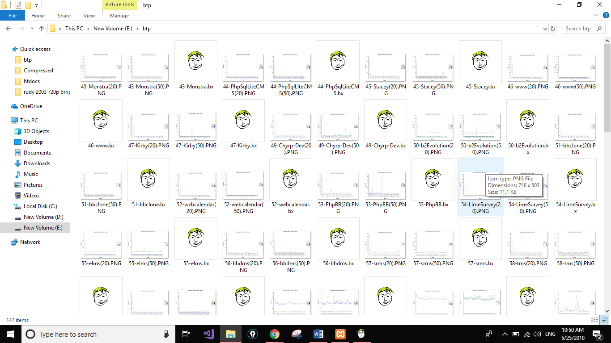

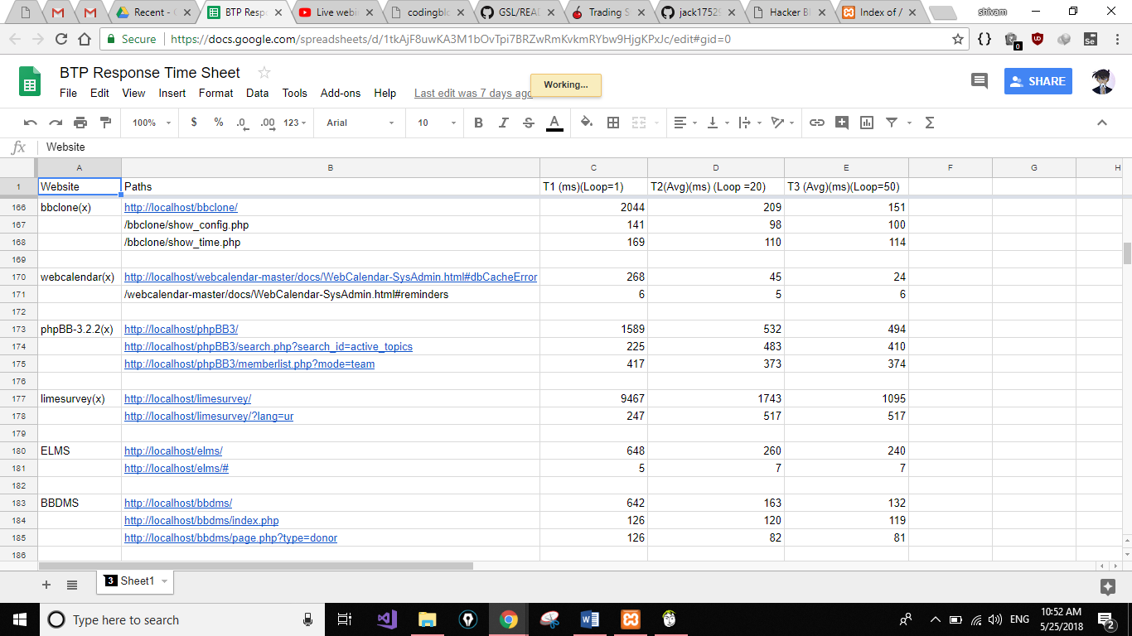

**Chapter-4**

***Conclusions & Results***

We were able to get Response Time data of 100 websites. All websites from different domains item selling websites, mailing websites, software application websites etc. Taking websites from different domain fetched us a variety of data . We have 2 graphs for each of these 100 websites . We learn’t a lot about Php errors . The security of websites related to databases . We even wrote the issues on Github based on the website . We even read a lot of websites documentations . we made different users in MyPhpAdmin for different websites . We learn’t how to create databases and also import databases for different websites. In the end we actually figured out why our laptops were slowing down as we take out more data. We gained a profound knowledge of XAMPP and WAMP and how to use them .We learn’t a lot about Response time from Research papers.

**4.1 Further Scope**

We will try to automate the task of calculating response time. We will find a software to make DFD of the remaining websites. We will try to make a model so as to predict the response time of any sample website. We will try to predict the response time of big websites like Amazon, Facebook etc. We will try hard to publish a paper related to the data gathered and the model made by us to predict response time.

**Bibliography**

1. *Measuring website’s response time* –

<https://www.websitepulse.com/blog/how-to-measure-website-response-time>

1. *Average response time* -

<https://docs.oracle.com/cd/E19316-01/820-4342/abfch/index.html>

1. *Difference between Response time and Page Load time* -

<https://help.pingdom.com/hc/en-us/articles/115001228925-Difference-between-Response-Time-and-Page-Load-Time>

1. *Uptime report calculations* –

<https://help.pingdom.com/hc/en-us/articles/211847325-Response-time-and-calculations-in-the-uptime-report>

# *Prediction of website response time based on support vector machine* –

<https://ieeexplore.ieee.org/abstract/document/7003908/>

1. *Website’s speed (need for speed 1997 article)* -

<https://www.nngroup.com/articles/website-response-times/>

1. *Nielson Norman Group Article* –

<https://www.nngroup.com/articles/response-times-3-important-limits/>

1. *20 Factors Influencing website’s response time* –

<http://www.apmdigest.com/website-response-time-1>

1. *What is a good response time ?*

<https://stackoverflow.com/questions/164175/what-is-considered-a-good-response-time-for-a-dynamic-personalized-web-applicat>