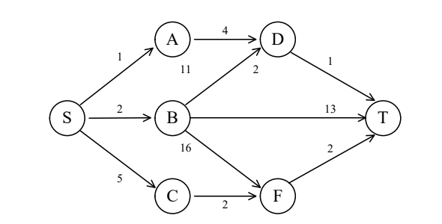

**d(S,T) = min{1+d(A,T),2+d(B,T),5+d(C,T)}**

**d(A,T) = min{4+d(D,T)}**

**= 5**

**d(B,T) = min{11+d(D,T),13,16+d(F,T)}**

**= min{11+1,13,16+2}**

**= 12**

**d(C,T) = min{2+d(F,T)}**

**= 2+2**

**= 4**

**d(S,T) = min{1+d(A,T),2+d(B,T),5+d(C,T)}**

**= min{1+5,2+12,5+4}**

**= 6**

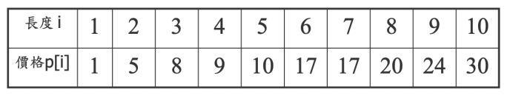

**N = 7**

**p[1] + p[6] = 18**

**p[2] + p[2] + p[3] = 18**