**List of sample projects**

Contents

1.Library system 2

2.POST system 5

3. Music Store 7

4. Cinema system 8

5. Auction system 9

6. Ted Shop system 11

7. Ceil Inn system 13

8. Student management system 16

9. Lab Reservation System 17

# Library system

The library system can provide functions as below:

**[1. Borrow process]**

The borrower can borrow the books by bring copy of the book they want to borrow to librarian. He also can to collect copy of reserved book

The librarian will check if it is the expected borrower. The librarian will then take the reserved copy and loan it out to the borrower.

The librarian will confirm the following information:

Borrower’s card number

Name

Unreturned books if any

Expected return date of these books

The copy number of each book to be borrowed is then keyed into the machine. The status of each copy indicates it is available, referenced, or borrowed. Only the available copy is allowed to be borrowed. **A 2 week loan period** is allowed per book. A referenced or borrowed copy is not allowed to be borrowed. If the copies to be borrowed are all available, the copy number, book name, borrow date and expected return date is used for confirmation

The maximum number of copies allowed to be borrowed is 5.

**[2. Return process]**

The book will be returned is brought to counter. The librarian then keys in the copy number.

The copy number, book name, and borrower name is checked for confirmation. If the book is overdue, the borrower will have to pay a fine of 1 USD per day

The librarian will keep the copy if there is a reservation waiting for a copy and, a first come first served basis is used to assign to the borrower.

**[3. Reservation process]**

Books may be reserved. Before the reservation is accepted, a check is made if they are any available copies in the shelf.

If they are available copies, the reservation is rejected and the reason is made known. If all available copies are out, the reservation is accepted.

The following is accepted for the reservation

The book number

The borrower card number

A first come, first served basic is used to assign copies when they are returned.

A borrower can only make 1 reservation.

**[4. Book registration process]**

The librarian may also register new books into the Library.

The registration can be an

1. Addition of a new copy

This means a new copy can be appended to an existing set of copies. The book number, the number of new copies, and price of each copy is entered

1. Creation of a new book entry and copy

The librarian enter the classification, book title, publisher and whether the copy reference or for borrow.

A book and copy number is automatically generated by the system

The following data are required for registration

Book information

Book number (should be generated by the system)

Title

Publisher

Authors

Copy information

Copy number

Book number

Sequence number

Price

The sequence number is a sequence number for each copy of the same book

The price indicates the cost of the copy

**[5. Borrower registration process]**

The following information are recorded when a new borrower is registered

Borrower number (this is sequential number)

Borrower name

Sex (F or M)

Address

Telephone

E-mail

The following figure shows ERD of Library system

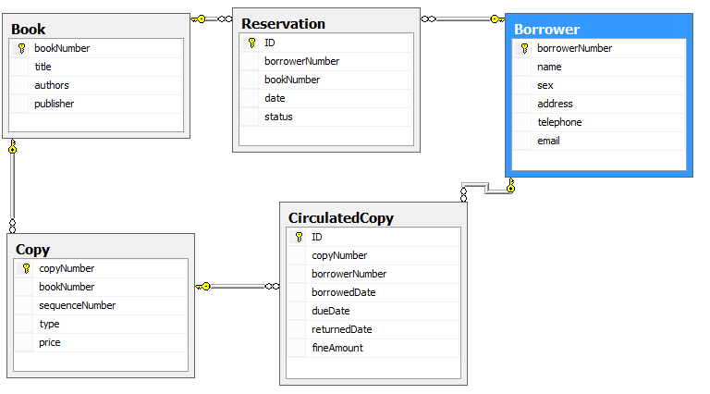

# POST system

**Overview of Project**

A point-of-sale terminal (POST) is a computerized system used to record sales and handle payments; it istypically used in a retail store. It includes hardware components such as a computer and a bar code scanner, and software to run the system (See the following figure).

[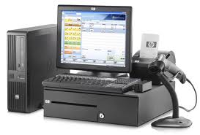](http://www.google.com.vn/imgres?q=Point-of-sale+image&um=1&hl=vi&sa=X&biw=1362&bih=583&tbs=isch:1&tbnid=VbBi9miVYIQ-VM:&imgrefurl=http://www.fitnessmarketingmuscle.com/fitness-sales-point-of-sale-systems/&imgurl=http://www.fitnessmarketingmuscle.com/wp-content/uploads/2010/03/rp5700pos.jpg&ei=Uz41TcrwDqTKcPi0kbkH&zoom=1&w=800&h=541&iact=hc&vpx=315&vpy=80&dur=523&hovh=185&hovw=273&tx=163&ty=93&oei=Uz41TcrwDqTKcPi0kbkH&esq=1&page=1&tbnh=123&tbnw=182&start=0&ndsp=19&ved=1t:429,r:1,s:0)

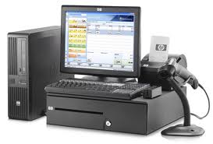

**Goals**

In general the goal is increased checkout automation, to support faster, better and cheaper services and business processes. More specifically, these include:

1. quick checkout for the customer,
2. fast and accurate sales analysis,
3. automatic inventory control.

**System description**

The main functions of POST system as below:

The system consists of a head office server, located at the head office, and the POSterminals placed at store cashiers. The head office server and the POS terminals areconnected to each other via a network. Products sold at stores have bar codes attachedwhich indicate the product codes. These bar codes can be read with bar code readers ofthe POS terminal.

Customers can have registration cards, whichbear bar codes indicating their member numbers, and when they purchase products withcash, they are awarded points based on the amount of their purchase. The followings are terms and regulations of the registration card:

1. Card is valid within 12 months in the store’s system
2. Each payment of 50.000 VND = 1 point
3. 20 point = 1 gift voucher valued at 20.000 VND
4. No point accumulation without card presentation

In the sales operation at the POS terminals, thebar codes of the products being purchased are scanned, and the total amount is determined.Next, his/her registration card will be scanned if he/she has. The customer either pays with cash, gift vouchers, or a combination of the two, and the salesdata, including the number of points earned and the number of points used, is recorded.

When the sale is committed, it will be recorded and the inventory will be reduced.

For each product, its standard priceis set as a part of theproduct data. The store, however, can set and use its own actual retail price instead of thestandard price during the limited period. The actual retail pricemust be set in advance, and it cannot be changed in the middle of the specified period.Products are classified into product types such as food, general merchandise, etc.

The system also have an administration capability and appropriate interfaces that can be used to add/remove POST (there more than one POST in the store) and the cashiers.

The following figure shows ERD of POST system

# 3. Music Store

Music Store is an application that contains three main parts to the application: shopping, checkout, and administration.

Visitors can browse Albums by Genre. Each Album contains information as Album ID, Title, and Price. Each Albumbelongs to one Genre and one Artist.

They can view a single album and add it to their cart.

They can review their cart, removing any items they no longer want. Then they can proceedto Checkout that will prompt them to login or register for a user account. After creating an account, they can complete the order by filling out shipping and payment information. Shipping information concludes first name, last name, address, city, country, phone, email address, and total amount.

After ordering, they see a simple confirmation screen.

In addition to customer-facing pages, we’ll also build an administrator section that shows a list of albums from which Administrators can Create, Edit, and Delete albums.

The following figure shows ERD of Music store system

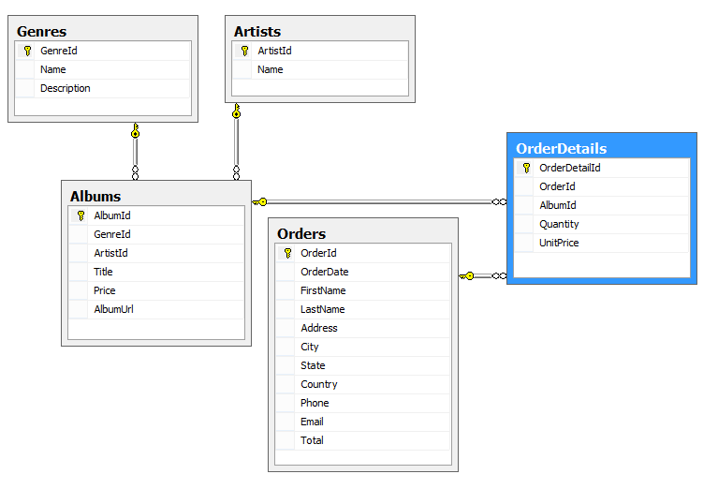

# 4. Cinema system

The cinema system is developed for a cinema with the following requirements:

1. The system records all cinema rooms with room ID, name, number of seats identified by number of rows and number of columns.
2. The system records all film with film ID, title, produce year, and description. Each film is categorized by genre and produce country. So the system also records movie genre information (including genre ID, genre name, and description) and country information (including country code, country name).
3. A film will be shown in a room at a time slot of a day. There are maximum 9 time slots per day for each room. Status of a show may be available or not available (closed) for booking.
4. Booking information for each show will be recorded, including customer name, several booked seats identified by row number and column number.

The following figure shows ERD of Cinema system

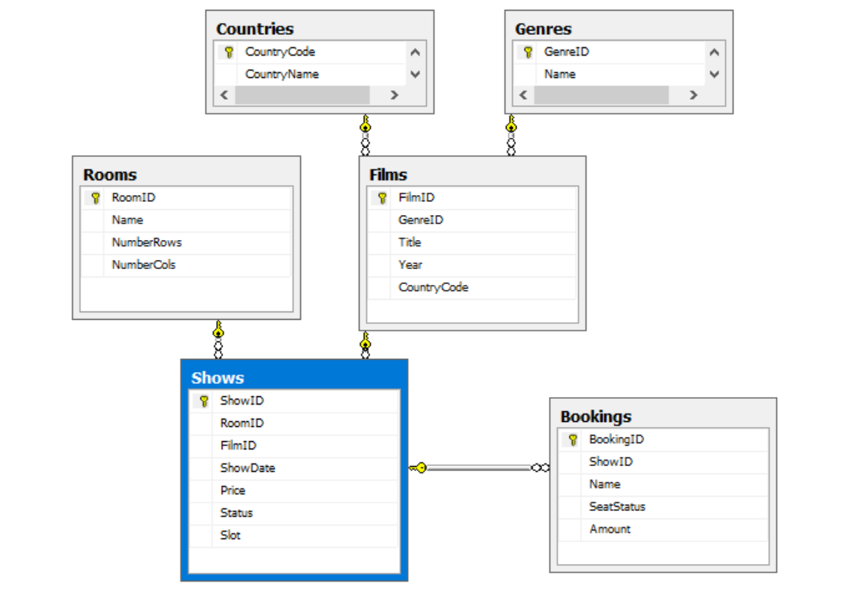

# 5. Auction system

Company T has decided to build a system which offers services for auctions among registered members. With this system, members will use a client machine to log into Company’s server for auction information management via the network, and participate in auctions by putting items up for auction or by bidding on auction items.

In order for members to put items up for auction, members enter data such as the item category, name, description, minimum bid increment, auction end date and time, etc.

Members who wish to purchase items search auction items, acquiring auction item information, including the current price (maximum bid price so far; initial value is 0). If there is something they wish to purchase, they specify the amount they wish to bid on the item.

When processing a bid operation, if the bid price is equal to or greater than the “Current price + Minimum_bid_increment”, then the entered bid price becomes the new current price. Bid processing is performed in the order that bid operation requests arrive at the system. If there are multiple bid operations with the same price for an auction item, no bids other than the first to arrive at the system are accepted. Whether a bid operation was accepted or not is displayed on-screen. The member who placed the bid with the current price is called the potential winning bidder of that auction item. When a

new bid is placed, the potential winning bidder changes, and the system sends an e-mail message to the previous potential winning bidder informing of this.

Moreover, members may bid repeatedly on the same item, but may not reduce bid amounts or withdraw bids.

Bidding is closed on the end date and time of the auction for the auction item, and the potential winning bidder becomes the winning bidder. The system sends an e-mail message to the seller and the winning bidder informing of this.

The table shows a (partial) list of system operations.

Table List of operations (incomplete)

|  |  |  |
| --- | --- | --- |
| **Operation** | **Performed by** | **Description** |
| Placing item  for auction | Member | Performs auction item placement processing |
| Item search /  Bid | Member | Performs auction item searching and display,  and bid processing |
| Auction status  display | Seller | Displays status of auction items placed by  the seller |
| Bid status  display | Bidder | Displays status of bids by the bidder |

Fig. 1 shows a sample screenshot which displays the auction item search result and is used to perform a bid operation as part of the “Item search / Bid” operation.

Item Search Result/Bid Screen

Bidder number: 1 Bidder: Nguyen Van B

Type name: Laptop

Item number: 1 Item name: Dell 1300

Item description: Seller: Nguyen Van A

Current price: 0 Minimum bid increment: 10

End date time: 24:12:2014,24:00 Time remaining: 14 hours

Bid

Cancel

Fig. 1 A sample bid operation screen

Member

Member_number

Name

Address

Email_address

Expiration_date

Auction_item

Item_number

Item_type_code

Item_name

Item_description

Seller_number

Minimum_bid_increment

End_datetime

Current_price

Minimum_bid_increment

End_datetime

Item_type

Item_type_code

Item_type_name

Bid

Bid_number

Item_number

Bidder_number

Bid_price

Bid_datetime

One to many

Note: Underlined attributes constitute a primary key

Note: Underlined attributes constitute a primary key

Note: Underlined attributes constitute a primary key

Fig. 2 shows the E-R diagram for the system

Fig. 2 E-R diagram

# 6. Ted Shop system

Ted shop system is used for selling products that are imported from oversea. There are three kinds of people using it: Manager, staff, and customer. Manager uses it to register information of product types, products, and staffs, and print summary report. Staff uses it to import, and deliver products. Customer uses it to order products.

Staff information contains staff ID (unique and generated by the system), name, address, phone, kind of staff (staff or manager), and a bank account.

Product type information contains product type ID (unique and generated by the system), and product type name. Product information contains product ID (unique and generated by the system), product name, description, produce country, product type ID, price, sell price (normally 20% higher than price), use guide, and quantity.

Summary report for a specified period (from start date to end date) is the list of sold product with quantity, price, and selling price, and total benefit amount during that period.

Importing information contains staff ID, import date, and imported products. Quantity of these products will be added to the quantity of the shop automatically.

Order information contains order ID (unique and generated by the system), customer name, customer address, customer phone, order date, and ordered products.

Staff will deliver products to customer and deliver date will be registered. Quantity of these products will be subtracted from the shop automatically.

The following table shows a (partial) list of system operations.

|  |  |  |
| --- | --- | --- |
| **Operation** | **Performed by** | **Description** |
| Register staffs | Manager | Perform registering information of staffs. |
| Register product types, products | Manager | Perform registering information of product types, and products. |
| Import products | Staff | Perform importing products. |
| Order products | Customer | Perform ordering products. |
| Deliver products | Staff | Perform delivering products. |
| Print summary report for a specified period | Manager | Display the list of sold products with price, sold price, quantity, and total benefit amount. |

Fig. 1 The ERD of the Ted shop system.

One to many

Note: Underlined attributes constitute a primary key

Staffs

Staff_ID

Name

Address

Phone

IsManager

Account

Imports

Import_ID

Staff_ID

Import_date

Import_details

Import_detail_ID

Import_ID

Product_ID

Quantity

Order_details

Order_detail_ID

Order_ID

Product_ID

Quantity

Orders

Order_ID

Order_date

Customer_name

Customer_address

Customer_phone

Total_amount

Staff_ID

Deliver_date

Note:

A solid line indicates an attribute of a primary key.

A dashed line indicates an attribute of a foreign key.

Both a solid line and a dashed line indicate an attribute of both a primary key and a foreign key.

Entity name

Attribute name

Attribute name

Attribute Product_Types

Product_type_ID

Product_type_name

Products

Product_ID

Product_type_ID

Produce_country

Product_name

Product_description

Use_guide

Price

Sell_price

Quantity

# 7. Ceil Inn system

Ceil Inn is a (fictional) hotel. There are various types of rooms (bedrooms, suites, and conference rooms). Rooms have different types of bed (queen, double, or king). Depending on the type of room and the bed(s), a certain rate is charged to occupy or use a room.

The system will provide the following functions:

**[1. Register employees]**

Employees are people who will manage all aspects of the database. In most databases, they are identified with as much information as possible. To keep our implication simple, we will need the name and the title of each employee. To uniquely identity an employee, each one will have an employee number. This number will be specified by the person who is creating the record for a new hire.

**[2. Register customers of the Hotel]**

The customers are the people who rent the rooms that the hotel offers. Like employees, customers have to be identified. For our database, we will just need each customer's name, the telephone number, and information about a person to contact in case of emergency.

When a customer comes to rent a room, an account will be created for him or her. If the same customer comes to rent a room another time, a new account will be created. This means that, for accounting purposes, we will need a unique account number for each renting session, even for a repeating customer.

**[3. Register available rooms]**

Rooms are probably the most important objects of a hotel. A room is primarily characterized by its category as a bedroom or a conference room. If it's a bedroom, then other pieces of information are necessary. We have already seen what they are: bed type and status.

Each room must have a unique room number. The rate applied when renting a room should be specified. After all, en employee should not guess the price of a room when a customer is about to rent it.

**[3. Assign rooms]**

After registering a customer, the employee can assign a room. Normally, the employee would ask what type of room the customer wants to rent. After all some people want a bedroom, others a studio, and others a conference room. The employee can show the list of available rooms.

When assigning a room to a customer, we first need to know who (the employee) performed this operation. We also would like to know the date when this operation was performed. We may just use that same date as the first day a customer rented a room or the day a conference room was used. Of course, the employee needs to identify the customer who is renting the room. The employee must also specify the room that is being rented and how much will be charged.

In our hotel, the Internet is free to all customers. If using the telephone in the room, if a customer makes local calls, they are free. Long distance calls are not free. We need to keep, on a daily basis, a calendar and rate of phone consumption (this is one of the reasons we create a new account for every customer, including returning customer).

As you can imagine, each room assignment must have a unique number that identifies its record. We will use an automatically incrementing number.

**[4. Make payments]**

A conference room is usually rented for one day or one evening. A bedroom is usually rented for one or more nights. If a room (whether a conference room or a bedroom) is rented for one day or night, the day will be registered. The rate will be applied. At the end of the day, the customer can pay. If a room is rented for one whole night (the classic case of a bedroom), the employee will register the first day but no rate will be applied. Each subsequent day will be registered and a rate will be applied for that day. After the number of days the customer would have used the room, the number of days will be counted and the sum of daily rates made. The customer can then pay the total.

We will need or use the following pieces of information for each payment:

1. Receipt Number: A receipt should be given to a customer
2. Employee Number: This is the employee who processed the payment. This is usually the employee at the desk when the customer checked out
3. Payment Date: This is the date the payment was made. It may not be the checked out date (a customer could pay on the check-in date or a few days after check-out)
4. Account Number: As mentioned previously, when a customer registers with the hotel, (s)he gets an account number. While the customer is using the room, this account number is used to keep track of both the customer's occupancy and phone use. This the reason we decide to create a new account every time, including a returning customer. When the customer decides to pay the bill, the account number holds a summary of his or her consumption
5. Amount Charged: This is the total resulting from the customer renting a conference room or occupying the bedroom
6. Tax Rate: The government needs to collect its due

A database “Hotel” is created for Ceil Inn hotel system. It consists of 5 tables as below:

Employees table:

|  |  |  |
| --- | --- | --- |
| Field Name | Data Type | Field Size |
| EmployeeNumber | Text | 10 |
| FirstName | Text | 25 |
| LastName | Text | 25 |
| Title | Text | 50 |

Customers table:

|  |  |  |
| --- | --- | --- |
| Field Name | Data Type | Field Size |
| AccountNumber | Text | 10 |
| FirstName | Text | 25 |
| LastName | Text | 25 |
| PhoneNumber | Text | 20 |
| EmergencyName | Text | 50 |
| EmergencyPhone | Text | 20 |

Rooms table:

|  |  |  |
| --- | --- | --- |
| Field Name | Data Type | Field Size |
| RoomNumber | Text | 10 |
| RoomType | Text | 10 |
| BedType | Text | 10 |
| Rate | Number | Double |
| RoomStatus | Text | 10 |

Occupancies table:

|  |  |  |
| --- | --- | --- |
| Field Name | Data Type | Field Size |
| OccupancyNumber |  |  |
| EmployeeNumber | Text | 20 |
| DateOccupied | Date |  |
| AccountNumber | Text | 20 |
| RoomNumber | Text | 10 |
| RateApplied | Number | Double |
| PhoneCharge | Number | Double |

Payments table:

|  |  |  |  |
| --- | --- | --- | --- |
| Field Name | Data Type | Field Size | Default Value |
| ReceiptNumber |  |  |  |
| EmployeeNumber | Text | 20 |  |
| PaymentDate | Date/Time |  |  |
| AccountNumber | Text | 20 |  |
| AmountCharged | Number | Double |  |
| TaxRate | Number | Double | 0.01 |

# 8. Student management system

An IT faculty of a university is going to develop the student management system. Some main requirements of this system are identified as below:

* 1. Each student can be only registered into one class. Information about the student are ID, name, birth date, address, phone number.Information about class are ID, name, start date, end date.
  2. Some different subjects will be taught in one class, and one subject can be taught in more than one class
  3. Each subject has some kind of exercises, tests, and final exam … to evaluate the student’s competence with according percentages. The responsible lecturer will decide these according kinds and percentage for each subject. For example. The total marks of subject CNET will be evaluated by Lab, Test, Project, and Practical Exam, Final exam marks with percentages 15%, 15%, 20%, 20%, and 30% respectively.

ER model for that problem is shown in the following figure

Classes

Students

Subjects

Exercises

has

has

has

marked

# 9. Lab Reservation System

The relevant part of database and lab reservation procedure ofanuniversityare shown as below.

1. **The part of University’s Database is shown in the figure 1.**

Students

Time_slots

Week_days

Labs

Bookable_periods

Reservations

Figure 1. A part of given university database

* 1. Labs table contains a list of computer labs of this university, including lab_id, lab_address, and no_computers (number of computers in totalofthe lab).
  2. Week_days table contains a list of week days of a week that students can study in the university, including week_day and date. The values of week_day column are all available days of a current week, from Monday to Saturday.
  3. Time_slots table contains information about the time period that students can practice in the lab, including slot_id, from (begin time), and to (end time).The form of the Time_slots table as below

|  |  |  |
| --- | --- | --- |
| **Slot_id** | **From** | **To** |
| 1 | 7h30 | 9h |
| 2 | 9h10 | 10h 40 |
| 3 | 10h 50 | 12h 20 |
| 4 | 12h 50 | 14h 20 |
| 5 | 14h 30 | 16h |
| 6 | 16h 10 | 17h 40 |

1. Students table contains information about all students, including std_id, name, address, and phone_number.
2. Bookable_periods table contains information about the period during a week for each lab that is available for reservation, including lab_id, week_day, slot_id and no_available_computers(number of computers available for reservation).
3. Reservations table contains student’s reservation records, including lab_id, week_day, slot_id, andstd_id
4. **The reservation procedure:**

When a student wants to practice in any lab, he or she must reserve in advance.

The reservation procedure as below (see figure 2):

1. Student must declare student ID and name, and system will check if the information of this student exists in the database or not.
2. If the student's information is stored in the system, the list of week days and time slots will be displayed for the student to choose one.
3. Display all available labs for the student to choose one (only one computer is reserved).
4. At the end, a new reservation record will be added in Reservations table.

The flowchart of the reservation procedure is shown in Figure 2

Start

Display

Error

Reservations

Display week days, time slots and allow the user to choose one

Add the new reservation record

Students

Week_days

Check if there is that student

End

Get student’s information

Login: Name and ID

Students

`

Week_days

Display all week days, time slots, and allow the user to choose one

Time_slots

Bookable_periods

Display all available labs for that time slot, and allow the user to choose one

one

Labs

Figure 2. Reservation procedure flowchart