**Background Facts:**

On April 28, 2021 at about 8:10 pm Amy Chestnut was the restrained driver of a 2017 Honda Accord 2 DR coupe that was stopped in the northbound left turn only lane of SW 13th St. (aka US-441) at the intersection with W. University Ave.(aka Florida 26), Gainesville, Florida when it was struck from behind by a 2019 Jeep Wrangler Moab edition SUV, driven by Jennifer Johnstone along with Alex Pellegrino as the right front seat passenger. No police response occurred. The images below depict an FRA produced diagram (based on statements and the provided photos) and the subject vehicles, post-collision:

**FRA diagram, Ms. Chestnut’s Honda is labeled “V2”**

**Ms. Chestnut’s Honda, repair shop, post-collision**

**Jeep, unknown location, post-collision**

The damage estimate for the Honda amounted to about $1,612 and indicated replacement was required for the left and right rear bumper mounting brackets and the right rear bumper camera. Repair was required for the rear bumper cover and the rear body panel. The Honda was not towed from the scene.

No damage estimate was provided for the Jeep for review. The provided photos showed minor scuff damage to the left and right fog lamp bezels on the front bumper. The Jeep was not towed from the scene.

**Reconstruction**

According to information in Ms. Johnstone’s deposition it was dry, clear and the lighting was dusk.

A review of the crash location on Google Earth Pro street view (imagery date September 2023) showed the speed limit on SW 13th St. as 30 mph.

Ms. Chestnut, deposed on May 4, 2023, testified that she was traveling down US- 441 (NW 13th St.) and was stopped at a light in the left turn lane at the intersection with Newberry Rd. (a Google Earth Pro review showed the intersection to be US-441/NW 13th St. and W. University Ave.) behind another stopped car. She did not see the Jeep approaching from behind and felt a jolt. Her car went forward, and her body went forward. She got out of her car and determined that the front of her car had not struck the car stopped in front of her. She contacted the driver of the Jeep, Ms. Johnstone, and smelled a heavy odor of marijuana on her. Ms. Johnstone was yelling at her from the moment she got out of her car, and she wanted to have the police respond due to Ms. Johnstone’s demeanor and the odor of marijuana, however, the police never arrived. The passenger in Ms. Johnstone’s car tried to get Ms. Johnstone to calm down. She did not see any damage to the Jeep.

In other court documents she stated she was stopped in the northbound left turn lane with an appropriate amount of space between her car and the car ahead of her.

Ms. Johnstone, deposed on June 12, 2023, testified that she and her passenger, Ms. Pellegrino, were northbound on 13th St., they were in stop and go traffic at the intersection of 13th and University in the left turn lane. There had been a lot of traffic in that lane, and she had her foot on the brake edging forward at a very slow crawl by applying and releasing the brake pedal repeatedly. She estimated her speed as under 1 mph. She had been relatively close to the car in front of her, it stopped, she didn’t realize it had, she was not able to brake in time and she bumped into it. They moved to a nearby parking lot, and she contacted Ms. Chestnut. She denied yelling at her and said that Ms. Chestnut was angry at her. She denied any marijuana use. She said that there wasn’t any damage done to either car but later said the damages were very insignificant. Her Jeep did not have any pre-existing damage on it.

No deposition or statement from Ms. Pellegrino was provided for review.

*Analysis:*

Based on the repair estimates, and level of damage observed in the photos there is less than 1 inch of deformation penetration in the Jeep and slightly more than 4 inches in the Honda. A widely used crash simulation program[1] is capable of modeling deformation and depth of penetration or maximum engagement during a collision. By overlapping the damage between scale models of both subject vehicles as observed in the photos, I can model the subject crash to determine a closing speed estimate, which will in turn, estimate an approximate speed change or delta V imparted to the Honda in the crash by using a momentum, energy and restitution (MER) analysis, and then matching these results to the physical and other evidence.

An impact speed of 15 mph from the Jeep would have resulted in a delta V in the Honda of approximately 11.2 mph, with a peak vehicle acceleration for the impact of approximately 8.1 g. Deformation (overlap or depth of penetration) between the Jeep and the Honda is shown below and is fairly consistent with what is observed in the photos.

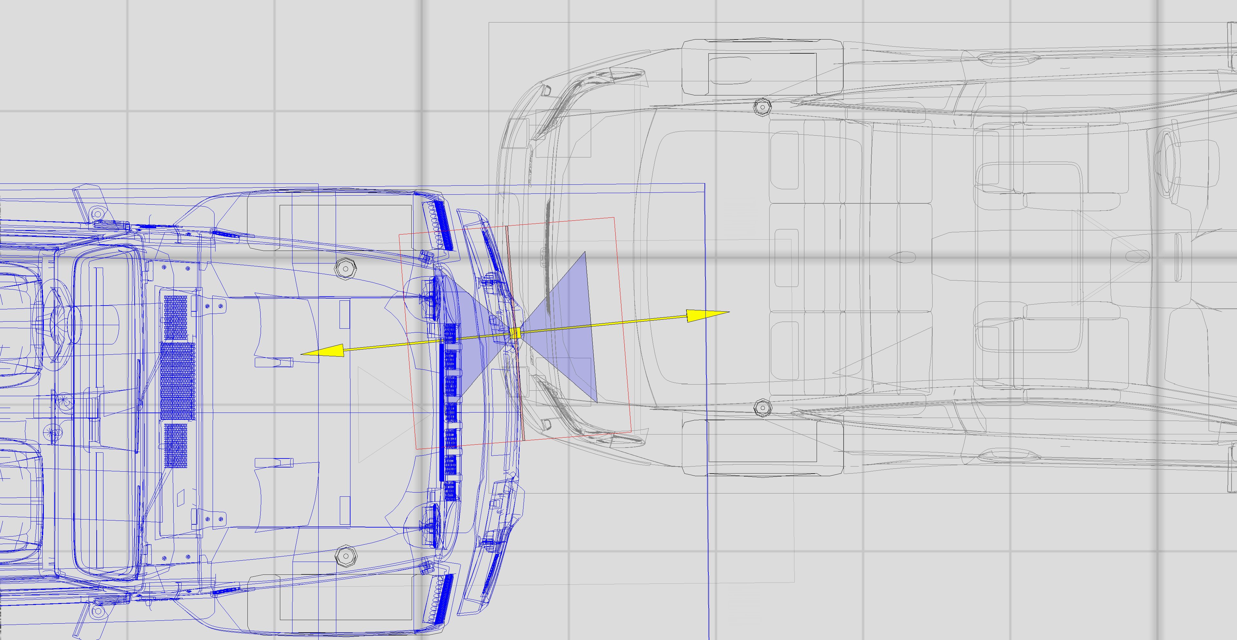

**Simulated 15 mph depth of penetration (overlap or maximum engagement) fairly consistent with photos. Honda is the vehicle on the right. Impulse vector shown by yellow arrows.**

1. Virtual Crash 5, vCrash America Inc.