No speeds are were estimated by the involved parties. Deformation to Ms. Lema’s Mercedes is around 2-3 inches and 3-4 inches in the Genesis. A widely used crash simulation program is capable of modeling deformation and depth of penetration or maximum engagement during a collision. It is also capable of modeling vehicle dynamics to estimate vehicle positions at the time of collisions. By overlapping the damage between scale models of the involved vehicles as observed in the photos, I can model the subject crash to determine a closing speed estimate, which will in turn, estimate an approximate speed change or delta V imparted to the Mercedes in the crash by using a momentum, energy and restitution (MER) analysis, and then matching these results to the physical and other evidence.

An impact speed of 30 mph from the Toyota into the Genesis traveling 20 mph causes the Genesis to collide into the Mercedes at approximately 15 mph. This would have resulted in a delta V in the Mercedes of approximately 5.9 mph, with a peak vehicle acceleration for the impact of approximately 4.2 g. Deformation (overlap or depth of penetration) between the Genesis and the Mercedes is shown below and is fairly consistent with what is observed in the photos.

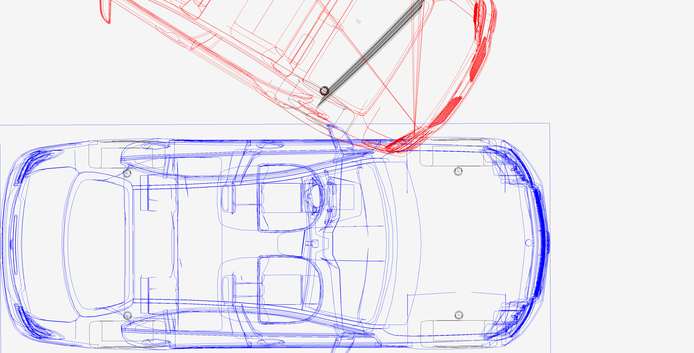

**Simulated 15 mph depth of penetration (overlap or maximum engagement) fairly consistent with photos. Ms. Lema’s Mercedes is the vehicle on the bottom in blue.**