**Background Facts:**

On July 22, 2021, at about 5:30 pm Riley Bond was the restrained driver of a 2007 Ford Focus 4DR sedan that was traveling in the #1 non-express eastbound lane of Hwy. 470, approaching S. University Blvd., Highlands Ranch, Colorado when he began slow for traffic ahead of him. He was actively braking and slowed to a stated speed between 30 and 45 mph when he was struck from the rear by a 2011 Kia Sportage SUV, driven by Ava Davis. No police response occurred. The images below depict a satellite view of the approximate crash location based on information provided and the subject vehicles, post-collision:

**Satellite view- Hwy. 470 near S. University Blvd.**

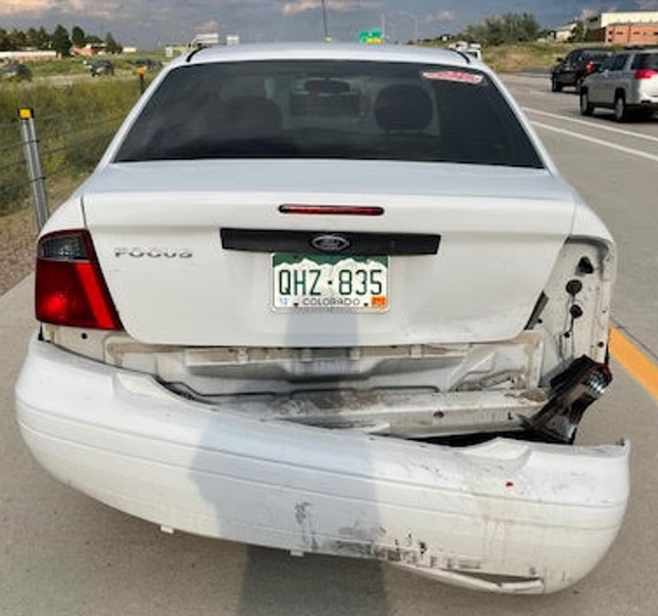

**Mr. Bond’s Ford at scene, post-collision**

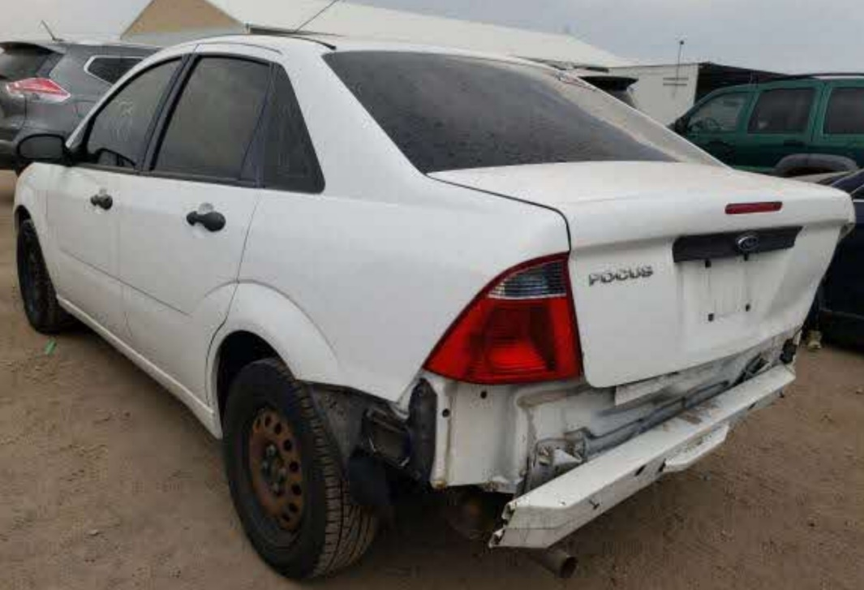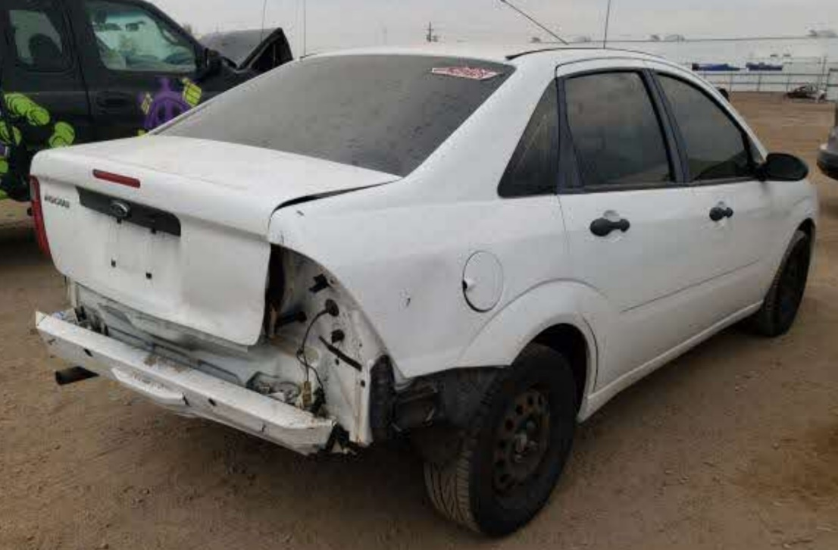

**Mr. Bond’s Ford at storage lot, post-collision**

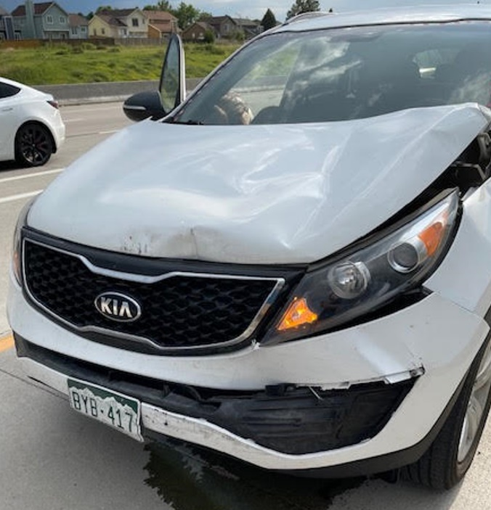

**KIA at scene, post-collision**

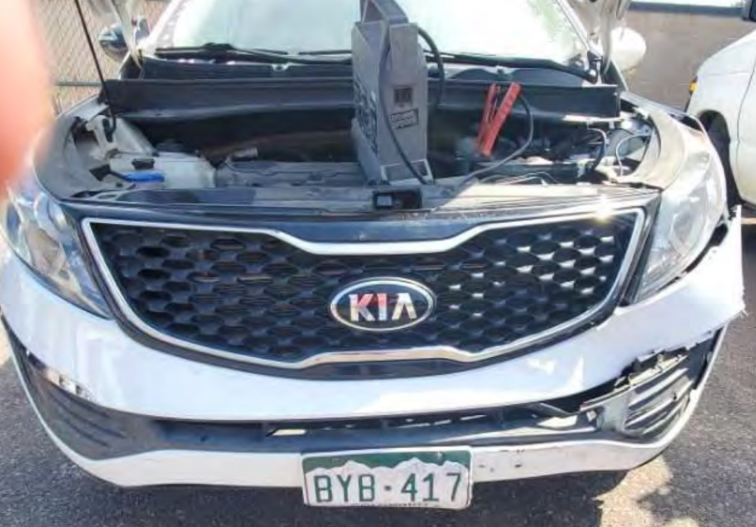

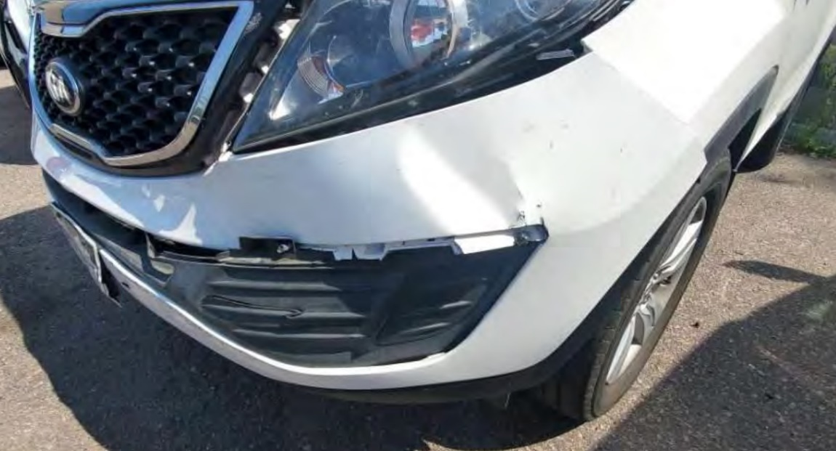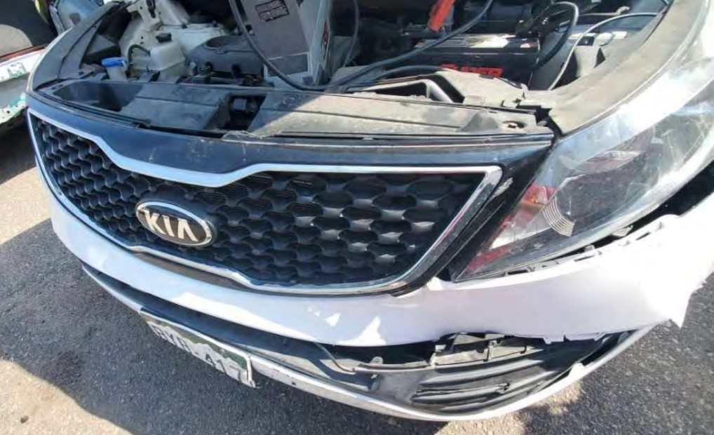

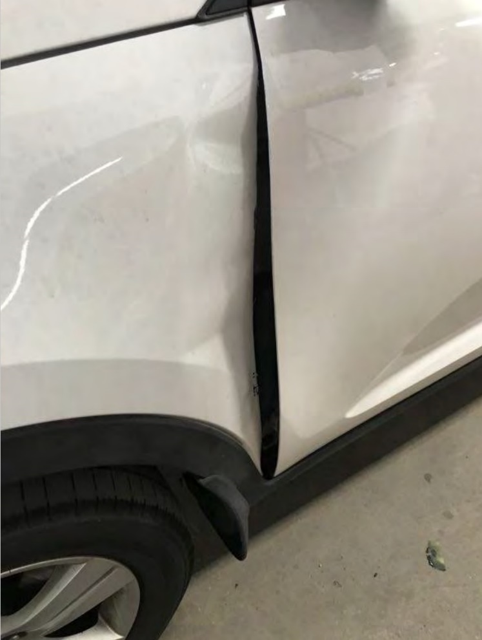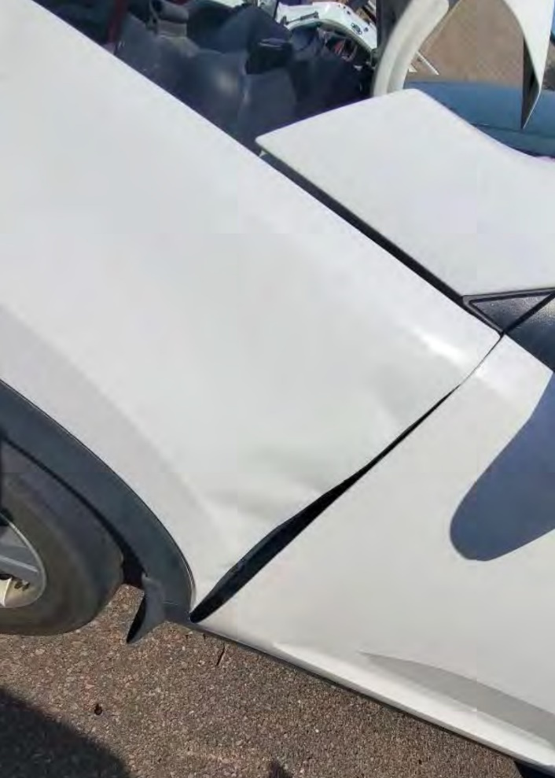

**KIA at repair shop, post-collision**

The damage estimate for the Ford amounted to about $3,361 and did not contain any itemization of the parts needing replacement or repair and it was deemed a total loss. The provided photos showed damage to the rear bumper cover, rear hood, right rear lighting assembly, right rear quarter panel and the rear bumper reinforcement bar appeared to be directed downwards. Mr. Bond testified that his rear bumper was completely destroyed and hanging by a thread, the truck was completely smashed in, one of the rear passenger doors would no longer open as the frame had shifted, and it was deemed a total loss. The Ford was not towed from the scene.

Numerous damage estimates for the KIA were provided. The most current estimate, dated September 20, 2021, amounted to about $7,405 and indicated replacement was required for the front bumper system (bumper cover, absorber, impact bar, lower grille, valance panel, left side bracket, right side bracket, left upper bracket), left headlamp assembly, radiator support, radiator assembly, fan assembly, AC condenser, hood, both hood hinges, hood latch assembly, left front fender assembly, air cleaner assembly, fuse box, and the left front impact sensor. Repair was required for the left front fender apron panel and the left front fender rail assembly. The provided at scene photo showed fluid leakage from the engine compartment occurred. The KIA required towing from the scene due to damage and there was no report of air bag deployment.