**Opinions of defendant’s expert, Dr. Lu with JS Held**

Dr. Lu did not offer any opinions at deposition and did not complete a report for this case. Her crush calculations show an impact speed for the Hyundai of 8.5 mph, a delta-V for the Nissan of 4.7 mph over 0.12 sec and a peak acceleration of 3.6 g. She did not make any statements or opine regarding biomechanical causation.

*Analysis:*

Deformation in the Nissan extends beyond the bumper plane into the rear body panels. Dr. Lu’s calculation sheet estimated 2.6 inches in the Nissan which would not account for deformation beyond the bumper. I would estimate the deformation is at least 4 inches. The deformation to the Hyundai is not well documented but it is more than likely that the damage to it is 2-3 inches which is more than Dr. Lu’s estimate of 1 inch.

A widely used crash simulation program[1] is capable of modeling deformation and depth of penetration or maximum engagement during a collision. By overlapping the damage between scale models of the Hyundai and the Nissan as observed in the photos, I can model the subject crash to determine a closing speed estimate, which will in turn, estimate an approximate speed change or delta V imparted to the Nissan in the crash by using a momentum, energy and restitution (MER) analysis, and then matching these results to the physical and other evidence.

An impact speed of 10 mph from the Hyundai would have resulted in a delta V in the Nissan of approximately 5.9 mph, with a peak vehicle acceleration for the impact of approximately 4.3 g. Deformation (overlap or depth of penetration) between the Hyundai and the Nissan is shown below and is fairly consistent with what is observed in the photos.

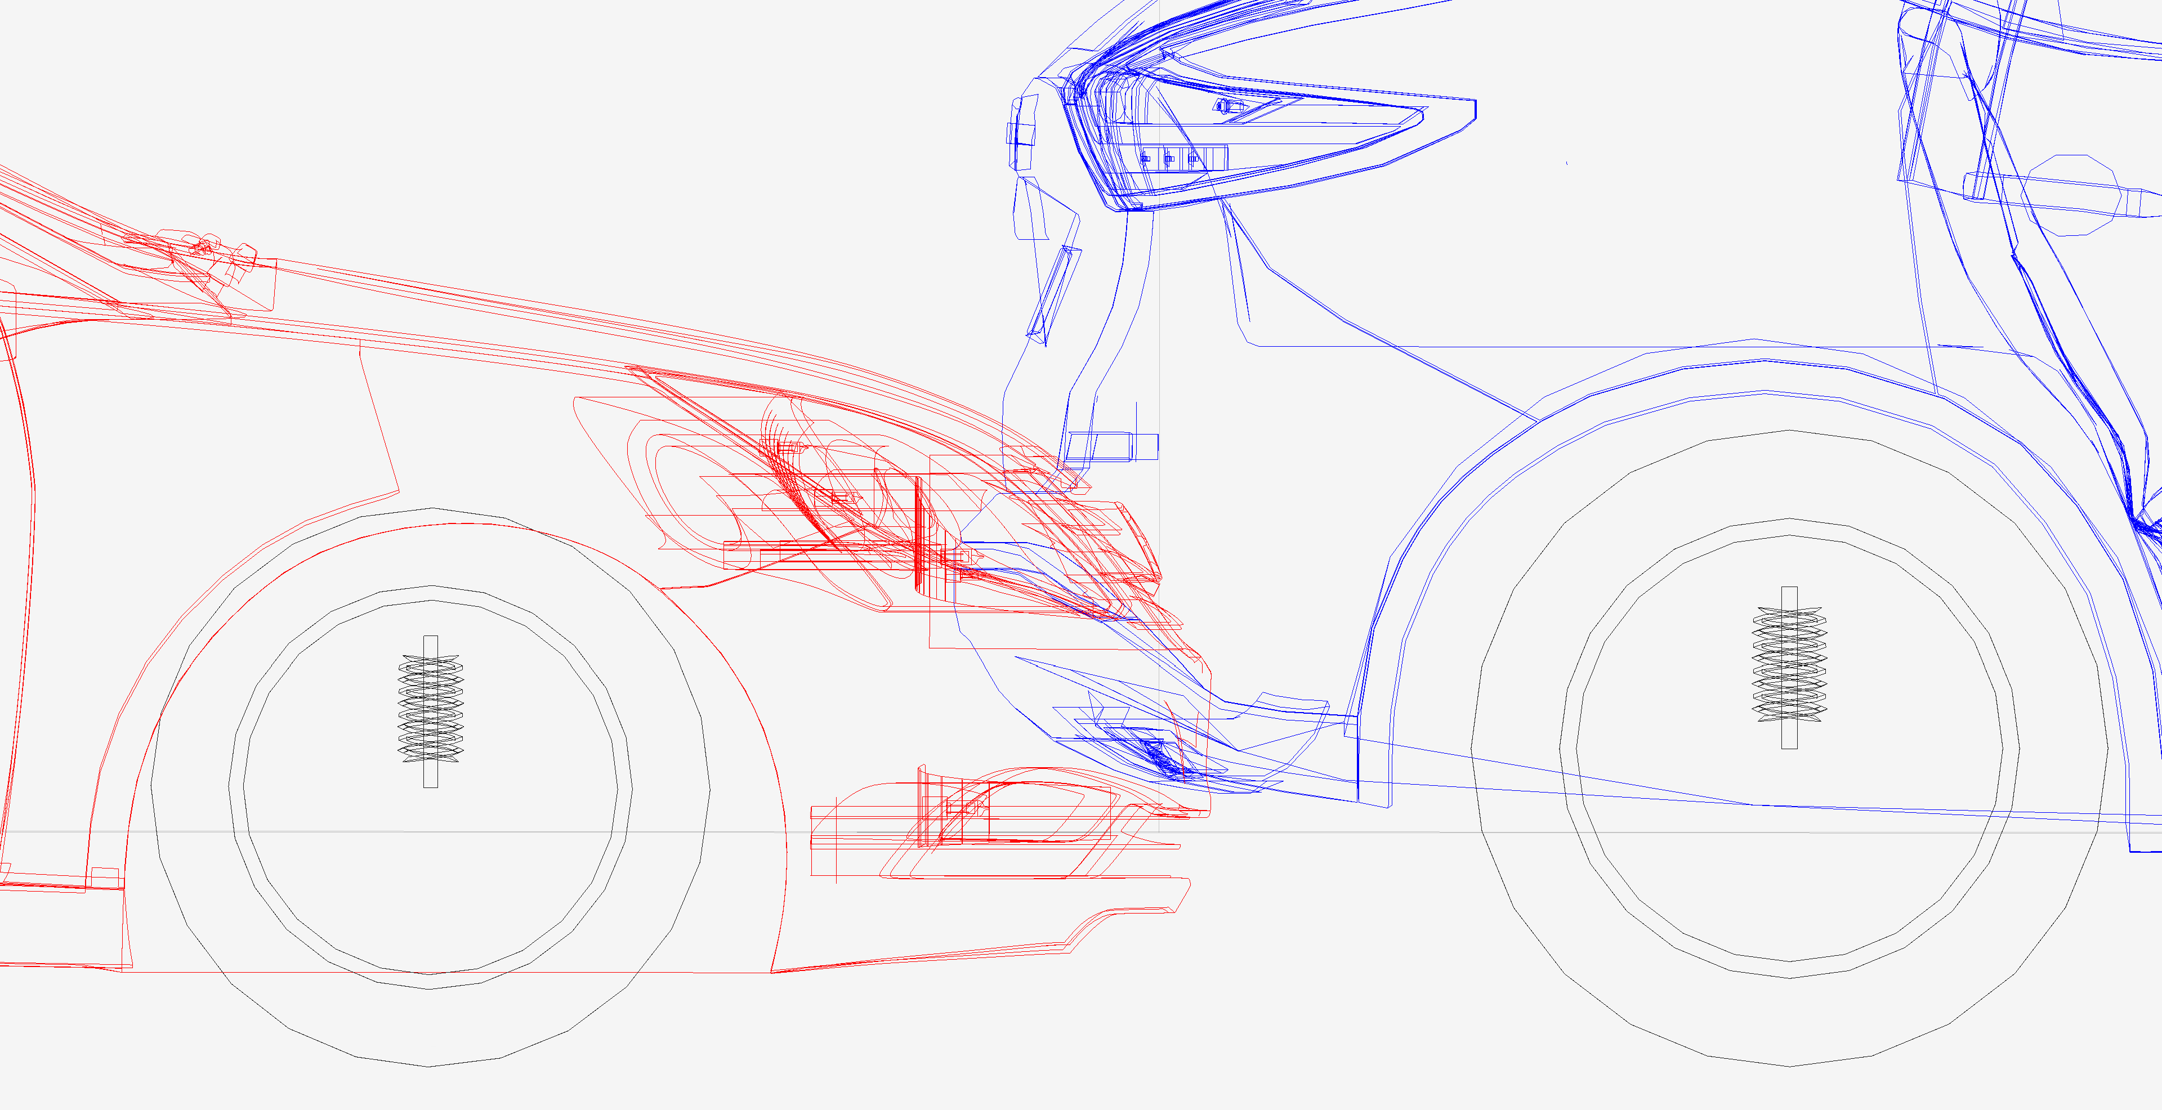

**Simulated 10 mph depth of penetration (overlap or maximum engagement) fairly consistent with photos. The Nissan is the vehicle on the right in blue.**

Dr. Lu’s calculation sheet shows 120 millisecond impulse in both vehicles which is a little long for a low-speed impact. An 8.5 mph closing speed is likely to produce less than a 100 ms impulse in each vehicle and she used a restitution of 0.25 which low for this speed, it should be 0.31[2]. Had she used the proper impulse and restitution, her delta V for the Nissan would have been around 5.0 mph. Despite her errors, her depth of penetration is close but incorrect due to her erroneous impulse and restitution estimates.

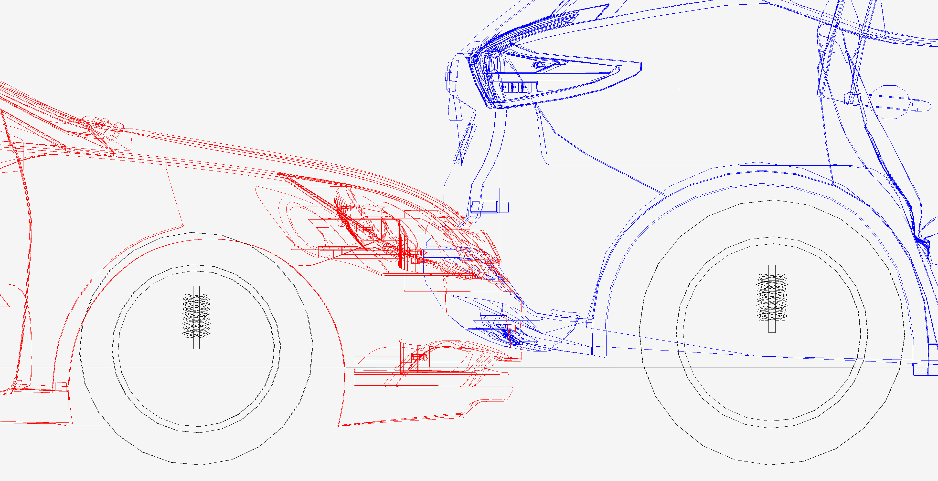

**Depth of penetration using Dr. Lu’s estimates**

1. Virtual Crash 5, vCrash America Inc.
2. SAE 2002-01-0540 Low Speed Collinear Impact Severity: A Comparison between Full Scale Testing and Analytical Prediction Tools with Restitution Analysis, Cipriani et al, 2002