*Crash reconstruction*

According to the police report there no adverse weather or roadway conditions at the time of the crash. It was daylight, clear weather, with dry roadways, and the speed limit for Lockwood Blvd was 35 mph.

**Thomas Vravis** testified at deposition on July 28, 2021 that he had been driving at the time of the crash and had been stopped at a red light with a vehicle in front of him, in the right turn lane, when his car was struck from the rear. He felt two impacts.

**Barbara Vravis** testified at deposition on July 28, 2021 that the vehicle she had been a passenger in was stopped in the right turn lane, southbound on McCulloch Rd, when the car was struck from the rear. She felt two impacts.

**Virginia Deer** testified at deposition on July 5, 2023 that she stopped behind a line of cars in the right turn lane, with Mr. and Mrs. Vravis’s vehicle directly in front of her. Although the light was still red, she saw cars proceed with the turn. She took her foot off the brake and the car rolled forward at an idle speed as she looked down to turn down her music. She looked back up after her vehicle collided with the rear of Mr. and Mrs. Vravis’s vehicle.

**Vicki Deer** testified at deposition on July 5, 2023 that she owned the vehicle her daughter Virginia was driving at the time of the crash. Mrs. Deer was not present during the crash and did not have any first-hand testimony directly related to how the crash occurred.

**Opinions of defendant’s expert, Dr. Lu with JS Held**

Dr. Lu did not offer any opinions at deposition and did not complete a report for this case. Her crush calculations show an impact speed for the Hyundai of 8.5 mph, a delta-V for the Nissan of 4.7 mph over 0.12 sec and a peak acceleration of 3.6 g. She did not make any statements or opine regarding biomechanical causation.

*Analysis:*

Deformation in the Nissan extends beyond the bumper plane into the rear body panels. Dr. Lu’s calculation sheet estimated 2.6 inches in the Nissan which would not account for deformation beyond the bumper. I would estimate the deformation is at least 4 inches. The deformation to the Hyundai is not well documented but it is more than likely that the damage to it is 2-3 inches which is more than Dr. Lu’s estimate of 1 inch.

A widely used crash simulation program[1] is capable of modeling deformation and depth of penetration or maximum engagement during a collision. By overlapping the damage between scale models of the Hyundai and the Nissan as observed in the photos, I can model the subject crash to determine a closing speed estimate, which will in turn, estimate an approximate speed change or delta V imparted to the Nissan in the crash by using a momentum, energy and restitution (MER) analysis, and then matching these results to the physical and other evidence.

An impact speed of 10 mph from the Hyundai would have resulted in a delta V in the Nissan of approximately 5.9 mph, with a peak vehicle acceleration for the impact of approximately 4.3 g. Deformation (overlap or depth of penetration) between the Hyundai and the Nissan is shown below and is fairly consistent with what is observed in the photos.

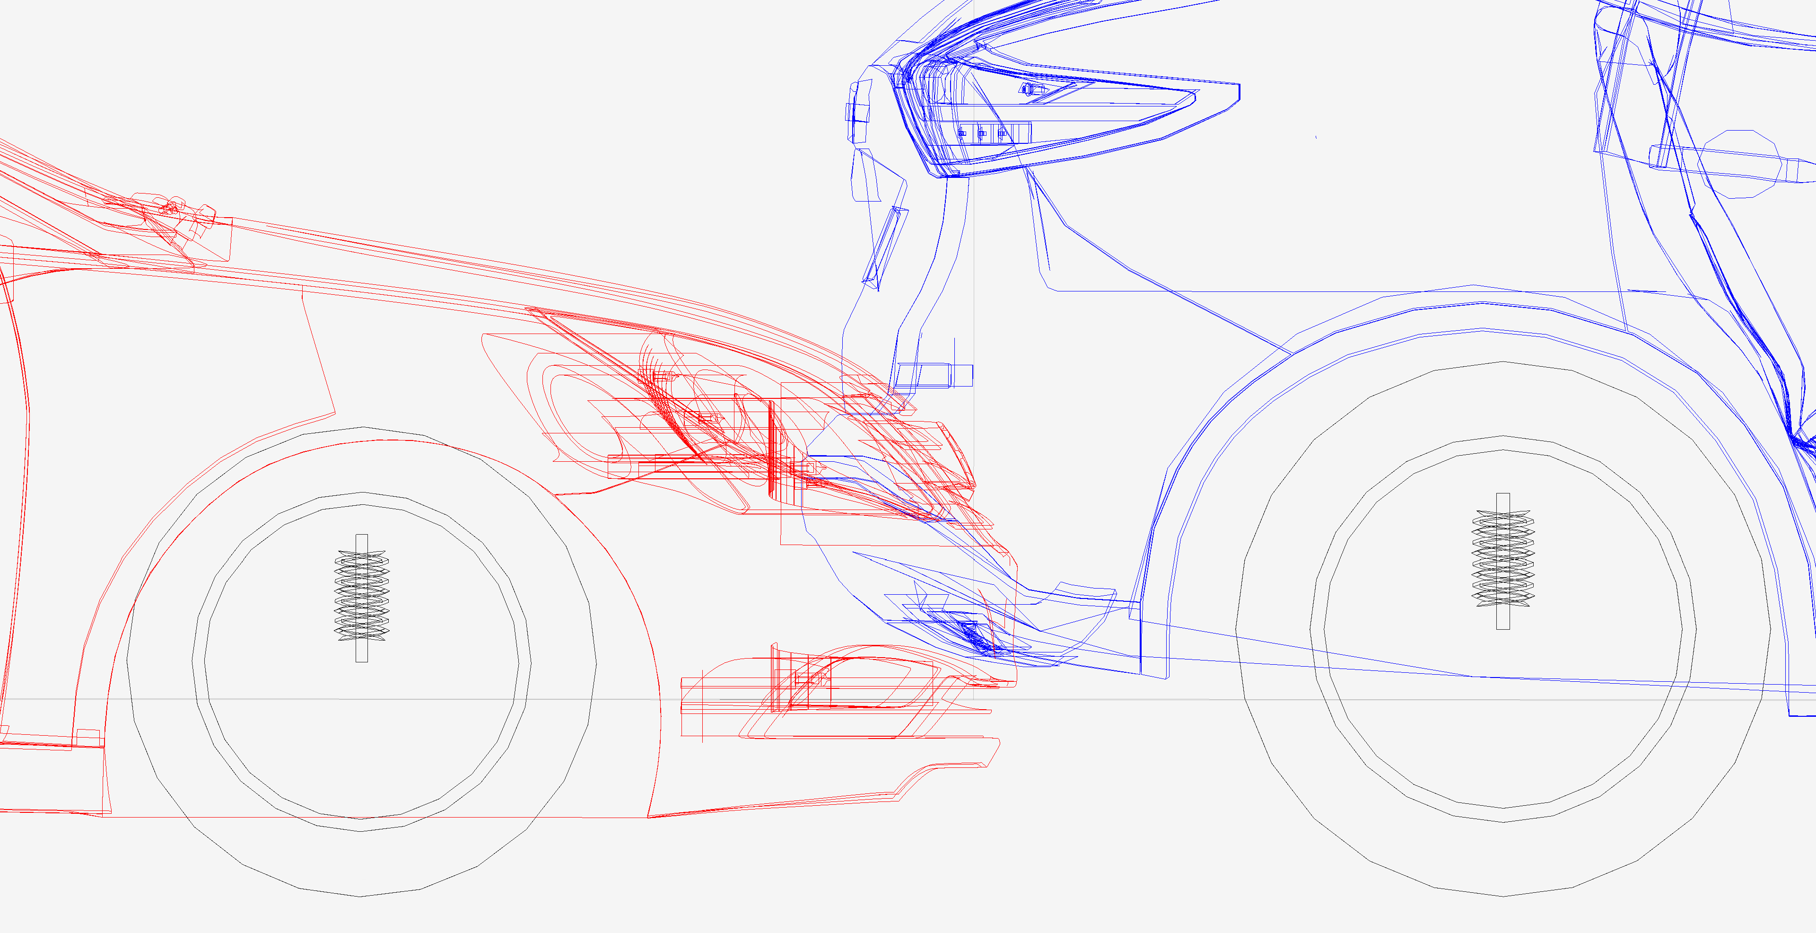

**Simulated 10 mph depth of penetration (overlap or maximum engagement) fairly consistent with photos. The Nissan is the vehicle on the right in blue.**

Dr. Lu’s calculation sheet shows 120 millisecond impulse in both vehicles which is a little long for a low-speed impact. An 8.5 mph closing speed is likely to produce less than a 100 ms impulse in each vehicle and she used a restitution of 0.25 which low for this speed, it should be 0.31[2]. Had she used the proper impulse and restitution, her delta V for the Nissan would have been around 5.0 mph. Despite her errors, her depth of penetration is close but incorrect due to her erroneous impulse and restitution estimates.

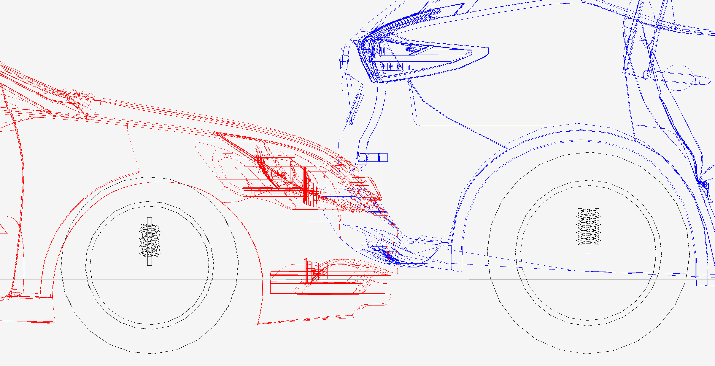

**Depth of penetration using Dr. Lu’s estimates**

1. Virtual Crash 5, vCrash America Inc.
2. SAE 2002-01-0540 Low Speed Collinear Impact Severity: A Comparison between Full Scale Testing and Analytical Prediction Tools with Restitution Analysis, Cipriani et al, 2002