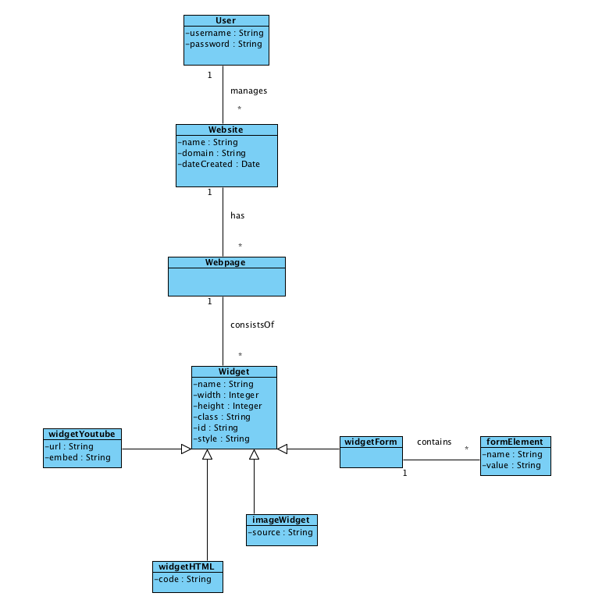

This is UML diagram depicting a Content Management System. In this representation, each User can manage multiple Websites. Websites can have multiple Webpages which consist of Widgets. Widget is a generalization and represents an Interface so all of the widget classes would inherit its attributes. The Form widget can contain multiple Form Elements which capture some user input value held as a String. This diagram is “well formed” because it doesn’t consist of any “many to many” cardinality relationships, instead only utilizing “one to many” relationships.