**Institute of Technology Tralee**

**BSc. in Computing with Specialism (Group 2) - Year 1**

**Early Assessment**

**Date: 28/9/15**

**Time: 2 – 2.45 p.m.**

**Introduction to Programming**

**Instructions:** Attempt the following question. You should use the JCreator IDE for coding. When you are finished you must print out your code for correction.

**________________________________________________________**

**Q1.**

Write a Java program that first of all sets (initialises) a String variable called *metalName* to the value “Gold”. It should then prompt for and read in values from the user for the weight of the gold (could be a fractional number) and then its purity (a whole number). Once this information is read in, the program should then just display some output, formatted as indicated in the sample screenshot below:

The “===” are in 1 tab while the text “Metal Details” is in **3 tabs**

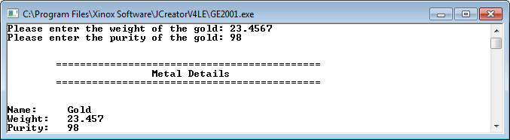

weight value gets displayed to **3 decimal places**

These 3 pieces of text take up exactly **10 spaces** in the output window

Note that there will be a few marks awarded for the use of **meaningful variable names**, having a **single and multi-line comment at the top of the program** and for **proper indentation** in the coding of the program. Make sure to use tabs and newlines where necessary also. There are about 44/45 “=” symbols in the header. Also note that you cannot just hardcode the values “Gold”, “23.457” and “98” in the output – you **must use the variables** that store those values.