**Endless Airships**

Final Game Design Document

Team 1

Nandan Das  
Shahbaz Virk  
Ynel Jon Garcia  
Yingge Liu  
Issam Anis

Jiachen Hou

DATT 2300, April 7, 2016

Index

1. Index
2. Game design……………………………………………………………………………………………
3. Summary
4. Gameplay
5. End of Game
6. Technical………………………………………………………………………………………………….
7. Rules of play
8. Mechanics
9. Dynamics/Advanced rules
10. Level design………………………………………………………………………………………………
11. Setting (pre-beta)
12. Settings (beta)
13. Objects (pre-beta)
14. Objects (beta)
15. Challenges (pre-beta)
16. Challenges (beta)
17. Development……………………………………………………………………………………………..

a. Pre-Beta

b. Beta

1. Conclusion…………………………………………………………………………………………………
2. Beta Patch Notes………………………………………………………………………………………..
3. Prototype & Ideas……………………………………………………………………………………….

a. Pre-Beta

b. Beta

Game Design

Summary

Endless Airships is an turn-based action RPG which throws players into a strange airship flying high in the clouds. On their adventure the player takes on the role of Lee, a young man who has lost most of his memories, but over the course of the game starts to pick up fragments on who he is, and what sinister events are taking place. Survival in this strange new world is dependent on gathering resources (ex. potions and stimulants), and wisely prioritizing enemies in order to come out as the victor.

Gameplay

The goal of this game is for players to survive and adventure through the environment, defeating any enemies that may try to harm them. Due to the turn-based nature of this game, attacks and heals are all carried out rotationally between the player, his companions, and the enemies. Both progression in the story and leveling up is achieved by defeating enemies and taking any loot dropped from them in order to purchase power ups.

End of Game

Each game can end in three ways, that being either victory, death or the player quitting the game.

END OF THE GAME: DEATH

* The player has lost all of his/her health, as a result of a hostile enemy attack. The player can either restart from a new game, a save file, or exist entirely.

END OF THE GAME: VICTORY

* The player has defeated all the enemies on the airship. The player can either restart from a new game, a save file, or exist entirely.

END OF THE GAME: QUITTING

* The player has decided on their personal account to quit the game. This is achieved by opening the menu and closing the application.

Technical

Rules of play

-can only be played by 1 player playing at a time

-in game companions may join the player’s group as story progresses

-combat between enemies and player group can extend from 1v1, to 3v3 (3v2 in prototype build) situations depending on how many companions the player has in their party

-player controls all actions of companions within their party

-combat is turn-based

-each encounter starts with two option: fight or escape

-failing to escape will result in the enemy having the first attack

-when it is time for the player to attack they have four options: attack, magic, guard, or use an item

-attacks act as normal damage though weapon action (ex. sword swing, or axe hit)

-magic can be either used to heal or release a alternate attacks

-guards can be used to lower or avoid damage

-the abilities of items vary from health restoration to stimulants which increase attack power

-turns are taken for each individual in combat and any one action can be taken per turn

-victory is achieved by killing all enemies on the field

-any loot dropped (like gold) can be used to trade and upgrade armors, potions, or other pick ups once outside of battle

Mechanics

The game first starts off with the player encountering a single enemy they must defeat in order to progress. The two options they initially have are to either attack the monster by using their weapons, or to use magic. Afterwards if the enemy hasn’t been defeated, it will choose to attack the player. This pattern of taking turns to determine what action is executed continues until either all the enemies are destroyed or the player’s health reaches zero. If the player survives, they receive experience points, as well as loot drops which can be used to upgrade the player’s stats and items. This encounter acts as a semi tutorial for teaching the player the basic combat, and movement mechanics.

Dynamics/Advanced Rules

While the rules and mechanics of this game seem very simple, it is the variation that can exist between every encounter that makes the gameplay far more complex. For instance there are enemies of different types who have differing amounts of health and damage output per attack. This creates a sense of tactical decision making when deciding on what action to take. Will players take down lower threat minions, and endure the damage of the larger enemy, or will they slay their largest threat first and then deal with the remaining foes? This system is even made all the more complex when factoring in the multiple companions that can be added to the player’s group in the most recent build, and both the player and enemies have a chance to miss their attacks. The result is that the player can decide to have certain companions act as either healers, or primary damage dealers depending on what enemy they are facing, and what situation they are in.

Level Design

Setting

As the name implies Endless Airships takes place in a series of different airships floating above the clouds (the prototype only takes place in one airship). While limited by the “open-world” aspect that can exist within the linear space of an airship, this game strives to reward players who go off the dirt road and take the time to further explore the environment. Enemies and sometimes allies can be found when detouring from the main route, and can either serve the player by dropping loot in the form of gold, or joining them on their adventure as a companion to their party.

Settings (Beta)

The input from the play testing lab provided many inspirations and critiques that were implemented in the beta build of this game. One of the most frequent comments was that there wasn’t enough explorable area for the RPG style of game we set out to make. This lead to the construction of additional levels and rooms where the player had much more space for interactions and battle between the environment and enemies.

Objects

Potions, stimulus and other purchasable pickups serve as the gameplay features that can have a lingering effect after battle encounters. This is because due to the inventory system any pickups bought will last until the player has decided to use or discard them.

Objects (Beta)

The beta build of the game refines this by supplying players with an expanded variety of objects to interact with. The beta also notably removes the “god weapons” that served as a way of giving players easy access to the next level during playtesting.

Challenges

The challenges faced by players are directly related to the gameplay, and what actions they decide to take. For example if a player encounters a group of three enemies, and only has one other companion, they would need to decide if dedicating the other member of the team strictly for healing would serve as a better method of battle than having two characters be constantly attacking. As mentioned before prioritizing targets also can prove to be challenges in their own right. Deciding who to attack first, while micro-managing and entire party as to what the best route is to keep everyone alive, while destroying the other team's defenses challenge players to make tactical decisions even before the first attack is made.

Challenges (Beta)

This primary focus on the challenge being solely directed through gameplay stayed true to the beta build. However, the feedback from play testing resulted in us fine-tuning the combat interactions that took place. Many of the play testers acknowledged that the emphasis on the frequency and mass use of potions didn’t come off as very apparent in the tutorial and actual gameplay. Combined with the massive health of some of the more powerful enemy bosses, play testers felt they were at an unfair disadvantage and that the difficulty curve in progression was far too high. In order to remedy this, the current build of Endless Airships has a much more lenient and forgiving combat system.

Development

Pre-Beta

Initially the plot of Endless Airships was to be very different than what was finally presented in the prototype. This was because our original conception of the game was to be very high-fantasy, and focus more of an importance on the plot and use time travel as both a game mechanic and plot device. Akin to the film Groundhog Day, the player would have originally found himself waking up in an open field, having little to no memory of who they were, and what was going on. While some of these aspects didn’t make it to the final prototype, the humor initially envisioned still stayed prominent in the current build. A great example of this would be the comedic dialogue exchanges between the Lee and the other NPCs, and even at times some of the enemies. The result of this was a build of the game that stayed true to the meta humor, and self aware mocking of the common tropes found in many RPGs.

However, while the plot and humor remained mostly intact, the environmental design and art direction took a totally different shift. This, was very much due to the time constraints and availability of teams members who would be able to dedicate hours to painting the environmental backdrops as well as character design. Though pieces were created during the initial conception phase as well as work for character design, the vast difference in art style from the drawings to the game engine assets, were agreed upon by the group as something that took away from the overall experience of the game. As a result in our prototype build there is a greater reliance on the assets provided by the game engine.

Before the start of playtesting there were some final ideas made by the team when discussing what steps should be taken when improving upon the prototype. Prominent health bars on targeted enemies, and conveying the message that this game relies heavily on the use of powerups were both ideas that were brought up during final talks.The reasoning behind this was that when team members who hadn’t yet played the build tested it out, they were left feeling somewhat taken back by the difficulty curve. If these responses are proven not to be only outliers during the much larger classroom playtesting session, these issues will have to be addressed and fixed when making a final build.

Beta

The beta version of Endless Airships has come a long way in both the overall game design, and actual gameplay it contains. Many of the concerns initially expressed by the team during the production of the pre-beta was validated further in the play testing phase. This time to showcase our project to other members of the class proved the most influential as it yielded critical input to direct changes that were implemented in both the progression, level design, and character interactions in the final game build. As a result there was massive reworking of several systems in the game to accommodate for the player feedback we received, however our original vision in terms of game mechanics, and rules managed to stay primarily the same from our original conception all the way to the latest version.

The first major change the team had to implement was to the actual environments and game levels. This was because an astounding amount of play testers thought that our original pre-beta build lacked the scope that was usually attributed to a RPG. This in and of itself raised several creative differences within the team. Since our environmental setting was the sky (hence the name Endless Airships), a debate arose over whether the additional levels should diverge from the consistent backdrop of clouds in favour of having more diversity in the aesthetic portion of level design. In the end, we sectioned off the map into two different categories; those being interior, and outside. The majority of the outside levels were what was offered in the pre-beta that was available for all play-testers. The new levels however acted as both an expansion of the game, as well as a tool for tackling other concerns we experienced.

The first of these concerns revolved around the flow of the game. This was something that was also mentioned by play-testers as the trigger that progressed the player into the next stage was all the vertical squares that composed all the outer edges of each level. This was remedied in the beta as now each trigger is designated with a circular marking to show player exactly where each trigger lied. Along with this to further streamline game flow and progression, the player cannot backtrack at certain points in pivotal moments that further progress the story and plot. The largest example of this would be that once the player reaches the dragon statue, they will no longer be able to return to the previous level. As a result those who took the time to explore, collect and level up will expect a boss fight that is more manageable, while those who simply rushed though the game without any potions or companions will come across a harder battle.

The combat experience itself was actually something that underwent a heavy amount of change. As mentioned before team members who hadn’t yet already played the game in pre-beta were taken back by the steep difficulty curve. Likewise, many of our classmates and play-tester also expressed this as the first major fight located at the dragon statue was in their eyes far too difficult in the natural progress we had laid out. In response to this feedback two major changes were made. The first was the refinement of the battle system, as certain actions like using a shield of a defender being equipped. The other was the addition of a completely new companion called Joseph. Joseph serves both as a means of making battle encounters more manageable (as he levels up, can equip certain weapons and magic, and can be a third member of the player’s party), and as a means for story progression and plot. He in many ways symbolizes all the new changes that are present in the beta that wasn’t available in prior versions of Endless Airships. This is because he can only he found in a new portion of the map that is now explorable, and the means in which the player arrives to him is through battle encounters with new enemies and puzzles that were created by the input and critiques we received in order to add more diversity and overall enjoyment to the game experience.

Conclusion

Pre-Beta

In many regards this Endless Airships proved to be quite an enjoyable challenge. Creatively speaking, many individuals from the group pitched in some great ideas during the conception phase, and continued to build and expand upon those ideas during the remaining five weeks. However as time progressed it seem that many of our ambitions for the prototype proved to be too high as a lot of us were hit with other obligations from both within and outside of school. As a result we as a team had to reevaluate what was now possible with the limited time and resources available. This proved to be a great motivation at the end however, as this crunch time resulted in the incentive and work ethic we needed as a team to not only fulfill our individual tasks, but to also help and cooperate with others when they needed the assistance. Because of this, our team ultimately came out stronger than how we initially entered, due to our ability to take constructive criticism, and work together in this team building exercise.

Beta

Looking back the road that lead to the final version of Endless Airships was by no means a purely easy experience. There were many times where addressing certain issues and settling creative differences got to be a handful for our team. With many of us having no prior knowledge in developing games, writing code, or a clue as to how a game engine worked, it was the distribution of roles in the group and the work ethic of individuals that proved to be our biggest asset as well as our hardest challenge as time progressed. As mentioned before the conception of this game to where we now find it now, has in many ways been vastly changed time and time again by the resources and availability of our team members. This was a challenge that became increasingly more apparent as we reached the April 7th deadline.

Writers and concept artists now found themselves with little work to do, as the programmers and level design members were hard at work refiguring our game based on what input we received from play-testing. Exams, and essays as well as outside of school obligations once again appeared and further limited the time each member had to pledge to working on this project. Along with this, late additions to the team and troubles with game file sharing also made it very difficult when it came for everyone to stay updated on the most recent changes. However eventually like before, in the final moments we had left to work on this project, the crunch and desire to finish on time to met the deadline resulted in the last push we needed to finish the beta build.

When the final adjustments to the technical side of development was completed, the members who had been left to stare in the sidelines once again had jobs that needed to be done. Proofreading, adjusting options for the dialogue branching, and cataloging the weekly progressions in every build finally gave some of the more inexperienced members of the team (experienced in terms of game development) positions that wouldn’t have been open due to how the production of our game functioned. The dependence on shifted to the other half of the team to fulfill their roles in a timely manner. With communications between both sides of the team being at an all time high, we managed to finally put together a product that was made stronger by the sum of its parts.

In the end, Endless Airships turned out to be what we hope is a game made better by the feedback, co-operation, and general passion in games that this group had. While it probably won’t beat out Breath of the Wild for game of the year, it was in many ways a project that was rewarding in it’s own rights. The comradery, and genuine interest put forward by everyone in this team was made all the more satisfying when the challenges put before us in this game seemed to be at times impossible to pass. However, whether it may be trying to explore different levels without totally ignoring our desired aesthetic, or coming up with a method to readjust our difficulty curve, we always found a way to work together and put aside our clashing ideas in order to better construct the game we set out to make.

Beta Patch Notes

(patch notes include what was changed from the play-test build)

-added prison level

-added interior level

-added fire caldrons/ health restoration points

-added chests

-added chest traps

-added clock puzzle

-added axe

-added Joseph companion

-added visible room progression triggers

-added branching dialogue options

-added confirmation option at dragon statue

-adjusted damage from shield equipped defender

-increased enemy variety

-increased party size

-player cannot back travel at certain points

-fixed grammar and error in NPCs

-removed god weapons

Prototypes & Ideas

Pre-Beta

The following pages are scraped enemy designs, as well as one digitally colorized landscape concept form early development.

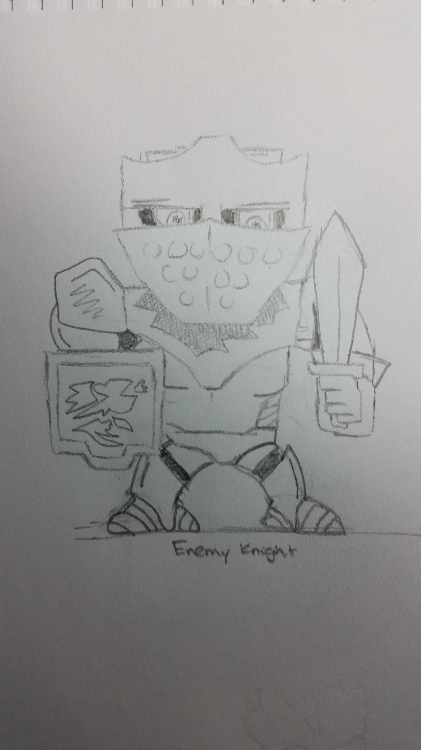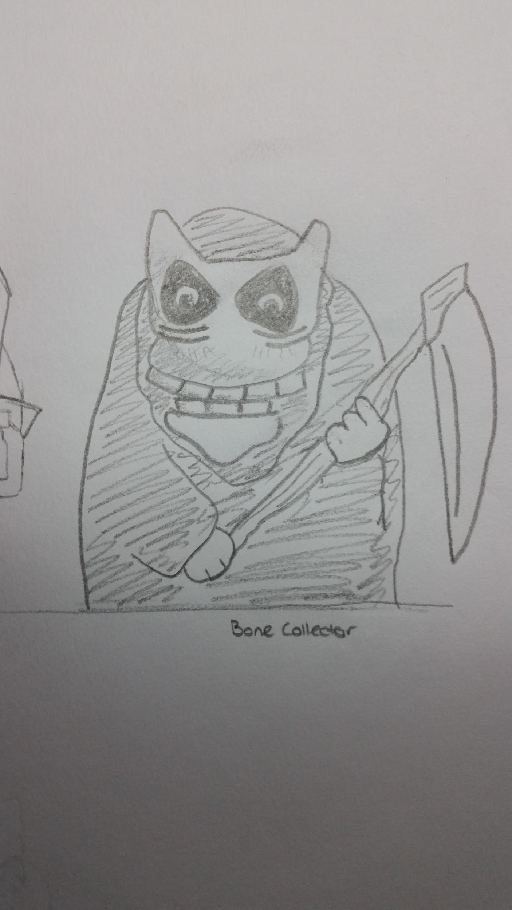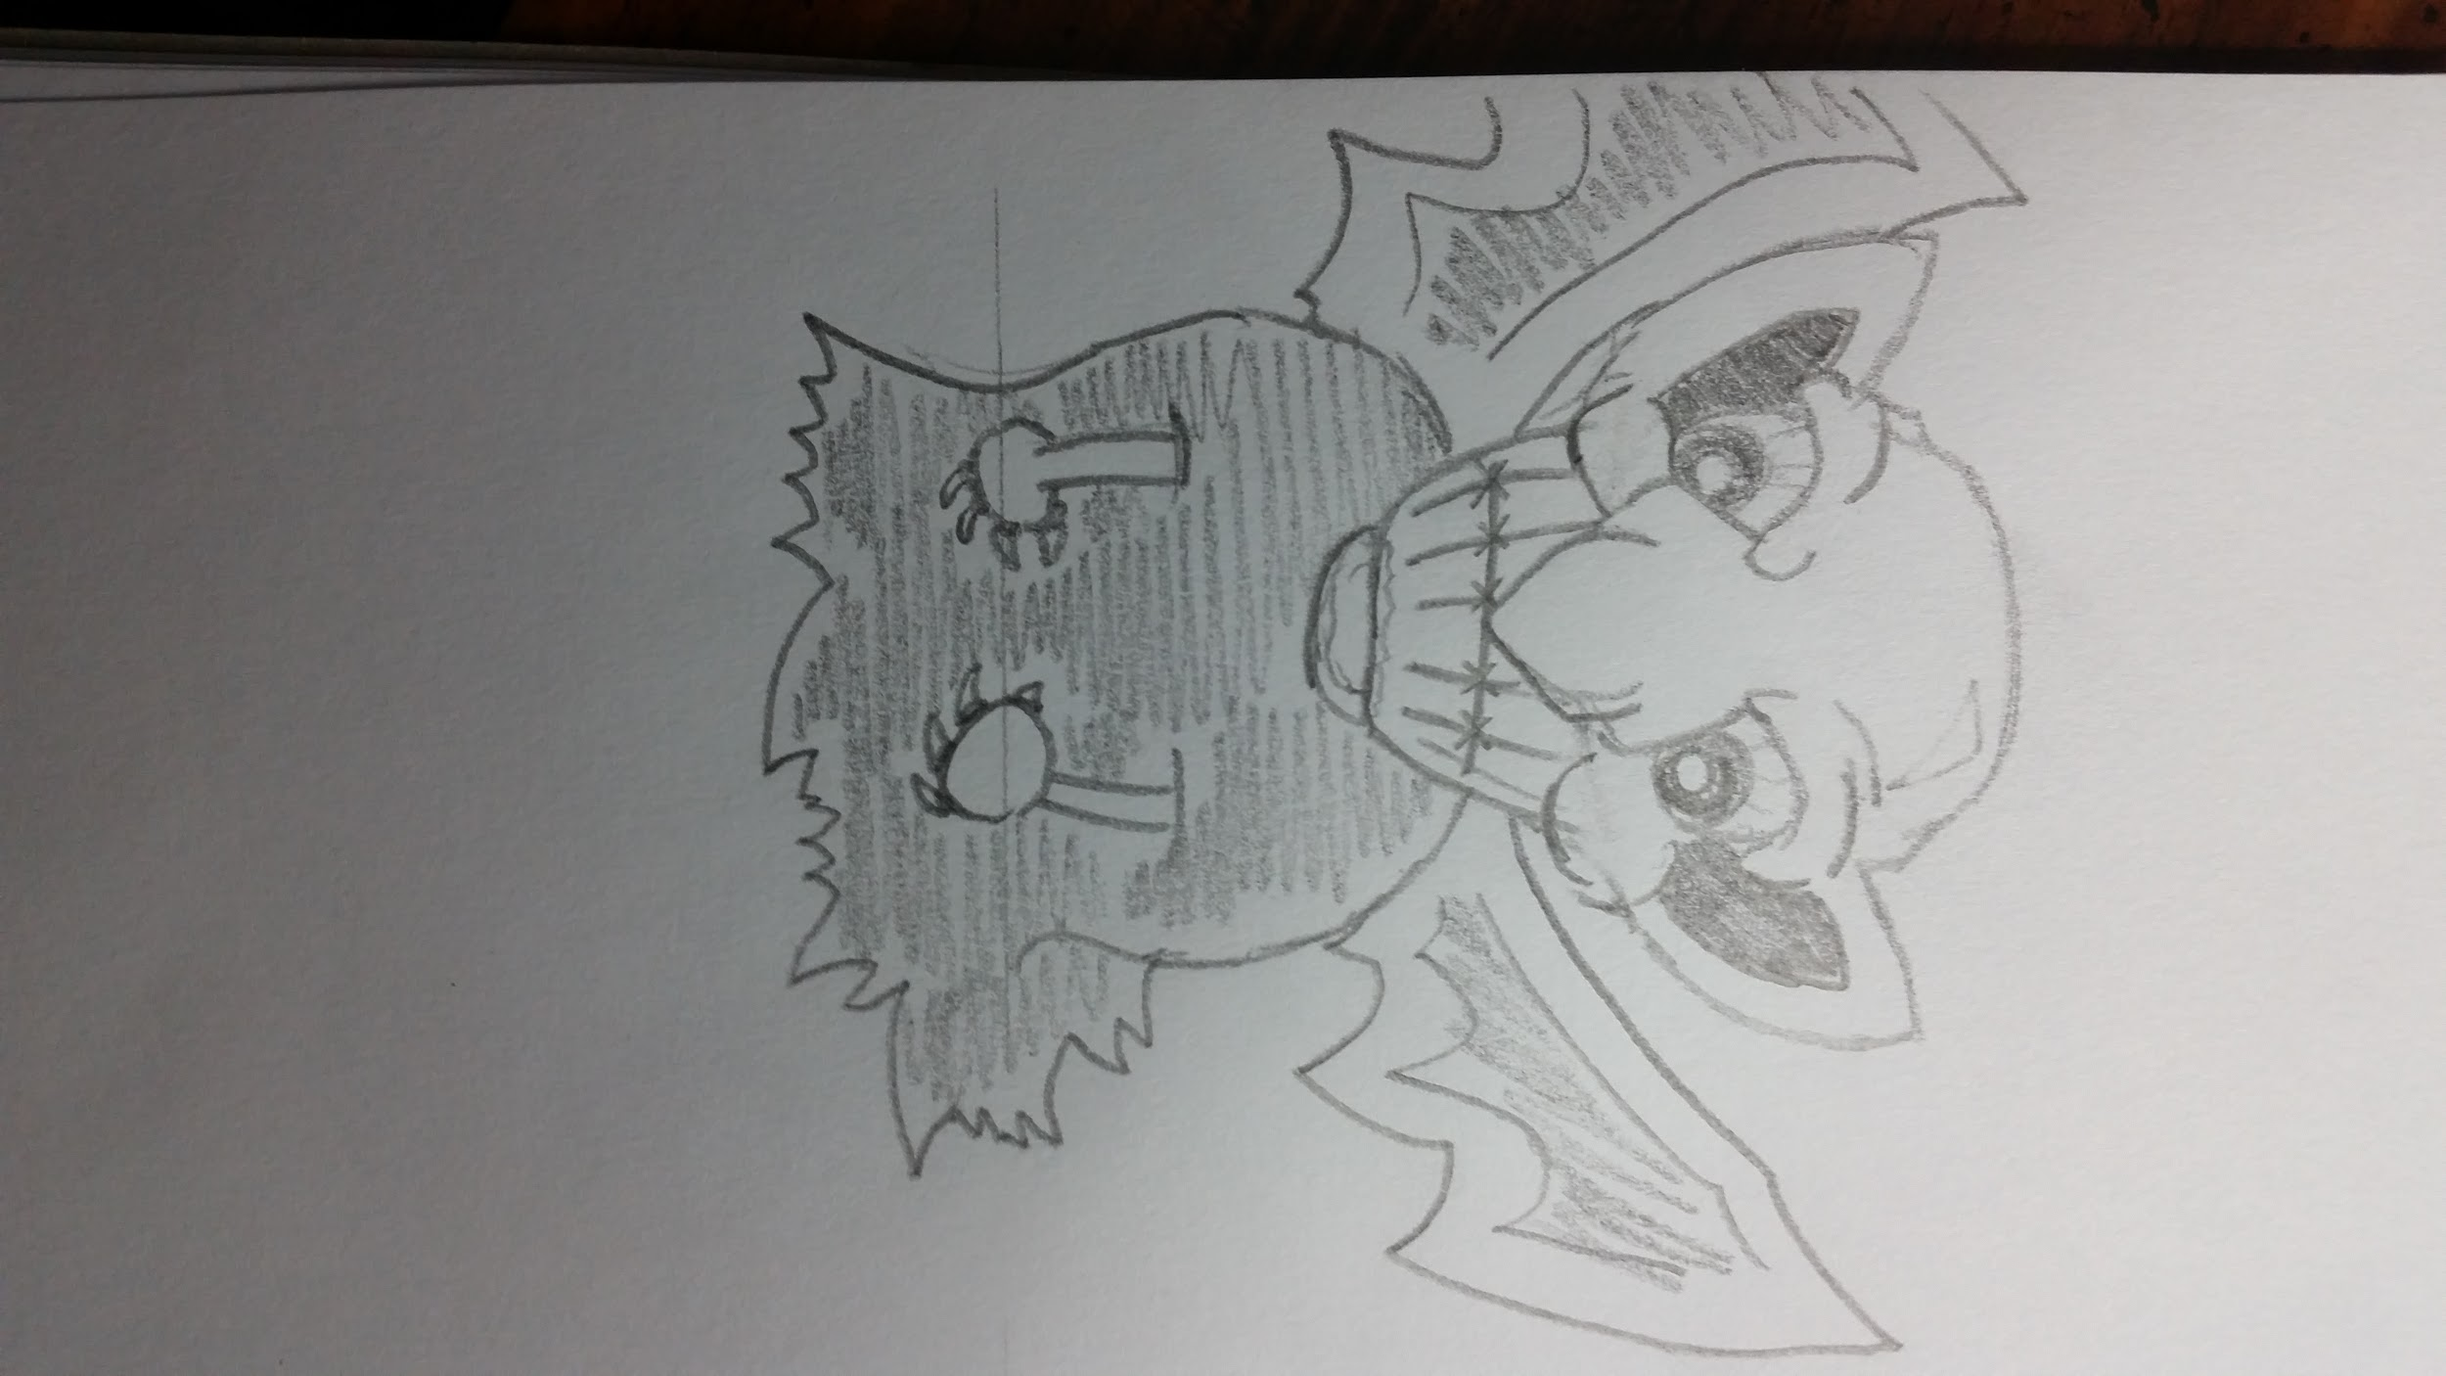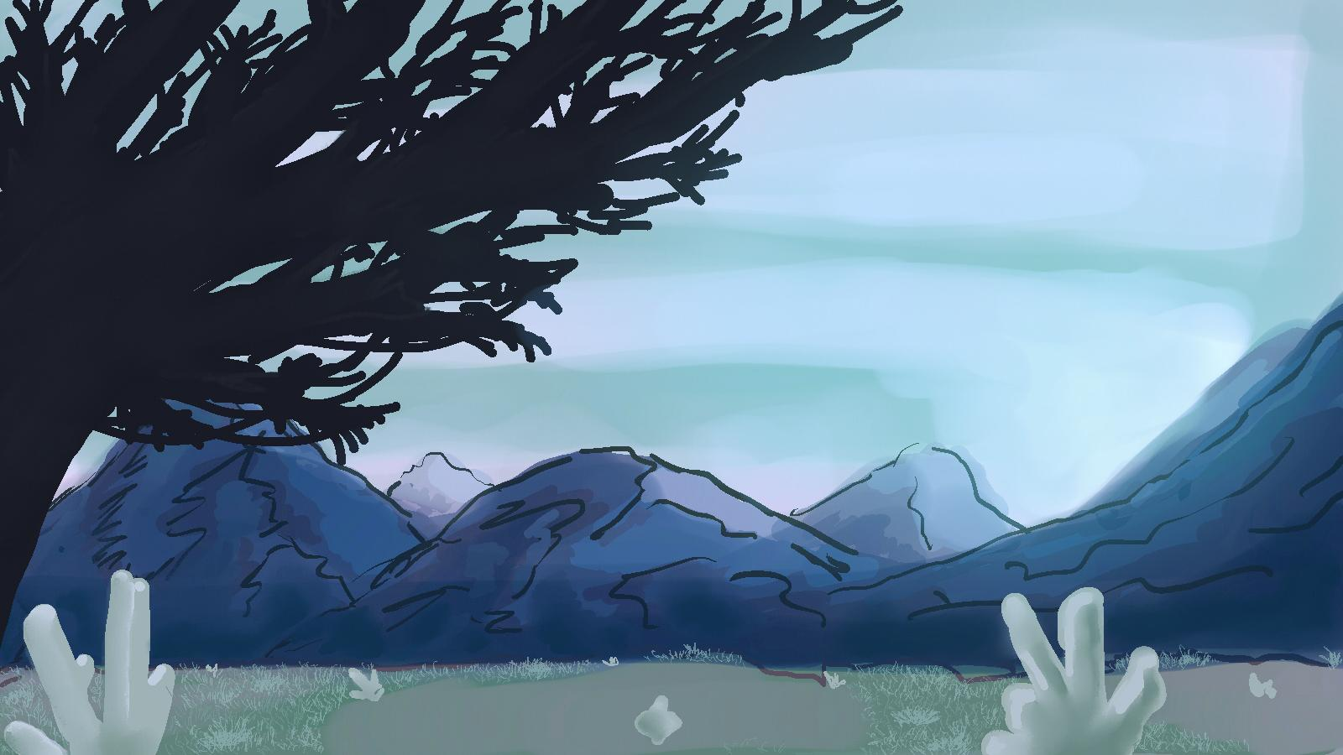

Beta

The following is screencaptures of the additional levels added to the game in the beta build.

