Architecture Diagram
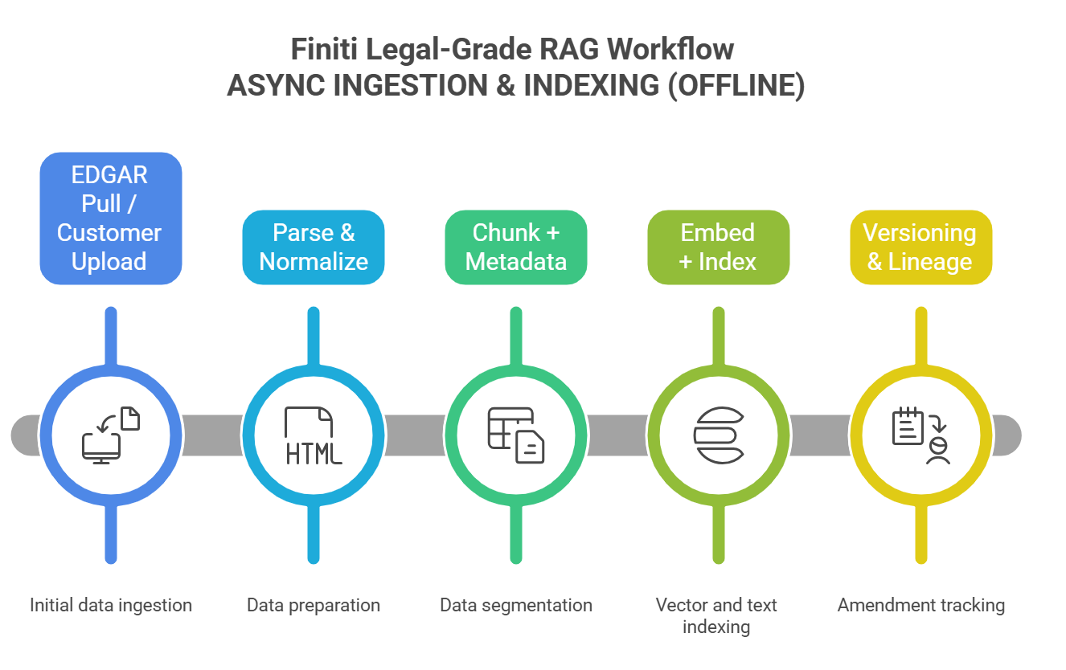

LANE 1 — ASYNC INGESTION & INDEXING (OFFLINE)
- EDGAR Pull / Customer Upload
  - idempotency_key = tenant_id + filing_version_id
- Parse & Normalize
  - inputs: HTML / PDF / XBRL (table-aware extraction; OCR if needed)
- Chunk + Metadata
  - paragraph/table chunks
  - metadata: section_key, filing_type, period_end, company_id, peer tags
  - span pointers: char_start/char_end (and page/bbox if PDF)
- Embed + Index
  - embeddings (vector index) + BM25/full-text index
  - filters: section_key, filing_type, period_end, company_id, peer_set_id
- Versioning & Lineage
  - amendment chain via superseded_by_id (e.g., 10-K → 10-K/A)
  - replay roots: stable references to source artifacts

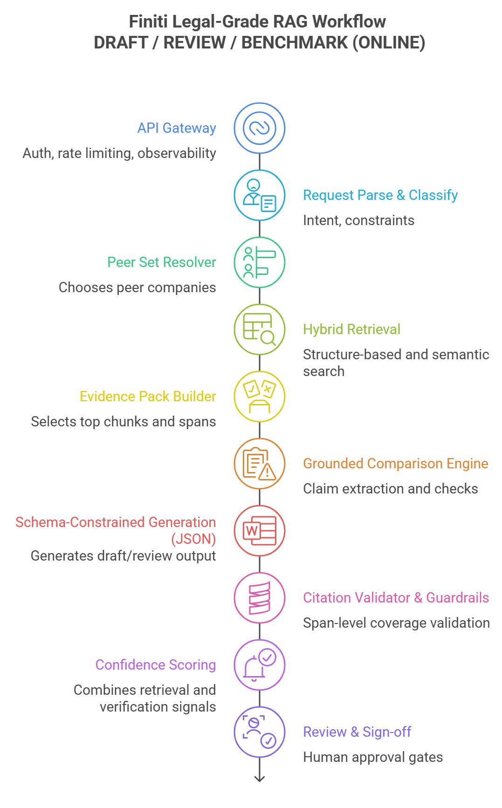

LANE 2 — ONLINE DRAFT / REVIEW / BENCHMARK (REQUEST-TIME)
- API Gateway
  - auth, rate limiting, observability (tracing + metrics)
- Request Parse & Classify
  - intent: draft / review / benchmark
  - constraints: section_key, period window, filing_type, tone/format rules
- Peer Set Resolver
  - chooses peer companies using rules/manual selection
  - stores audit reason + configuration
- Hybrid Retrieval
  - structure-based section matching (Item alignment)
  - BM25 keyword search + vector semantic search
  - pre-filters: section_key, filing_type, period_end, peer_set
- Evidence Pack Builder
  - selects top chunks + spans + relevance scores
  - includes doc metadata and version references
- Grounded Comparison Engine
  - claim extraction: split text into atomic factual claims
  - deterministic checks: numbers/dates/units/period alignment
  - contradiction detection: flag conflicting evidence
  - outputs structured findings + required citations per claim
- Schema-Constrained Generation (JSON)
  - generates draft/review output using a strict JSON schema
  - rule: each claim must cite >= 1 span (chunk_id + start/end)
- Citation Validator & Guardrails
  - span-level coverage validation
  - block/flag: UNSUPPORTED_CLAIM, CONTRADICTED, AMBIGUOUS, OUTDATED_SOURCE
  - prompt-injection hardening: retrieved text treated as untrusted data
- Confidence Scoring
  - combines: retrieval score + rerank score + citation coverage + verifier signals
  - returns calibrated score or qualitative label (High/Med/Low)
- Review & Sign-off
- human approval gates; export controls
- Output
- JSON + HTML report (benchmarks + citations + issues)

CROSS-CUTTING

Audit & Reproducibility
- Append-only audit log with tamper-evident hash chain (tenant-scoped)
- Every step logs:
  - retrieval_trace (queries, filters, scores, chosen chunks)
  - model_config (model name, temperature, safety settings)
  - prompt_version (template + variables)
  - outputs + edits + exports
- workflow_runs enable full replay for any draft/review decision

Reliability & Operations
- Workflow engine / state machine for step transitions
- retries with exponential backoff
- DLQ for failed jobs after N retries (triage + replay)
- key SLOs: P95 latency, cost per draft, DLQ rate, citation coverage %, unsupported claim rate

