CSCI3320

Assignment 0

Chim Ka Long 1155094482

Environment:

Debian Linux 9

Python 3.5.3

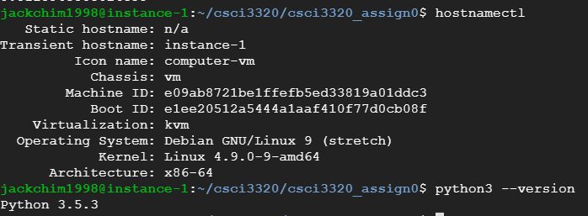

**Problem 1:**

Process:

Before processing, I check there are total 3 classes. Then I split the 3000 training points into train set (2400) and test set (600) without shuffle.

The prior value is calculated as n_i/N, where n_i is the number of points belong to class i and N is total number of points.

The estimated_p is calculated as the following MLE formula, be noticed that X contains training point belong to class i only.

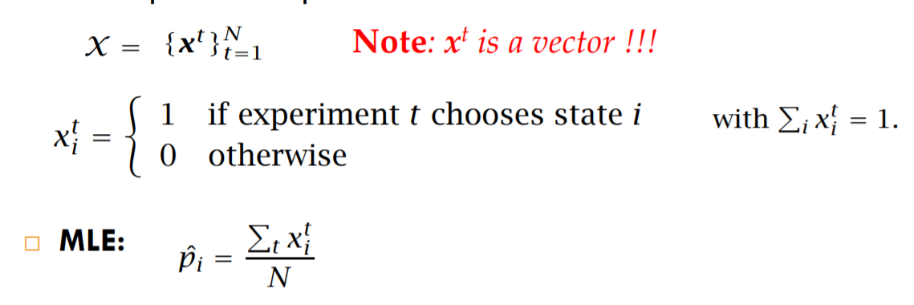

The discriminant function is defined as the following equation.

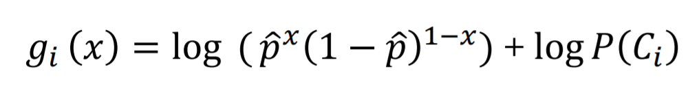

Be noticed that we have only two input value 0 or 1. For each value, we will create 3 discriminant functions and choose the highest one. As a result, our prediction results only have 2 possibility class 1 or 2. Therefore the precision of class 3 will be undefined which is the result of dividing 0.

The f1_score function in sklearn treat the undefined precision as 0 by default and the f1_score of class 3 become 0. The disadvantage of this setting is that we can’t know there is undefined value by only observing f1_score. The advantage is we can still get average f1_score by treating f1_score of class as 0.

Be noticed that the columns of confusion matrix is predication and the rows are truth.

Result:

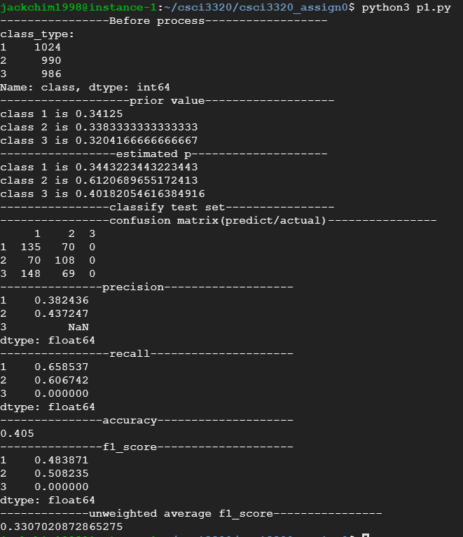

**Problem 2:**

Process:

The estimate parameters are following these equations

The whole process is similar as Problem 1.

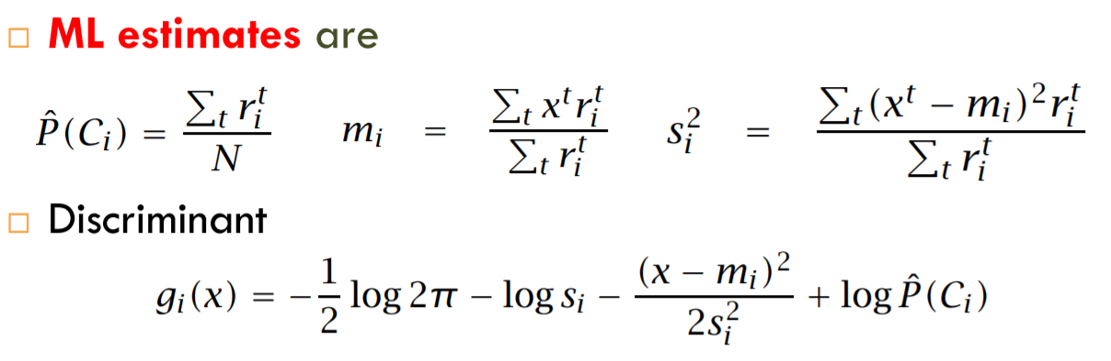

Result:

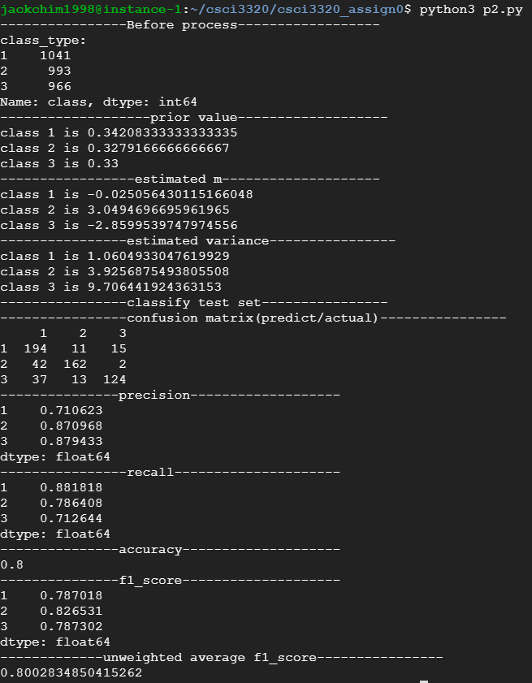

**Problem 3:**

The estimate parameters are following these equations

The whole process is similar as Problem 2.

The data type of estimated values are stored as Numpy array, since it is convenient to use Numpy to implement matrix calculation

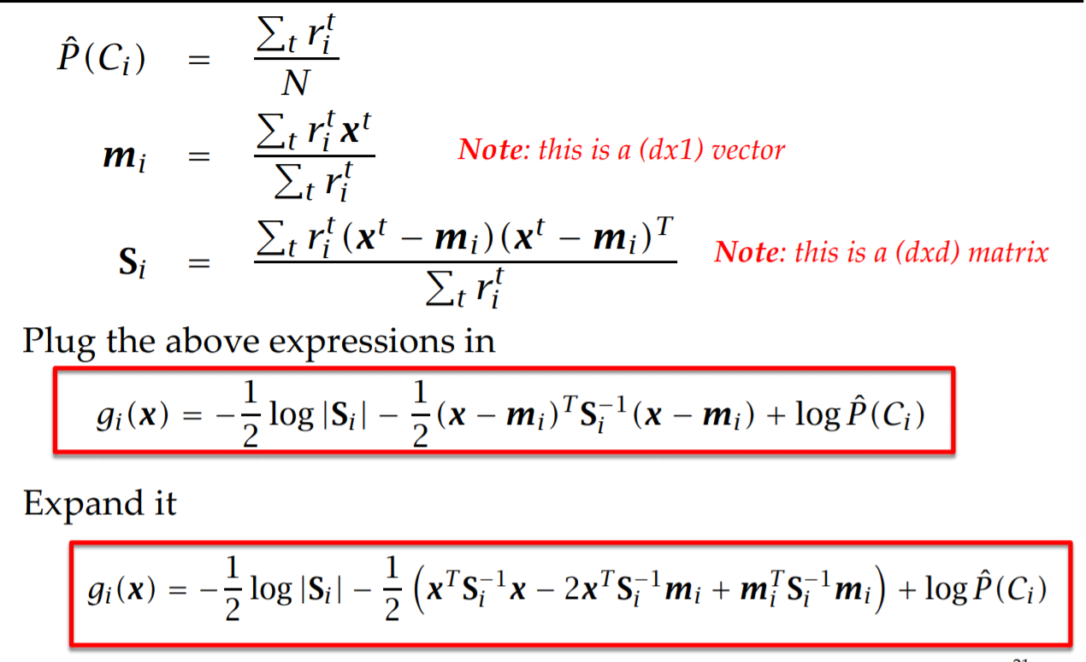

Result:

