Name: Chim ka long

SID: 1155094482

Assignment 2

1). Train ():  
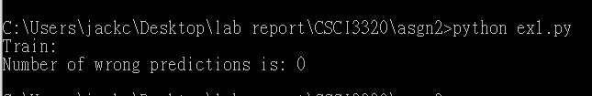

Train_matrix():

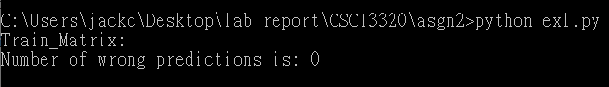

I test 5 times for train() and train_matrix() respectively. All of them have 0 wrong predictions.

2). For max_depth = 3 :



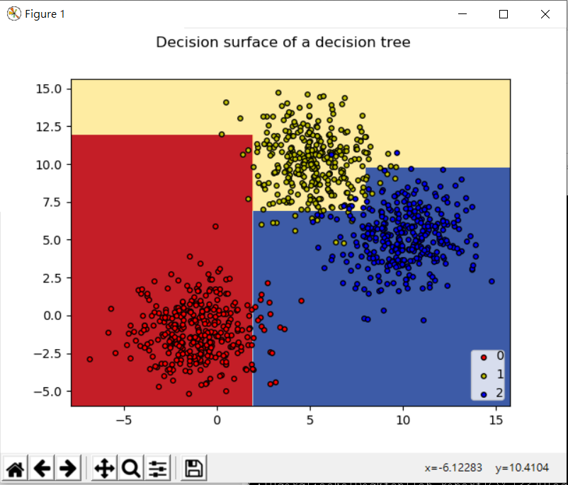

For max_depth = 5:



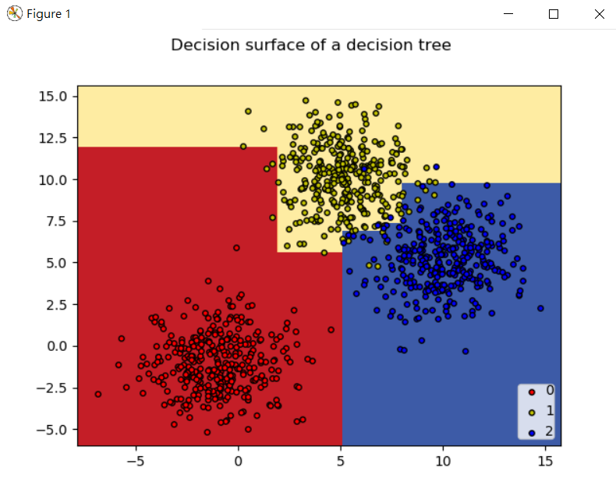

For max_depth = 7:



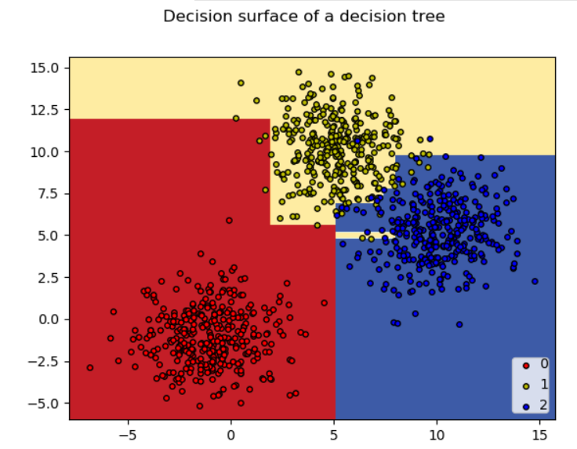

|  |  |  |  |
| --- | --- | --- | --- |
| Max_depth | 3 | 5 | 7 |
| Number of wrong prediction | 18 | 9 | 10 |

From figure, we can see decision tree classify more regions detail. However, the error is minimum when maximum depth is 5, due to bias-variance dilemma. Very high complexity can decrease error in train set but may increase error in test set.

When we compare the difference between figures of max_depth = 5, 7.

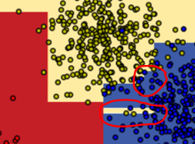 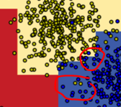

There is small yellow area surrounded by large blue area, because model of high complexity is sensitive to those outlier points in train set. However, those small area may wrongly classify points in test set.

Enviroment:

Python 3.5.3

Package Version

--------------- ------------

imageio 2.8.0

kiwisolver 1.1.0

matplotlib 3.0.3

numpy 1.18.2

Pillow 7.0.0

pip 20.0.2

scikit-learn 0.22.2.post1

scipy 1.4.1