**5JAM Assignment Part 3**

**Jack Church**

Contents

Additions: 2

Add 3 more number for a total of 4 numbers: 2

Error adding nothing and then a duplicate: 3

Error, add the 5th number then attempt to add a 5th number: 4

Deletion 1: 5

Deletion 2: 6

Deletion 3: 7

Return to main screen after deletion 3: 8

Deletion with debugging: 9

ButtonDeleteOnClickHandler 17

ButtonAddNewOnClickHandler 18

# Additions:

## Add 3 more number for a total of 4 numbers:

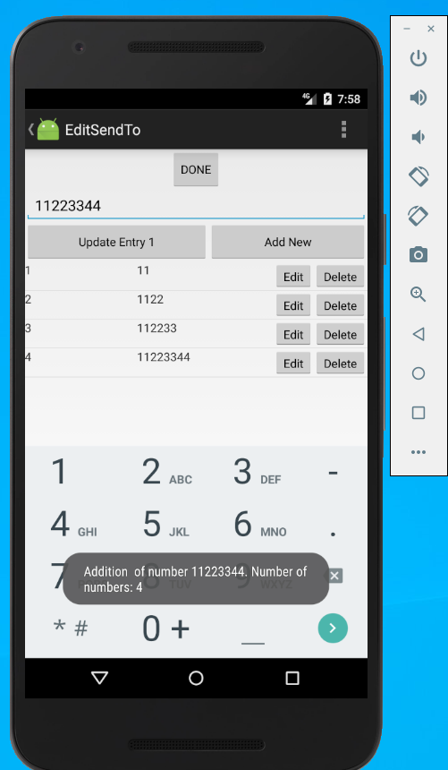

Error adding nothing and then a duplicate:

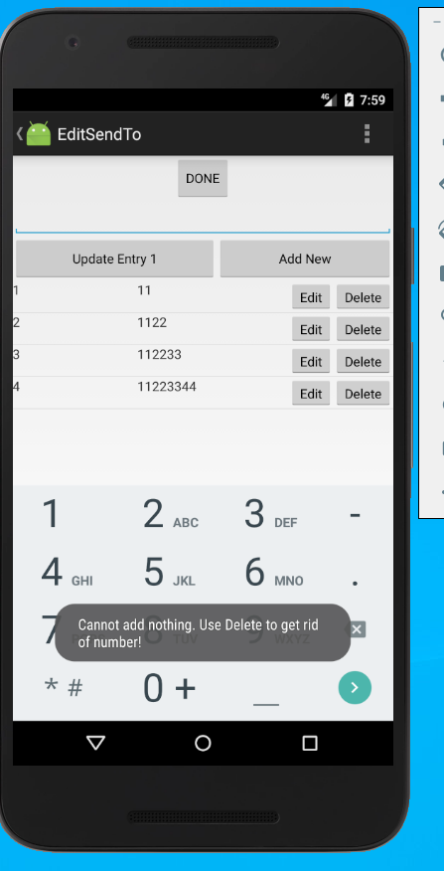 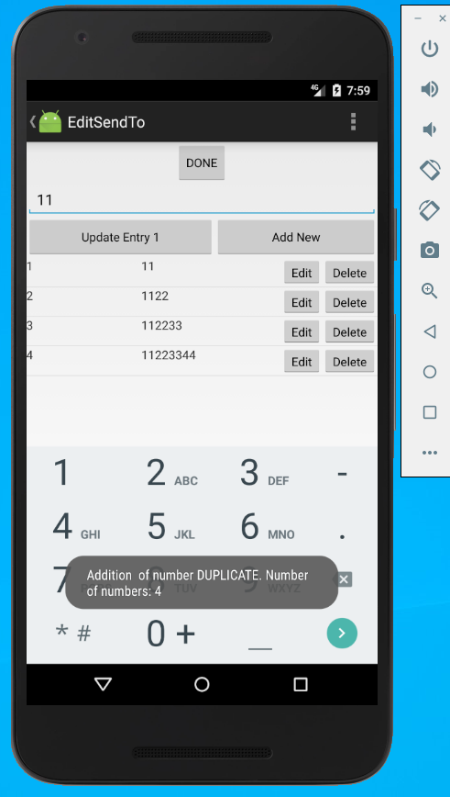

## Error, add the 5th number then attempt to add a 5th number:

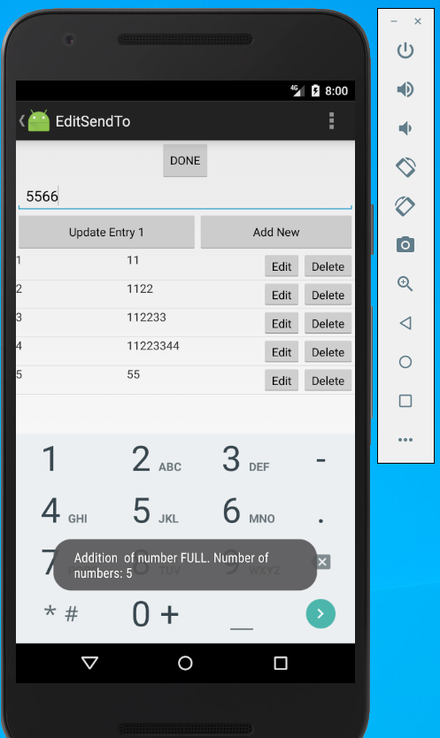

# Deletion 1:

Successful usage of the “Delete” button with at least 4 items in the list and showing the third item as selected then deleting the first item.

Before: After:

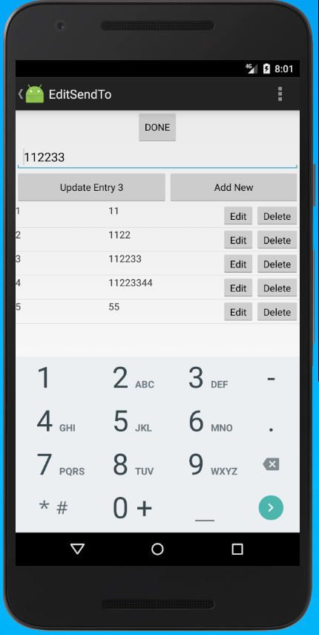 \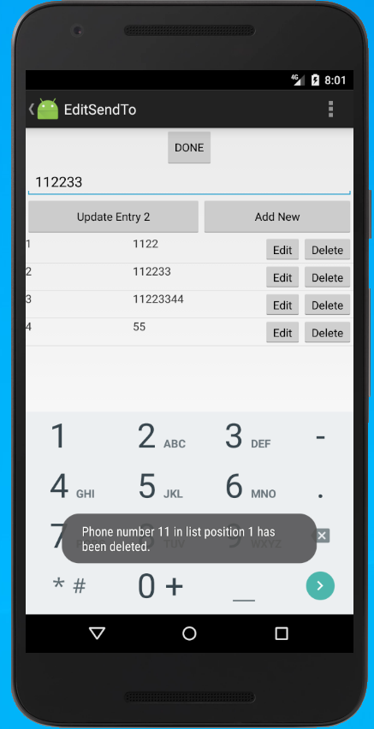

# Deletion 2:

Successful usage of the “Delete” button with at least 4 items in the list and showing the third item as selected then deleting the last item.

Before: After:

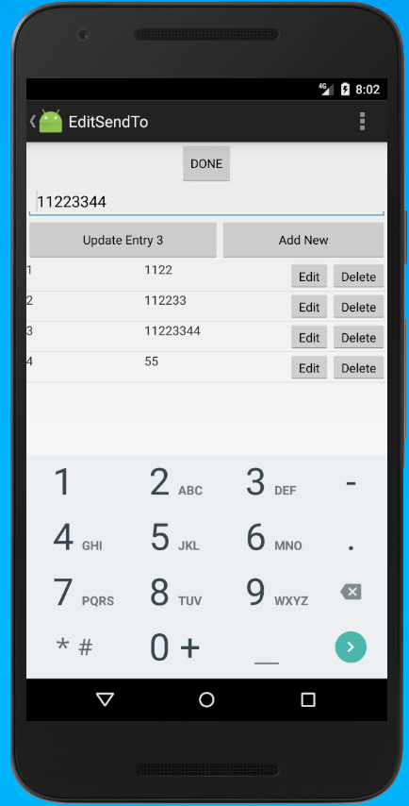 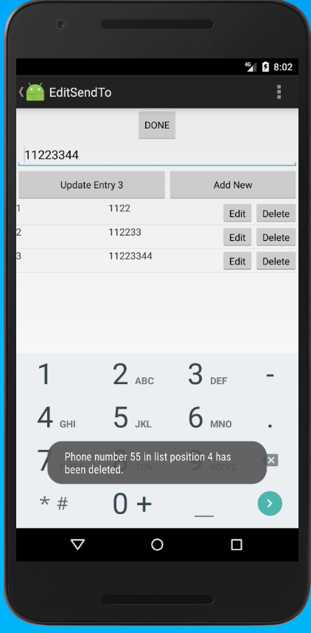

# Deletion 3:

Repopulate with 4 fresh numbers:

Successful usage of the “Delete” button with at least 4 items in the list and showing the third item as selected then deleting the third item.

Before: After:

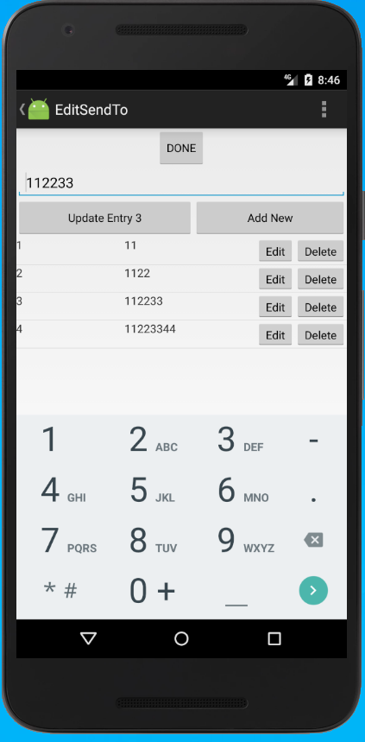 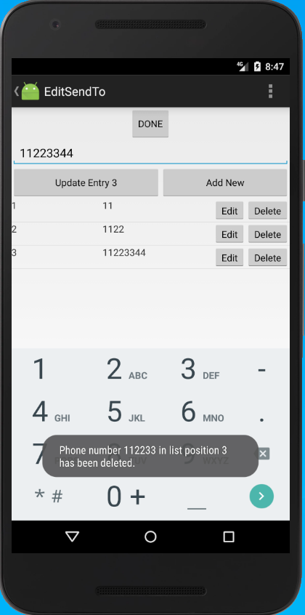

## Return to main screen after deletion 3:

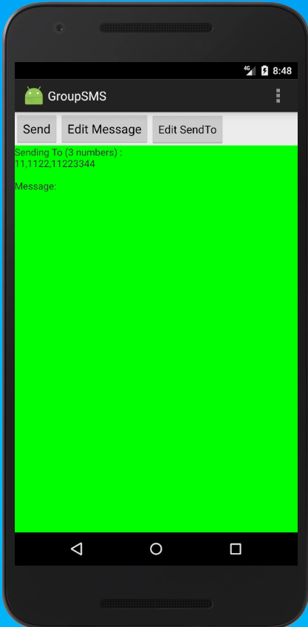

Deletion with debugging: Repeat the last deletion exercise with debug turned on in Android Studio: Successful usage of the “Delete” button with at least 4 items in the list and showing the third item as selected then deleting the third item. 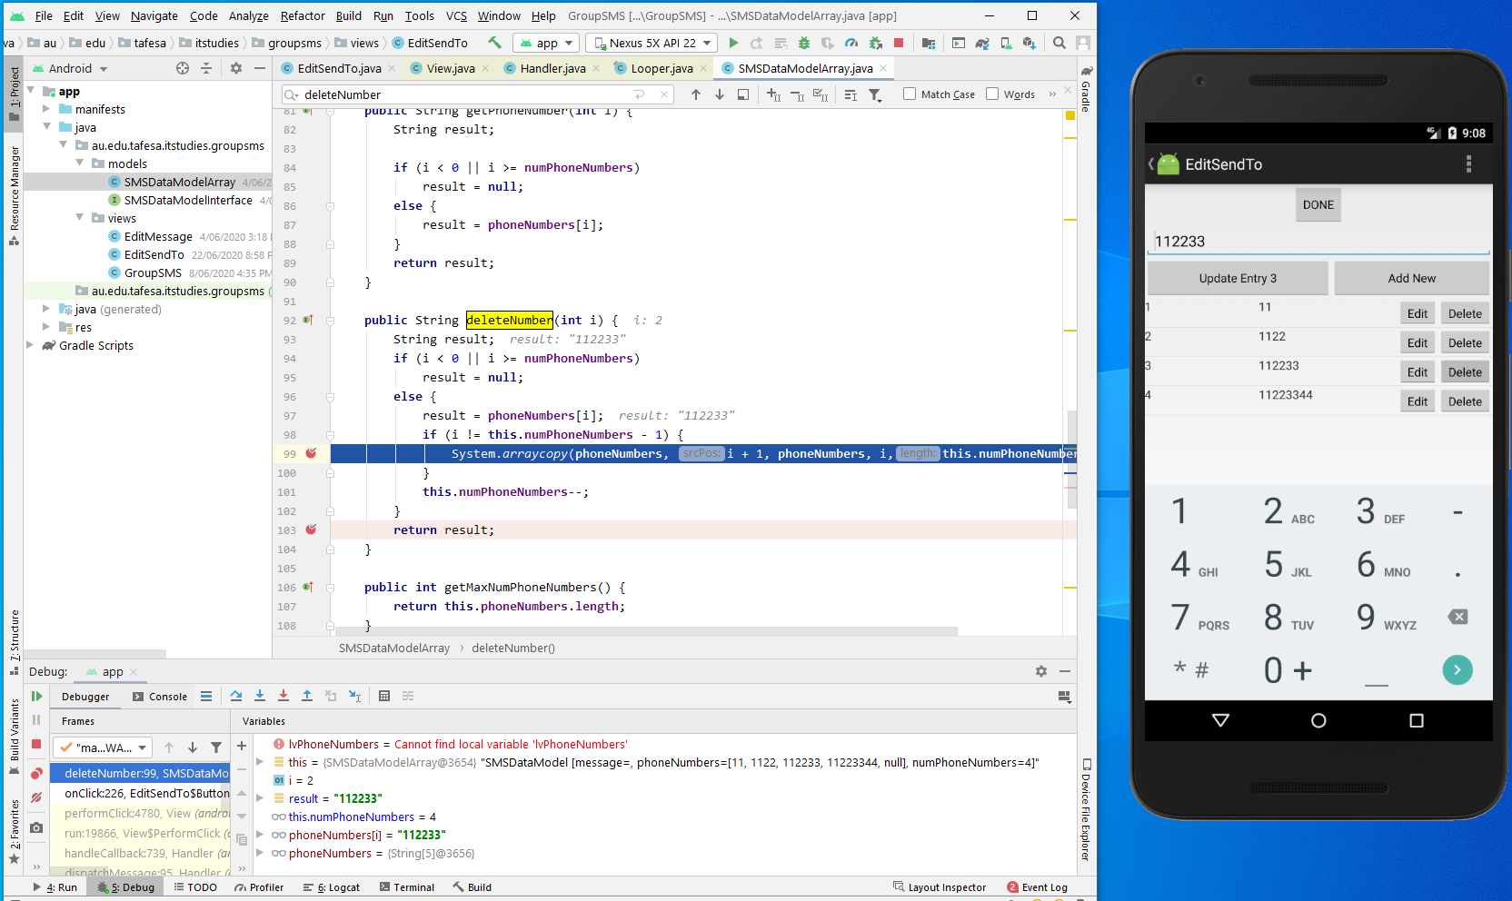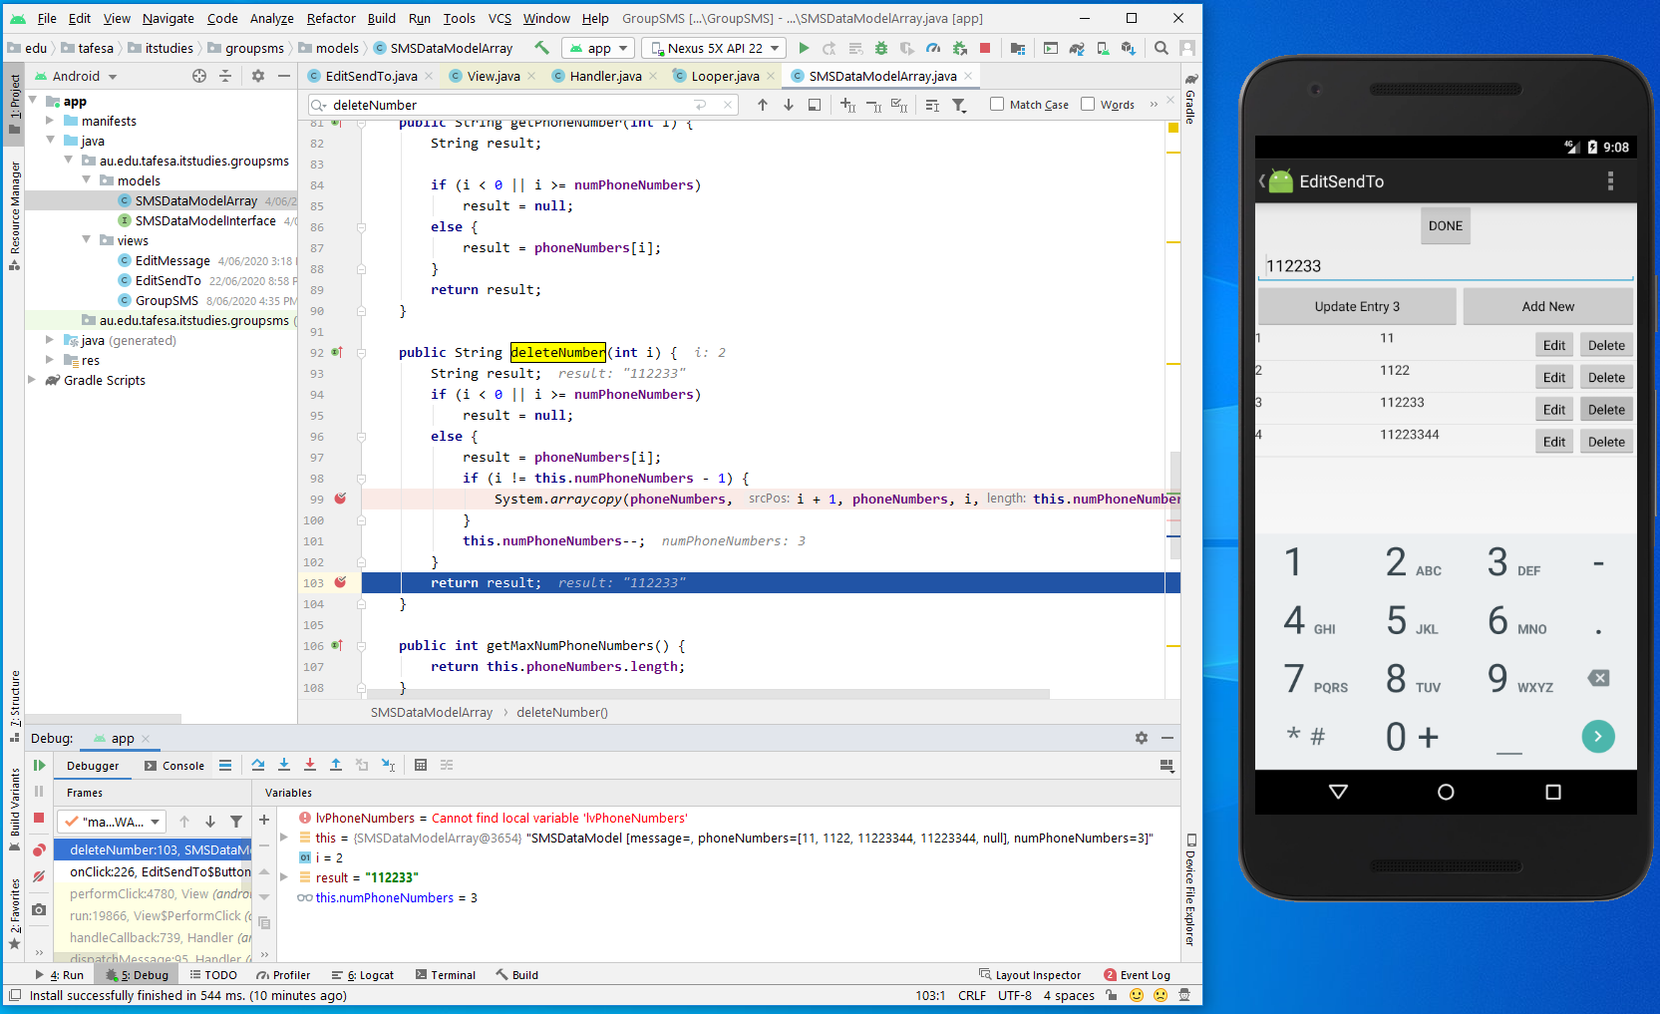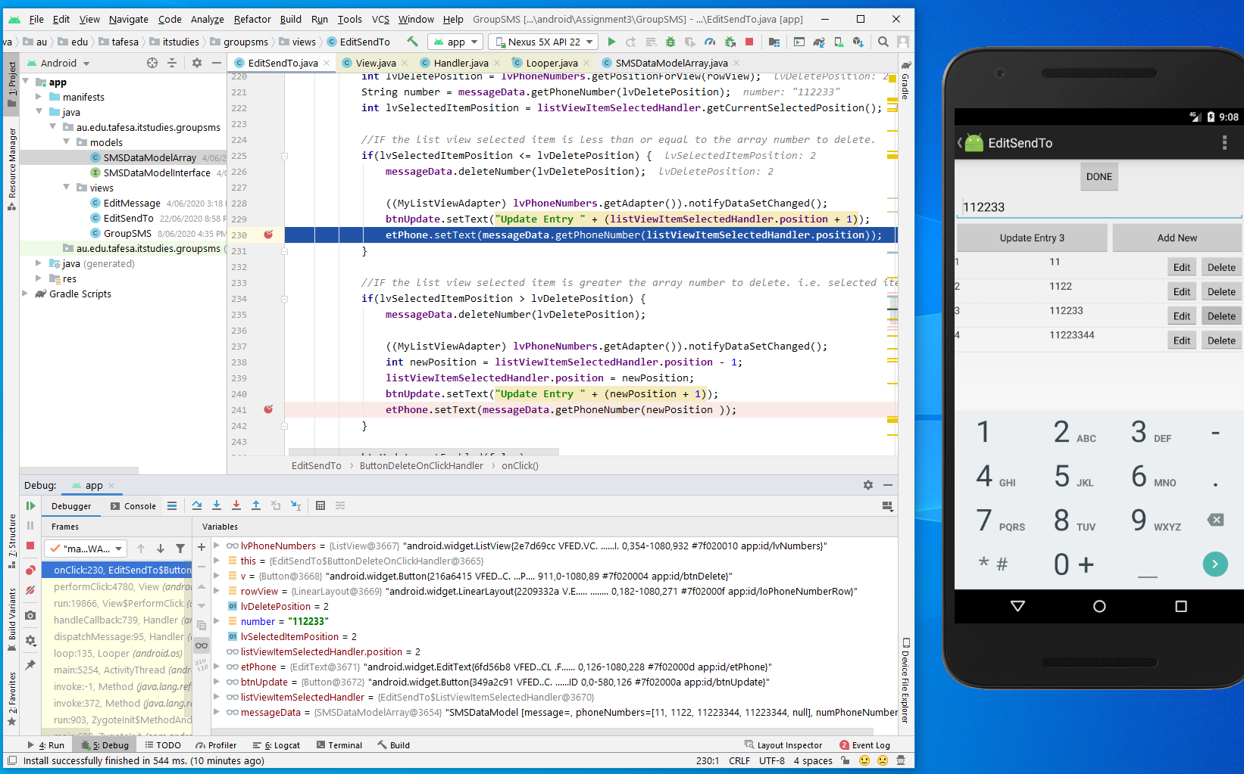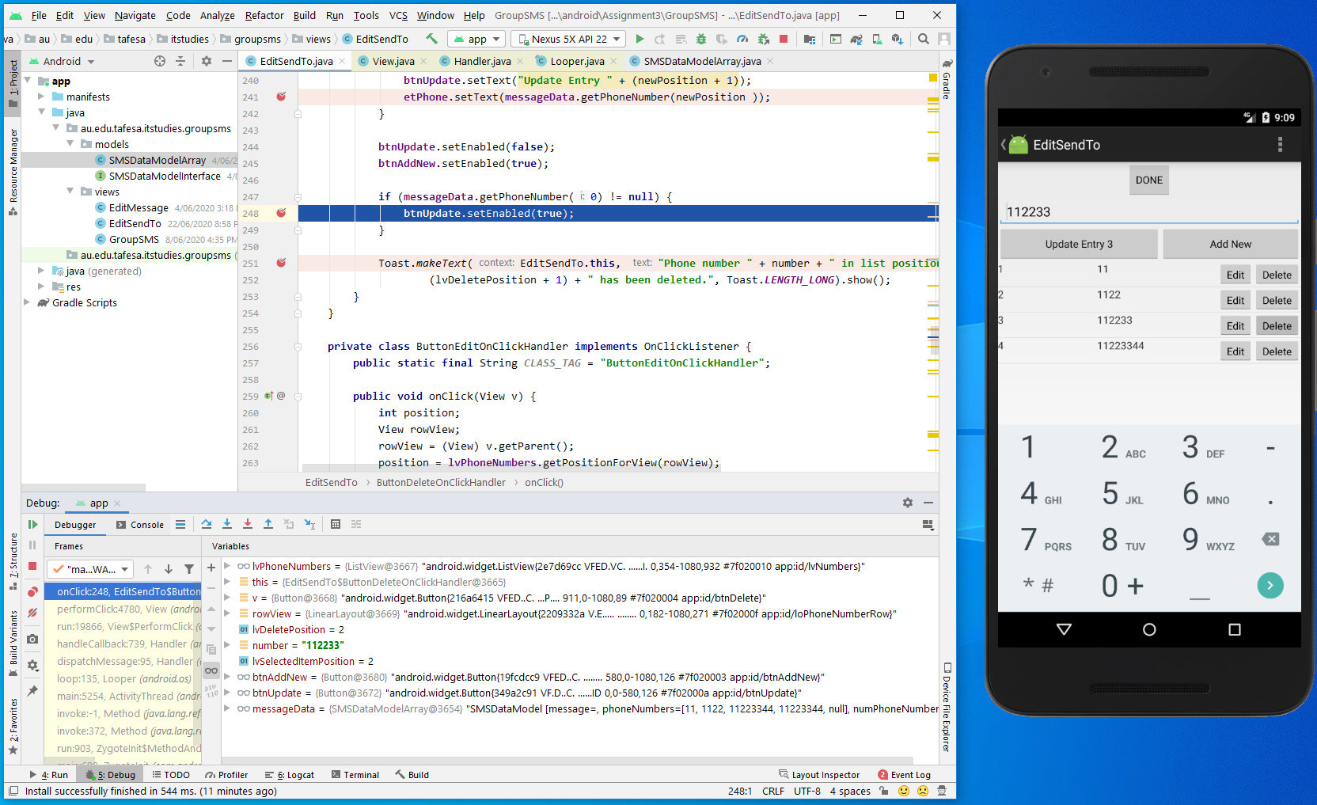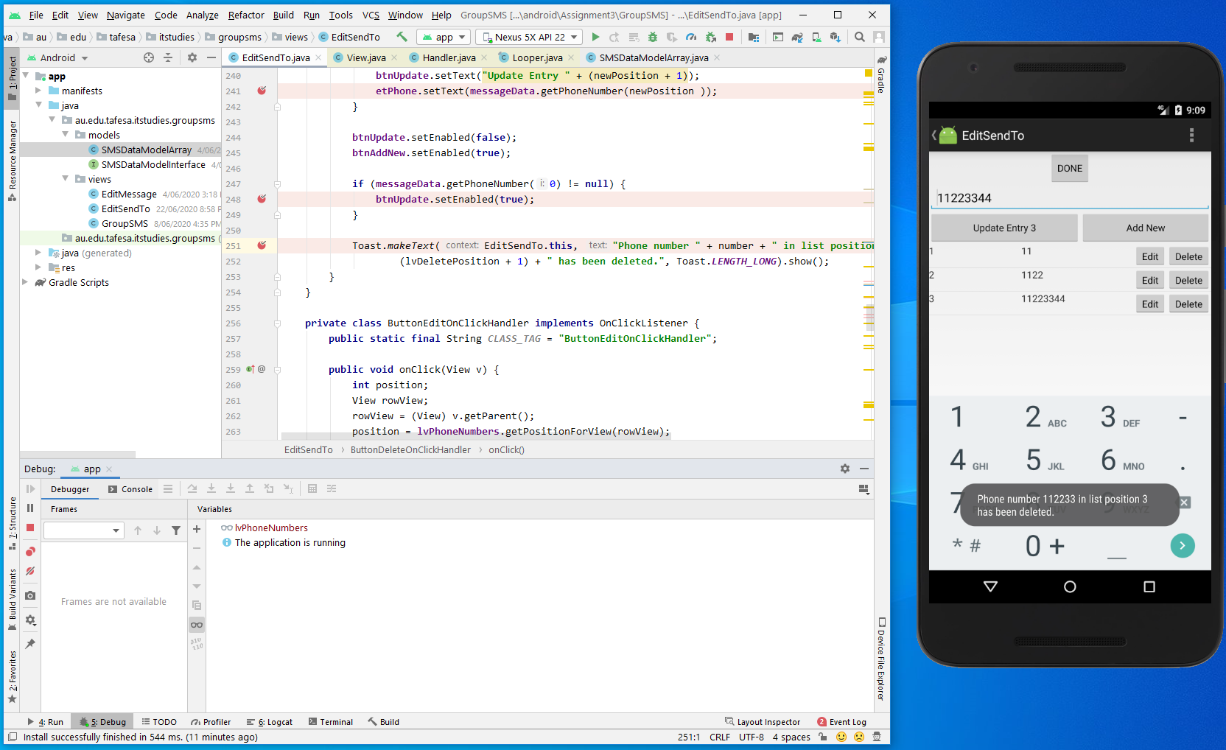

# ButtonDeleteOnClickHandler

**private class** ButtonDeleteOnClickHandler **implements** OnClickListener {  
 **public static final** String ***CLASS_TAG*** = **"ButtonDeleteOnClickHandler"**;  
  
 **public void** onClick(View v) {  
 Log.*i*(***CLASS_TAG***, **"OnClick..."**);  
 *//****TODO See comments above*** View rowView = (View) v.getParent();  
 **int** lvDeletePosition = **lvPhoneNumbers**.getPositionForView(rowView);  
 String number = **messageData**.getPhoneNumber(lvDeletePosition);  
 **int** lvSelectedItemPosition = **listViewItemSelectedHandler**.getCurrentSelectedPosition();  
  
 *//IF the list view selected item is less than or equal to the array number to delete.* **if**(lvSelectedItemPosition <= lvDeletePosition) {  
 **messageData**.deleteNumber(lvDeletePosition);  
  
 ((MyListViewAdapter) **lvPhoneNumbers**.getAdapter()).notifyDataSetChanged();  
 **btnUpdate**.setText(**"Update Entry "** + (**listViewItemSelectedHandler**.**position** + 1));  
 **etPhone**.setText(**messageData**.getPhoneNumber(**listViewItemSelectedHandler**.**position**));  
 }  
  
 *//IF the list view selected item is greater the array number to delete. i.e. selected item 3 and delete item 1.* **if**(lvSelectedItemPosition > lvDeletePosition) {  
 **messageData**.deleteNumber(lvDeletePosition);  
  
 ((MyListViewAdapter) **lvPhoneNumbers**.getAdapter()).notifyDataSetChanged();  
 **int** newPosition = **listViewItemSelectedHandler**.**position** - 1;  
 **listViewItemSelectedHandler**.**position** = newPosition;  
 **btnUpdate**.setText(**"Update Entry "** + (newPosition + 1));  
 **etPhone**.setText(**messageData**.getPhoneNumber(newPosition ));  
 }  
  
 **btnUpdate**.setEnabled(**false**);  
 **btnAddNew**.setEnabled(**true**);  
  
 **if** (**messageData**.getPhoneNumber(0) != **null**) {  
 **btnUpdate**.setEnabled(**true**);  
 }  
  
 Toast.*makeText*(EditSendTo.**this**, **"Phone number "** + number + **" in list position "** +  
 (lvDeletePosition + 1) + **" has been deleted."**, Toast.***LENGTH_LONG***).show();  
 }  
}

# ButtonAddNewOnClickHandler

**private class** ButtonAddNewOnClickHandler **implements** OnClickListener {  
 **public static final** String ***CLASS_TAG*** = **"ButtonAddNewOnClickHandler"**;  
  
 **public void** onClick(View v) {  
 Log.*i*(***CLASS_TAG***, **"OnClick..."**);  
 *//****TODO See comments above.*** String number;  
  
 number = **etPhone**.getText().toString();  
 *//IF number is empty, error* **if** (number.equals(**""**)) {  
 Toast  
 .*makeText*(EditSendTo.**this**, **"Cannot add nothing. Use Delete to get rid of number!"**, Toast.***LENGTH_SHORT***)  
 .show();  
 }  
 *//ELSE add number to messageData* **else** {  
 number = **messageData**.addPhoneNumber(number);  
 **int** currentPositionInListView = **messageData**.getNumPhoneNumbers();  
  
 Toast.*makeText*(  
 EditSendTo.**this**,  
 **"Addition of number "** + number + **". Number of numbers: "** + currentPositionInListView, Toast.***LENGTH_SHORT***).show();  
 ((MyListViewAdapter) **lvPhoneNumbers**.getAdapter()).notifyDataSetChanged();  
 **btnUpdate**.setEnabled(**true**);  
  
 **listViewItemSelectedHandler**.**position** = currentPositionInListView;  
 **etPhone**.setText(**messageData**.getPhoneNumber(currentPositionInListView -1));  
 **btnUpdate**.setText(**"Update Entry "** + (currentPositionInListView));  
 ((MyListViewAdapter) **lvPhoneNumbers**.getAdapter()).notifyDataSetChanged();  
  
 }  
 }