**Computer Vision HW2 Report**

Student ID: R11921041

Name: 蔣沅均

**Part 1. (10%)**

**• Plot confusion matrix of two settings. (i.e. Bag of sift and tiny image) (5%)**

**Ans:**

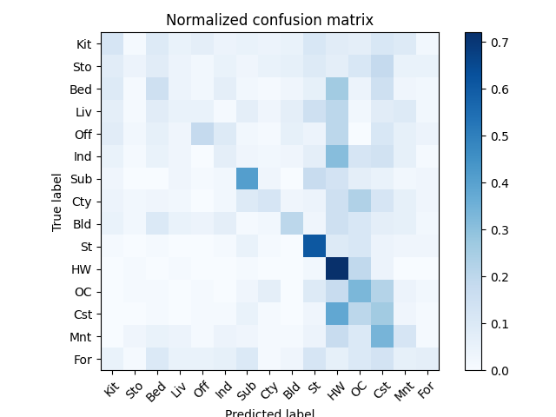

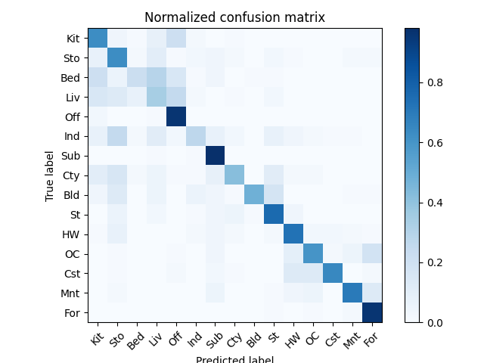

**• Compare the results/accuracy of both settings and explain the result. (5%)Ans:**

**tiny image的accuracy是0.243，而bag of sift的是0.622。兩個方法使用的knn分類器設定都一樣，因此可以比較出bag of sift相較於tiny image更能有效的抽取出利於場景分類的圖像特徵。**

**Part 2. (25%)**

**• Report accuracy of both models on the validation set. (2%)**

**Ans:**

|  |  |  |
| --- | --- | --- |
|  | **A - mynet** | **B - resnet18** |
| **accuracy** | **0.8182** | **0.8824** |

**• Print the network architecture & number of parameters of both models. What is the main difference between ResNet and other CNN architectures? (5%)**

**Ans:**

|  |  |  |
| --- | --- | --- |
|  | **A - mynet** | **B - resnet18** |
| **# of params** | **317,866** | **11,310,666** |
| **arch** |  |  |

**ResNet use residual connection.**

**It should be easier for the solver to find the perturbations(F(x)) with reference to an identity mapping(x) than to learn the function as a new one.**

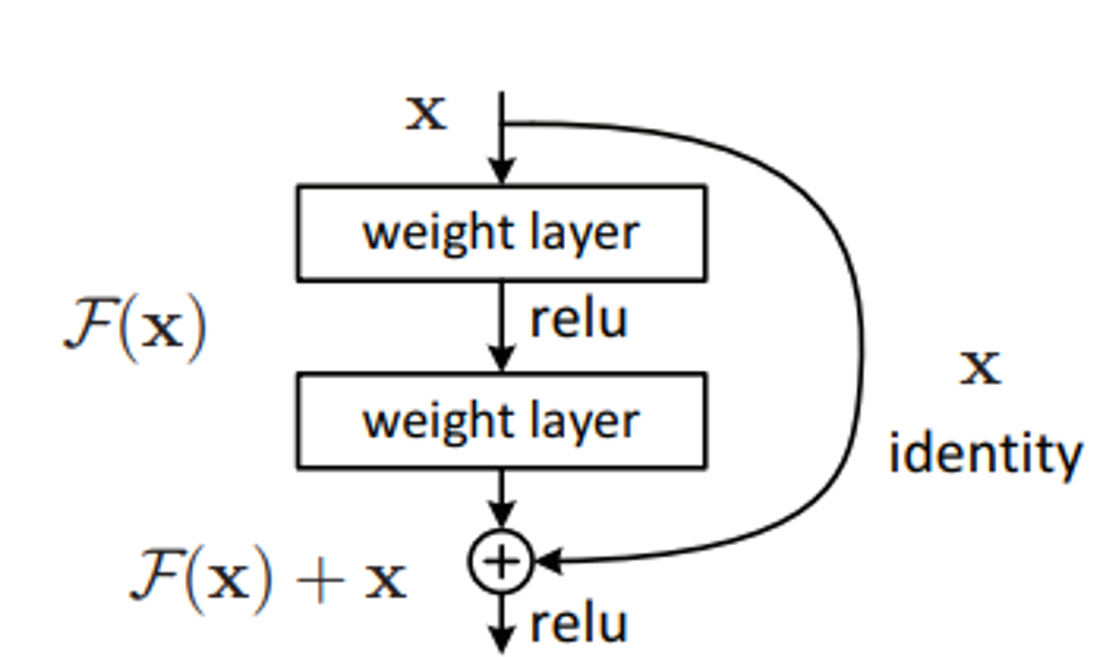

**• Plot four learning curves (loss & accuracy) of the training process (train/validation) for both models. Total 8 plots. (8%)**

**Ans:**

|  |  |  |
| --- | --- | --- |
|  | **train** | **validation** |
| **A - mynet accuracy** |  |  |
| **A - mynet loss** |  |  |
| **B – resnet18 accuracy** |  |  |
| **B – resnet18 loss** |  |  |

**• Briefly describe what method do you apply on your best model? (e.g. data augmentation, model architecture, loss function, etc) (10%)**

**Ans:**

* **data augmentation**
  + **Random Crop**
  + **TrivialAugment (**[**https://arxiv.org/abs/2103.10158**](https://arxiv.org/abs/2103.10158)**)**
  + **RandomErasing(**[**https://arxiv.org/abs/1708.04896**](https://arxiv.org/abs/1708.04896)**)**
* **model architecture**
  + **Based on Resnet18**
  + **Remove the first maxpool layer**
  + **Modify the fc module**
* **loss function**
  + **cross entropy**