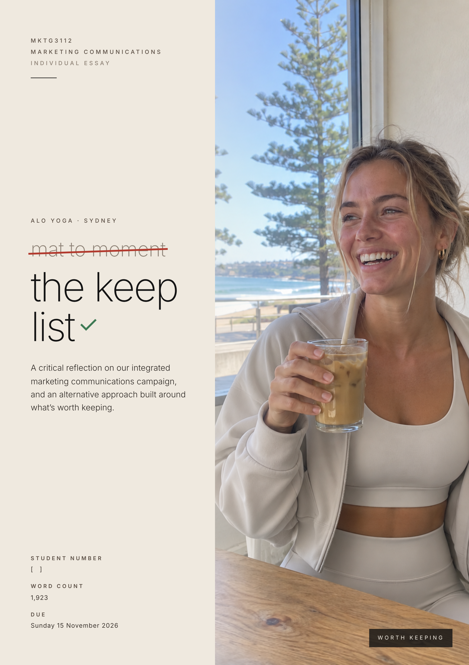

Contents
Question One – Evaluating “Mat to Moment” 2
1.1 Overall Assessment 2
1.2 Target Audience 2
1.3 Message Design 2
1.4 Channel Selection 3
1.5 Integration 3
1.6 Likely Effectiveness and Measurement 3
Question Two – An Alternative Approach, “The Keep List” 4
2.1 What I Changed and Why 4
2.2 Audience and Insight 4
2.3 Message, Persuasion Route and Sources 5
2.4 Journey 6
2.5 Channels and Budget 7
2.6 Creative Mock-up 9
2.7 Advantages, Limitations and Expected Effectiveness 11
References 12
Appendix A – Evaluation of “Mat to Moment” Against Its Objectives 15
Appendix B – Two-Sided Message Structure, Inoculation and Mental Accounting 16
Appendix C – Pulsing Schedule, Before and After 17
Appendix D – Pre-Testing, In-Flight and Post-Testing Plan 18
Word count Question One 664 · Question Two 1259 · Total 1,923. Headings and body text, excluding figures, notes, prompts, references and appendices.

Question One – Evaluating “Mat to Moment”

1.1 Overall Assessment
Campaign effectiveness means achieving intended outcomes, not simply generating reach or likes (Belch & Belch, 2021). Against our four objectives, Mat to Moment is more likely to build store awareness (O3) than perceived worth (O1), despite our ranking O1 first (Appendix A). The objectives themselves are a strength because they are specific, measurable and linked to identified challenges (Colley, 1961). The weakness was how consistently our execution supported them.

1.2 Target Audience
Segment A, 22-34 year old women in Sydney who treat activewear as part of their identity, remains appropriate (Belk, 1988). However, financial pressure creates a tension our campaign did not resolve (Deloitte, 2026). At A$100–200 per item, Alo is positioned as “masstige” rather than luxury. These buyers buy more in categories they value while cutting back elsewhere (Silverstein & Fiske, 2003). We followed Kapferer and Bastien’s (2009) argument that luxury needs meaning rather than justification. I now see that our audience also needs a reason to prioritise Alo, as guilt can suppress indulgent purchases unless the expense feels worthwhile (Okada, 2005).

1.3 Message Design
Our line, “From Mat to Moment”, is clear, and its calm, after-class imagery contrasts with rivals’ focus on sweat, highlighting creative divergence (Smith & Yang, 2004). However, moving from exercise to everyday wear defines athleisure (Merriam-Webster, n.d.), and our report shows that P.E Nation already promotes leggings this way (P.E Nation, n.d.). Therefore, the execution may stand out without making the proposition distinctive to Alo. Competitor attribution is a risk to our 60% brand-attribution target, although this requires testing.
Price justification is also underdeveloped. On bus panels and Instagram posts, “Worth it” is supported only by an “instructor-tested” label. Interested viewers might consider this relevant evidence, but without explaining what was tested, it may function mainly as a peripheral quality cue (Petty et al., 1983). Attitudes formed peripherally tend to be less enduring, less resistant to competing messages, and less predictive of behaviour (Petty & Cacioppo, 1986). More complete justification appears only on product pages, in stores, and at 36 sessions reaching a few hundred people. Most viewers would therefore see only the label, so their sense that Alo is worth the price (O1) could fade or lose out to rivals before they buy.

1.4 Channel Selection
Outdoor receives A$55,000, or 22% of the budget, despite its low audience selectivity (Belch & Belch, 2021). Store-route panels can support O3, but their limited scope to explain price makes their contribution to O1 less convincing. By contrast, Instagram and TikTok allow the proposed creator videos to combine a fuller value argument with targeted exposure. Their potential ad reach equals 69.2% and 51.2% of Australian adults respectively, although overlapping audiences mean Sydney tests should guide the split (Kemp, 2026).

1.5 Integration
Integration is our plan’s main strength. Every touchpoint carries the same line, set and sign-off, while hooks and calls to action vary, creating consistency without identical executions (Batra & Keller, 2016). However, our objectives assumed Vaughn’s (1980) feel–learn–do order, in which people feel something about a fashion brand before weighing facts, yet our AIDA journey delays the more complete price argument until Desire in Burst 2 (Strong, 1925). Therefore, our touchpoints achieved commonality but not complementarity, because the key argument needed to support O1 appeared where only a few people were likely to see it (Keller, 2001).

1.6 Likely Effectiveness and Measurement
O3 is most likely to succeed because store locations are repeated across touchpoints, and such simple facts can be learned with little elaboration (Petty et al., 1983). O2 is plausible because Sydney sources add local relevance, which builds closer consumer relationships even for global brands (Sichtmann et al., 2019). O1 remains at risk, potentially weakening O4, as visits tend to follow attitudes rather than precede them (Vaughn, 1980). Evaluation is also limited. Only paid social, representing 21% of spend, uses randomised holdouts. The remaining activity relies on before-and-after comparisons, which can overstate advertising effects (Gordon et al., 2019).

Question Two – An Alternative Approach, “The Keep List”

2.1 What I Changed and Why
The Keep List retains Segment A, objectives O1–O4, Sydney sources and consistent brand codes, while addressing the weaknesses identified in Question One (Figure 1). Perceived worth remains the highest-ranked objective, but now leads the creative strategy rather than relying on explanations in lower-reach touchpoints.
Figure 1
What Changes From the Group Campaign
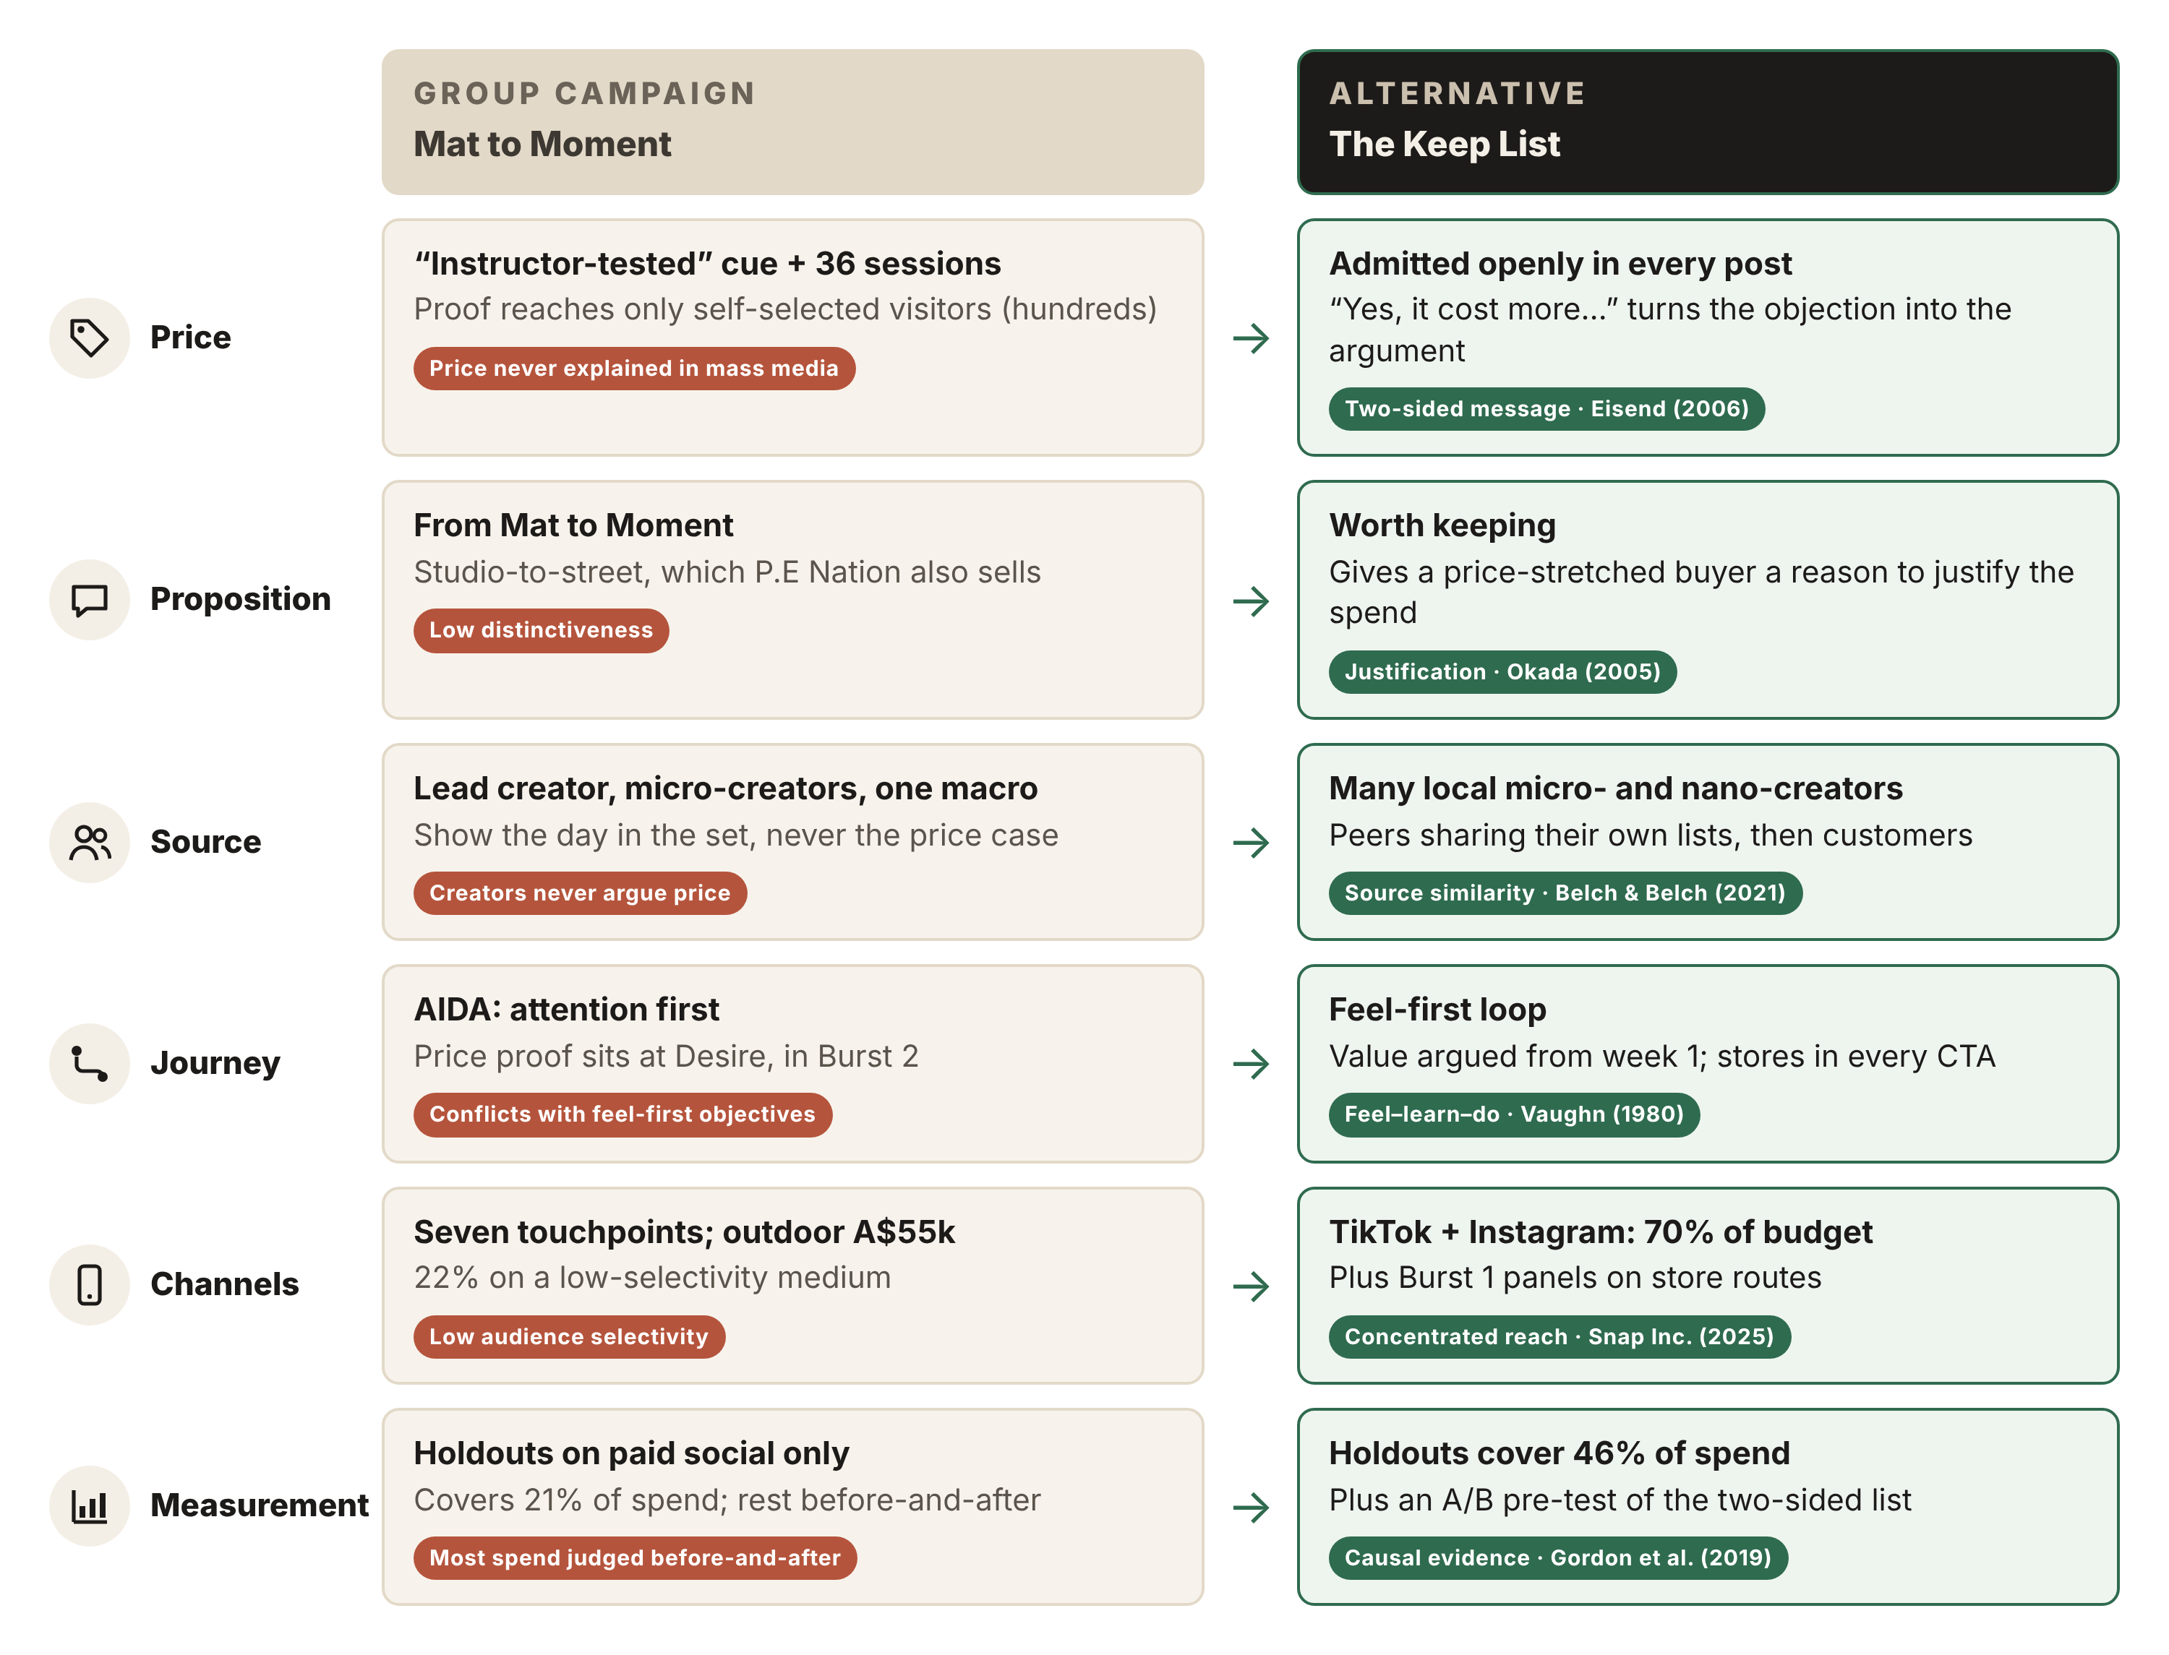
Note. Weaknesses come from Question One, and tags show the main source justifying each change.

2.2 Audience and Insight
I retain Segment A because its identity-driven buying fits Alo (Belk, 1988). The unresolved price tension needs a stronger value argument, not a different audience. In 2024, "loud budgeting", openly naming what you will not spend on, spread on TikTok as a statement of choice (Axios, 2024). My insight, extending Belk's idea that possessions express the self, is that what financially pressured young women choose to keep can express their identity as clearly as what they cut. Alo's premium all-day positioning remains, but is expressed as "worth keeping" rather than "studio to street".

2.3 Message, Persuasion Route and Sources
My message is two-sided, with creators acknowledging the premium before explaining why Alo is worth keeping. This admission can strengthen credibility, although Eisend's (2006) meta-analysis shows that persuasion depends on how negative information is presented, not simply whether it is included. The list therefore keeps the admission brief and answers it immediately, as creators explain how frequent wear makes the expense worthwhile (Okada, 2005). This draws on mental accounting, where consumers organise spending into separate budgets (Thaler, 1999; Appendix B). Placing Alo beside cancelled takeaway moves it from a "fashion splurge" into "things I use every day", justifying the price without discounts that could weaken Alo's premium positioning (Kapferer & Bastien, 2009).
However, frequent wear alone could justify any activewear brand. Creators must show their actual Alo products across different occasions and explain the specific reasons they repeatedly choose it over alternatives. This makes Alo the subject of the explanation, rather than attaching its logo to a general spending argument.
Under the Elaboration Likelihood Model, careful consideration (the central route) requires motivation and ability (Petty et al., 1983). The Keep List brings the price argument into the ad, so viewers get reasons why Alo is worth the price rather than just a label suggesting quality (Figure 2). Financial pressure supplies the motivation, as price already matters to this audience, while the short list supplies the ability, as its reasoning can be followed in seconds. This creates an opportunity for central processing, not a guarantee, as feed distraction and argument strength still matter. The case for O1 now reaches viewers at first exposure, not only those who seek it out.
Figure 2
Elaboration Likelihood Model, Before and After
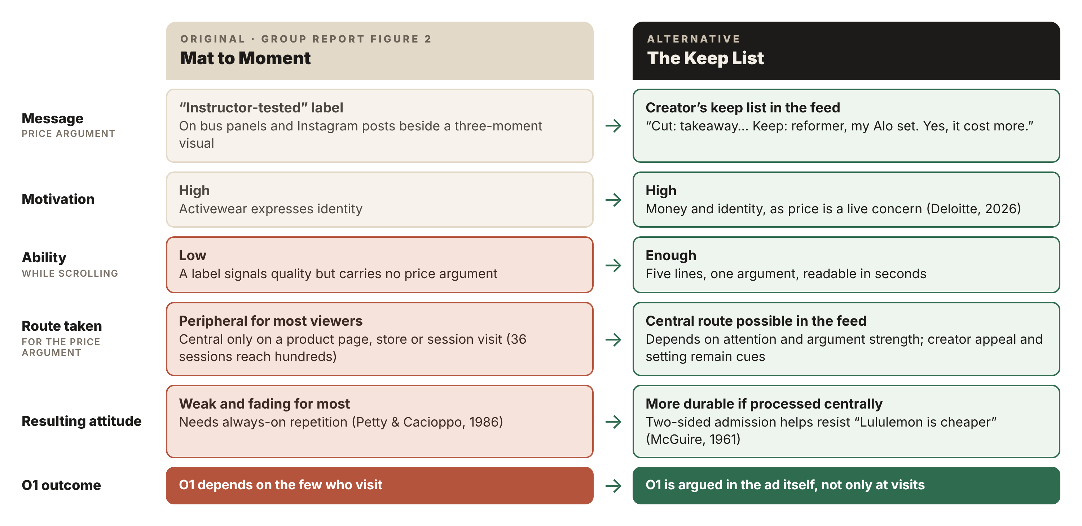
Note. Adapted from Petty et al. (1983) and the group report’s Figure 2.
Sydney micro- and nano-creators introduce the format, with customers then invited to share their own lists. Unlike our original creators, all argue price, and micro-creators' closeness to their followers can make an honest price admission more credible (Campbell & Farrell, 2020). The repeated format, wordmark and sign-off act as distinctive assets, helping viewers attribute each story to Alo (Sharp, 2010).

2.4 Journey
Figure 3 replaces our AIDA journey with Vaughn's (1980) feel–learn–do model, the order our objectives already assumed, with bursts reordered to match (Appendix C). I use it as a planning guide, not a fixed path every viewer follows. Each list makes Alo feel worth keeping through local peers (feel, O1, O2), then names the stores (learn, O3). Retargeting and in-store try-ons turn that interest into visits (do, O4). Customers' Stitched replies on TikTok can each become another viewer's first exposure, linking advocacy back to discovery (Court et al., 2009).
Figure 3
Consumer Journey, Before and After
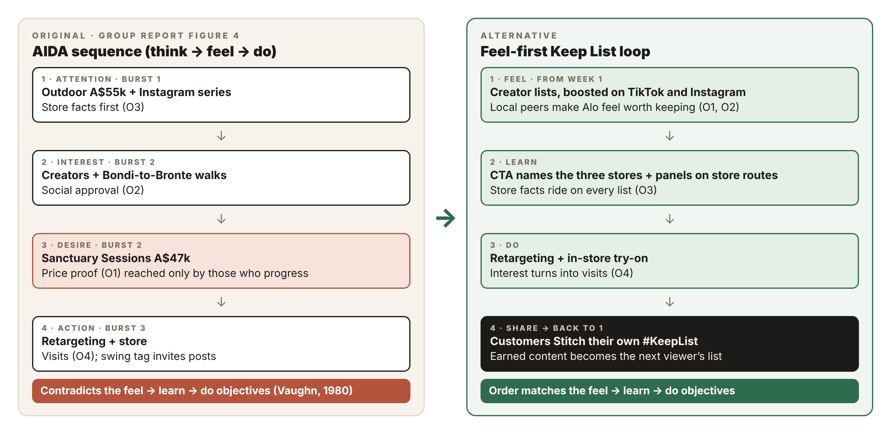
Note. Adapted from Strong (1925), Vaughn (1980), Court et al. (2009) and the group report’s Figure 4.

2.5 Channels and Budget
Within A$250,000 (Figure 4), I remove Sanctuary Sessions (A$47,000), which reached only a few hundred people, and reduce outdoor from A$55,000 to A$20,500, retaining Burst 1 panels on store routes despite their low audience selectivity. Paid social and creator partnerships rise from A$103,000 to A$175,000, or 70% of the budget, because these channels carry the value argument itself rather than only the store message. At an assumed A$12 per thousand impressions (Admetrics, 2025), A$115,000 in paid social could generate approximately 9.6 million impressions, against the original forecast of about four million. This is a planning scenario, not proof of greater effectiveness.
Figure 4
Budget Reallocation Within A$250,000
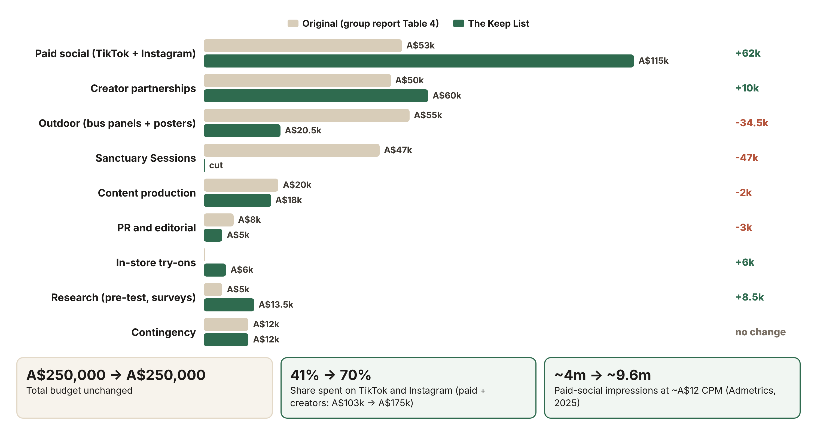
Note. Original figures are from the group report’s Table 4. Bus panels cover 20 panels for three weeks at GoTransit (n.d.) rates plus production, with A$4,000 for posters. Creators cover about 100 micro and nano posts at A$150–750 each (Wise, 2025).
A pre-test would compare one-sided and two-sided messages on perceived worth and brand attribution (Belch & Belch, 2021). Randomised holdouts would assess paid-social effects on perceived worth and store-visit intention, covering 46% of spend rather than 21% (Gordon et al., 2019; Appendix D). Store-locator clicks and visit data would add indicators of actual visits, though not causal ones.

2.6 Creative Mock-up
Figure 5
“The Keep List” TikTok In-Feed Creator Post (Burst 1)
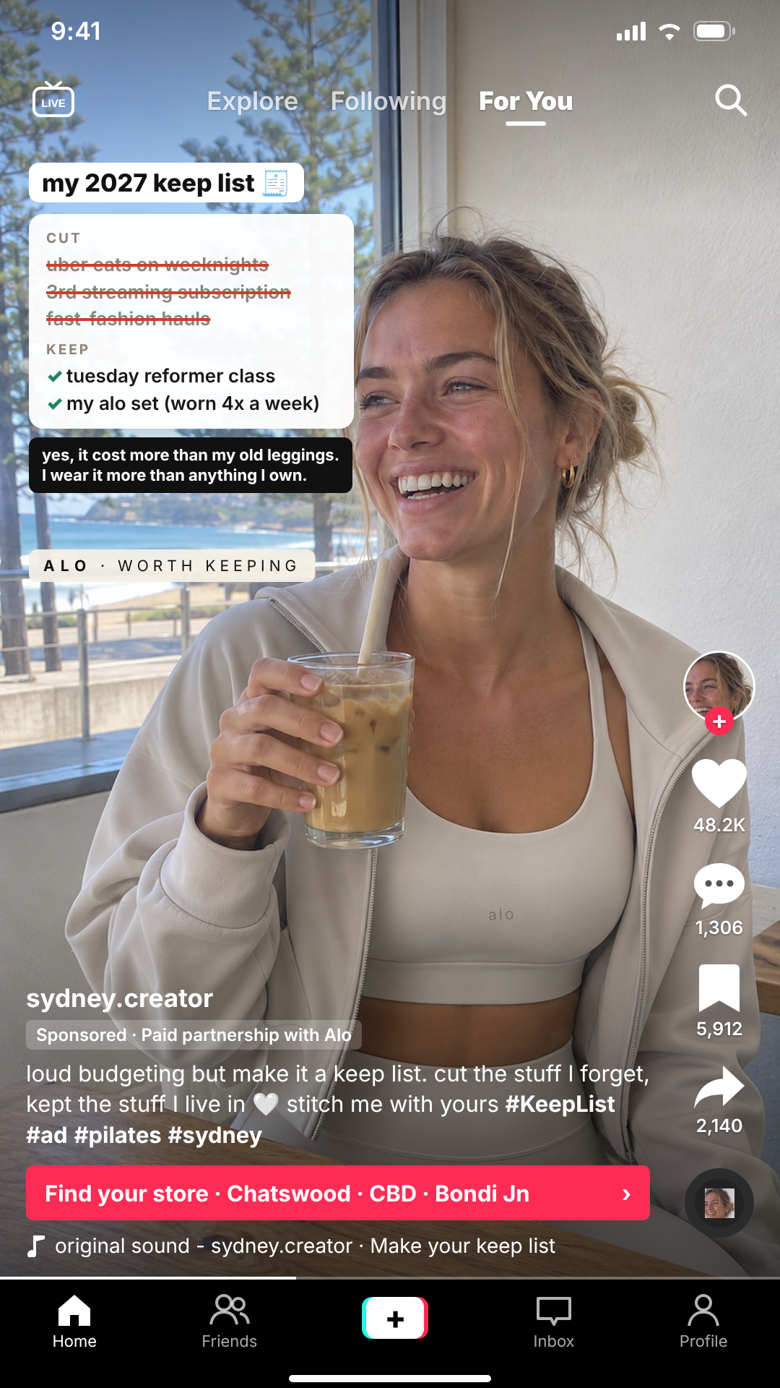
Note. AI-generated photograph composed into a TikTok frame. The person is not real, and the handle and engagement figures are illustrative. AI prompts used. (1) Photograph, generated with [name the image tool you used], using the prompt “Photorealistic vertical 9:16 smartphone photo that looks like a still from an iPhone TikTok video, not a professional shoot. A woman in her mid-twenties sits at a small timber table by the window of a casual café in Bondi, Sydney, around 9am, just after a reformer Pilates class. She wears a matching Alo Yoga–style set: a sleek, smooth sculpting sports bra and high-waisted leggings with a subtle sheen, in a soft neutral ‘bone’ colour, with an oversized cropped zip jacket in the same colour open over it. Clean, minimal, premium design. Do not render any text or logos on the clothing. Natural, unretouched skin, minimal makeup, hair in a slightly messy low bun, small gold hoop earrings. She is laughing naturally while holding an iced oat latte and looking just off camera. Soft morning sunlight comes through the window, with the ocean and Norfolk pines faintly visible and out of focus behind her. Handheld phone-camera look: slight grain, true-to-life colour, shallow depth of field. Composition: she sits in the right half of the frame, shown from the waist up, with her face about 45% of the way down the image. Keep the upper-left third and the bottom quarter visually quiet so text overlays can sit there. No text, logos, watermarks or other people in focus.” (2) TikTok frame, composed with Claude (Anthropic), using the prompt “Place this photo in an accurate TikTok For You in-feed Spark Ad frame (1080 × 1920 px) with the status bar, LIVE/Explore/Following/For You tabs, right-hand rail (creator avatar with follow button, likes, comments, saves, shares, sound disc), ‘Sponsored · Paid partnership with Alo’ under the handle, the caption with #KeepList and #ad, a red call-to-action button ‘Find your store · Chatswood · CBD · Bondi Jn’ and the sound line. Add native TikTok text overlays in the empty window area: ‘my 2027 keep list’, a Notes-style list (CUT: uber eats on weeknights; 3rd streaming subscription; fast-fashion hauls, struck through; KEEP: tuesday reformer class; my alo set (worn 4x a week)), the aside ‘yes, it cost more than my old leggings. I wear it more than anything I own.’ and an ‘ALO · WORTH KEEPING’ sticker. Add a small, correctly spelled ‘alo’ wordmark on the sports bra. Keep every overlay clear of her face.”
Media format. Figure 5 shows a 15-second TikTok Spark Ad. The list appears line by line alongside the creator’s voice-over, moving from the price admission to her reasons for keeping the set, before introducing Alo. Promoting the creator’s original post keeps her username and comments visible (TikTok for Business, n.d.-a), so viewers can see who is explaining the choice.
Message. The lowercase headline “my 2027 keep list” feels like a personal note and introduces the idea within three seconds, following TikTok’s guidance on presenting the main proposition early (TikTok for Business, n.d.-b). The price admission acknowledges the objection rather than avoiding it, while “worn 4x a week” gives the creator a clear starting point for explaining the set’s value. “Alo. Worth keeping.” then connects that explanation to the brand.
Imagery. The creator wears the matching set in a beachside Sydney café after class, showing how it fits into everyday life beyond exercise. The setting adds local relevance (O2), but one café scene cannot demonstrate frequent use. Brief clips of the same set throughout her week would make “worn 4x a week” more convincing. Natural light and handheld footage would help the video feel like an everyday creator post rather than a polished brand shoot. Actual posts would feature creators with different body types and avoid retouching, given concerns that fitness imagery on Instagram can increase appearance pressure among young women (Camacho-Miñano et al., 2019).
Design. TikTok’s built-in text style makes the list feel familiar, while red strikethroughs and green ticks help viewers follow each choice as it appears. Alo’s neutral colours and wordmark keep the brand recognisable and maintain its premium, minimal look rather than making the ad resemble a discount promotion. “Paid partnership” and #ad keep its commercial purpose clear, even though the post feels personal (Australian Association of National Advertisers [AANA], 2021; Wojdynski & Evans, 2016).
Call to action. “Find your store” names Chatswood, the CBD and Bondi Junction, giving viewers a practical next step (O3, O4). The ad directs them to stores rather than online checkout because O4 measures visits.
AI limitations. The AI-generated photograph looks too polished for the intended phone-footage style. It also reproduces Alo’s garments and logo inaccurately, while one slim model cannot represent the different bodies within Segment A. The mock-up therefore communicates the concept more clearly than it demonstrates the intended realism or inclusivity. Actual posts would need real creators wearing Alo and giving honest accounts of their use and spending choices, rather than presenting scripted claims as personal experience (Competition and Consumer Act 2010 (Cth) sch 2 s 18).

2.7 Advantages, Limitations and Expected Effectiveness
The main risk is tone. Cutting other spending to justify premium leggings could appear tone-deaf, particularly alongside café and Pilates imagery. Creators must present personal choices, not imply viewers should sacrifice necessities for Alo (Sher, 2011). Removing sessions also reduces hands-on proof. Overall, I expect stronger support for O1 and O2, while O3 remains supported. O4 depends on whether credible, Alo-specific explanations give prospective buyers enough reason to visit, not simply whether the campaign generates more impressions.

References
Admetrics. (2025). Instagram ads costs: Complete 2025 pricing guide. https://admetrics.io/en/post/instagram-ads-costs-complete-2025-pricing-guide
Australian Association of National Advertisers. (2021). AANA code of ethics. https://aana.com.au/self-regulation/codes-guidelines/code-of-ethics/
Axios. (2024, February 2). Gen Z fuels “loud budgeting” personal finance trend. https://www.axios.com/2024/02/02/loud-budgeting-personal-finance-trend-gen-z
Batra, R., & Keller, K. L. (2016). Integrating marketing communications: New findings, new lessons, and new ideas. Journal of Marketing, 80(6), 122–145. https://doi.org/10.1509/jm.15.0419
Belch, G. E., & Belch, M. A. (2021). Advertising and promotion: An integrated marketing communications perspective (12th ed.). McGraw-Hill Education.
Belk, R. W. (1988). Possessions and the extended self. Journal of Consumer Research, 15(2), 139–168. https://doi.org/10.1086/209154
Camacho-Miñano, M. J., MacIsaac, S., & Rich, E. (2019). Postfeminist biopedagogies of Instagram: Young women learning about bodies, health and fitness. Sport, Education and Society, 24(6), 651–664. https://doi.org/10.1080/13573322.2019.1613975
Campbell, C., & Farrell, J. R. (2020). More than meets the eye: The functional components underlying influencer marketing. Business Horizons, 63(4), 469–479. https://doi.org/10.1016/j.bushor.2020.03.003
Colley, R. H. (1961). Defining advertising goals for measured advertising results. Association of National Advertisers.
Competition and Consumer Act 2010 (Cth). https://www.legislation.gov.au/C2004A00109/latest/text
Court, D., Elzinga, D., Mulder, S., & Vetvik, O. J. (2009). The consumer decision journey. McKinsey Quarterly, (3), 96–107.
Deloitte. (2026). 2026 Gen Z and millennial survey. https://www.deloitte.com/global/en/issues/work/genz-millennial-survey.html
Eisend, M. (2006). Two-sided advertising: A meta-analysis. International Journal of Research in Marketing, 23(2), 187–198. https://doi.org/10.1016/j.ijresmar.2005.11.001
Gordon, B. R., Zettelmeyer, F., Bhargava, N., & Chapsky, D. (2019). A comparison of approaches to advertising measurement: Evidence from big field experiments at Facebook. Marketing Science, 38(2), 193–225. https://doi.org/10.1287/mksc.2018.1135
GoTransit. (n.d.). Bus advertising. Retrieved October 28, 2026, from https://gotransit.com.au/
Kapferer, J.-N., & Bastien, V. (2009). The luxury strategy: Break the rules of marketing to build luxury brands. Kogan Page.
Keller, K. L. (2001). Mastering the marketing communications mix: Micro and macro perspectives on integrated marketing communication programs. Journal of Marketing Management, 17(7–8), 819–847. https://doi.org/10.1362/026725701323366836
Kemp, S. (2026). Digital 2026: Australia. DataReportal. https://datareportal.com/reports/digital-2026-australia
McGuire, W. J. (1961). The effectiveness of supportive and refutational defenses in immunizing and restoring beliefs against persuasion. Sociometry, 24(2), 184–197. https://doi.org/10.2307/2786067
Merriam-Webster. (n.d.). Athleisure. In Merriam-Webster.com dictionary. Retrieved November 1, 2026, from https://www.merriam-webster.com/dictionary/athleisure
Okada, E. M. (2005). Justification effects on consumer choice of hedonic and utilitarian goods. Journal of Marketing Research, 42(1), 43–53. https://doi.org/10.1509/jmkr.42.1.43.56889
P.E Nation. (n.d.). Dynamic full length legging in major brown. Retrieved November 8, 2026, from https://www.pe-nation.com/products/dynamic-full-length-legging-in-major-brown
Petty, R. E., & Cacioppo, J. T. (1986). The elaboration likelihood model of persuasion. Advances in Experimental Social Psychology, 19, 123–205. https://doi.org/10.1016/S0065-2601(08)60214-2
Petty, R. E., Cacioppo, J. T., & Schumann, D. (1983). Central and peripheral routes to advertising effectiveness: The moderating role of involvement. Journal of Consumer Research, 10(2), 135–146. https://doi.org/10.1086/208954
Sharp, B. (2010). How brands grow: What marketers don’t know. Oxford University Press.
Sher, S. (2011). A framework for assessing immorally manipulative marketing tactics. Journal of Business Ethics, 102(1), 97–118. https://doi.org/10.1007/s10551-011-0802-4
Sichtmann, C., Davvetas, V., & Diamantopoulos, A. (2019). The relational value of perceived brand globalness and localness. Journal of Business Research, 104, 597–613. https://doi.org/10.1016/j.jbusres.2018.10.025
Silverstein, M. J., & Fiske, N. (2003). Luxury for the masses. Harvard Business Review, 81(4), 48–57.
Smith, R. E., & Yang, X. (2004). Toward a general theory of creativity in advertising: Examining the role of divergence. Marketing Theory, 4(1–2), 31–58. https://doi.org/10.1177/1470593104044086
Snap Inc. (2025). Ben & Jerry’s success story. Snapchat for Business. https://forbusiness.snapchat.com/inspiration/ben-and-jerry-success-story
Strong, E. K., Jr. (1925). The psychology of selling and advertising. McGraw-Hill.
Thaler, R. H. (1999). Mental accounting matters. Journal of Behavioral Decision Making, 12(3), 183–206. https://doi.org/10.1002/(SICI)1099-0771(199909)12:3<183::AID-BDM318>3.0.CO;2-F
TikTok for Business. (n.d.-a). About Spark Ads. Retrieved November 10, 2026, from https://ads.tiktok.com/help/article/spark-ads
TikTok for Business. (n.d.-b). Creative best practices for performance ads. Retrieved November 10, 2026, from https://ads.tiktok.com/help/article/creative-best-practices
Vaughn, R. (1980). How advertising works: A planning model. Journal of Advertising Research, 20(5), 27–33.
Wise. (2025). Influencer marketing in 2025: Complete guide for Australian businesses. https://wise.com/au/blog/influencer-marketing
Wojdynski, B. W., & Evans, N. J. (2016). Going native: Effects of disclosure position and language on the recognition and evaluation of online native advertising. Journal of Advertising, 45(2), 157–168. https://doi.org/10.1080/00913367.2015.1115380

Appendix A
Figure A1
Evaluation of “Mat to Moment” Against Its Objectives
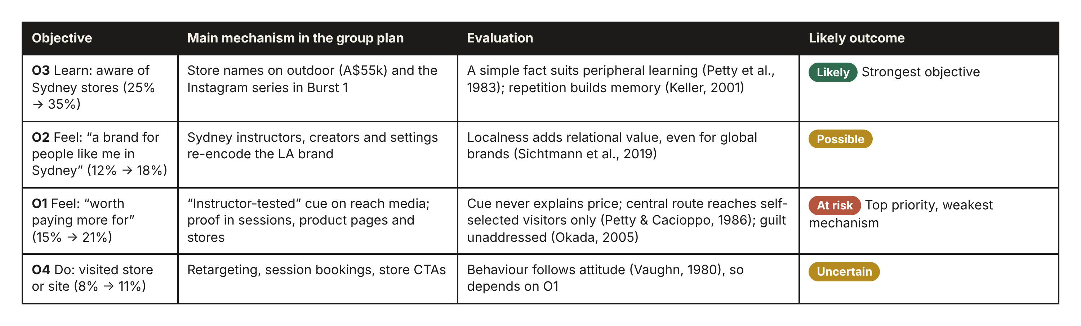
Note. My evaluation, supporting Question One.

Appendix B
Figure B1
Two-Sided Message Structure, Inoculation and Mental Accounting
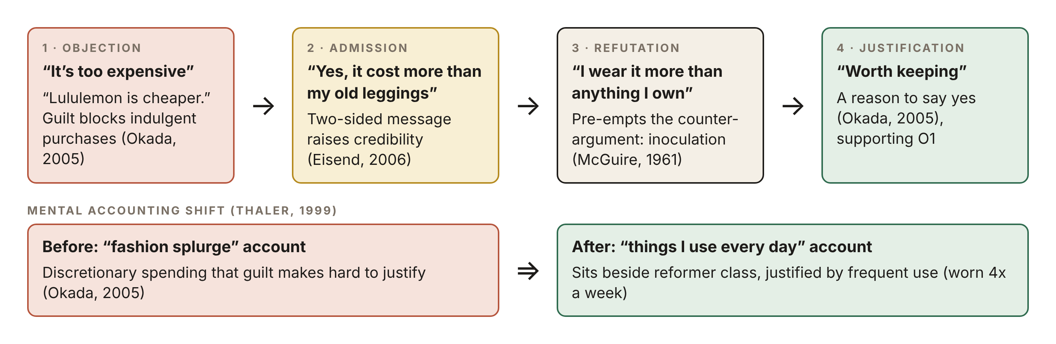
Note. Adapted from Eisend (2006), McGuire (1961), Okada (2005) and Thaler (1999).

Appendix C
Figure C1
Pulsing Schedule, Before and After
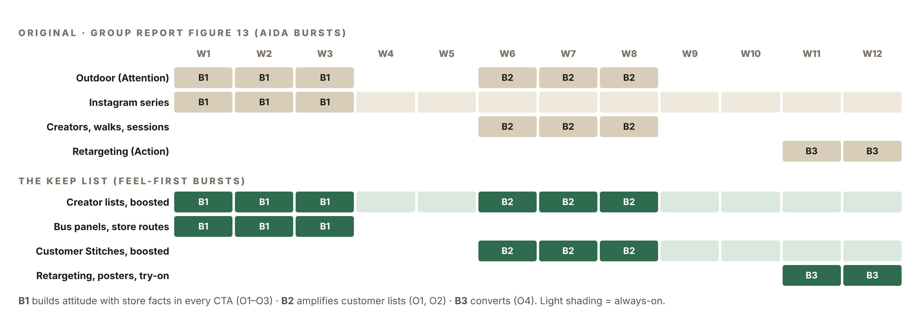
Note. Adapted from the group report’s Figure 13, with pulsing from Belch and Belch (2021).

Appendix D
Figure D1
Pre-Testing, In-Flight and Post-Testing Plan
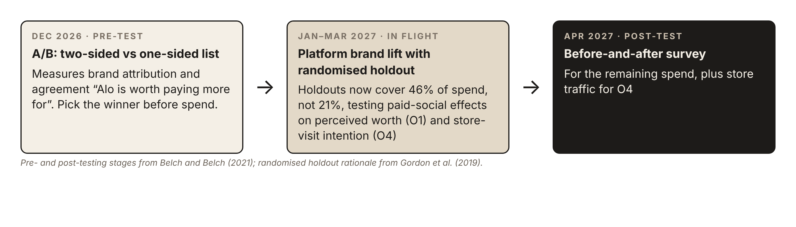
Note. Adapted from Belch and Belch (2021) and Gordon et al. (2019).

