MKTG3114 | PRODUCT INNOVATION
Apply+
Executive Summary
One profile. Clearer choices. A reply date.

Decision requested | Approve a capped 12-week Australian pilot of Apply+ within LinkedIn Easy Apply during graduate recruitment.
Prepared for | LinkedIn Jobs leadership team
Prepared by | Blake Downs, Jack Dady, Amelia Towner and Spencer Goldfinch
Date | 3 November 2026

Contents
1. Product Opportunity 3
2. Product Innovation Charter (PIC) 3
3. Product Concepts and Selection 3
4. Final Product Concept 5
5. Launch and Management Plan 6
6. Sales Forecast and Commercial Potential 7
7. Recommendations 8
References 9
AI Use Statement 10

1. Product Opportunity
Company. Microsoft-owned LinkedIn connects over one billion members with employers through Talent Solutions and LinkedIn Jobs (LinkedIn, n.d.-a).
Problem and consumer need. Easy Apply speeds applying but overwhelms recruiters: 37% of jobseekers apply more yet hear back less, and 73% of HR professionals say most applications miss listed criteria (LinkedIn Corporate Communications Team, 2025). Graduates need faster applications and certainty about replies.
Emerging trend. Graduates reflect a consumer shift towards simplicity and reassurance (Euromonitor International, 2025). Students we interviewed wanted fewer forms and clear reply dates.
Market opportunity. SEEK Pass already verifies credentials, so speed alone will not differentiate LinkedIn, but a committed reply date can.

2. Product Innovation Charter (PIC)
Mission. Help final-year students and recent graduates juggling study, part-time work, and social lives apply faster, with less repetition, and know when they will hear back.
Target market. Australian final-year students and graduates (within two years) in marketing, finance, data science, engineering or computer science.
Opportunity area. Graduate recruitment on LinkedIn Jobs as an incremental innovation using LinkedIn’s profile data and Job Match AI.
Strategic objectives. Update at least 70% of applicants within ten working days (Robert Half, 2024), keep applications under five minutes (Zielinski, 2016), maintain interview rates, and break even.

3. Product Concepts and Selection
Concept A: Apply+ (Company Match). Swipeable AI-matched role cards, a reusable verified profile and a committed reply date.
Concept B: Career Circles. Six applicants meet weekly with an employer mentor for shortlists and application reviews.
Screening process. Both concept boards were scored against six weighted criteria (Table 1), led by applicant effort (25%) and platform fit (20%).
Selection rationale. Career Circles led on differentiation, feasibility and inclusion but scored 2/5 on economics, as each mentor serves only six students. Apply+ scored 3.80 versus 3.45, still led when inclusion was weighted higher, and gives every applicant a reply date that neither LinkedIn nor SEEK offers.
Table 1
Weighted concept screening (scores out of 5)
Criterion | Weight | Apply+ | Career Circles
Applicant effort | 25% | 4 | 3
Platform fit | 20% | 5 | 4
Differentiation | 15% | 3 | 4
Feasibility | 15% | 3 | 4
Economics | 15% | 4 | 2
Inclusion | 10% | 3 | 4
Weighted score | 100% | 3.80 | 3.45
Note. Sensitivity test: moving ten percentage points from economics to inclusion gives Apply+ 3.70 and Career Circles 3.65.
Figure 1
Concept boards: Apply+ and Career Circles
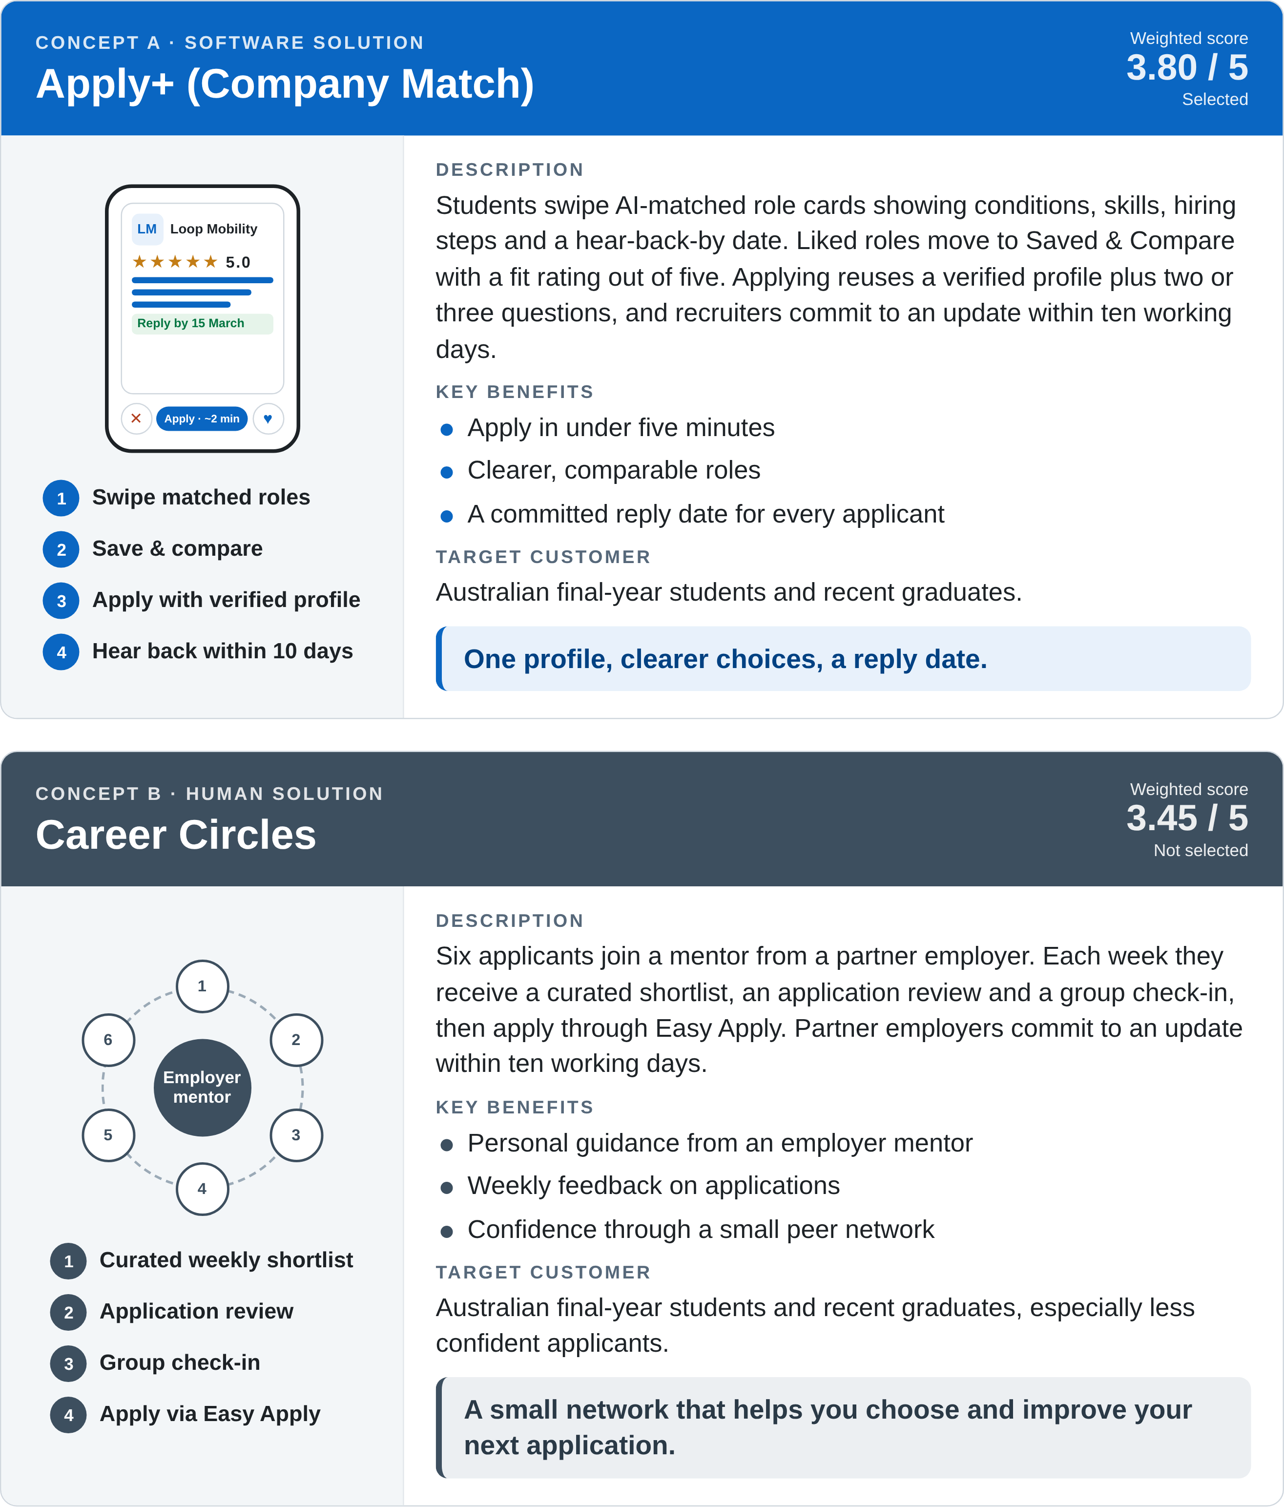

4. Final Product Concept
Product description and target customer. A LinkedIn Jobs feature for graduates such as Jordan Lee, a final-year marketing student who applies constantly and rarely hears back (Figure 2).
Key features.
- Profile imported from LinkedIn, with five-point match ratings.
- Swipeable role cards showing hiring stages and reply dates, plus a Saved & Compare view.
- Verified Application in about two minutes.
- Recruiters commit to updates within ten working days with reliable employers earning a response badge.
Value proposition. One profile, clearer choices, a reply date.
Competitive advantage. SEEK Pass verifies credentials and LinkedIn’s current job pages show some hirers’ past responsiveness (LinkedIn, n.d.-b), but neither promises a reply date. LinkedIn’s data and employer network make this commitment hard to copy.
Figure 2
Apply+ prototype: Discover screen
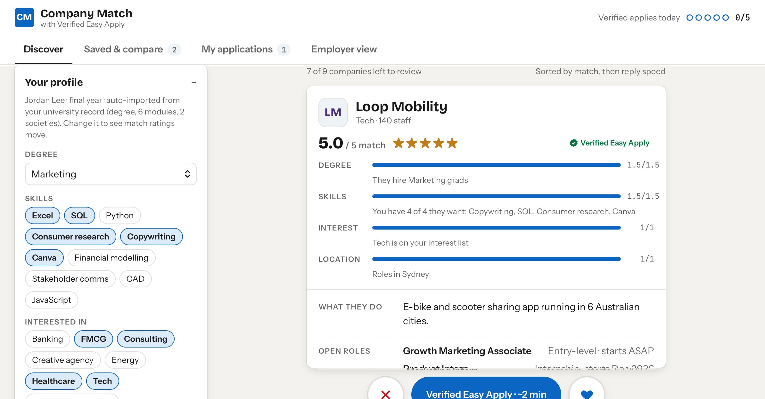
Note. Jordan’s auto-imported profile (left) drives a 5.0/5 match for a Sydney role, with one-tap Verified Easy Apply (bottom). Prototype created by the group with Claude (Anthropic, 2026).

5. Launch and Management Plan
Target market. Graduate recruiters pay while students and graduates use Apply+ free.
Positioning. For Australian graduates who apply widely and rarely hear back, Apply+ is the LinkedIn Jobs feature to compare roles, apply in minutes and know when they will hear back (Table 2).
Branding. Retain LinkedIn Jobs with no sub-brand, inheriting established trust.
Awareness. University careers teams, campus events, LinkedIn advertising, and in-app prompts.
Trial. A 30-day free employer trial tests interviews per application and staff time before A$149 monthly billing.
Distribution. Within LinkedIn Jobs in graduate season, starting with Sydney roles and expanding segment by segment.
Table 2
Strategic launch platform
Decision | Choice | Rationale
Replacement demand | Upgrade Easy Apply, niche first | Builds on an existing habit: 65 million people search for jobs on LinkedIn weekly (Analyzify, 2025)
Cautious entry | Prove, then scale | Break-even sits just above benchmark conversion
In to stay | Continue only if pilot goals are met | Week-12 targets (Section 7)
Roll-in, roll-out | Australia first, then segment by segment | Australia first: about 17 million LinkedIn members (Search Scope, 2026)
Image | Reinforce LinkedIn Jobs | Inherits established trust

6. Sales Forecast and Commercial Potential
A-T-A-R assumptions. Of 73,200 Australian businesses with 20+ employees (Australian Bureau of Statistics, 2025), the model assumes 40% awareness, conservative for a niche launch; 75% availability, as only firms that hire on LinkedIn qualify; 8% trial (Electroiq, 2025); and 18% repeat purchase over six paid months (Bailyn, 2025; Table 3). At A$149 monthly, Apply+ is priced about 40% below LinkedIn Recruiter Lite (A$256).
Expected sales. 316 paying employers generate A$282,504 in Year 1 revenue.
Profit expectations. Building on existing Easy Apply infrastructure keeps costs low (A$200,000 fixed plus A$25 per account-month), producing an A$8,821 Year 1 loss; break-even needs only 12 more payers (Table 4).
Table 3
A-T-A-R forecast, Year 1 national scenario
Stage | Assumption | Employers
Market: businesses with 20+ staff | ABS (2025) | 73,200
Awareness | 40% | 29,280
Availability (hiring on LinkedIn) | 75% | 21,960
Trial (30-day free) | 8% | 1,757
Repeat (convert to paid) | 18% | 316
Revenue | 6 months × A$149 | A$282,504
Total costs | A$200,000 fixed + A$25/account-month | A$291,325
Year 1 result |  | −A$8,821
Table 4
Year 1 sensitivity to employer conversion and retention
Scenario | Paying firms | Paid months¹ | Year 1 result
Base case | 316 | 6 | −A$8,821
Break-even² | 328 | 6 | +A$107
Shorter retention | 316 | 5 | −A$48,005
Note. ¹ Average per paying employer. ² 328 of 1,757 trials (18.7%), or 12 additional paying employers. Each free trial incurs one account-month of servicing cost.

7. Recommendations
- Approve a capped pilot: 12 weeks with up to 50 employers.
- Give every reply date an owner: named recruiters, automated reminders and badge suspension for repeated misses.
- Tie expansion to outcomes: require 90% on-time updates, five-minute median completion and stable interview progression by week 12.
- Scale on renewal evidence: extend to other disciplines and cities once 18.7% of trials convert and payers average six months.

References
Analyzify. (2025). LinkedIn statistics. Retrieved November 1, 2026, from https://analyzify.com/hub/linkedin-statistics
Australian Bureau of Statistics. (2025, August 26). Counts of Australian businesses, including entries and exits, July 2021–June 2025. https://www.abs.gov.au/statistics/economy/business-indicators/counts-australian-businesses-including-entries-and-exits/jul2021-jun2025
Bailyn, E. (2025, September 5). SaaS free trial conversion rate benchmarks. First Page Sage. https://firstpagesage.com/seo-blog/saas-free-trial-conversion-rate-benchmarks/
Elad, B. (2025, July 22). Average conversion rate benchmark statistics by industry, ad type, region and category (2025). https://electroiq.com/stats/average-conversion-rate-benchmark-statistics/
Euromonitor International. (2025, November 5). Euromonitor International unveils global consumer trends for 2026. https://www.euromonitor.com/newsroom/press-releases/november-2025/euromonitor-international-unveils-global-consumer-trends-for-2026
LinkedIn. (n.d.-a). About LinkedIn. Retrieved November 2, 2026, from https://about.linkedin.com/
LinkedIn. (n.d.-b). Hirer responsiveness insights on jobs. LinkedIn Help. Retrieved November 2, 2026, from https://www.linkedin.com/help/linkedin/answer/a1661038
LinkedIn Corporate Communications Team. (2025, January 15). More applicants but harder to hire: Majority of job applications do not meet listed criteria, finds LinkedIn. LinkedIn. https://news.linkedin.com/2025/talent-campaign-b2b-press-release
OpenAI. (2026). Codex [AI assistant]. https://openai.com/codex/
Robert Half. (2024, September 11). How to lose a job candidate in 10 (business) days. https://www.roberthalf.com/au/en/about/press/how-to-lose-a-job-candidate-in-ten-business-days
Search Scope. (n.d.). LinkedIn statistics 2026: 1.3B members, 17M in Australia. Retrieved November 3, 2026, from https://searchscope.com.au/industry-research/linkedin-statistics/
SEEK Pass. (n.d.). Shortlist candidates with confidence. Retrieved November 2, 2026, from https://seekpass.co/au/seek-employers
Zielinski, D. (2016, March 8). Study: Most job seekers abandon online job applications. SHRM. https://www.shrm.org/topics-tools/news/technology/study-job-seekers-abandon-online-job-applications

