MKTG3112 GROUP REPORT · INTEGRATED MARKETING COMMUNICATIONS BRIEF
Alo in Australia
Mat to Moment: One Set, Made for the Whole Day
A 12-week Sydney campaign · 4 January – 28 March 2027 · Budget A$250,000
Prepared for: Alo Australia
Prepared by: [Group name and student numbers]

Contents

Executive Summary
Alo opened in Sydney in 2026 to strong curiosity that has since faded (Appendix A). Sydney women know the name but do not yet see Alo as worth its price, as a brand for them, or as easy to find. Mat to Moment is a 12-week, A$250,000 integrated campaign for style-conscious women aged 22–34. It delivers one message, that one Alo set is made for the whole Sydney day, through every touchpoint, from Bondi Pilates studios to CBD bus shelters.

1. Situation Analysis

1.1 Company Overview
Alo Yoga is a Los Angeles premium activewear and lifestyle brand founded in 2007, with around 170 stores worldwide (SGB Media, 2026) and estimated 2025 sales near US$2 billion (Modaes, 2026). Its owners are reportedly weighing an IPO or sale (Rydzek, 2026), so performance in new markets is under scrutiny. Alo opened at Chatswood Chase, opposite Lululemon, in May 2026 (Inside Retail, 2026), and at The Galeries in the CBD in September, with Bondi Junction planned (Concrete Playground, 2026). Beyond leggings and tops, it sells footwear, luxury handbags (Alo Atelier) and online classes (Alo Moves), with Australian leggings and bras priced at roughly A$100–200 (Concrete Playground, 2026). Its premium, fashion-led image was built on social media and celebrity visibility (Inside Retail, 2026). Brand equity depends on awareness and favourable associations (Keller, 1993), and IMC is what converts brand identity into local equity (Bryant, 2026f). In Sydney, that conversion has barely begun.

1.2 Competitor Analysis
Table 1
Competitor Evaluation
Competitor | Strengths | Weaknesses | Threat
Lululemon (primary) | Community model; fabric technology (Salpini, 2025b); ~3× Alo's search interest | "Too predictable" (Salpini, 2025b); losing share to Alo (Salpini, 2025a) | High
Lorna Jane (primary) | Local loyalty; profit doubled (Chadwick, 2025a); well known (Russh, 2026) | A$5m penalty for false claims (Australian Competition and Consumer Commission [ACCC], 2021) | Medium
P.E Nation, Aje Athletica (primary) | Fashion-led local credentials (Chadwick, 2025b) | Activewear one of several lines | Medium
Nike, Adidas (secondary) | Scale (OpenPR, 2026); Adidas reputation rising (Danziger, 2026) | Performance-led, not premium lifestyle | Low
Gymshark, LSKD (secondary) | Cheaper (Lanoue, 2025; Pedestrian, 2026) | Not premium | Low

Figure 1
Perceptual Positioning Map of Australian Premium Activewear
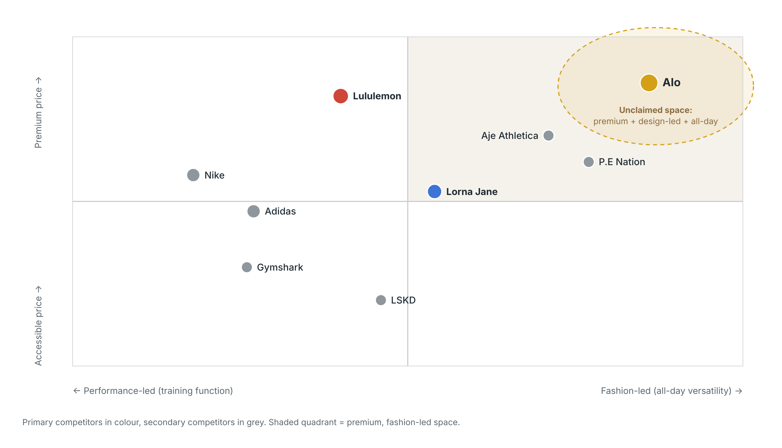
Note. Agency judgement from Table 1; to be validated in the pre-campaign survey.
Lululemon's search interest is almost three times Alo's (Appendix A), and larger brands enjoy more buyers and more loyalty (Sharp, 2010). Alo therefore cannot argue loyalists away; it must become easier to think of and to find. Lorna Jane's penalty for unsupported claims (ACCC, 2021) shows that trust is fragile in this category, and that overclaiming is a risk for Alo too. Competitor weaknesses cluster around dated, functional design or mid-market focus, which leaves premium, design-led, all-day wear unclaimed (Figure 1). Fashion alone is not defensible, because P.E Nation sits nearby with local credentials. Fashion plus proven studio performance, made locally relevant, is. Under financial pressure consumers trade down (Bryant, 2026d), so cheaper brands such as Gymshark become the fallback whenever Alo's premium is not justified. Adidas's rise through community-led marketing (Danziger, 2026) confirms that community works in this category, but also that the space is crowded; Alo needs a community with a distinct purpose.

1.3 Target Audience
Of three segments (Smith, 1956; see Appendix B), we target style-conscious women aged 22–34 in Greater Sydney who do Pilates, yoga or gym and use Instagram and TikTok daily. Affluent women aged 35–50 are loyal to Lululemon and Lorna Jane and hard to switch, and men are a small part of Alo's range, so both are reached only as spillover. The chosen segment buys activewear as identity: possessions extend the self (Belk, 1988), and Alo turns a healthy lifestyle into a visible identity (36Kr, 2026). It spans older Gen Z, who value authenticity, and younger Millennials, who value experiences and use streaming and podcasts (Bryant, 2026a), so the campaign pairs creator content with bookable experiences and audio. Social dynamics matter as well: messages aligned with a group's norms spread further by word of mouth (Bryant, 2026a), and the studio class is this segment's most visible reference group, which is where the campaign places its sources. Critically, more than half of Gen Z and Millennials have delayed major decisions because of financial pressure (Bryant, 2026a). The audience most drawn to Alo is also the most price-stretched, which is why price justification ranks first below and why value is framed as longevity rather than discount.

1.4 Communication Challenges (Prioritised)
Challenges are ranked by how directly each blocks a store visit. The first two block the feel and learn stages of Section 2; the last three explain why generic advertising would not solve them.
- Justifying the premium price: luxury needs meaning, not features (Kapferer & Bastien, 2009).
- Sustaining awareness: interest has fallen to pre-opening levels, and The Galeries opening produced no lift (Appendix A), so novelty alone will not sustain the brand.
- Limited reach: two stores cannot cover Greater Sydney, so media must bring people to them.
- Standing apart from Lululemon, which already owns "community" (Salpini, 2025b); a generic community message would strengthen the leader.
- Feeling imported: Alo's fame rests on Los Angeles celebrity (Inside Retail, 2026), which Section 3.1 shows Sydney decodes as distance.

2. Communication Objectives
Table 2
DAGMAR Objectives: Segment A, Greater Sydney, 12 Weeks
# | Stage | Challenge | Survey measure | Baseline | Target
O1 | Feel | 1 | Agree "Alo is worth paying more for" | 15% | 30%
O2 | Feel | 4, 5 | Agree Alo "is a brand for people like me in Sydney" | 12% | 25%
O3 | Learn | 2 | Aware Alo has stores in Sydney | 25% | 50%
O4 | Do | 3 | Visited an Alo store or website in the past three months | 8% | 15%

The objectives follow DAGMAR (Colley, 1961). AIDA and the hierarchy of effects assume that consumers think, then feel, then do (Bryant, 2026k; Lavidge & Steiner, 1961). Figure 2 shows why this campaign reverses the first two steps. Premium activewear is a high-involvement purchase worn in public, so attitude precedes information (Vaughn, 1980): until Segment A feels Alo is "for people like me", knowing a store's address is worthless. The hierarchy is a heuristic, not a law, so all four objectives are tracked simultaneously. Each objective is specific and measurable. O3 (doubling store awareness) is the most ambitious, but it is attainable because every paid asset carries the store line, and it links directly to the reach objective in Section 5. Baselines are estimates to be confirmed by the pre-campaign survey, and visits rather than sales are targeted because price and stock sit outside communication's control (Belch & Belch, 2021).
Figure 2
Response Hierarchy Applied to the Objectives
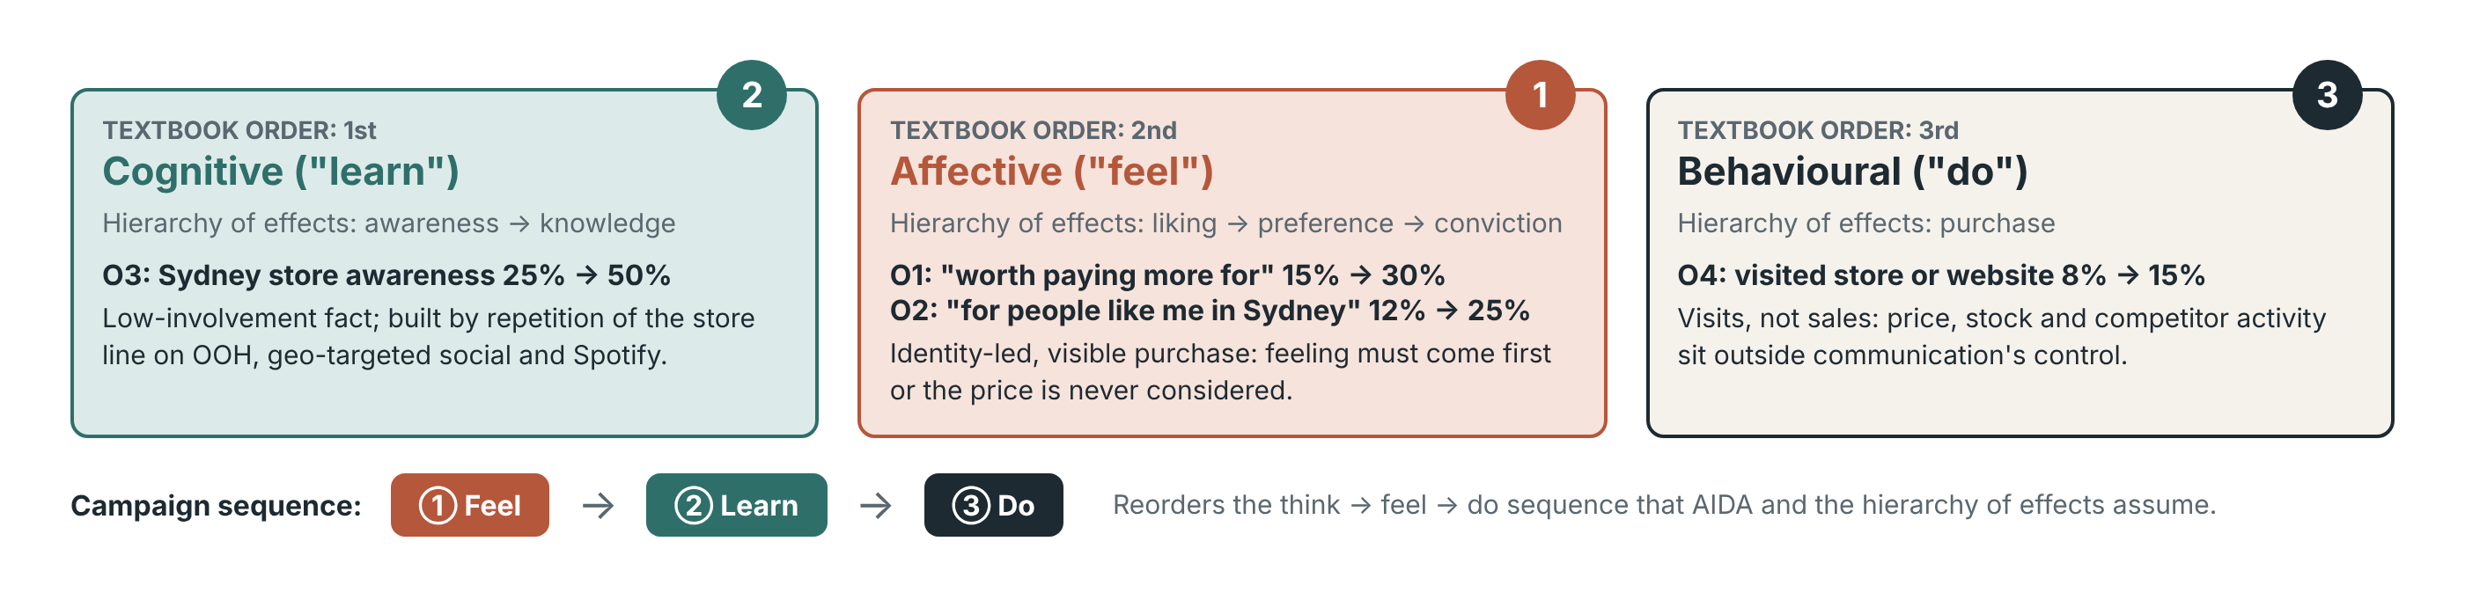
Note. Adapted from Bryant (2026k), Lavidge and Steiner (1961) and Vaughn (1980).

3. Communication Strategy

3.1 Insight and Diagnosis
Insight: for Segment A, studio fitness is a social performance. Young women experience exercise as visible "aesthetic labour" on Instagram (Camacho-Miñano et al., 2019), so activewear is judged at the café as much as in class. The communication process model (Bryant, 2026k) explains why Alo has not yet capitalised on this (Figure 3). Meaning is shared only where fields of experience overlap. Alo's launch was encoded in Los Angeles and decoded in Sydney as "beautiful, but not for me". The fix is not more volume but re-encoding the message through Sydney instructors and creators, whose fields of experience overlap almost completely with the audience's. The model also highlights noise from Lululemon's far larger share of search and a crowded influencer feed, which favours repeating one idea. The model's feedback loop is built into the plan: creator comments, bookings and search interest are reviewed between bursts so the encoding can be adjusted (Section 6).
Figure 3
Communication Process Model Applied to Alo's Sydney Launch
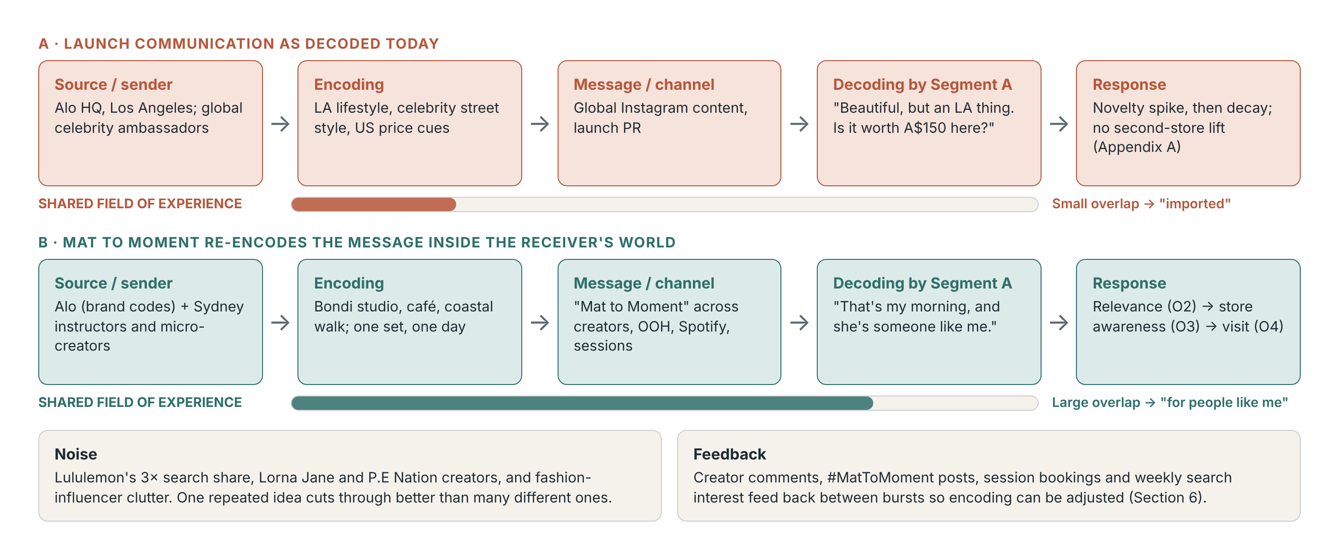
Note. Adapted from Bryant (2026k).

3.2 Positioning: Global Brand, Local Meaning
For style-led studio women in Sydney, Alo is the premium activewear brand designed to move from the reformer to the rest of the day. Global IMC warns that efficiency for the company is not relevance for the consumer (Bryant, 2026l). Following the governance split in Bryant (2026l; see Appendix C), Alo's identity, positioning and visual assets are standardised to protect its global prestige: logo, neutral palette, studio aesthetic and a no-discount policy. People, places, partnerships and offers are localised: Sydney instructors, Bondi and CBD settings, Body by Berner, and styling appointments. Localness adds relational value even for foreign brands (Sichtmann et al., 2019). The risk is that Alo's own global celebrity content keeps reaching Sydney feeds, so the local work must be distinctive enough to compete with Alo's global voice.

3.3 Message Strategy
One message carries the proposition everywhere: "Mat to Moment: one set, made for the whole day." Figure 4 traces its three pillars from challenge to touchpoint. The pillars divide the persuasive work; they are not three campaigns. Each carries the same line, and the shared brand codes beneath them are what make the campaign integrated rather than merely multi-channel.
Figure 4
Integration Architecture: One Message, Three Pillars
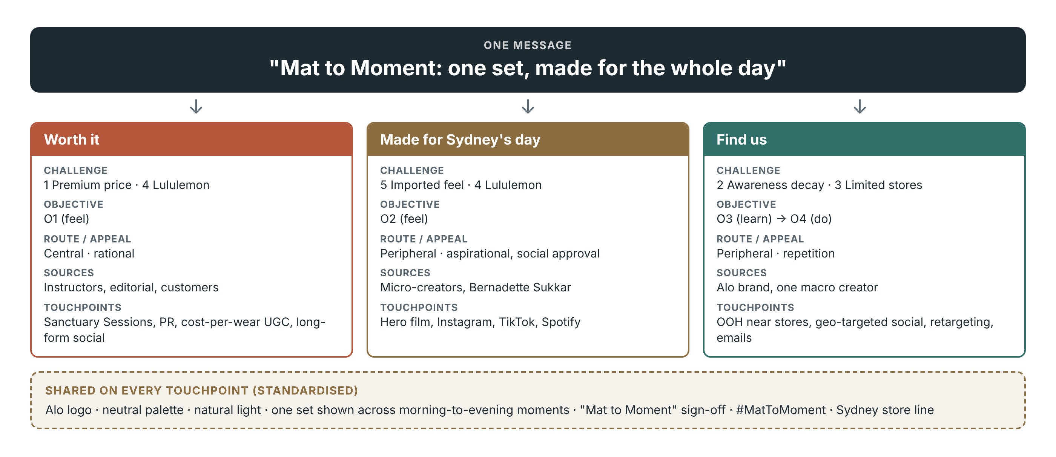
Note. Challenges, objectives and touchpoints refer to Sections 1.4, 2 and 5.
Under the Elaboration Likelihood Model, the persuasion route depends on motivation and ability (Bryant, 2026k; Petty et al., 1983). Segment A is motivated but meets most messages while scrolling, when ability is low (Figure 5). Made for Sydney's day therefore works peripherally, through local sources and familiar settings, and Find us through repetition that builds memory structures (Sharp, 2010). Peripheral attitudes are weaker and fade faster, which is why the schedule keeps an always-on base rather than relying on bursts alone. Worth it takes the central route: fit, fabric and cost per wear are tested hands-on at Sanctuary Sessions, because centrally formed attitudes resist counter-arguments such as "Lululemon is cheaper" (Petty & Cacioppo, 1986). The routes are not exclusive, since one post can trigger both product and source thoughts (Bryant, 2026k), and sessions reach hundreds rather than thousands, so every session is filmed to carry its proof further. Discounting was rejected because it weakens brand equity (Bryant, 2026d).
Figure 5
Elaboration Likelihood Model Applied to the Pillars
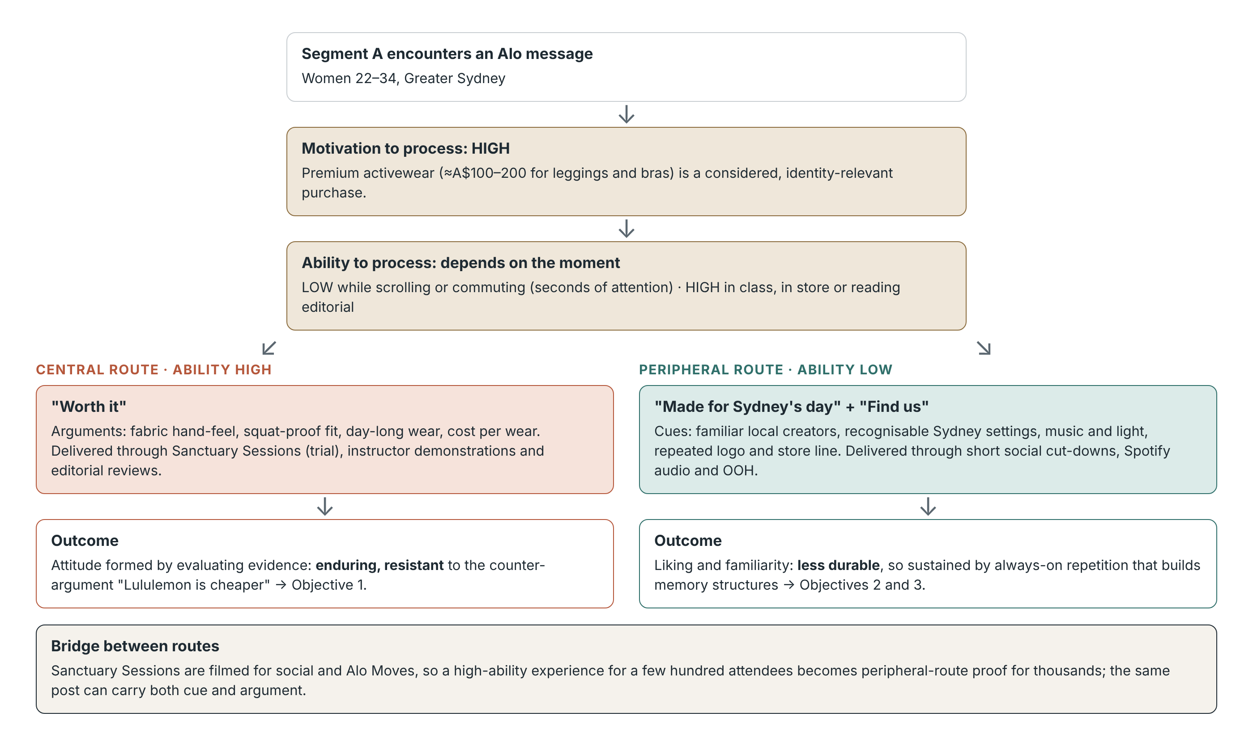
Note. Adapted from Bryant (2026k) and Petty et al. (1983).

3.4 Source Selection
Sources are judged on credibility, attractiveness (Bryant, 2026k; Ohanian, 1990) and fit with the claim (Kamins, 1990), across the influencer tiers in Bryant (2026e) (Figure 6). Instructors are experts matched to a performance claim. Micro-creators trade reach for credibility, which drives trust in influencer content (Lou & Yuan, 2019), and very large followings can reduce perceived uniqueness (De Veirman et al., 2017). Editorial adds third-party credibility (Cameron, 1994). A celebrity was rejected because high attractiveness with low local fit would re-encode the Los Angeles meaning. The cost is reach, which one macro creator and paid media buy back. Credibility is also legal: 96% of fashion influencers reviewed had posts raising consumer-law concerns (Bryant, 2026g), so disclosure is mandatory in every brief. Virtual and AI-generated influencers were excluded, because attractiveness loses its persuasive power when audiences doubt a source is real (Bryant, 2026k).
Figure 6
Source Characteristics Applied Across Influencer Tiers
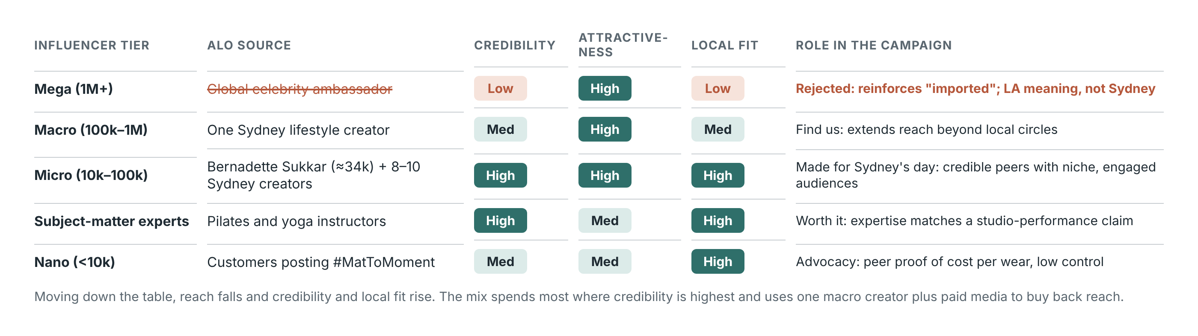
Note. Adapted from Bryant (2026e, 2026k).

3.5 Integration Across the Journey
IMC exists because fragmented messages weaken brand equity and trust (Bryant, 2026f). Figure 7 maps the campaign onto the social consumer decision journey (Bryant, 2026k): each stage has a different job, but all six tell the same story, and advocates' #MatToMoment posts become discovery content for the next customer at no media cost. Figure 8 shows the cost of this approach. About 45% of the budget goes to creators, sessions and PR, which carry higher impact but lower control (Bryant, 2026f), Company-created touchpoints such as outdoor are controllable but persuade least. Customer-initiated and unexpected ones, such as a #MatToMoment post, a critical review or a creator controversy, persuade most but cannot be scripted. Shared brand codes, tight creator briefs and weekly social listening protect consistency. This is the campaign's central bet: an advertising-led plan would be more controllable but less believable, which is the opposite of what Challenges 1 and 5 need. Because the journey is non-linear, attribution across touchpoints will remain imperfect (Bryant, 2026d), which Section 6 acknowledges.
Figure 7
Social Consumer Decision Journey Applied to the Campaign
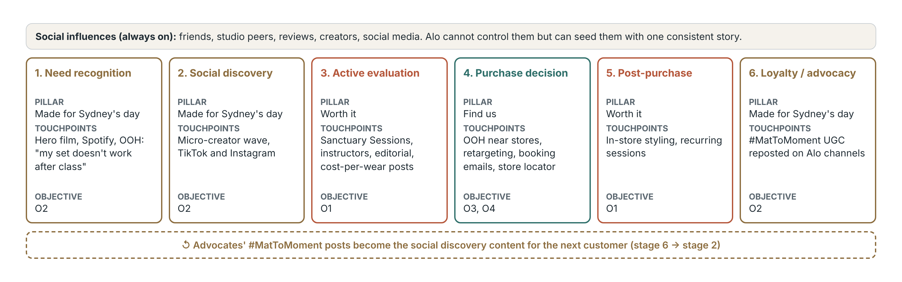
Note. Adapted from Bryant (2026k).
Figure 8
Campaign Touchpoints by Impact and Control
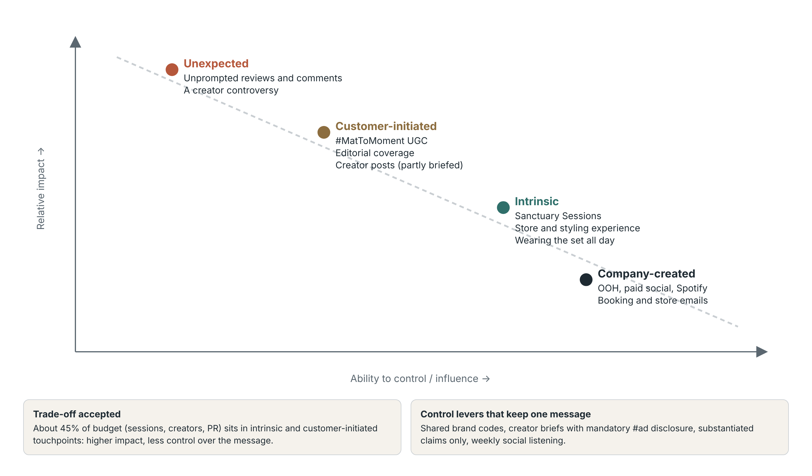
Note. Adapted from Bryant (2026f).

4. Creative Strategy

4.1 Creative Brief and Concept
Table 3
Creative Brief Summary
Element | Mat to Moment
Target audience | Style-conscious women, 22–34, Greater Sydney
Key insight | Activewear is judged after class as much as in it
Key message | One set, made for the whole day
Reasons to believe | Instructor-tested fit, cost per wear, editorial reviews
Tone | Calm, confident, natural light, diverse bodies
Mandatories | #ad disclosure, substantiated claims, sync licences
Deliverables | Hero film, cut-downs, audio, outdoor, creator toolkits
Note. Elements from Bryant (2026h).
One Set, One Day follows a single Alo set through a real Sydney day. The lead creator, Bernadette Sukkar of Body by Berner in Bondi, combines Pilates expertise with a fashion-PR background, matching both halves of the message (RIISE, 2026). Her studio hosts the first Sanctuary Sessions: a class, a fabric trial and styling advice, followed by a complimentary styling appointment rather than a discount. Event marketing creates immersive experiences that strengthen brand recall (Bryant, 2026f), and the sessions add something Lululemon's run clubs do not: the community continues into the "moment" after class, which is the half of the proposition Lululemon does not own.

4.2 Creativity, Appeals and Execution
The idea is divergent, because it shows quiet post-class moments rather than the category's sweat and intensity. It is also relevant, because that narrative is the positioning (Bryant, 2026h; Smith & Yang, 2004). On the divergence dimensions (Appendix D), it shows originality (quiet moments), synthesis (linking the reformer and the café through one garment) and flexibility (it works as film, still, audio and live session). The risk is that divergent work is remembered without the brand, so the logo, palette and "Mat to Moment" sign-off appear in every execution. The lead appeals are aspirational and social approval (Bryant, 2026h). Social approval is the riskiest choice here, because visibility drives appearance pressure (Camacho-Miñano et al., 2019), and persuasion becomes manipulation when it exploits vulnerability (Bryant, 2026g). Executions therefore show diverse bodies and use no retouching. A rational appeal reframes price as cost per wear, reflecting that value now means longevity (Bryant, 2026d). Slice-of-life storytelling carries the emotion, and demonstration carries the proof. Together they meet the execution criteria in Bryant (2026h) of message clarity, storytelling, brand integration and credibility, so neither appeal has to work alone.

4.3 One Idea Across Every Channel
The Burberry case shows that strong campaigns use many tactics in service of one idea (Bryant, 2026h). In Figure 9, each channel adapts the hook and call to action to suit its medium, but all share one story and one sign-off, which gives consistent meaning without identical executions (Bryant, 2026d). Because IMC builds recall through repetition and consistency (Bryant, 2026f), a viewer who hears the audio, passes a bus shelter and then sees a creator's post meets one idea three times, not three different ideas once. Weaker formats compress the idea rather than abandon it: outdoor shows three moments in a single frame, and audio replaces visuals with spoken timestamps, the sounds of waves and a coffee machine, and a sonic sign-off. Claims must also meet section 18 of the Australian Consumer Law, a risk Lorna Jane's A$5 million penalty illustrates (ACCC, 2021). Creator posts carry #ad labels, emails need Spam Act consent, and the music needs sync licences (Bryant, 2026g).
Figure 9
Creative Tactics Adapted by Channel Around One Idea
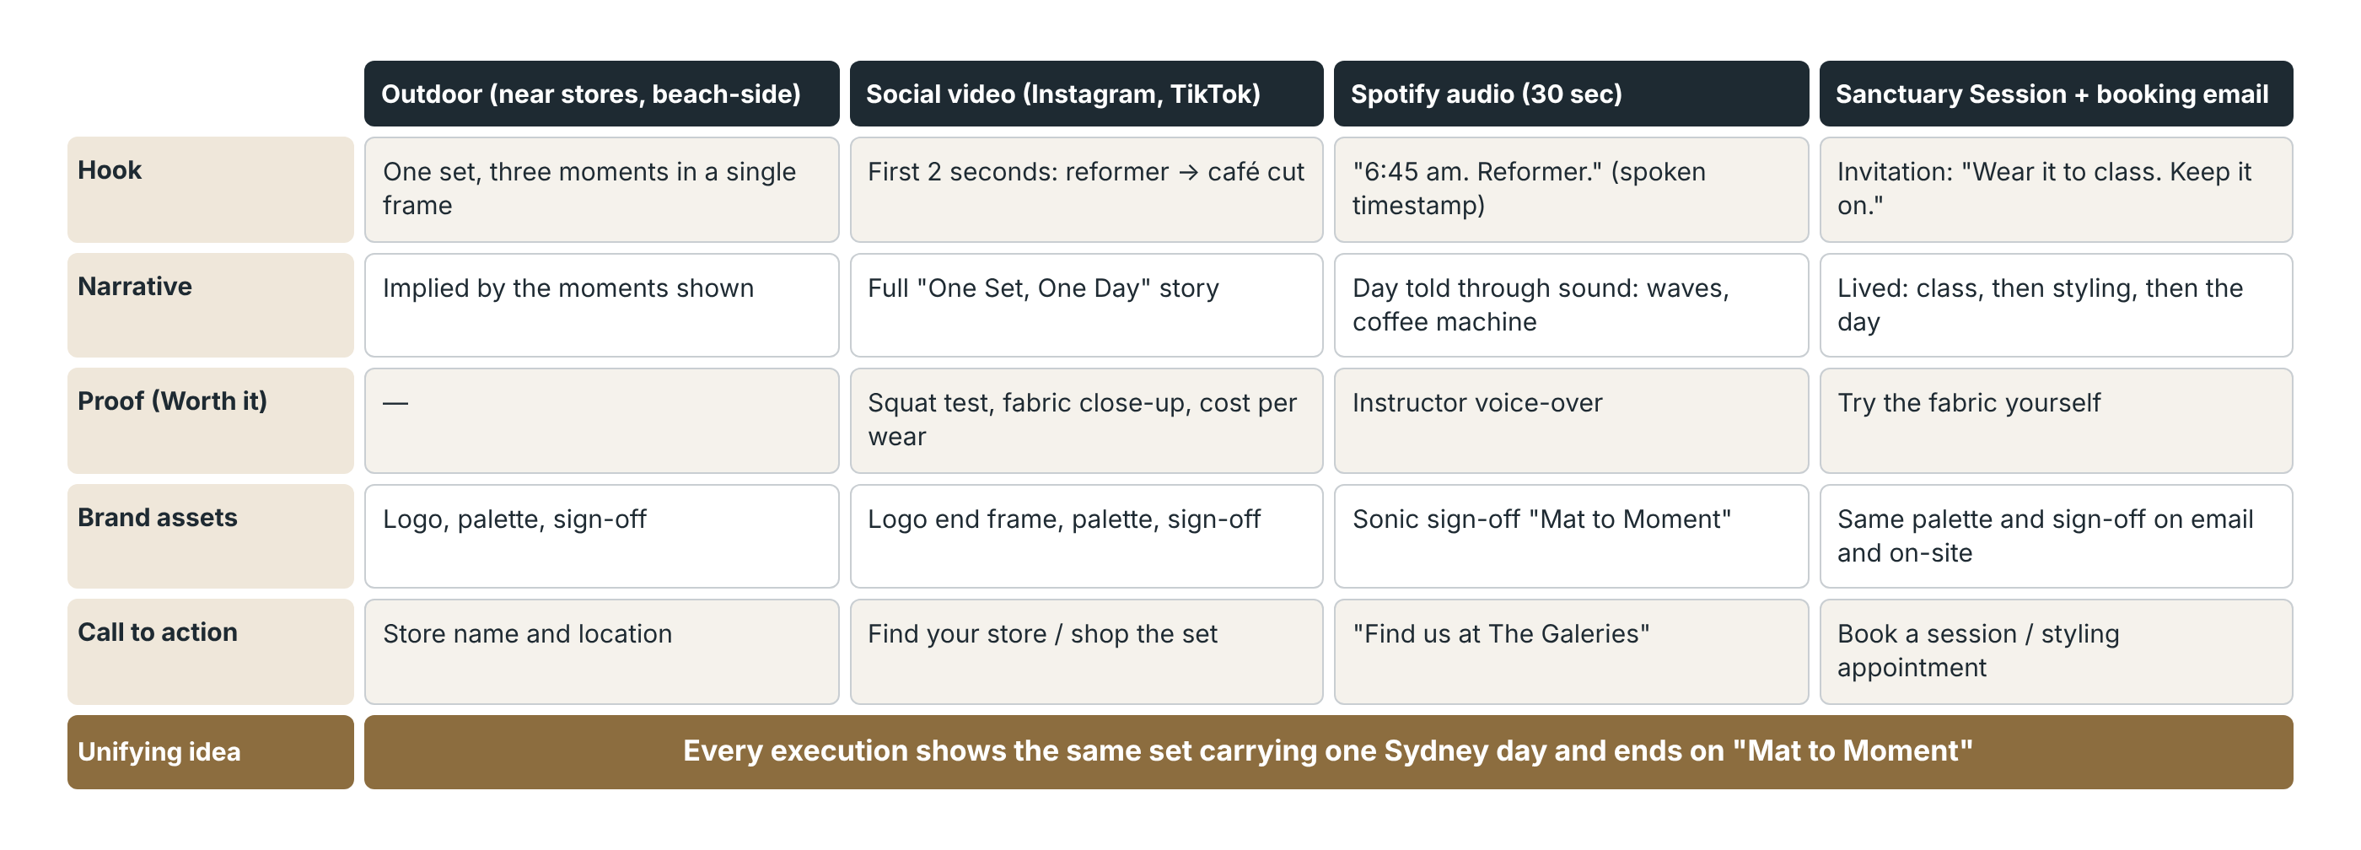
Note. Adapted from Bryant (2026h).

5. Media Strategy and Budget
Media planning balances reach for awareness against frequency for persuasion (Bryant, 2026i), and the campaign splits that job. Outdoor, Spotify and geo-targeted social provide reach for Find us; creators and sessions provide depth for Worth it and Made for Sydney's day. The media objective is to reach 70% of Segment A at least once in Burst 1, at an average frequency of four, and to retarget 20% of those exposed in Burst 3. Geographic coverage is Greater Sydney, weighted to the catchments around Chatswood Chase, The Galeries and Bondi Junction. If Bondi Junction opens late, its weight moves to the CBD. Outdoor has low selectivity (Bryant, 2026e), so it carries only the store line, near the stores. Spotify suits Millennial listening (Bryant, 2026a) but cannot show the set, so it uses sound cues, and retargeting follows anyone exposed (Bryant, 2026c). PR must pass the publicity test (Bryant, 2026j). A branded class fails it, so the hook is a free Bondi-to-Bronte walk series. Sessions also act as a free trial, which reduces purchase risk without a price cut (Bryant, 2026j). Booking and store emails are personalised direct marketing that converts interest into visits, so they are sent only with recorded consent (Bryant, 2026e, 2026g).
Table 4
Media Mix
Vehicle | Pillar | Type | Role
Outdoor near stores | Find us | Paid | Reach, store cue
Spotify audio | Sydney's day | Paid | Reach
Paid social, retargeting | All | Paid | Reach, then frequency
Creators | Sydney's day | Paid → earned | Credibility
Sanctuary Sessions, PR | Worth it | Earned | Trial, credibility
Owned social, emails | Find us | Owned | Conversion

Interest decays after each novelty spike (Appendix A), so scheduling uses pulsing: an always-on base with three bursts (Bryant, 2026i; Figure 10). Burst 1 (weeks 1–3) builds awareness, Burst 2 (weeks 6–8) builds consideration in February, when many people resume fitness routines, and Burst 3 (weeks 11–12) drives visits and advocacy. Flighting would leave gaps in which interest decays, and full continuous weight is unaffordable.
Figure 10
Twelve-Week Pulsing Schedule, 4 January – 28 March 2027
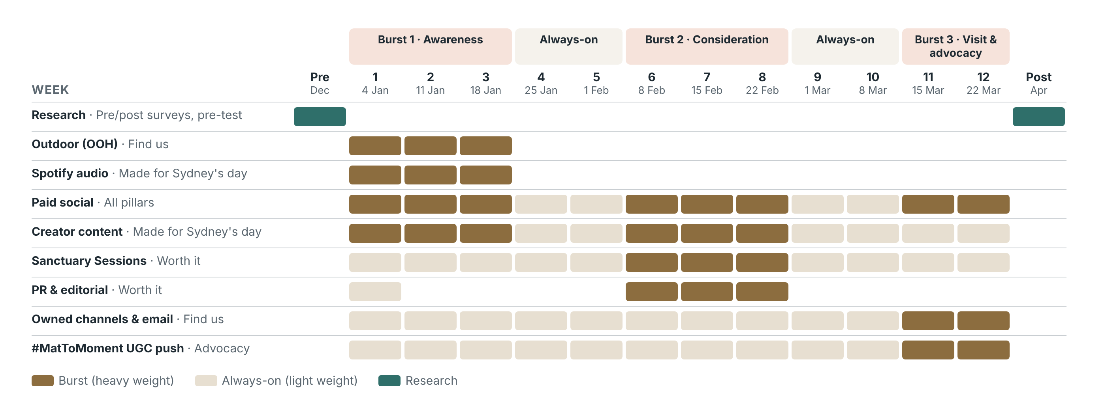
Note. Adapted from Bryant (2026i).
The budget uses the objective-and-task method (Belch & Belch, 2021). Partnerships receive 42% because they span paid, owned and earned media (Bryant, 2026c): a creator partnership is paid, its content is reused on Alo's owned channels, and audiences share it as earned media. Discounting and celebrity fees are excluded because both would weaken Alo's premium, local position. The weakness is that only 40% buys traditional reach, so if Burst 1 misses its reach target, the contingency moves into paid social. Figures are planning estimates to be confirmed with media quotes and creator rate cards, and the 5% contingency also covers rate rises and a delayed Bondi Junction opening.
Table 5
Budget (A$)
Line item | Subtotal | A$ | %
Paid social | A. Paid media | 45,000 | 18
Outdoor | A. Paid media | 40,000 | 16
Spotify audio | A. Paid media | 15,000 | 6
Subtotal A |  | 100,000 | 40
Sanctuary Sessions and instructors | B. Partnerships | 55,000 | 22
Creator partnerships | B. Partnerships | 50,000 | 20
Subtotal B |  | 105,000 | 42
Content production | C. Content and PR | 20,000 | 8
PR and editorial | C. Content and PR | 8,000 | 3.2
Research (pre/post surveys) | D | 5,000 | 2
Contingency | E | 12,000 | 4.8
TOTAL |  | 250,000 | 100

6. Campaign Evaluation
Effectiveness means achieving the intended outcomes, not likes (Bryant, 2026b). Pre-testing in December 2026 uses concept tests, A/B comparisons of edits and the baseline survey to check comprehension, brand attribution, relevance and the call to action (Bryant, 2026b). Because test viewers are made to watch, results are used to choose between executions rather than forecast outcomes. In-flight digital metrics guide reallocation between bursts (Bryant, 2026c), Creators are judged on audience fit, credibility, brand lift and tracked action, not followers (Bryant, 2026b). Each measure in Table 6 maps to one objective, so the evaluation tests the same feel → learn → do logic that built the campaign. Post-testing in April 2027 repeats the survey, uses social listening, checks self-reported visits against store traffic and web analytics, and compares results with a Melbourne control sample. Because correlation is not causation, results will be reported as indicative rather than proven (Bryant, 2026b). AI tools can speed up this analysis, but their outputs still need human judgement. Unexpected audiences, such as older shoppers responding to outdoor, will be reported as learning rather than noise.
Table 6
Evaluation Plan
Objective | Measures | Timing | Success
O1, O2 | Survey agreement; UGC and comment sentiment | Dec 2026, Apr 2027 | ≥30%, ≥25%
O3 | Prompted awareness; weekly Google Trends | Surveys, weekly | ≥50%
O4 | Self-reported visits; store traffic; tracked links | Surveys, weekly | ≥15%

7. Conclusion
Alo arrived in Sydney with a famous name but little local meaning. Every pillar, source, channel and burst in this brief answers a diagnosed challenge, with one message adapted to every channel but never changed: one set, made for the whole Sydney day.

References
Australian Competition and Consumer Commission. (2021, July 23). Lorna Jane pays $5 million over false 'anti-virus activewear' claims [Media release]. https://www.accc.gov.au/media-release/lorna-jane-pays-5-million-over-false-anti-virus-activewear-claims
Belch, G. E., & Belch, M. A. (2021). Advertising and promotion: An integrated marketing communications perspective (12th ed.). McGraw-Hill Education.
Belk, R. W. (1988). Possessions and the extended self. Journal of Consumer Research, 15(2), 139–168. https://doi.org/10.1086/209154
Bryant, P. (2026a). The audience: Consumers and marketing communications [Lecture slides, Week 2]. MKTG3112 Marketing Communications, The University of Sydney.
Bryant, P. (2026b). Did it work? Measuring the effectiveness of the campaign [Lecture slides, Week 10]. MKTG3112 Marketing Communications, The University of Sydney.
Bryant, P. (2026c). Digital media [Lecture slides, Week 8]. MKTG3112 Marketing Communications, The University of Sydney.
Bryant, P. (2026d). The future of IMC in a polycrisis world [Lecture slides, Week 13]. MKTG3112 Marketing Communications, The University of Sydney.
Bryant, P. (2026e). IMC tools II: Support media, direct marketing and influencer marketing [Lecture slides, Week 7]. MKTG3112 Marketing Communications, The University of Sydney.
Bryant, P. (2026f). Introduction to marketing communications: Message, story and strategy [Lecture slides, Week 1]. MKTG3112 Marketing Communications, The University of Sydney.
Bryant, P. (2026g). Legal, ethical and misleading: IMC and the law [Lecture slides, Week 11]. MKTG3112 Marketing Communications, The University of Sydney.
Bryant, P. (2026h). Making a plan 2: The creative brief and creative strategy implementation and development [Lecture slides, Week 5]. MKTG3112 Marketing Communications, The University of Sydney.
Bryant, P. (2026i). Media strategy and IMC tools I: Traditional media planning [Lecture slides, Week 6]. MKTG3112 Marketing Communications, The University of Sydney.
Bryant, P. (2026j). Media strategy and IMC tools IV: The personal touch of sales promotion, public relations and publicity [Lecture slides, Week 9]. MKTG3112 Marketing Communications, The University of Sydney.
Bryant, P. (2026k). Talking about a…: The communication process [Lecture slides, Week 3]. MKTG3112 Marketing Communications, The University of Sydney.
Bryant, P. (2026l). Top of the world: Global IMC strategy [Lecture slides, Week 12]. MKTG3112 Marketing Communications, The University of Sydney.
Camacho-Miñano, M. J., MacIsaac, S., & Rich, E. (2019). Postfeminist biopedagogies of Instagram: Young women learning about bodies, health and fitness. Sport, Education and Society, 24(6), 651–664. https://doi.org/10.1080/13573322.2019.1613975
Cameron, G. T. (1994). Does publicity outperform advertising? An experimental test of the third-party endorsement. Journal of Public Relations Research, 6(3), 185–207. https://doi.org/10.1207/s1532754xjprr0603_02
Chadwick, [Initial]. (2025a). Lorna Jane's profit doubles thanks to strong demand for athletic clothing. Inside Retail. https://insideretail.com.au/business/lorna-janes-profit-doubles-thanks-to-strong-demand-for-athletic-clothing-202501
Chadwick, [Initial]. (2025b). [Article title]. [Publication]. [URL]
Colley, R. H. (1961). Defining advertising goals for measured advertising results. Association of National Advertisers.
Concrete Playground. (2026, September 15). Now open: Cult LA activewear brand Alo has opened a store in the heart of Sydney's CBD at The Galeries. https://concreteplayground.com/sydney/?p=1144787
Danziger, P. N. (2026). [Article title]. Forbes. [URL]
De Veirman, M., Cauberghe, V., & Hudders, L. (2017). Marketing through Instagram influencers: The impact of number of followers and product divergence on brand attitude. International Journal of Advertising, 36(5), 798–828. https://doi.org/10.1080/02650487.2017.1348035
Google Trends. (2026). Lorna Jane, Lululemon and Alo Yoga (topics): Interest over time, New South Wales, 2026 [Data set]. Google. Retrieved October 28, 2026, from https://trends.google.com/trends/
Inside Retail. (2026, May). Alo makes Australian debut at Sydney's Chatswood Chase. https://insideretail.com.au/stores/openings-closings/alo-makes-australian-debut-at-sydneys-chatswood-chase-202605
Kamins, M. A. (1990). An investigation into the "match-up" hypothesis in celebrity advertising: When beauty may be only skin deep. Journal of Advertising, 19(1), 4–13. https://doi.org/10.1080/00913367.1990.10673175
Kapferer, J.-N., & Bastien, V. (2009). The luxury strategy: Break the rules of marketing to build luxury brands. Kogan Page.
Keller, K. L. (1993). Conceptualizing, measuring, and managing customer-based brand equity. Journal of Marketing, 57(1), 1–22. https://doi.org/10.1177/002224299305700101
Lanoue, S. (2025, December 6). [Article title]. Apart Style. [URL]
Lavidge, R. J., & Steiner, G. A. (1961). A model for predictive measurements of advertising effectiveness. Journal of Marketing, 25(6), 59–62. https://doi.org/10.1177/002224296102500611
Lou, C., & Yuan, S. (2019). Influencer marketing: How message value and credibility affect consumer trust of branded content on social media. Journal of Interactive Advertising, 19(1), 58–73. https://doi.org/10.1080/15252019.2018.1533501
Modaes. (2026). The owner of Alo Yoga is considering an IPO after selling Bellacanvas. https://www.modaes.com/global/companies/the-owner-of-alo-yoga-is-considering-an-ipo-after-selling-bellacanvas
Ohanian, R. (1990). Construction and validation of a scale to measure celebrity endorsers' perceived expertise, trustworthiness, and attractiveness. Journal of Advertising, 19(3), 39–52. https://doi.org/10.1080/00913367.1990.10673191
OpenPR. (2026). [Article title]. [URL]
Pedestrian. (2026). [Article title]. Pedestrian.TV. [URL]
Petty, R. E., & Cacioppo, J. T. (1986). The elaboration likelihood model of persuasion. Advances in Experimental Social Psychology, 19, 123–205. https://doi.org/10.1016/S0065-2601(08)60214-2
Petty, R. E., Cacioppo, J. T., & Schumann, D. (1983). Central and peripheral routes to advertising effectiveness: The moderating role of involvement. Journal of Consumer Research, 10(2), 135–146. https://doi.org/10.1086/208954
RIISE. (2026). In motion with Bernadette Sukkar. https://riise.world/blogs/wellness/in-motion-with-bernadette-sukkar
Russh. (2026). [Article title]. Russh. [URL]
Rydzek, [Initial]. (2026, June). Alo Yoga owners eye IPO or sale after offloading wholesale T-shirt business. TheIndustry.fashion. https://www.theindustry.fashion/alo-yoga-owners-eye-ipo-or-sale-after-offloading-wholesale-t-shirt-business/
Salpini, C. (2025a). [Article title]. Retail Dive. [URL]
Salpini, C. (2025b). [Article title]. Retail Dive. [URL]
SGB Media. (2026). Alo Yoga opens first store in Greater China. https://sgbonline.com/alo-yoga-opens-first-store-in-greater-china/
Sharp, B. (2010). How brands grow: What marketers don't know. Oxford University Press.
Sichtmann, C., Davvetas, V., & Diamantopoulos, A. (2019). The relational value of perceived brand globalness and localness. Journal of Business Research, 104, 597–613. https://doi.org/10.1016/j.jbusres.2018.10.025
Smith, R. E., & Yang, X. (2004). Toward a general theory of creativity in advertising: Examining the role of divergence. Marketing Theory, 4(1–2), 31–58. https://doi.org/10.1177/1470593104044086
Smith, W. R. (1956). Product differentiation and market segmentation as alternative marketing strategies. Journal of Marketing, 21(1), 3–8. https://doi.org/10.1177/002224295602100102
36Kr. (2026). [Article title]. 36Kr. [URL]
Vaughn, R. (1980). How advertising works: A planning model. Journal of Advertising Research, 20(5), 27–33.

Appendix A: Google Trends, New South Wales, 2026
Figure A1
Search Interest for Lorna Jane, Lululemon and Alo Yoga (Topics), January–October 2026
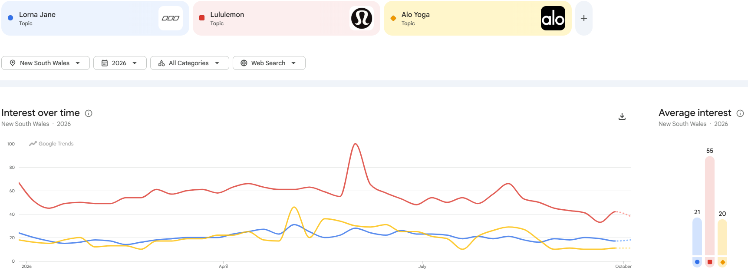
Note. From Google Trends (2026). Indexed relative search volume. Averages: Lululemon 55, Lorna Jane 21, Alo 20. Alo peaked at about 46 at the May opening and has sat near 11 since September; The Galeries opening produced no visible lift.

Appendix B: Segment Evaluation
Table B1
Evaluation of Potential Target Segments
Criterion | A: Style-conscious women, 22–34, Sydney | B: Affluent wellness women, 35–50 | C: Men and unisex
Profile | Pilates, yoga, gym; daily Instagram and TikTok; older Gen Z and younger Millennials (Bryant, 2026a) | Higher incomes; established routines | Growing, but small in Alo's range
Accessible | High: near Chatswood, CBD and Bondi stores; reachable through creators | Medium | Medium
Responsive | High: identity-driven purchase (Belk, 1988) | Low: loyal to Lululemon and Lorna Jane | Medium
Fit with Alo | High (36Kr, 2026) | Medium | Low–medium
Risk | Financial pressure (Bryant, 2026a) | Hard to switch | Needs separate creative
Decision | Primary target | Welcome spillover via outdoor and audio | Not targeted in this phase

Appendix C: Standardisation Versus Localisation
Table C1
Standardisation Versus Localisation Governance for the Australian Launch
Element | Standardised (Alo global) | Localised (Sydney)
Brand identity and assets | Logo, neutral palette, studio aesthetic, typography | —
Positioning | Premium, design-led activewear | Expressed as "Mat to Moment": studio to street in a Sydney day
Sources | No celebrity ambassadors in this launch phase | Sydney instructors, micro-creators, one macro creator
Settings and stories | — | Bondi studio, neighbourhood café, Bondi-to-Bronte walk
Partnerships | — | Body by Berner and partner studios near each store
Offers | No discounting (protects premium) | Styling appointments and early access to new drops
Media | — | Store-catchment outdoor, geo-targeted social, Greater Sydney audio
Note. Governance split adapted from Bryant (2026l).

Appendix D: Divergence and Relevance Assessment
Table D1
Divergence and Relevance Applied to One Set, One Day
Dimension | Evidence in the campaign
Divergence
Originality | Shows quiet post-class moments, not the category's sweat-and-intensity convention
Flexibility | One idea works as film, still, audio, outdoor and live session
Synthesis | Links two unrelated worlds, the reformer and the café, through one garment
Elaboration | Timestamps, sound cues and styling details reward repeat viewing
Artistic value | Natural light and restrained art direction suit a premium brand
Relevance
Meaningfulness | Mirrors Segment A's real routine and its "after class" problem
Brand appropriateness | Expresses Alo's studio-to-street design heritage
Persuasion | Turns a price objection into a cost-per-wear argument
Note. Dimensions adapted from Smith and Yang (2004) as presented in Bryant (2026h).

