How to debug NodeJs

- debug javascript with F5: the active view will be started
or add this to launch.json
{
"type": "pwa-node",
"request": "launch",
"name": "Launch Webserver",
"skipFiles": [
"<node_internals>/**"
],
"cwd": "${workspaceFolder}\\WebServer",
"program": "${workspaceFolder}\\WebServer\\api.js"
}

cwd = current working directory
program = which js to run

How to debug Svelte
- add to launch.json:
{
"type":"msedge",
"request": "launch",
"name": "Launch browser against dev server",
"url": "http://localhost:5000",
"webRoot": "${workspaceFolder}\\WebUI"
}

- start webserver in debug
- start WebUI with npm run dev
- start the configuration, Edge should start and display your page
- the bundle.js in “Loaded scripts” is executed, not the .svelte files !

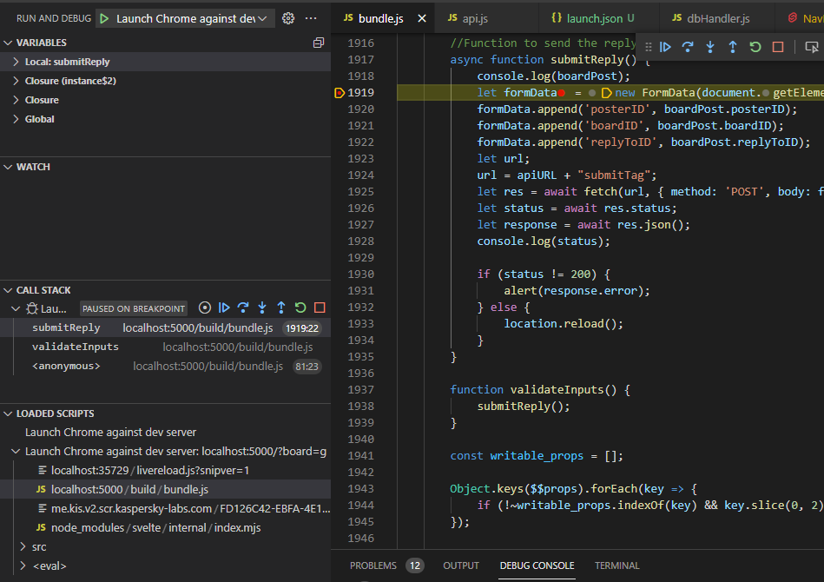

Importing Jquery
- $ and window.$ is reserved, we need to remap jquery
- in Index.html in <head>
<script src="//code.jquery.com/jquery-1.12.4.js"></script>
<script defer >window.jquery=$;</script>
- then you can use window.jquery

Sending Formdata
In .svelte:
<div class="replyBox">
<form action="{apiURL+"/submitTag"}" enctype="multipart/form-data" method="post" id="postForm">
<input type="text" id="nameInput" placeholder="Name" name="name" bind:value={boardPost.name}/>
<button id="replySubmit" on:click|preventDefault={submitReply}>Submit</button>
</form>
</div>

let boardID = urlparams.get('board');
let boardPost = {
"name": "Anonymous ",
"subject":"",
"posterID":"",
"replyToID": "",
"postText":"",
"boardID":"",
}

async function submitReply(){
let formData = new FormData(document.getElementById("postForm"));
formData.append('posterID', boardPost.posterID); //add add. info
let url;
url = apiURL+"submitTag";
let res = await fetch(url,{
method: 'POST',
body: formData,
});

let status = await res.status
let response = await res.json();
if (status != 200){
alert(response.error);
} else {
location.reload();
}
}

