# Debugging the server
- add this to configuration in launch.json
{
"name": "Attach",
"port": 9229,
"request": "attach",
"skipFiles": [
"<node_internals>/**"
],
"type": "pwa-node"
}
- run VITE, then use Attach-configuration from VS-code debugger. The command is equal to npm run dev but has the --inspect option set to start debugger-listener
------------------------------------------
D:\Projects\HTML\Sveltekit\my-app>node --inspect .\node_modules\vite\bin\vite.js
Debugger listening on ws://127.0.0.1:9229/1d80409e-877c-47bc-ae9a-dfdf3ba3fe5d
For help, see: https://nodejs.org/en/docs/inspector
VITE v4.4.3 ready in 1253 ms
➜ Local: http://localhost:5173/
➜ Network: use --host to expose
➜ press h to show help
Shortcuts
press r to restart the server
press u to show server url
press o to open in browser
press c to clear console
press q to quit
Debugger attached.
--------------------------------------------
- use --inspect-brk to stop on start until debugger connects
- you should now be able to set breakpoints (but only in js/svelte-files that run on the server) and see the logger-output in the debug-console
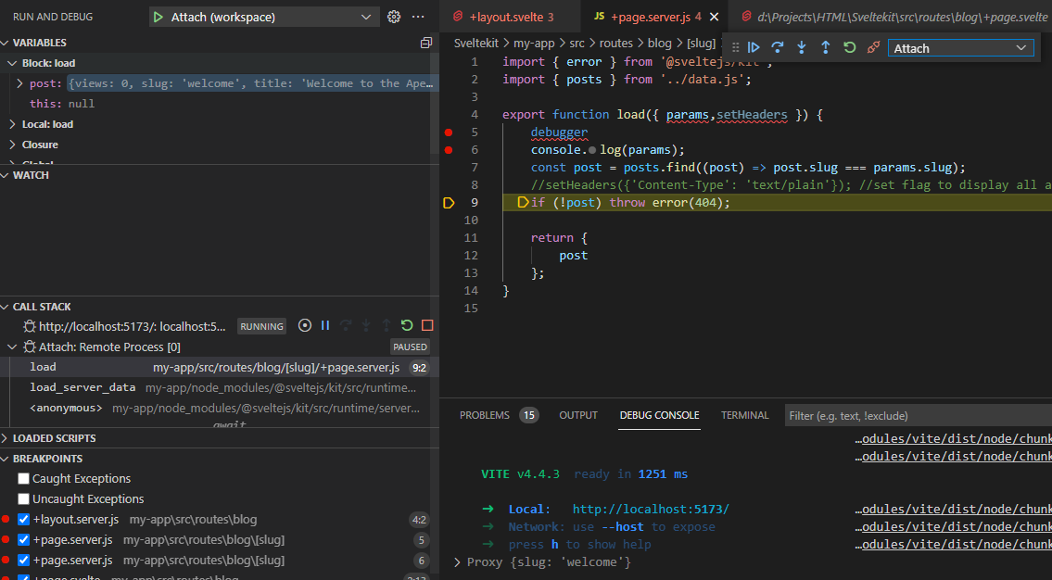

#Debugging the client

- add this to configuration in launch.json
{
"type": "pwa-msedge",
"name": "http://localhost:5173/",
"request": "launch",
"url": "http://localhost:5173/"
}

- start VITE (in debugging or normal)
- start the launch-configuration, the webbrowser should open and show the start-page
- start debugger in browser and navigate to your +page.svelt. It should be possible to set breakpoints in clientside code here.
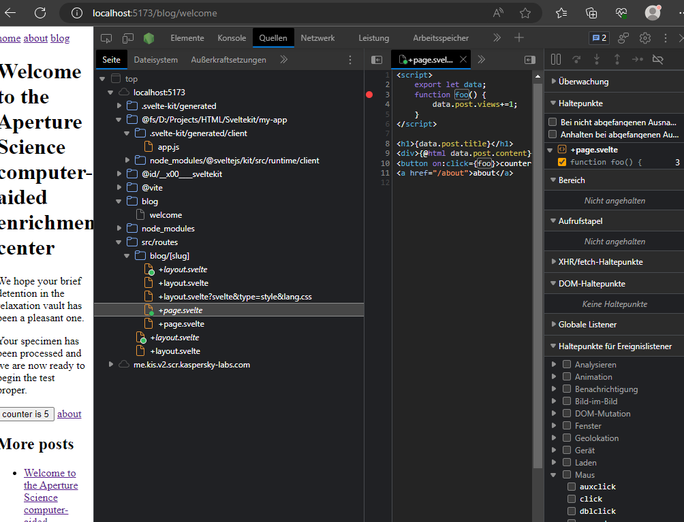
- Not sure if this is normal: on the first time starting browser-debugger, Edge asked for my workspace directory. After setting it to directory off My-App, the debugger in VS-code was working too (setting breakpoints, viewing variables, displaying callstack )!
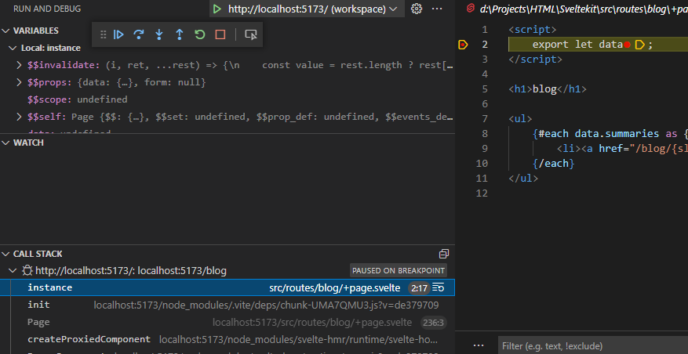
- callstack displays the current browsed page, but you cannot jump into code by doubleclicking. You need to open the file manually in the workspace treeview.
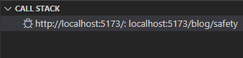
- you can use server & client debugger in VS code at the same time, you just have to switch debugger context in the debugger-toolbar

#Pitfalls when using routes like /gallery/[page]

Lets assume you have a gallery-page with a paginator-component and thumbnails-component and you want to switch to different pages like /gallery/2:

- in the page connect the paginators page-switch-prop with a function to react on page-flip
- this function calls goto(`/gallery/${route}`) to reload the new page
- your page will be reloaded (not the page itself but the data) and you should see the data change.
- However, it might occur that your components dont update because they are not programmed in a reactive way, especially if they require function-calls:
Maybe you have some function showThumbnails(data) in your thumbnails-comp. which is called in the scripts-section. Then you have to wrap that call into reactive statement or it will not be reevaluated on change of data!: $:{showThumbnails(data);}
- note that invalidateAll will not solve your issue as it just related to loading the data

- there are other suggestions that are bad design:
- force reconstruction of components with #key: This may mixup the pagelayout as the comp. Is injected in the main-slot?!
{#key $page.url.pathname}
<ThumbsList slot="footer" design="top" onclick={onthumb} data={data} onpage={routeToPage}/>
{/key}
- chain goto like goto(`/`).then(()=> goto(`/browser/${route}`, {replaceState:replaceState,invalidateAll:true })) to force full page reload. This is bad design as the whole page flickers.

#Alternative way for static images
You can do this in page.svelte. The rendered html is “<img src="/src/lib/assets/icon.png">”
<script> import Icon from "$lib/assets/icon.png"</script>
<img src={Icon} />

Static images will be copied to your dist-pakage. So for a dynamic gallery you have to follow the non-static approach.

#Non-static images and other files
Solution#1 use API endpoint GET to fetch data

Solution#2 use server-load and then createObjectURL in the page-load.

Be aware that you cannot access document or window until onMount is called and therefore cannot set img.src directly from script.

