Inhaltsverzeichnis
# Debugging the server 1
#Debugging the client 2
#Use import but not required 4
#Pitfalls with Reactivity 4
#Pitfalls when using routes like /gallery/[page] 4
#Loading data 5
##page-params or searchparams 5
##Loading non-static images or other files from outside the static-folder 6
#Uploading data 6
##With forms 6
#Layouts 7
##break out of layouts 7

# Debugging the server
- add this to configuration in launch.json
{
"name": "Attach",
"port": 9229,
"request": "attach",
"skipFiles": [
"<node_internals>/**"
],
"type": "pwa-node"
}
- run VITE, then use Attach-configuration from VS-code debugger. The command is equal to npm run dev but has the --inspect option set to start debugger-listener
------------------------------------------
D:\Projects\HTML\Sveltekit\my-app>node --inspect .\node_modules\vite\bin\vite.js
Debugger listening on ws://127.0.0.1:9229/1d80409e-877c-47bc-ae9a-dfdf3ba3fe5d
For help, see: https://nodejs.org/en/docs/inspector
VITE v4.4.3 ready in 1253 ms
➜ Local: http://localhost:5173/
➜ Network: use --host to expose
➜ press h to show help
Shortcuts
press r to restart the server
press u to show server url
press o to open in browser
press c to clear console
press q to quit
Debugger attached.
--------------------------------------------
- use --inspect-brk to stop on start until debugger connect
- you should now be able to set breakpoints (but only in js/svelte-files that run on the server) and see the logger-output in the debug-console
- sometimes breakpoints are not registered, try to stop VITE and start again
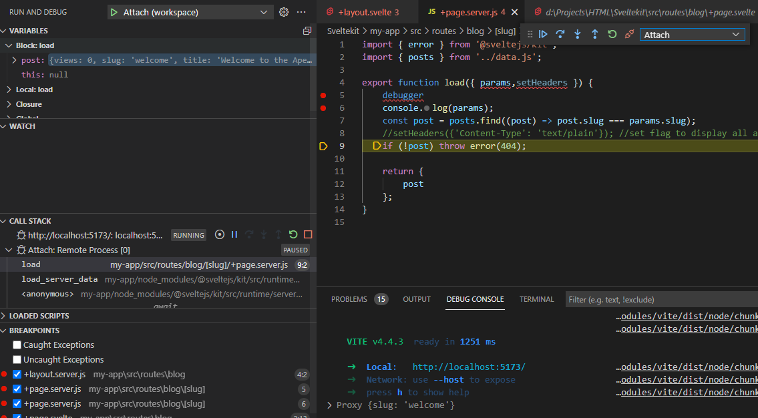

#Debugging the client

- add this to configuration in launch.json. You might need to adjust type to your browser.
{
"type": "pwa-msedge",
"name": "http://localhost:5173/",
"request": "launch",
"url": "http://localhost:5173/"
}

- start VITE (in debugging or normal)
- start the launch-configuration, the webbrowser should open and show the start-page
- start debugger in browser and navigate to your +page.svelt. It should be possible to set breakpoints in clientside code here.

- Note: with Node v17 IP6 is preffered. That causes issues because debugger trys to connect with IP4. This will lead to errors and slow processing in debugger (“Could not read source map for http://localhost...“)
Force IP6 in launch.json: "url": "http://[::1]:5173/"

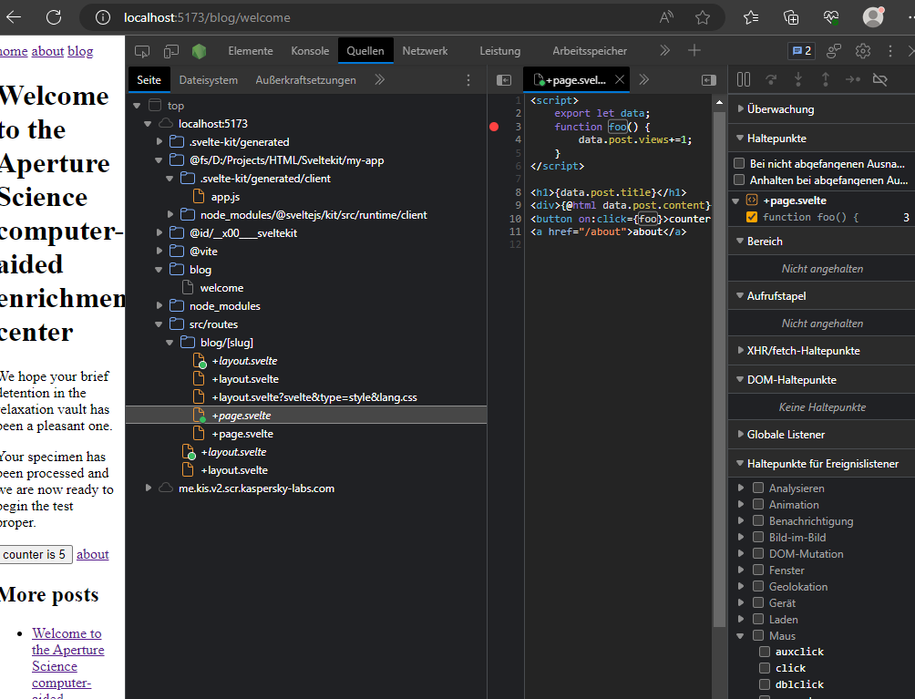
- Not sure if this is normal: on the first time starting browser-debugger, Edge asked for my workspace directory. After setting it to directory off My-App, the debugger in VS-code was working too (setting breakpoints, viewing variables, displaying callstack )!
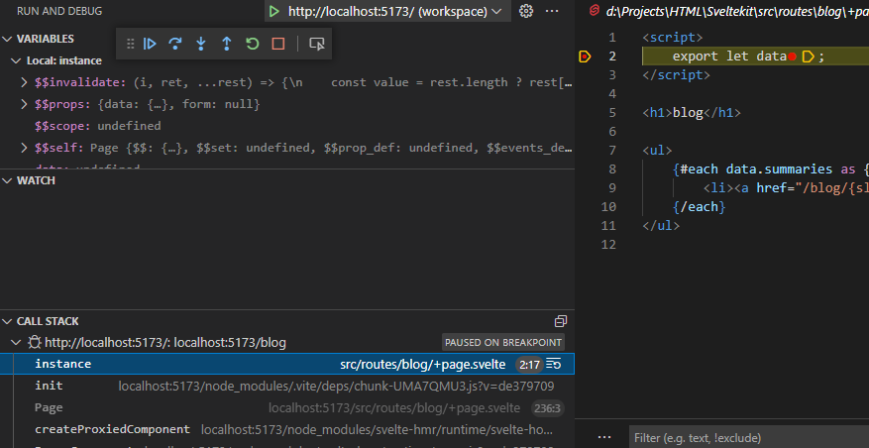
- callstack displays the current browsed page, but you cannot jump into code by doubleclicking. You need to open the file manually in the workspace treeview.
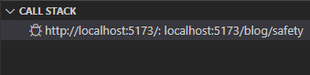
- you can use server & client debugger in VS code at the same time, you just have to switch debugger context in the debugger-toolbar

#Use import but not required
- Required is not supported by VITE which might cause issues with librarys using required internally. Workaround ?
You can import diffeent things in *.svelte:
- Import image(-path). The rendered html is “<img src="/src/lib/assets/icon.png">”
- <script> import Icon from "$lib/assets/icon.png"</script>
- <img src={Icon} />

- Svelte will copy those linked images to your dist-package. So for a dynamic gallery you have to follow the non-static approach.

- import style:
<script> import '$lib/styles/style.css'</script>

- import components:

- import scripts:

#Pitfalls with Reactivity
##Reactivity is triggered by assignment
- if you modify an object or array, this will not trigger an update, as only assignment (=) triggers. Other array or object manipulations like push, slice wont be noticed.
As a hack add a self-assignment: MyArray=MyArray;
- make sure that the reactive variable is on the left hand side:
const obj = foo.bar; obj=”123”; //wont trigger update for foo

#Pitfalls when using routes like /gallery/[page]

Lets assume you have a gallery-page with a paginator-component and thumbnails-component and you want to switch to different pages like /gallery/2:

- in the page connect the paginators page-switch-prop with a function to react on page-flip
- this function calls goto(`/gallery/${route}`) to reload the new page
- your page will be reloaded (not the page itself but the data) and you should see the data change.
- However, it might occur that your components dont update because they are not programmed in a reactive way, especially if they require function-calls:
Maybe you have some function showThumbnails(data) in your thumbnails-comp. which is called in the scripts-section. Then you have to wrap that call into reactive statement or it will not be reevaluated on change of data!: $:{showThumbnails(data);}
- note that invalidateAll will not solve your issue as it just related to loading the data

- there are other suggestions that are bad design:
- force reconstruction of components with #key: This may mixup the pagelayout as the comp. Is injected in the main-slot?!
{#key $page.url.pathname}
<ThumbsList slot="footer" design="top" onclick={onthumb} data={data} onpage={routeToPage}/>
{/key}
- chain goto like goto(`/`).then(()=> goto(`/browser/${route}`, {replaceState:replaceState,invalidateAll:true })) to force full page reload. This is bad design as the whole page flickers.

#Loading data

##page-params or searchparams
If you have a nested page tree, you may simply use the page-params:
- Routes/blog/[slug]
  - +page.server.js
  - +page.svelte
Slug is a property that can be used inside the load-function in page.server.js to load data
export function load({ params,setHeaders }) {
… ==params.slug … }

But if you have a lot of params that also might be optional, it might be easier to use url.searchParams:
- on button press call goto:
goto(`/browser?path=${path}&page=${pageNo}`, { replaceState:replaceState,invalidateAll:true })

- or create a href with such url
<a href="/browser?path=start”>browser</a>

- in load-function, check the url.serachParams
export async function load(event) {
- let search = event.url.searchParams;
params.path= search.get('path')||""; …

##Loading non-static images or other files from outside the static-folder
Solution#1 create API endpoint GET and use fetch from client

Solution#2 use server-load and then in the page-load.

Notice that you have to use createObjectURL to create a local URL as <img.src> requires an URI.

Be aware that you cannot access document or window until onMount is called and therefore cannot set img.src directly from script.

#Uploading data

##With forms
- this form will trigger submit on <ENTER> and calls action “assign”
<Form name="assignForm" id="assignForm" method="POST" enctype="multipart/form-data" action="?/assign" >
<input name="idlist" autocomplete="off"/>
</Form>

- on submit, forms trigger action defined in +page.server.js:
import { fail,error } from '@sveltejs/kit';
export const actions = {
upload: async (event) => {
let { cookies, request, locals } =event;
const data = await request.formData();
const dir = decodeURIComponent(data.get("dir"));
const file = data.get('file'); // this is a file-stream
try{
await writeFile(`${IMGDIR}/${dir}/${file.name}`, file.stream());
} catch(err) {
throw new error(422,err.message);
// return fail(422, {
// description: `uploading file to ./${dir}/${file.name}`,
// error: error.message
// }); this only works if form-submit is used but not with fetch?
}
return { success: true };
}};

- you cannot specify actions in +layout.server.js
- you can specify a function on:submit in <FORM> to check form-data before submission. Call e.preventDefault(); to supress submission.
on:submit={(e)=>{validateMe(e)}}

- when the action returns, this will trigger to reload the complete page and will set Url to the executed action (which will drop your searchparams :( ).
Use redirect to work around this:
- You can return fail from action and evaluate form.fail in your page to display a error-indicator:

- You can programmatically set or append data to a form and trigger submit.
function foo() {
let form=document.forms["assignForm"]; //see form-node with this name
form["idlist"].value=ids;
form.submit(); }

##With fetch
- you can trigger a fetch that calls those actions you have already created:
async function uploadItem(event){
let formData = new FormData(document.getElementById("uploadItem"));
//formData.set('idlist', ids); //could also .append
formData.append('dir', path); //path as encodeUri
let url ="?/upload"; //this is the action from the CURRENT page
let res = await fetch(url,{
method: 'POST',
body: formData,
});
let status = await res.status;
let response = await res.json(); //sveltekit.error is returned as json
if (status != 200){
alert(response.error.message);
} else { //reload page but keep url
//location.reload(); this causes page to flicker because full reload
goto(location.href, { replaceState:true,invalidateAll:true })
}
}
- Note that returning fail from the action does not work, you have to throw error and check result.status after fetch returns:

#Layouts

##break out of layouts
Usually you have a global +layout.svelte but then you want to have a certain page in a different layout.
Breaking out of layouts with +layout@.svelte is of no use then as you cannot break out from ROOT-layout.
You have those choices:
a) nest your pages in different route groups: a directory-tree like this
- routes
  - (group0)
    - about
      - +page.svelte
    - +layout.svelte
  - (group1)
    - viewer
      - +layout.svelte
      - +page.svelte
- +layout.svelte
- +layout.svelte

about-pages uses group0layout and root-layout while viewer-page uses viewer-layout+group1-layout+root-layout.
Note: You dont have to define a root-layout.

##Using iFrames for reducing page complexity
If you have many components on the page that can cause reloads of the page, you have to tell the server what their state is so that he can send the proper data again. (The server shouldnt memorize the state.) This can be done with urlparams. But if you have a lot of state-data to track it causes a bloat of params.
F.e. A page with a search-box, a Thumbnail-list with pagination-nav, a detail view of a item.
You have to store the state of the search, the current page and the actual displayed item.

If you construct your UI from iFrames pointing at different pages:
- the iframes have there own sandbox-> they dont use the images already cached in other frames? This might cause some flicker if they navigate.
- They keep their content if the parent-page is updated.

