|  |
| --- |
| **DIGITAL SYSTEM DESIGN LABORATORY** |
| **REPORT LAB 2** |

**IMPLEMENTATION OF SEQUENTIAL LOGIC CIRCUIT USING VERILOG IN FPGA KIT**

Nguyen Gia Cat Tuong ITITIU21117

### I. LAB OBJECTIVES

### This Lab experiments are intended to implement Basic Sequential Circuits in Verilog. Students are require to write test bench to simulate the given example code and Top level module to implement these codes in DE2-115 FPGA Kit.

### II. LAB EXPERIMENT EXERCISES

**AIM: WRITE VERILOG HDL CODES TO SIMULATE AND IMPLEMENT THE FOLLOWING DIGITAL SEQUENTIAL LOGIC CIRCUITS:**

1. **DFF with Asynchronous Reset**

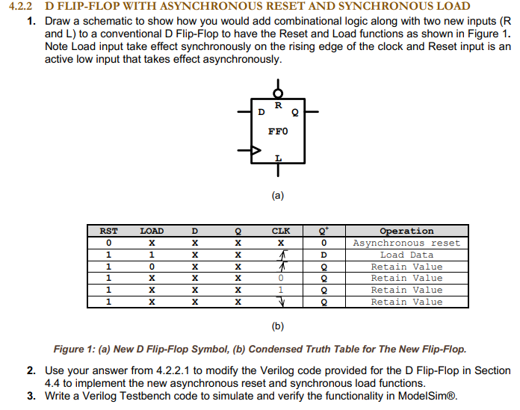

**Schematic**

**Truth Table**

**Verilog Code:**

module D_flipflop (

input clk, rst_n,

input d,

output reg q

);

always@(posedge clk or negedge rst_n) begin

if(!rst_n) q <= 0;

else q <= d;

end

endmodule

**Test bench Code:**

module tb;

reg clk, rst_n;

reg d;

wire q;

D_flipflop dff(clk, rst_n, d, q);

always #2 clk = ~clk;

initial begin

clk = 0; rst_n = 0;

d = 0;

#3 rst_n = 1;

repeat(6) begin

d = $urandom_range(0, 1);

#3;

end

rst_n = 0; #3;

rst_n = 1;

repeat(6) begin

d = $urandom_range(0, 1);

#3;

end

$finish;

end

initial begin

$dumpfile("dump.vcd");

$dumpvars(1);

end

endmodule

**Result :**

**Top-level Verilog Code :**

module top_module (

input clk, rst_n,

input [17:0] SW,

output reg [7:0] LEDG,

output reg [17:0] LEDR

);

reg [7:0] d; // Create an array of 8 bits to store D inputs for each flip-flop

wire [7:0] q; // Create an array of 8 bits to store outputs of flip-flops

// Instantiate 8 D_flipflop modules, each for one LED

genvar i;

generate

for (i = 0; i < 8; i = i + 1) begin : DFF_INST

D_flipflop dff(

.clk(clk),

.rst_n(rst_n),

.d(d[i]),

.q(q[i])

);

end

endgenerate

// Connect switches to D inputs of flip-flops

assign d = SW[7:0];

// Connect flip-flop outputs to LEDs

assign LEDG = q;

assign LEDR = SW; // Connect all switches to the red LEDs directly

endmodule

1. **DFF with Synchronous Reset**

**Schematic**

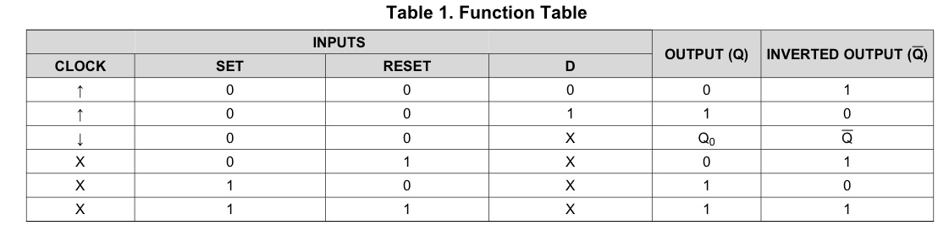

**Truth Table**

**Verilog Code:**

module D_flipflop (

input clk, rst_n,

input d,

output reg q

);

always@(posedge clk) begin

if(!rst_n) q <= 0;

else q <= d;

end

endmodule

**Test bench Code:**

module tb;

reg clk, rst_n;

reg d;

wire q;

D_flipflop dff(clk, rst_n, d, q);

always #2 clk = ~clk;

initial begin

clk = 0; rst_n = 0;

d = 0;

#3 rst_n = 1;

repeat(6) begin

d = $urandom_range(0, 1);

#3;

end

rst_n = 0; #3;

rst_n = 1;

repeat(6) begin

d = $urandom_range(0, 1);

#3;

end

$finish;

end

initial begin

$dumpfile("dump.vcd");

$dumpvars(1);

end

endmodule

**Result :**



**Top-level Verilog Code :**

module top_module (

input clk, rst_n,

input [17:0] SW,

output reg [7:0] LEDG,

output reg [17:0] LEDR

);

reg [7:0] d; // Create an array of 8 bits to store D inputs for each flip-flop

wire [7:0] q; // Create an array of 8 bits to store outputs of flip-flops

// Instantiate 8 D_flipflop modules, each for one LED

genvar i;

generate

for (i = 0; i < 8; i = i + 1) begin : DFF_INST

D_flipflop dff(

.clk(clk),

.rst_n(rst_n),

.d(d[i]),

.q(q[i])

);

end

endgenerate

// Connect switches to D inputs of flip-flops

assign d = SW[7:0];

// Connect flip-flop outputs to LEDs

assign LEDG = q;

assign LEDR = SW; // Connect all switches to the red LEDs directly

endmodule

1. **A diagram of a flip flop

   Description automatically generatedSR Flip Flop**

**Schematic**

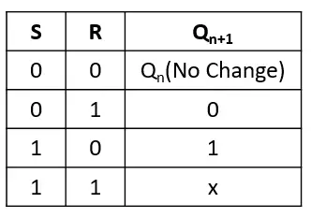

**Truth Table**

**Verilog Code:**

module SR_flipflop (

input clk, rst_n,

input s,r,

output reg q,

output q_bar

);

// always@(posedge clk or negedge rst_n) // for asynchronous reset

always@(posedge clk) begin // for synchronous reset

if(!rst_n) q <= 0;

else begin

case({s,r})

2'b00: q <= q; // No change

2'b01: q <= 1'b0; // reset

2'b10: q <= 1'b1; // set

2'b11: q <= 1'bx; // Invalid inputs

endcase

end

end

assign q_bar = ~q;

endmodule

**Test bench Code:**

module tb;

reg clk, rst_n;

reg s, r;

wire q, q_bar;

SR_flipflop dff(clk, rst_n, s, r, q, q_bar);

always #2 clk = ~clk;

initial begin

clk = 0; rst_n = 0;

$display("Reset=%b --> q=%b, q_bar=%b", rst_n, q, q_bar);

#3 rst_n = 1;

$display("Reset=%b --> q=%b, q_bar=%b", rst_n, q, q_bar);

drive(2'b00);

drive(2'b01);

drive(2'b10);

drive(2'b11);

#5;

$finish;

end

task drive(bit [1:0] ip);

@(posedge clk);

{s,r} = ip;

#1 $display("s=%b, r=%b --> q=%b, q_bar=%b",s, r, q, q_bar);

endtask

initial begin

$dumpfile("dump.vcd");

$dumpvars(1);

end

endmodule

**Result :**

**Top-level Verilog Code :**

module top_module (

input clk, rst_n,

input [1:0] SW, // Two switches

output reg [1:0] LED // Two LEDs

);

reg s_internal, r_internal;

// Connect the internal signals to the SR flip-flop inputs

assign s = s_internal;

assign r = r_internal;

// Test bench instance

tb tb_inst (

.clk(clk),

.rst_n(rst_n),

.s(s_internal),

.r(r_internal)

);

// SR flip-flop instance

SR_flipflop dff (

.clk(clk),

.rst_n(rst_n),

.s(s_internal),

.r(r_internal),

.q(LED[0]), // Connect the Q output to the first LED

.q_bar(LED[1]) // Connect the Q_bar output to the second LED

);

endmodule

1. **JK Flip Flop**

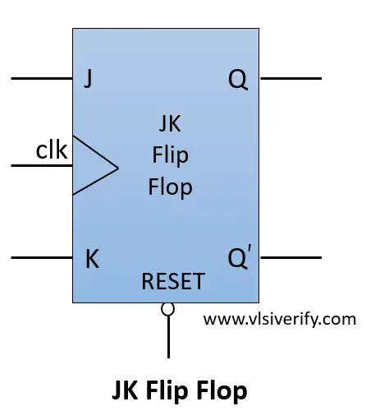

**Schematic**

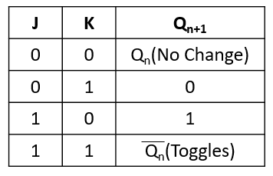

**Truth Table**

**Verilog Code:**

module JK_flipflop (

input clk, rst_n,

input j,k,

output reg q,

output q_bar

);

// always@(posedge clk or negedge rst_n) // for asynchronous reset

always@(posedge clk) begin // for synchronous reset

if(!rst_n) q <= 0;

else begin

case({j,k})

2'b00: q <= q; // No change

2'b01: q <= 1'b0; // reset

2'b10: q <= 1'b1; // set

2'b11: q <= ~q; // Toggle

endcase

end

end

assign q_bar = ~q;

endmodule

**Test bench Code:**

module tb;

reg clk, rst_n;

reg j, k;

wire q, q_bar;

JK_flipflop dff(clk, rst_n, j, k, q, q_bar);

always #2 clk = ~clk;

initial begin

clk = 0; rst_n = 0;

$display("Reset=%b --> q=%b, q_bar=%b", rst_n, q, q_bar);

#3 rst_n = 1;

$display("Reset=%b --> q=%b, q_bar=%b", rst_n, q, q_bar);

drive(2'b00);

drive(2'b01);

drive(2'b10);

drive(2'b11); // Toggles previous output

drive(2'b11); // Toggles previous output

#5;

$finish;

end

task drive(bit [1:0] ip);

@(posedge clk);

{j,k} = ip;

#1 $display("j=%b, k=%b --> q=%b, q_bar=%b",j, k, q, q_bar);

endtask

initial begin

$dumpfile("dump.vcd");

$dumpvars(1);

end

endmodule

**Result :**

**Top-level Verilog Code :**

module top_module (

input clk, rst_n,

input [1:0] SW, // Two switches

output reg [1:0] LED // Two LEDs

);

reg j_internal, k_internal;

// Connect the internal signals to the JK flip-flop inputs

assign j = j_internal;

assign k = k_internal;

// Test bench instance

tb tb_inst (

.clk(clk),

.rst_n(rst_n),

.j(j_internal),

.k(k_internal)

);

// JK flip-flop instance

JK_flipflop dff (

.clk(clk),

.rst_n(rst_n),

.j(j_internal),

.k(k_internal),

.q(LED[0]), // Connect the Q output to the first LED

.q_bar(LED[1]) // Connect the Q_bar output to the second LED

);

endmodule

1. **T Flip Flop**

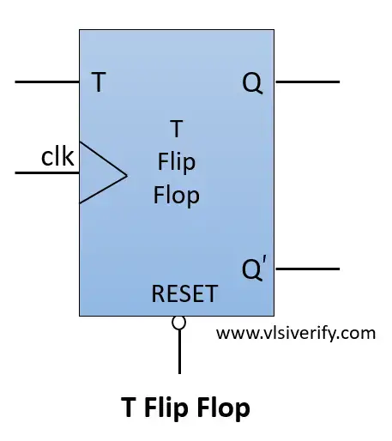

**Schematic**

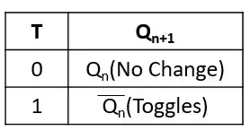

**Truth Table**

**Verilog Code:**

module T_flipflop (

input clk, rst_n,

input t,

output reg q,

output q_bar

);

// always@(posedge clk or negedge rst_n) // for asynchronous reset

always@(posedge clk) begin // for synchronous reset

if(!rst_n) q <= 0;

else begin

q <= (t?~q:q);

end

end

assign q_bar = ~q;

endmodule

**Test bench Code:**

module tb;

reg clk, rst_n;

reg t;

wire q, q_bar;

T_flipflop dff(clk, rst_n, t, q, q_bar);

always #2 clk = ~clk;

initial begin

clk = 0; rst_n = 0;

$display("Reset=%b --> q=%b, q_bar=%b", rst_n, q, q_bar);

#3 rst_n = 1;

$display("Reset=%b --> q=%b, q_bar=%b", rst_n, q, q_bar);

drive(0); // Same as previous output

drive(1); // Toggles previous output

drive(1); // Toggles previous output

drive(1); // Toggles previous output

drive(0); // Same as previous output

#5;

$finish;

end

task drive(bit ip);

@(posedge clk);

t = ip;

#1 $display("t=%b --> q=%b, q_bar=%b",t, q, q_bar);

endtask

initial begin

$dumpfile("dump.vcd");

$dumpvars(1);

end

endmodule

**Result :**

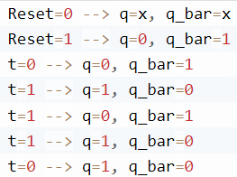

**Top-level Verilog Code :**

module top_module (

input clk, rst_n,

input [1:0] SW, // Two switches

output reg [1:0] LED // Two LEDs

);

reg t_internal;

// Connect the internal signal to the T flip-flop input

assign t = t_internal;

// Test bench instance

tb tb_inst (

.clk(clk),

.rst_n(rst_n),

.t(t_internal)

);

// T flip-flop instance

T_flipflop dff (

.clk(clk),

.rst_n(rst_n),

.t(t_internal),

.q(LED[0]), // Connect the Q output to the first LED

.q_bar(LED[1]) // Connect the Q_bar output to the second LED

);

endmodule

1. **Universal Shift Register 4-bit**

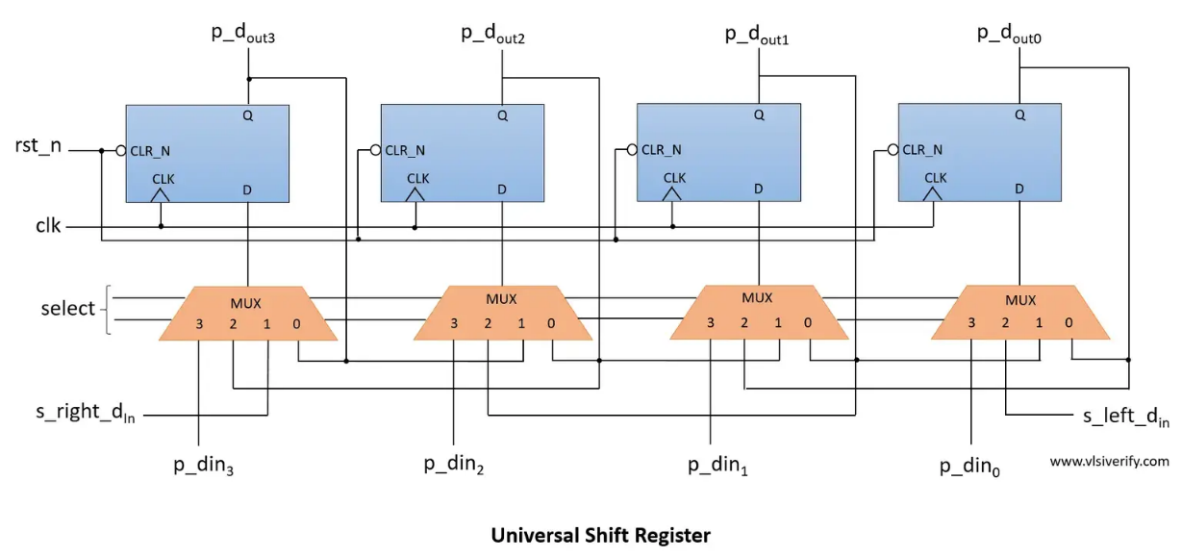

**Schematic**

**Truth Table**

**Verilog Code:**

module universal_shift_reg(

input clk, rst_n,

input [1:0] select, // select operation

input [3:0] p_din, // parallel data in

input s_left_din, // serial left data in

input s_right_din, // serial right data in

output reg [3:0] p_dout, //parallel data out

output s_left_dout, // serial left data out

output s_right_dout // serial right data out

);

always@(posedge clk) begin

if(!rst_n) p_dout <= 0;

else begin

case(select)

2'h1: p_dout <= {s_right_din,p_dout[3:1]}; // Right Shift

2'h2: p_dout <= {p_dout[2:0],s_left_din}; // Left Shift

2'h3: p_dout <= p_din; // Parallel in - Parallel out

default: p_dout <= p_dout; // Do nothing

endcase

end

end

assign s_left_dout = p_dout[0];

assign s_right_dout = p_dout[3];

endmodule

**Test bench Code:**

module TB;

reg clk, rst_n;

reg [1:0] select;

reg [3:0] p_din;

reg s_left_din, s_right_din;

wire [3:0] p_dout; //parallel data out

wire s_left_dout, s_right_dout;

universal_shift_reg usr(clk, rst_n, select, p_din, s_left_din, s_right_din, p_dout, s_left_dout, s_right_dout);

always #2 clk = ~clk;

initial begin

$monitor("select=%b, p_din=%b, s_left_din=%b, s_right_din=%b --> p_dout = %b, s_left_dout = %b, s_right_dout = %b",select, p_din, s_left_din, s_right_din, p_dout, s_left_dout, s_right_dout);

clk = 0; rst_n = 0;

#3 rst_n = 1;

p_din = 4'b1101;

s_left_din = 1'b1;

s_right_din = 1'b0;

select = 2'h3; #10;

select = 2'h1; #20;

p_din = 4'b1101;

select = 2'h3; #10;

select = 2'h2; #20;

select = 2'h0; #20;

$finish;

end

// To enable waveform

initial begin

$dumpfile("dump.vcd"); $dumpvars;

end

endmodule

**Result :**

select=xx, p_din=xxxx, s_left_din=x, s_right_din=x --> p_dout = xxxx, s_left_dout = x, s_right_dout = x

select=xx, p_din=xxxx, s_left_din=x, s_right_din=x --> p_dout = 0000, s_left_dout = 0, s_right_dout = 0

select=11, p_din=1101, s_left_din=1, s_right_din=0 --> p_dout = 0000, s_left_dout = 0, s_right_dout = 0

select=11, p_din=1101, s_left_din=1, s_right_din=0 --> p_dout = 1101, s_left_dout = 1, s_right_dout = 1

select=01, p_din=1101, s_left_din=1, s_right_din=0 --> p_dout = 1101, s_left_dout = 1, s_right_dout = 1

select=01, p_din=1101, s_left_din=1, s_right_din=0 --> p_dout = 0110, s_left_dout = 0, s_right_dout = 0

select=01, p_din=1101, s_left_din=1, s_right_din=0 --> p_dout = 0011, s_left_dout = 1, s_right_dout = 0

select=01, p_din=1101, s_left_din=1, s_right_din=0 --> p_dout = 0001, s_left_dout = 1, s_right_dout = 0

select=01, p_din=1101, s_left_din=1, s_right_din=0 --> p_dout = 0000, s_left_dout = 0, s_right_dout = 0

select=11, p_din=1101, s_left_din=1, s_right_din=0 --> p_dout = 0000, s_left_dout = 0, s_right_dout = 0

select=11, p_din=1101, s_left_din=1, s_right_din=0 --> p_dout = 1101, s_left_dout = 1, s_right_dout = 1

select=10, p_din=1101, s_left_din=1, s_right_din=0 --> p_dout = 1101, s_left_dout = 1, s_right_dout = 1

select=10, p_din=1101, s_left_din=1, s_right_din=0 --> p_dout = 1011, s_left_dout = 1, s_right_dout = 1

select=10, p_din=1101, s_left_din=1, s_right_din=0 --> p_dout = 0111, s_left_dout = 1, s_right_dout = 0

select=10, p_din=1101, s_left_din=1, s_right_din=0 --> p_dout = 1111, s_left_dout = 1, s_right_dout = 1

select=00, p_din=1101, s_left_din=1, s_right_din=0 --> p_dout = 1111, s_left_dout = 1, s_right_dout = 1

**Top-level Verilog Code :**

module top_module (

input clk, rst_n,

input [1:0] select, // Select operation

input [3:0] p_din, // Parallel data in

input s_left_din, // Serial left data in

input s_right_din, // Serial right data in

output reg [3:0] p_dout, // Parallel data out

output reg s_left_dout, // Serial left data out

output reg s_right_dout // Serial right data out

);

// Universal Shift Register instance

universal_shift_reg usr_inst (

.clk(clk),

.rst_n(rst_n),

.select(select),

.p_din(p_din),

.s_left_din(s_left_din),

.s_right_din(s_right_din),

.p_dout(p_dout),

.s_left_dout(s_left_dout),

.s_right_dout(s_right_dout)

);

endmodule

1. **Universal Shift Register 8-bit**

**Verilog Code:**

module universal_shift_reg_8bit(

input clk, rst_n,

input [1:0] select, // select operation

input [7:0] p_din, // parallel data in

input s_left_din, // serial left data in

input s_right_din, // serial right data in

output reg [7:0] p_dout, //parallel data out

output s_left_dout, // serial left data out

output s_right_dout // serial right data out

);

always@(posedge clk) begin

if(!rst_n) p_dout <= 0;

else begin

case(select)

2'h1: p_dout <= {s_right_din,p_dout[7:1]}; // Right Shift

2'h2: p_dout <= {p_dout[6:0],s_left_din}; // Left Shift

2'h3: p_dout <= p_din; // Parallel in - Parallel out

default: p_dout <= p_dout; // Do nothing

endcase

end

end

assign s_left_dout = p_dout[0];

assign s_right_dout = p_dout[7];

endmodule

**Test bench Code:**

module universal_shift_reg_8bit_tb;

// Parameters

parameter CLK_PERIOD = 10; // Clock period in simulation time units

// Signals

reg clk, rst_n;

reg [1:0] select;

reg [7:0] p_din;

reg s_left_din, s_right_din;

wire [7:0] p_dout;

wire s_left_dout, s_right_dout;

// Instantiate the DUT

universal_shift_reg_8bit dut (

.clk(clk),

.rst_n(rst_n),

.select(select),

.p_din(p_din),

.s_left_din(s_left_din),

.s_right_din(s_right_din),

.p_dout(p_dout),

.s_left_dout(s_left_dout),

.s_right_dout(s_right_dout)

);

// Clock generation

always #((CLK_PERIOD / 2)) clk = ~clk;

// Stimulus

initial begin

// Initialize inputs

clk = 0;

rst_n = 0;

select = 2'b00; // Do nothing initially

p_din = 8'h00;

s_left_din = 0;

s_right_din = 0;

// Reset

#20 rst_n = 1;

// Test shifting to the right

select = 2'b01; // Right shift

p_din = 8'b10101010; // Input data

#50;

// Test shifting to the left

select = 2'b10; // Left shift

s_left_din = 1; // Serial left input

#50;

// Test parallel in - parallel out

select = 2'b11; // Parallel in - parallel out

p_din = 8'b11001100; // Input data

#50;

// End simulation

$finish;

end

endmodule

1. **Asynchronous Counter 4-bit**

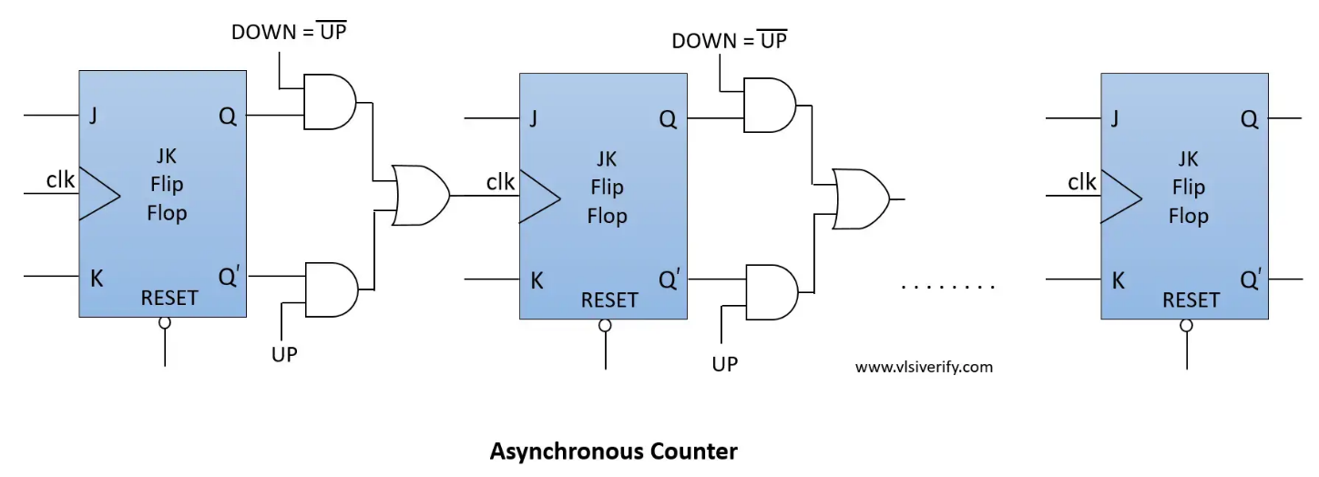

**Schematic**

**Verilog Code:**

module JK_flipflop (

input clk, rst_n,

input j,k,

output reg q, q_bar

);

always@(posedge clk or negedge rst_n) begin // for asynchronous reset

if(!rst_n) q <= 0;

else begin

case({j,k})

2'b00: q <= q; // No change

2'b01: q <= 1'b0; // reset

2'b10: q <= 1'b1; // set

2'b11: q <= ~q; // Toggle

endcase

end

end

assign q_bar = ~q;

endmodule

module updown_selector(input q, q_bar, bit up, output nclk);

assign nclk = up?q_bar:q;

endmodule

module asynchronous_counter #(parameter SIZE=4)(

input clk, rst_n,

input j, k,

input up,

output [3:0] q, q_bar

);

wire [3:0] nclk;

genvar g;

/*

// Up Counter (at output q)

JK_flipflop jk1(clk, rst_n, j, k, q[0], q_bar[0]);

JK_flipflop jk2(q_bar[0], rst_n, j, k, q[1], q_bar[1]);

JK_flipflop jk3(q_bar[1], rst_n, j, k, q[2], q_bar[2]);

JK_flipflop jk4(q_bar[2], rst_n, j, k, q[3], q_bar[3]);

// Down Counter (at output q)

JK_flipflop jk1(clk, rst_n, j, k, q[0], q_bar[0]);

JK_flipflop jk2(q[0], rst_n, j, k, q[1], q_bar[1]);

JK_flipflop jk3(q[1], rst_n, j, k, q[2], q_bar[2]);

JK_flipflop jk4(q[2], rst_n, j, k, q[3], q_bar[3]);

// Up and Down Counter (at output q)

JK_flipflop jk1(clk, rst_n, j, k, q[0], q_bar[0]);

updown_selector ud1(q[0], q_bar[0], up, nclk[0]);

JK_flipflop jk2(nclk[0], rst_n, j, k, q[1], q_bar[1]);

updown_selector ud2(q[1], q_bar[1], up, nclk[1]);

JK_flipflop jk3(nclk[1], rst_n, j, k, q[2], q_bar[2]);

updown_selector ud3(q[2], q_bar[2], up, nclk[2]);

JK_flipflop jk4(nclk[2], rst_n, j, k, q[3], q_bar[3]);

*/

// Using generate block

JK_flipflop jk0(clk, rst_n, j, k, q[0], q_bar[0]);

generate

for(g = 1; g<SIZE; g++) begin

updown_selector ud1(q[g-1], q_bar[g-1], up, nclk[g-1]);

JK_flipflop jk1(nclk[g-1], rst_n, j, k, q[g], q_bar[g]);

end

endgenerate

endmodule

**Test bench Code:**

module tb;

reg clk, rst_n;

reg j, k;

reg up;

wire [3:0] q, q_bar;

asynchronous_counter(clk, rst_n, j, k, up, q, q_bar);

initial begin

clk = 0; rst_n = 0;

up = 1;

#4; rst_n = 1;

j = 1; k = 1;

#80;

rst_n = 0;

#4; rst_n = 1; up = 0;

#50;

$finish;

end

always #2 clk = ~clk;

initial begin

$dumpfile("dump.vcd"); $dumpvars;

end

endmodule

**Result :**

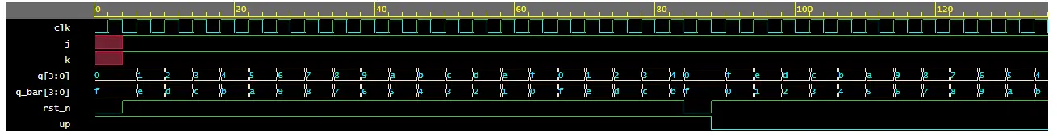

1. **Asynchronous Counter 8-bit**

**Verilog Code:**

module JK_flipflop (

input clk, rst_n,

input j, k,

output reg q, q_bar

);

always@(posedge clk or negedge rst_n) begin // for asynchronous reset

if(!rst_n) q <= 0;

else begin

case({j,k})

2'b00: q <= q; // No change

2'b01: q <= 1'b0; // reset

2'b10: q <= 1'b1; // set

2'b11: q <= ~q; // Toggle

endcase

end

end

assign q_bar = ~q;

endmodule

module updown_selector(

input q, q_bar,

input bit up,

output nclk

);

assign nclk = up ? q_bar : q;

endmodule

module asynchronous_counter_8bit #(parameter SIZE=8)(

input clk, rst_n,

input j, k,

input up,

output reg [SIZE-1:0] q, q_bar

);

wire [SIZE-1:0] nclk;

genvar g;

// Using generate block

JK_flipflop jk0(clk, rst_n, j, k, q[0], q_bar[0]);

generate

for(g = 1; g < SIZE; g++) begin

updown_selector ud1(q[g-1], q_bar[g-1], up, nclk[g-1]);

JK_flipflop jk1(nclk[g-1], rst_n, j, k, q[g], q_bar[g]);

end

endgenerate

endmodule

module asynchronous_counter_8bit_tb;

// Parameters

parameter CLK_PERIOD = 10; // Clock period in simulation time units

parameter SIZE = 8; // Counter size

// Signals

reg clk, rst_n;

reg [1:0] j, k;

reg up;

wire [SIZE-1:0] q;

wire [SIZE-1:0] q_bar;

// Instantiate the DUT

asynchronous_counter_8bit #(.SIZE(SIZE)) dut (

.clk(clk),

.rst_n(rst_n),

.j(j),

.k(k),

.up(up),

.q(q),

.q_bar(q_bar)

);

// Clock generation

always #((CLK_PERIOD / 2)) clk = ~clk;

// Stimulus

initial begin

// Initialize inputs

clk = 0;

rst_n = 0;

j = 2'b00;

k = 2'b00;

up = 1'b0;

// Reset

#20 rst_n = 1;

// Test Up Counter

up = 1;

#50;

// Test Down Counter

up = 0;

#50;

// Test Up-Down Counter

up = 1;

#50;

up = 0;

#50;

// End simulation

$finish;

end

endmodule

1. **Synchronous Counter 4-bit**

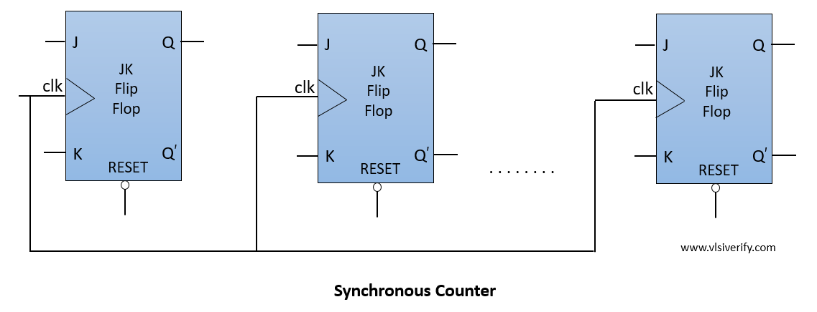

**Schematic**

**Verilog Code:**

module synchronous_counter #(parameter SIZE=4)(

input clk, rst_n,

input up,

output reg [3:0] cnt

);

always@(posedge clk) begin

if(!rst_n) begin

cnt <= 4'h0;

end

else begin

if(up) cnt <= cnt + 1'b1;

else cnt <= cnt - 1'b1;

end

end

endmodule

**Test bench Code:**

module tb;

reg clk, rst_n;

reg up;

wire [3:0] cnt;

synchronous_counter(clk, rst_n, up, cnt);

initial begin

clk = 0; rst_n = 0;

up = 1;

#4; rst_n = 1;

#80;

rst_n = 0;

#4; rst_n = 1; up = 0;

#50;

$finish;

end

always #2 clk = ~clk;

initial begin

$dumpfile("dump.vcd"); $dumpvars;

end

endmodule

**Result :**

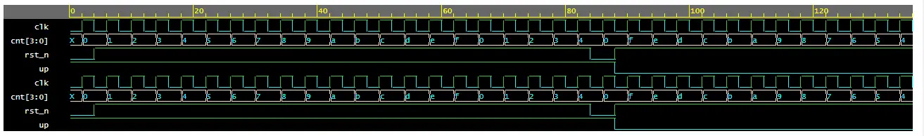

1. **Synchronous Counter 8-bit**

**Verilog Code:**

module synchronous_counter_8bit #(parameter SIZE=8)(

input clk, rst_n,

input up,

output reg [SIZE-1:0] cnt

);

always@(posedge clk) begin

if(!rst_n) begin

cnt <= SIZE'd0;

end

else begin

if(up) cnt <= cnt + 1'b1;

else cnt <= cnt - 1'b1;

end

end

endmodule

1. **Synchronous Counter n-bit**

**Verilog Code:**

module synchronous_counter #(parameter SIZE=4)(

input clk, rst_n,

input up,

output reg [SIZE-1:0] cnt

);

always @(posedge clk or negedge rst_n) begin

if (!rst_n) begin

cnt <= {SIZE{1'b0}}; // Initialize to all zeros

end

else begin

if (up)

cnt <= cnt + 1'b1;

else

cnt <= cnt - 1'b1;

end

end

endmodule