

**INTERNATIONAL UNIVERSITY SCHOOL OF ELECTRICAL ENGINEERING (EE)**

**EE091 ELECTRONICS DEVICES LAB**

**LAB 3**

BJT BIASING

**Nguyễn Gia Cát Tường - ITITIU21117………………………...**

**Electronics Devices lab** Page 1 of 10



**INTERNATIONAL UNIVERSITY SCHOOL OF ELECTRICAL ENGINEERING (EE)**

# OBJECTIVES

The purpose of this lab is to measure some characteristics of a transistor (a bipolar junction transistor, or BJT) in two useful circuit configurations, the emitter follower amplifier and the common emitter amplifier.

# MATERIAL AND EQUIPMENT

* 1. Oscilloscope
  2. Power Supply
  3. Multimeter
  4. 2N3904
  5. Assorted Resistors

# BACKGROUND

The bipolar junction transistor (BJT) can be modeled as a current controlled current source. The circuit symbol and the pin out for the actual device can be seen in Figure 1.

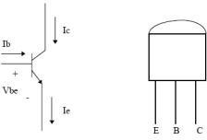

Figure 1: The bipolar junction transistor.

In order to analyze a BJT circuit the following simplified equations can be used:



These equations assume the device is operating in the active region (typical for amplifier applications). From these equations we see that the current through the collector of the device is controlled by the input current to the base. Thus if we change the current into the base, we get a proportional change in the collector current. The constant of proportionality is called β, or sometimes *hfe*. β is typically on the order of 20 - 500.

In order to characterize the operation of a particular transistor, a complete set of characteristic equations is needed. Typically, these curves look like those in Figure 2. These

**Electronics Devices lab** Page 2 of 10



**INTERNATIONAL UNIVERSITY SCHOOL OF ELECTRICAL ENGINEERING (EE)**

curves show that in the active region of operation, the collector current is constant and depends on the base current.

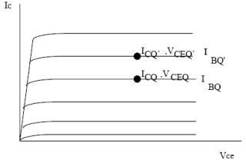

Figure 2: Characteristic curves for the BJT transistor.

These curves can be used to calculate the large signal current gain, βDC (or hFE) and the small signal current gain, βAC (or hfe). These values are in general calculated for a given bias point ICQ, VCEQ using the following equations:

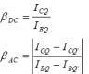

From this, one can see that the large signal gain depends only on the Q point and the small signal gain depends only on small deviations around the Q point.

In order to use a transistor in an amplifying circuit it has to be biased. In other words, a Q point has to be set in order to place the device in the active region of operation. There are several methods which can be used bias a transistor. Figures 3 and 4 demonstrate two possibilities.

The first scheme (Figure 3) is called a fixed bias scheme. In a fixed biasing the base current is set through a base resistor and the emitter of the transistor is grounded. This scheme is not used in practice since the Q point depends very strongly on β.

**Electronics Devices lab** Page 3 of 10



**INTERNATIONAL UNIVERSITY SCHOOL OF ELECTRICAL ENGINEERING (EE)**

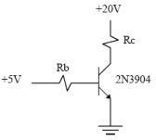

Figure 3: Fixed biasing scheme.

A second possibility, which is commonly used, is the self-biasing scheme. Here the base voltage is set through a voltage divider and the emitter is tied to ground through a resistor. If designed correctly, this scheme is relatively independent of β.

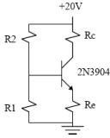

Figure 4: Self-biasing voltage divider scheme.

**Electronics Devices lab** Page 4 of 10



**INTERNATIONAL UNIVERSITY SCHOOL OF ELECTRICAL ENGINEERING (EE)**

# PROCEDURE

* 1. 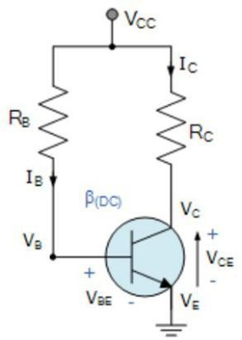**FIXED BASE BIASING (Simulation)**

Figure 5: Fixed biasing circuit,

In this exercise, you will examine the values of the DC biasing process in a fixed biasing circuit. Assuming 𝑉𝑐𝑐 = 15𝑉, 𝑅𝐵 = 910𝑘Ω, 𝑅𝐶 = 10𝑘Ω, β = 100. Fill in the below table.

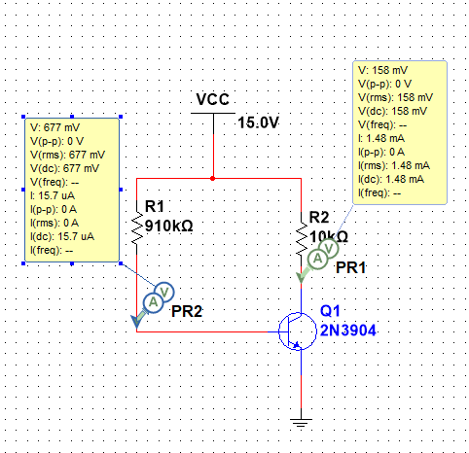

|  |  |  |  |  |  |  |  |  |
| --- | --- | --- | --- | --- | --- | --- | --- | --- |
|  | VB | VE | VC | VBE | IB | IE | IC | β |
| **Calculation** | 700 mV | 0 | 100 mV | 700 mV | 15.7 uA | 1.85 mA | 1.57 mA | 100 |
| **Simulation** | 677 mV | 0 | 158 mV | 677 mV | 15.7 uA | 1.5 mA | 1.48 mA | 97.1 |

* 1. 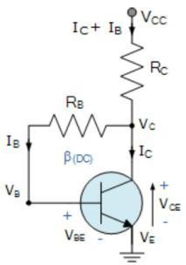**COLLECTOR FEEDBACK BIASING (Simulation)**

Figure 6: Fixed biasing circuit,

In this exercise, you will examine the values of the DC biasing process in a fixed biasing circuit.

Assuming 𝑉𝑐𝑐 = 15𝑉, 𝑅𝐵 = 470𝑘Ω, 𝑅𝐶 = 4.7𝑘Ω, β = 100. Fill in the bellow table.

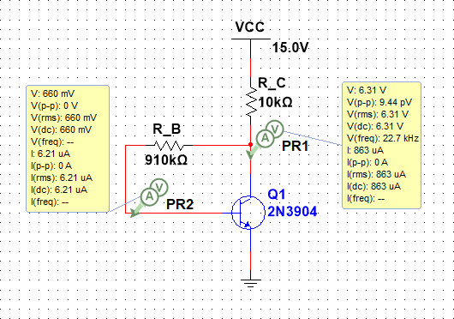

|  |  |  |  |  |  |  |  |  |
| --- | --- | --- | --- | --- | --- | --- | --- | --- |
|  | VB | VE | VC | VBE | IB | IE | IC | β |
| **Calculation** | 700 mV | 0 | 7.88 | 700 mV | 15.14 uA | 1.53 mA | 1.51 mA | 100 |
| **Simulation** | 660 mV | 0 | 6.31 | 660 mV | 6.21 uA | 269 uA | 863 uA | 98.4 |



**INTERNATIONAL UNIVERSITY SCHOOL OF ELECTRICAL ENGINEERING (EE)**

* 1. **EMITTER FOLLOWER (COMMON COLLECTOR) AMPLIFIER**

In this exercise, you will see what the transistor does in an emitter follower circuit and what the entire circuit does. Construct the emitter follower circuit shown in figure 7.

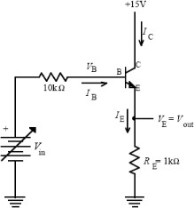

Figure 7: Emitter follower amplifier.

First, examine the behavior of the transistor. Set VB to approximately 2,4,6,8,10,12, and 14 volts and for each VB measure Vin, VB (accurately), and VE. From this, calculate VBE = VB

- VE, IB and IE from Ohm's law, IC = IE − IB, and hfe = β = IC /IB. Put all of this in one data table.

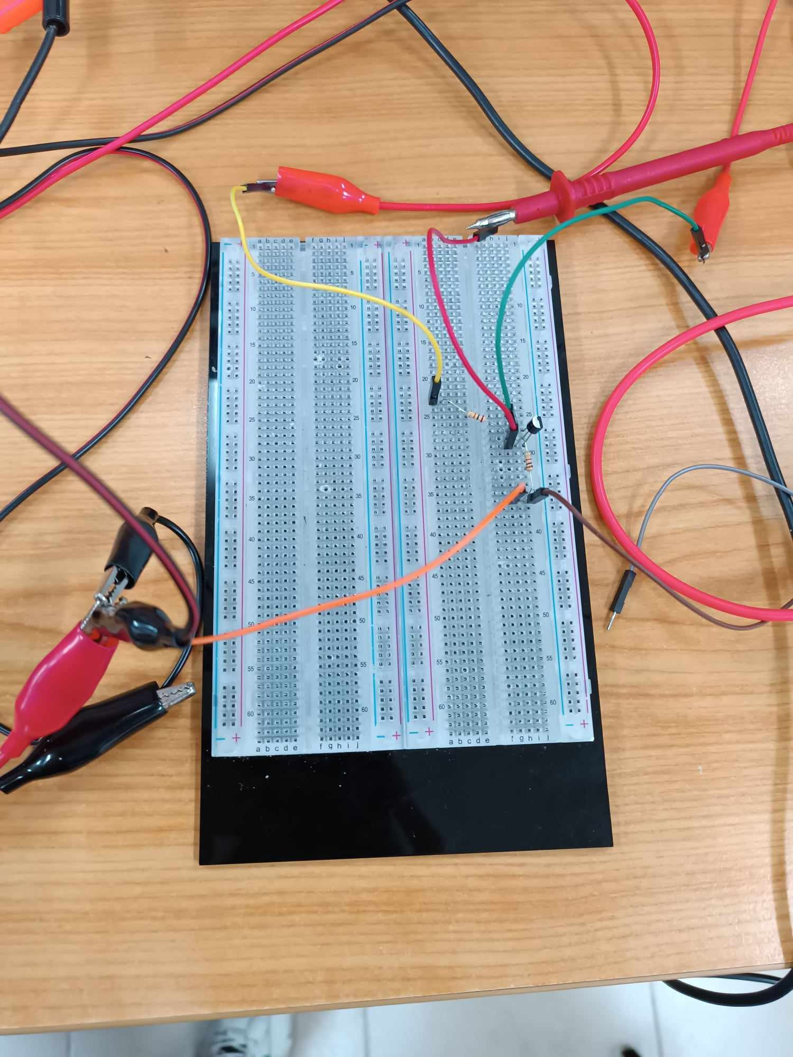

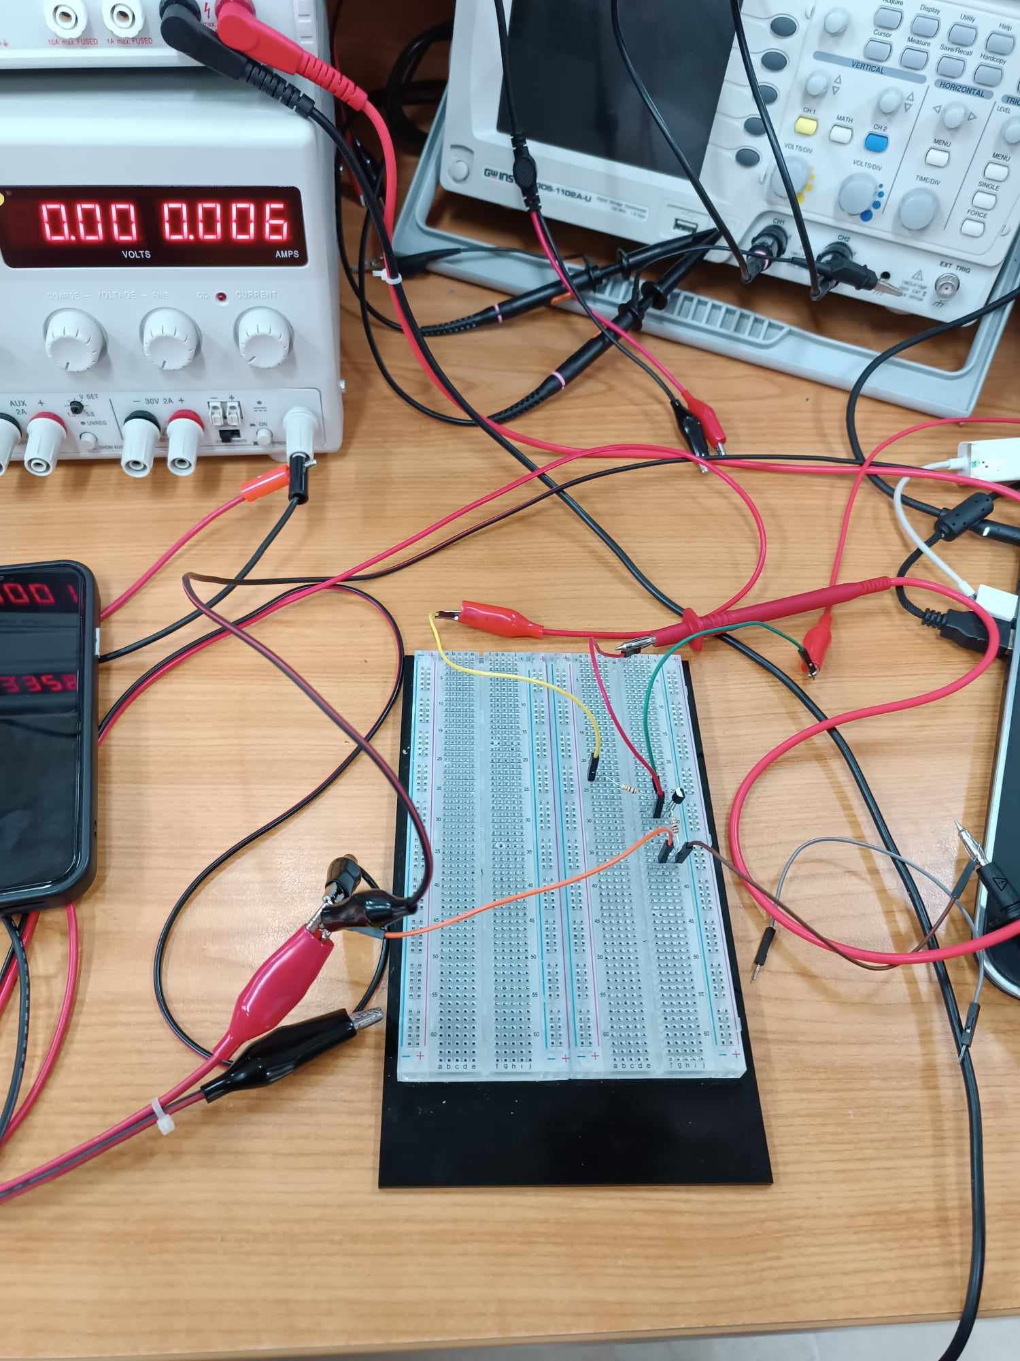

|  |  |  |  |  |  |  |  |
| --- | --- | --- | --- | --- | --- | --- | --- |
| **VB** | **VE** | **VC** | **VBE** | **IB (mA)** | **IE (mA)** | **IC (mA)** | **β** |
| **2** | 2.1 | 1.45 | 0.65 | 0.2 | 2.1 | 1.9 | 9.5 |
| **4** | 4.05 | 3.38 | 0.67 | 0.4 | 4.05 | 3.65 | 9.125 |
| **6** | 5.9 | 5.412 | 0.488 | 0.6 | 5.9 | 5.3 | 8.83 |
| **8** | 8.16 | 7.112 | 1.048 | 0.8 | 8.16 | 7.36 | 9.2 |

|  |  |  |  |  |  |  |  |
| --- | --- | --- | --- | --- | --- | --- | --- |
| **10** | 10.5 | 9.296 | 1.204 | 1 | 10.5 | 9.5 | 9.5 |
| **12** | 12.8 | 10.833 | 1.967 | 1.2 | 12.8 | 10.7 | 8.9167 |
| **14** | 14.44 | 13.3 | 1.14 | 1.4 | 14.44 | 13.04 | 9.3143 |

**Electronics Devices lab** Page 6 of 10



**INTERNATIONAL UNIVERSITY SCHOOL OF ELECTRICAL ENGINEERING (EE)**

To analyze this data, plot IB vs. VBE. This will look like a nearly vertical line, but since the base-emitter junction is a forward biased diode, it is actually part of diode exponential curve. On the same graph, plot a calculated diode curve that approximately fits your data. Comment how a straight line can fit these data points fairly well.

Now, looking at the data and the graph, answer these questions:

1. What is the range of VBE? **From 0.65 to 1.14**
2. Does VBE stay at approximately 0.7V? **No, it doesn’t. It fluctuates due to error in laboratory**
3. What does it mean for a transistor to be in its "active region"? **The active region is defined region in which the emitter-base junction is forward bias while the**

**collector-base junction is reverse bias**

1. Does the transistor stay in its active region? **Yes, it does according to the given data,**
2. Is IC ≈ IE? **Yes, usually in a bipolar junction transistor (BJT), we see that the**

**collector current (IC) is approximately equal to the emitter current (IE) under ideal conditions.**

* 1. **COMMON EMITTER AMPLIFIER**

In this section, you will analyze the bias characteristic of a common emitter amplifier, a popular transistor amplifier circuit.

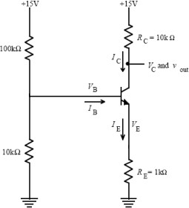

Figure 8: Common emitter amplifier.

.

**Electronics Devices lab** Page 7 of 10



**INTERNATIONAL UNIVERSITY SCHOOL OF ELECTRICAL ENGINEERING (EE)**

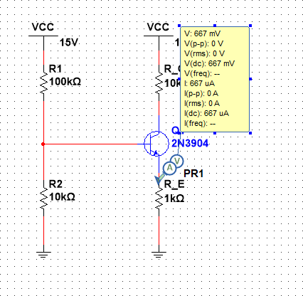Find the bias conditions of the transistor. That is, find the voltages and currents in the circuit with no input signal. This is also called the "quiescent point", the "operating point", or the "DC" conditions for the circuit. To do this, first using theory to calculate VB, VE, and VC, IE, IC, IB and VBE. Is the transistor in its active region now? Then measure VB, VE, and VC, use Ohm's law to calculate IE and IC, calculate IB = IC / β using the β you found in section 1, and calculate VBE.

|  |  |  |  |  |  |  |  |  |
| --- | --- | --- | --- | --- | --- | --- | --- | --- |
|  | **VB** | **VE** | **VC** | **VBE** | **IB** | **IE** | **IC** | **β** |
| **Calculation** | 1.36 | 0.66 | 8.36 | 0.65 | 6.63 uA | 663 uA | 663 uA | 100 |
| **Simulation** | 1.32 | 667 mV | 8.38 | 0.653 | 4.86 uA | 667 uA | 662 uA | 115.4 |
| **Measurement** | 1.3411 | 705 mV | 1.9345 | 0.6221 | 148 uA | 0.7192 | 0.5712 | 5.5 |

Put all this data to one table. Compare the error between calculating and measuring.

**Electronics Devices lab** Page 8 of 10



**INTERNATIONAL UNIVERSITY SCHOOL OF ELECTRICAL ENGINEERING (EE)**

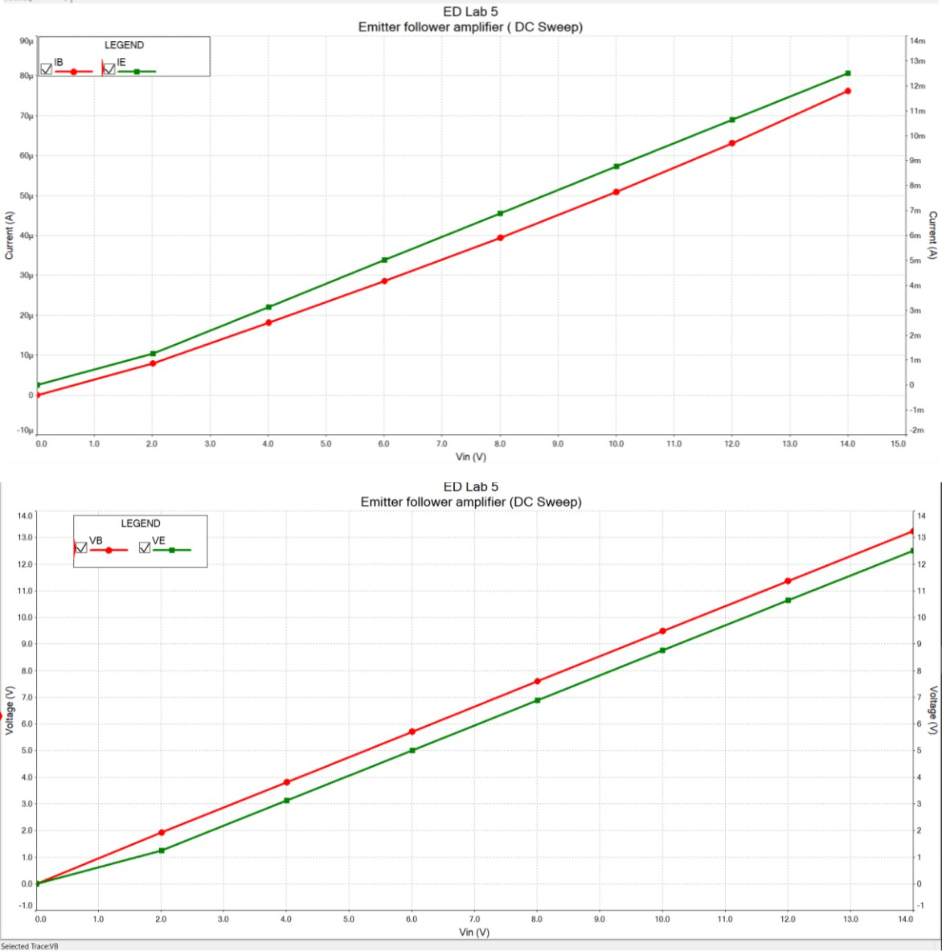

**Electronics Devices lab** Page 9 of 10



**INTERNATIONAL UNIVERSITY SCHOOL OF ELECTRICAL ENGINEERING (EE)**

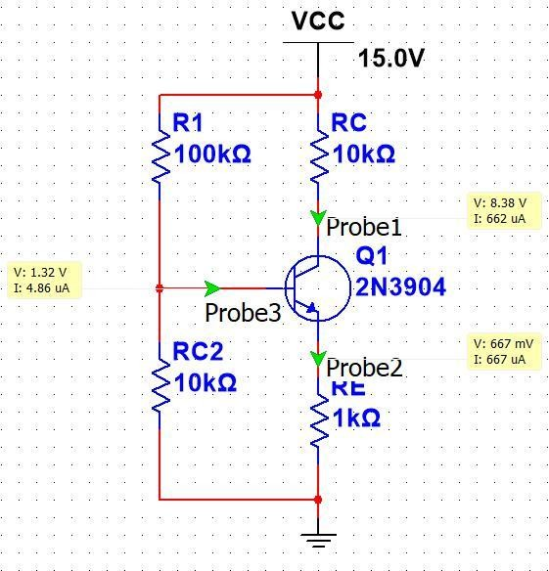

**Electronics Devices lab** Page 10 of 10