**EE091**

**ELECTRONIC DEVICES**

**LAB 6**

COMMON COLLECTOR AND COMMON BASE AMPLIFIER

**Nguyễn Gia Cát Tường - ITITIU21117………………………...**

# OBJECTIVES

This lab introduces the operation of common emitter amplifier. You will know how to build a CC, CB circuit, measure the gain and compare to the theory calculation

# MATERIAL AND EQUIPMENT

* 1. Oscilloscope
  2. Power Supply
  3. Multimeter 4. 2N3904

5. Assorted Resistors

# INTRODUCTION

The three types of BJT voltage amplifiers are the common-emitter, common-base, and common-collector amplifiers. The word common means that both the input and output share that particular node. The common-emitter and common-base amplifiers have voltage gain. The input signal voltage is multiplied by the gain of the amplifier at the output. The commoncollector amplifier does not have voltage gain. Rather, the output *follows* the input which gives rise to the more popular name, the emitter-follower. The emitter-follower is used to drive a load that could otherwise not be driven by the signal source. The three topologies are shown below in Fig. 1.

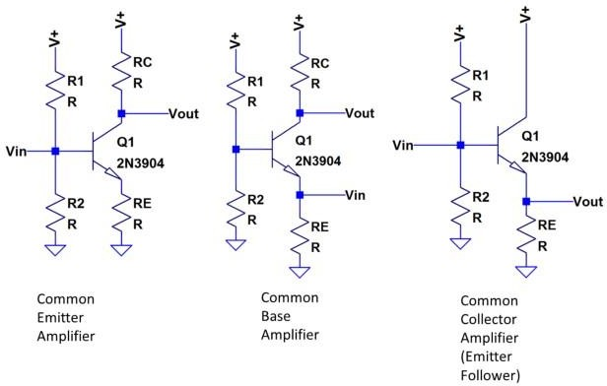

Figure 1. Three main types of BJT voltage amplifiers.

# PRE-LAB

You are responsible to simulate EVERY scenario analysis from the DC operation points to the Transient analysis, the AC Sweep, and the Parameter Sweep of R4 for both amplifiers.

You also responsible to provide calculations of each parameter of the DC operation points, small signal analysis to calculate the gain of amplifiers

# PROCEDURE

## Common Base Amplifier

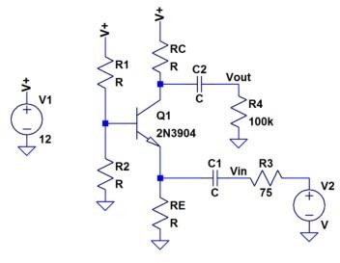In this section, you will analyze a common base amplifier, a popular transistor amplifier circuit.

Figure 2: Common Base Amplifier.

R1 = 330K, R2 = 39K, RC = 18K, RE = 1.8K, C1 = C2 = C3 = 2.2uF.

## DC analysis:

Using a digital multimeter to measure DC values of voltage 𝑉𝐶𝐸, 𝑉𝐶, 𝑉𝐸, 𝑉𝐵𝐸, 𝑉𝐵𝐶, 𝑉𝐵 then calculate current values 𝐼𝐵, 𝐼𝐶, 𝐼𝐸.

|  |  |  |  |  |  |  |  |  |  |  |
| --- | --- | --- | --- | --- | --- | --- | --- | --- | --- | --- |
|  | 𝑉𝐵 | 𝑉𝐸 | 𝑉𝐶 | 𝑉𝐵𝐸 | 𝑉𝐶𝐸 | 𝑉𝐵𝐶 | 𝐼𝐵 | 𝐼𝐸 | 𝐼𝐶 | β |
| **Calculation** | **1.17** | 0.476 | 7.281 | 0.7 | 6.049 | -6.05 | 2.62 x10-6 | 2.64 x10-4 | 2.621 x10-4 | 100 |
| **Simulation** | **1.2** | 0.58 | 6.56 | 0.58 | 6.21 | -5.30 | 2.32 x10-6 | 2.86 x10-4 | 3.231 x10-4 | 120 |
| **Measurement** | **1.25** | 0.8 | 8.4 | 0.6 | 7.9 | -7.23 | 1.11 x10-6 | 3.23 x10-4 | 4.02 x10-4 | 291 |

## AC analysis:

Connect the function generator to *vin* and use a 0.2V peak-to-peak 10kHz sine wave as the input signal. Connect C3 to terminal B of transistor, the other pin is connected to ground. Monitor *vin* and *vout* simultaneously with the oscilloscope and sketch them on the same set of axes.

Measure the gain of this amplifier.

Perform a frequency sweeping with input frequency from 100Hz to 100KHz. Determine the

𝑣𝑜𝑢𝑡 gain [ ] 𝑑𝐵 and plot the frequency response.

𝑣𝑖𝑛

|  |  |  |  |  |  |  |  |
| --- | --- | --- | --- | --- | --- | --- | --- |
| Frequency | Gain | Frequency | Gain | Frequency | Gain | Frequency | Gain |
| 100 | 29.41 | 1000 | 45.35 | 10,000 | 45.72 | 60,000 | 45.6 |
| 200 | 37.6 | 2000 | 46.2 | 20,000 | 46.8 | 70,000 | 43.5 |
| 400 | 42.3 | 3000 | 45.5 | 30,000 | 45.7 | 80,000 | 46.7 |
| 600 | 44.44 | 4000 | 45.23 | 40,000 | 45.2 | 90,000 | 44.4 |
| 800 | 44.7 | 5000 | 44.7 | 50,000 | 44.3 | 100,000 | 45.7 |

Change the value of *R*4 from 1KOhm to 101KOhm (10kOhm per increment), observer the effects of *R*4on the Vout of the circuit, and comment on results. Assume that Vin does not

𝑣𝑜𝑢𝑡 change, compute the gains[ ] 𝑑𝐵based on the change the value of *R*4 .

𝑣𝑖𝑛

|  |  |  |  |  |  |
| --- | --- | --- | --- | --- | --- |
| 𝑅4 | Gain (Simulation) | Gain (Measurement) | 𝑅4 | Gain (Simulation) | Gain (Measurement) |
| 1𝑘Ω | 23.3 | 22.995 | 47𝑘Ω | 45.8 | 46.1 |
| 10𝑘Ω | 39.8 | 40.7 | 56𝑘Ω | 45.5 | 46.41 |
| 20𝑘Ω | 42.6 | 43.8 | 68𝑘Ω | 44.2 | 46.375 |
| 33𝑘Ω | 46.4 | 45.56 | 100𝑘Ω | 45.7 | 46.375 |

## Common Collector Amplifier

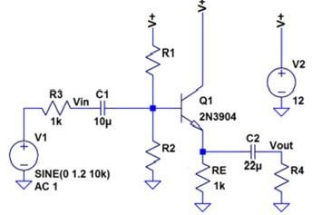

Figure 3: Common Collector Amplifier R1 = 5.6K, R2 = 6.8K, R4 = 1K Ohm.

## DC analysis:

Using a digital multimeter to measure DC values of voltage 𝑉𝐶𝐸, 𝑉𝐶, 𝑉𝐸, 𝑉𝐵𝐸, 𝑉𝐵𝐶, 𝑉𝐵 then calculate current values 𝐼𝐵, 𝐼𝐶, 𝐼𝐸.

|  |  |  |  |  |  |  |  |  |  |  |
| --- | --- | --- | --- | --- | --- | --- | --- | --- | --- | --- |
|  | 𝑉𝐵 | 𝑉𝐸 | 𝑉𝐶 | 𝑉𝐵𝐸 | 𝑉𝐶𝐸 | 𝑉𝐵𝐶 | 𝐼𝐵 | 𝐼𝐸 | 𝐼𝐶 | β |
| **Calculation** | 7.23 | 5.4 | 6.57 | 12.5 | 14.523 | 13.5 | 0.134 | 0.114 | 0.1243 | 100 |
| **Simulation** | 7.25 | 6.23 | 6.315 | 11.562 | 15,63 | 12.45 | 0.15 | 0.154 | 0.134 | 100 |
| **Measurement** | 7.23 | 6.1 | 6.45 | 11.52 | 14.52 | 12. 62 | 0.11 | 0.1123 | 0l.141 | 100 |

## AC analysis

Connect the function generator to *vin* and use a 2V peak-to-peak 10kHz sine wave as the input signal. Monitor *vin* and *vout* simultaneously with the oscilloscope and sketch them on the same set of axes.

Measure the gain of this amplifier.

Perform a frequency sweeping with input frequency from 100Hz to 100KHz. Determine the

𝑣𝑜𝑢𝑡 gain [ ] 𝑑𝐵 and plot the frequency response.

𝑣𝑖𝑛

|  |  |  |  |  |  |  |  |
| --- | --- | --- | --- | --- | --- | --- | --- |
| Frequency | Gain | Frequency | Gain | Frequency | Gain | Frequency | Gain |
| 100 | 1.23 | 1000 | 2.98 | 10,000 | 7.67 | 60,000 | 15.5 |
| 200 | 1.523 | 2000 | 3.89 | 20,000 | 8.75 | 70,000 | 16.7 |
| 400 | 2.13 | 3000 | 3.98 | 30,000 | 9.76 | 80,000 | 18.9 |
| 600 | 2.32 | 4000 | 5.786 | 40,000 | 10.45 | 90,000 | 20.5 |
| 800 | 2.52 | 5000 | 6.78 | 50,000 | 13.6 | 100,000 | 20.6 |

Change the value of *R*4 from 100 Ohm to 10KOhm (1kOhm per increment), observe the

effects on the Vout of the circuit, and comment on results. Assume that Vin does not change,

𝑣𝑜𝑢𝑡 compute the gains[ 𝑣𝑖𝑛 ] 𝑑𝐵 based on the change the value of *R*4.

|  |  |  |  |  |  |
| --- | --- | --- | --- | --- | --- |
| 𝑅4 | Gain (Simulation) | Gain (Measurement) | 𝑅4 | Gain (Simulation) | Gain (Measurement) |
| 100Ω | 1.24 | 1.45 | 4.7𝑘Ω | 5. 63 | 5.78 |
| 1𝑘Ω | 1.345 | 1.332 | 5.6𝑘Ω | 6.53 | 6.23 |
| 2.2𝑘Ω | 2.54 | 2.23 | 6.8𝑘Ω | 7.64 | 7.54 |
| 3.3𝑘Ω | 4.64 | 4.32 | 10𝑘Ω | 8.65 | 8.345 |

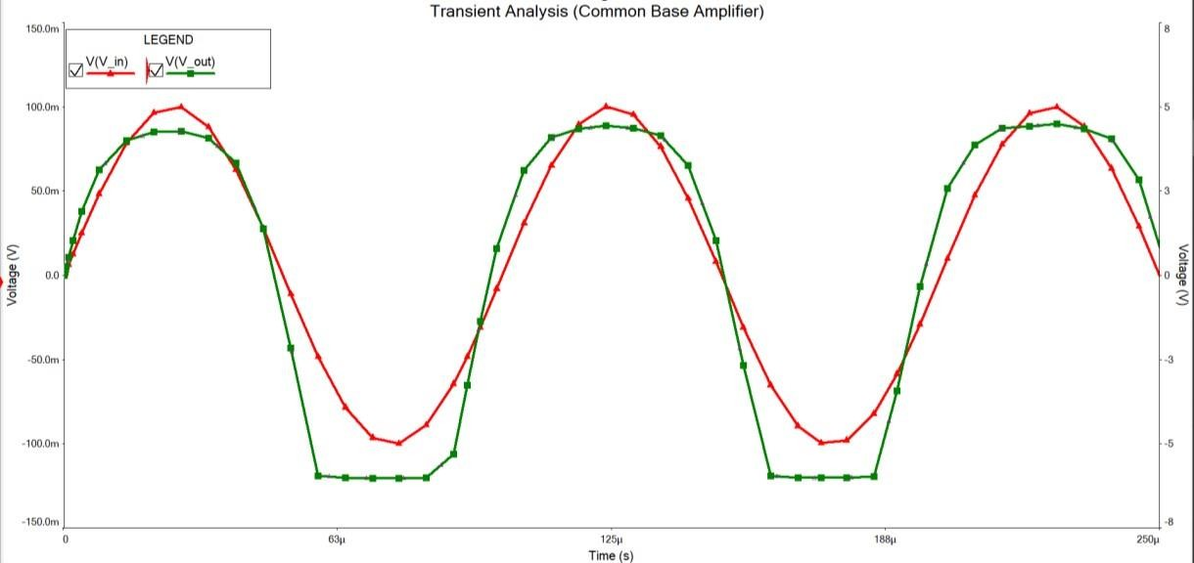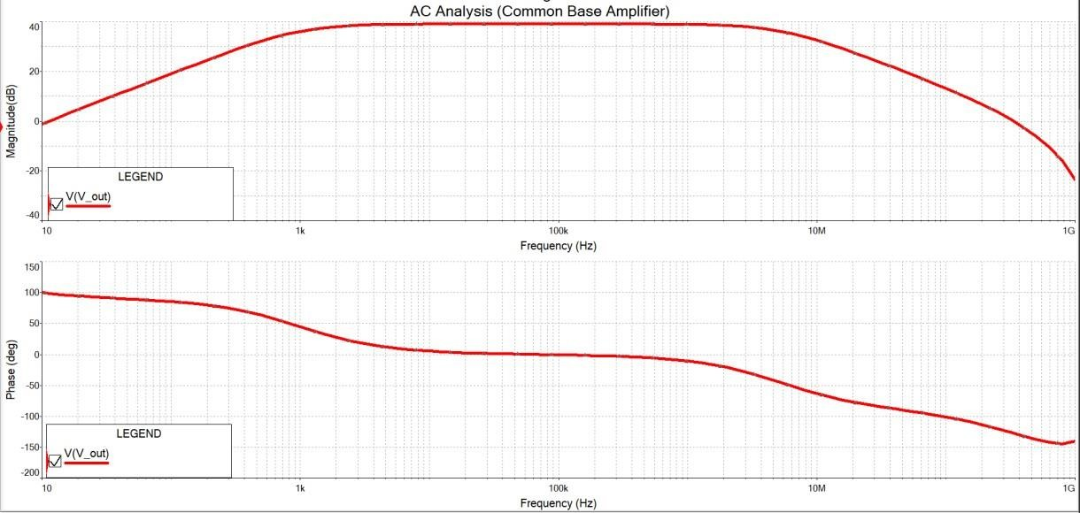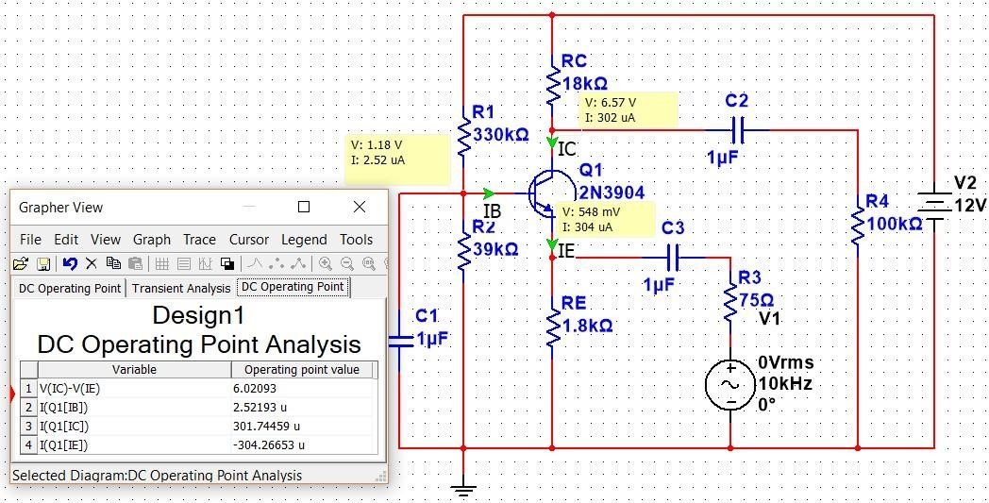

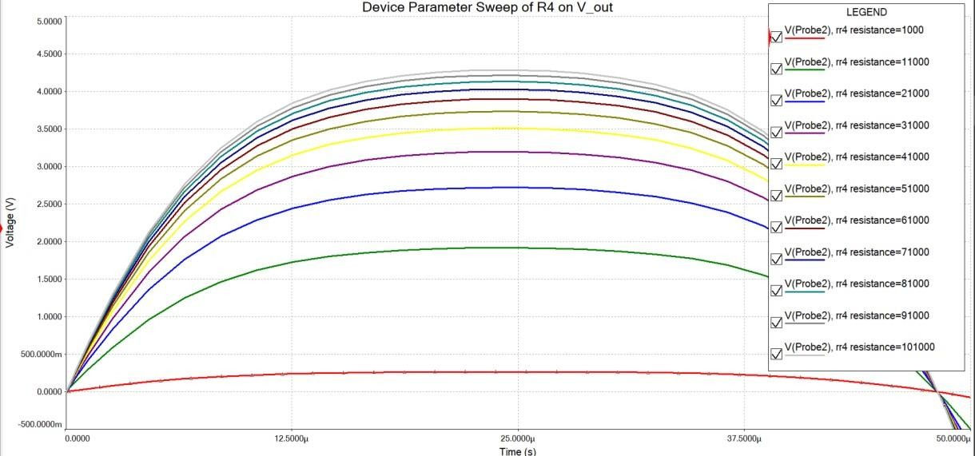

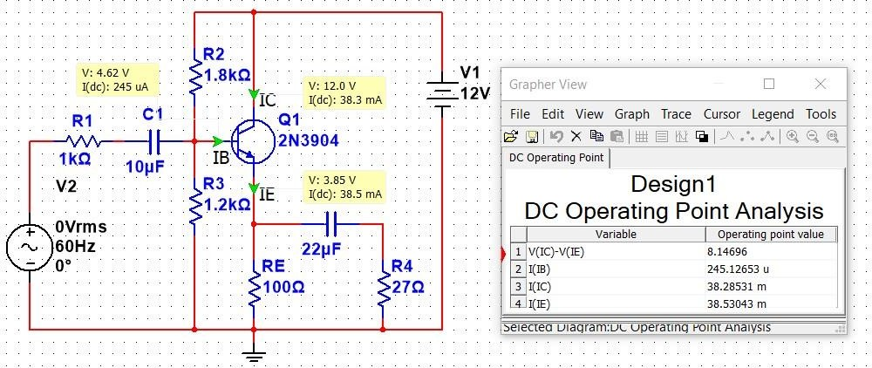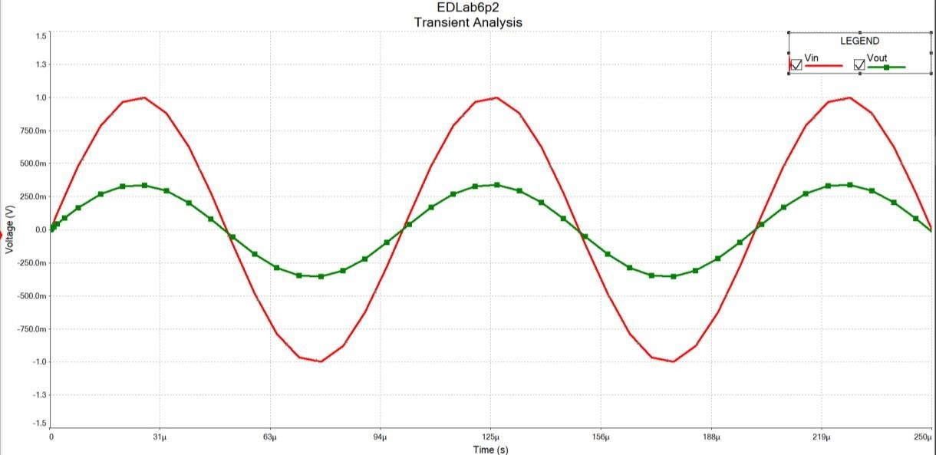

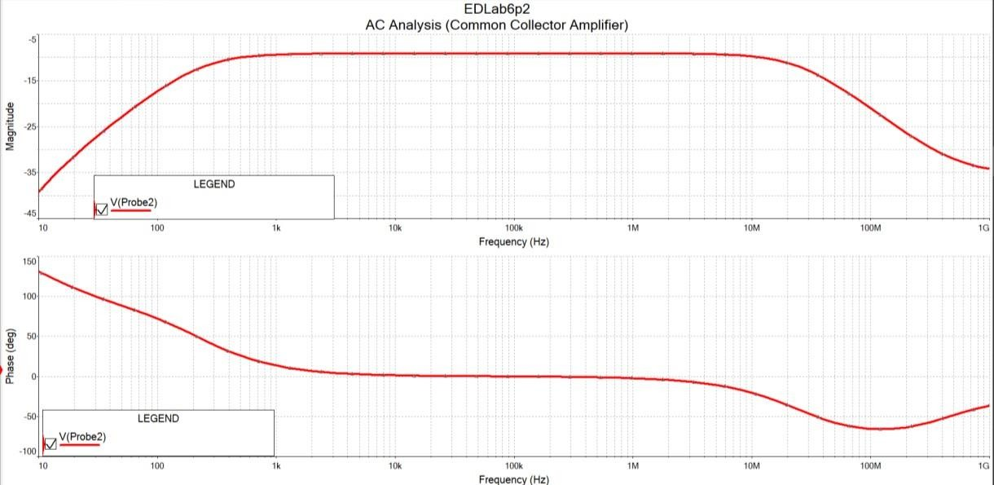

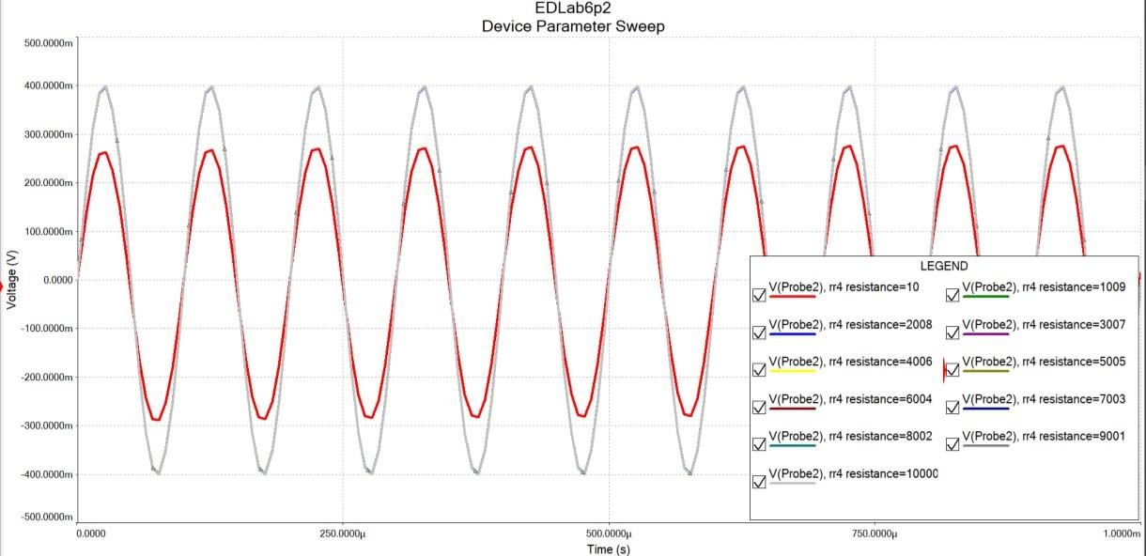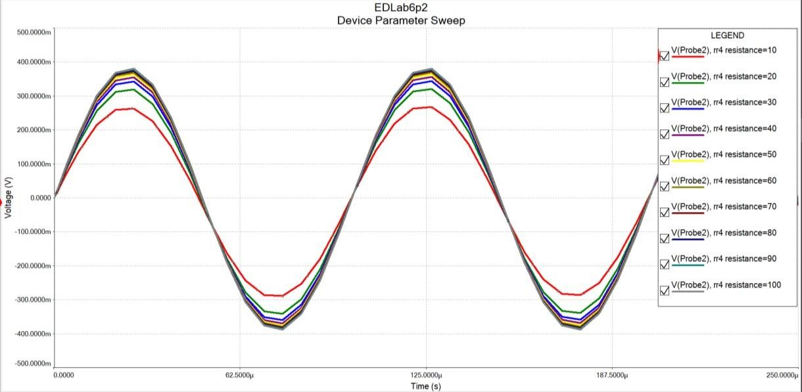

age