**33f**

**Project Blue Horizon - Increment V**

**Enhanced Morse Decoder**

**Hardware Design Description**

|  |  |
| --- | --- |
| **Revision** |  |
| **Date:** |  |

|  |  |
| --- | --- |
| **Document Number:** | [SDRLxx] |
| **Status:** |  |
| **SDRL No:** | xX |
| **DOORS™ Module Reference:** |  |
| **Classification:** |  |

Dylan Thorner

|  |
| --- |
| This document is the property of ASCEND. If found, please return it to:  Lockheed Martin System Integration, ELDP Offices, 1801 State Route 17C Owego, NY 13827-3998  Together with your name and address. Letter postage need not be prepaid.  Lockheed Martin Owego's Engineering Leadership Development Program (ELDP) is dedicated to the professional development of the company's future technical and business leaders. This comprehensive three-year program consists of [rotational work assignments,](http://www.owg.fs.lmco.com/projects/ldp/eldp/assignments.html) leadership training, and technical graduate studies leading to a Master of Engineering degree in Systems Engineering from [Cornell University](http://www.owg.fs.lmco.com/projects/ldp/eldp/cornell.html). This proven combination of academics, in-house training and rotational assignments provides entry-level professionals with the broad-based exposure that will facilitate their ability to perform with distinction in the challenging leadership roles within Lockheed Martin Systems Integration. |



Issue Record

The content of this document is wholly defined by the issue number and, where appropriate, the revision letter detailed below. The document will be reproduced in its entirety when any change has been incorporated and approved.

This document is under Configuration Control and any changes to the document will be subject to a change request via Configuration Management.

|  |  |  |  |  |
| --- | --- | --- | --- | --- |
| **Revision** | **Incorporated**  **by** | **Revision**  **Date** | **Description of Change** | **CR(s)**  **Applied** |
| - | Sean Winfree | 12/31/2010 | DRAFT |  |
|  |  |  |  |  |
|  |  |  |  |  |
|  |  |  |  |  |
|  |  |  |  |  |

Authorization Notification

Prepared by: Sean Winfree, Chief Engineer

ASCEND;

Dylan Thorner, Engineer

Enhanced Solutions

Approved by: <<APPROVER>>, <<ROLE>>

ASCEND

Contents

References 5

1. Scope 6

1.1 System Overview 6

1.1.1 Air Vehicle 7

1.1.2 Mission Payload 8

1.2 Enhanced Morse Decoder Architecture Design 9

1.2.1 Enhanced Morse Decoder Overview 9

1.2.2 Enhanced Morse Decoder Requirements Traceability 9

1.2.3 Enhanced Morse Decoder Trade Studies 9

1.2.4 Enhanced Morse Decoder Detailed Design 9

1.2.4.1 Enhanced Morse Decoder Block Definition Diagram 9

1.2.5 Enhanced Morse Decoder Mechanical Design 10

1.2.5.1 Enhanced Morse Decoder Printed Wiring Board Layout 10

1.2.6 Enhanced Morse Decoder Electrical Design 10

1.2.6.1 Enhanced Morse Decoder Schematics (or Wiring Diagram) 10

1.2.7 Enhanced Morse Decoder Interface Description 10

1.2.8 Enhanced Morse DecoderBill of Materials 11

1.2.9 Enhanced Morse DecoderSafety Functions / Properties 11

1.2.10 Enhanced Morse DecoderAssembly 11

Appendix A. Design Prototype 12

Appendix B. Acronyms 16

Figures

Figure 1: PBH Inc. V System Overview 6

Figure 2: Air Vehicle Block Diagram 7

Figure 3: Enhanced Morse Decoder Block Diagram 8

Tables

Table 1: Enhanced Solutions ICD 9

References

This table lists the documents applicable to the Hardware Design Docuement. It includes documents referred to in the text as well as related complementary documents that could be of interest to the reader.

**ASCEND Docuementation**

All ASCEND Documentation listed below is available in the [Configuration Management](https://sharepoint.global.lmco.com/sites/Project-Blue-Horizon/PBH%202011/Forms/AllItems.aspx?RootFolder=%2Fsites%2FProject%2DBlue%2DHorizon%2FPBH%202011%2FConfiguration%20Management&View=%7b1DB310D5%2d9313%2d4443%2d9563%2dAB437CB32796%7d) folder on the PBH Sharepoint.

|  |  |
| --- | --- |
| **Doc #** | **Document Title** |
| XX-XXX | Enhanced Morse Decoder White Paper |
| XX-XXX | Enhanced Morse Decoder ICD |
|  |  |

**Enhanced Solutions Docuementation**

The following table lists all supporting documentation provided by Enhanced Solutions in reference to the design.

|  |  |
| --- | --- |
| **Doc #** | **Document Title** |
| xx-xxx | Enhanced Morse Decoder Schematics |
| xx-xxx | Enhanced Morse Decoder Bill Of Materials |
| xx-xxx | Enhanced Morse Decoder Layout Artwork Images |
|  |  |
|  |  |
|  |  |
|  |  |

**Supplier Docuementation**

The following table lists key supporting documentation provided by suppliers of components used in the design.

|  |  |
| --- | --- |
| **Doc #** | **Document Title** |
|  |  |
|  |  |
| DS70xxxx | dsPIC33F Family Reference Manual Part 1 (24-Apr-2009) |
| DS51700A | MPLAB Starter Kit fordsPIC® Digital Signal Controllers User’s Guide |

# Scope

This Hardware Design Document (HDD) serves as both a receptacle of parts of the design and a pointer to additional descriptions of the design of the Hardware Configuration Items (HWCI) identified as the Enhanced Morse Decoder of the Project Blue Horizion (PBH) systems. This design was derived from requirements contained within the PBHV System Specification. All information required to understand the design of these HWCI is either provided here or assessed and referenced from this document.

The artifacts in the document were generated as part of the preliminary and detailed design phase as documented in the ASCEND PBH Intergrated Master Schedule.

## System Overview

The PBH Increment V systems include the Air Vehicle and Ground Segment. Figure 1: PBH Inc. V System Overview details the interaction between the individual systems.

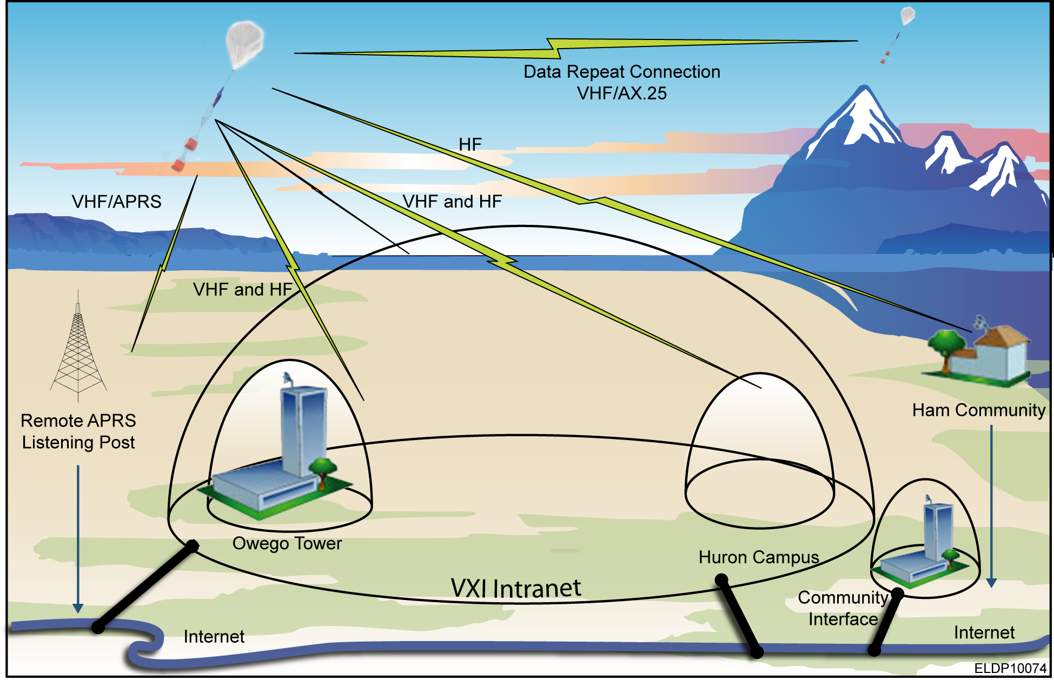

Figure : PBH Inc. V System Overview

## Air Vehicle

The Air Vehicle contains the following items, detailed in Figure 1: Air Vehicle Block Diagram.

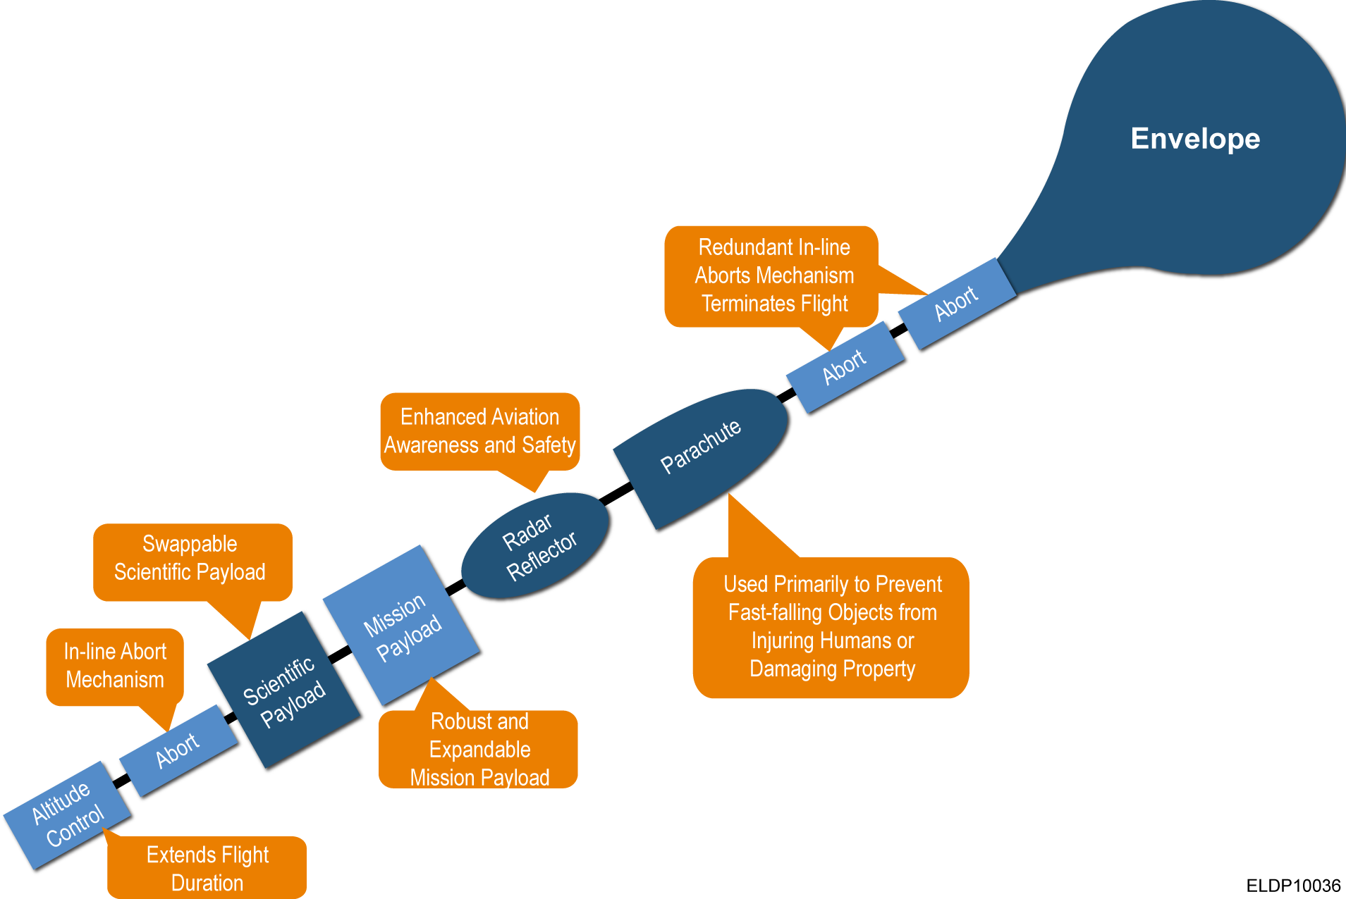

Figure : Air Vehicle Block Diagram

## Mission Payload

The distance/duration Mission Payload configuration which includes the Enhanced Morse Decoder is shown in Figure 3: Distance/Duration Mission Payload Configuration.

Figure : Distance/Duration Mission Payload Configuration

## Enhanced Morse Decoder Architecture Design

A very brief description of the Subsystem.

### Enhanced Morse Decoder Overview

The Enhanced Morse Decoder (EMD) is used to decode Morse Code messages transmitted over the HF band.

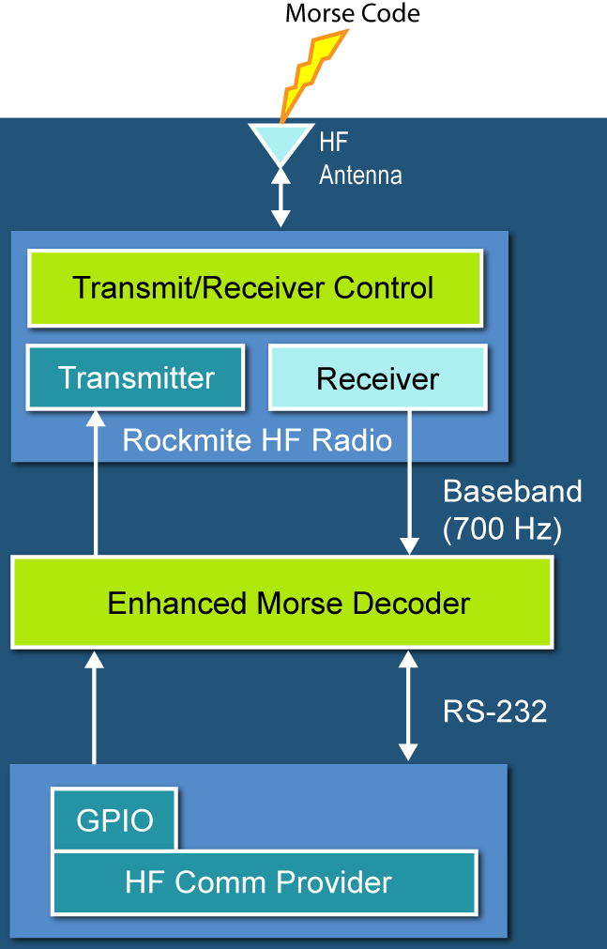

Figure : Enhanced Morse Decoder Block Diagram

### Enhanced Morse Decoder Requirements Traceability

Traceability to requirements will be accomplished through indication via text within this document:

| **HRS Location** |
| --- |
| DOORS: Blue_Horizon/PBHV /<HRS FILE NAME>/ |

### Enhanced Morse Decoder Trade Studies

(Optional) Describe any trade studies performed. Copy and past OR Reference from proposal if already completed.

### Enhanced Morse Decoder Detailed Design

A description of the solution that systematically traces requirements through all levels of decomposition into the subsystem functions and features.

### Enhanced Morse Decoder Block Definition Diagram

Block diagram of all interfaces only showing the EMD.

### Enhanced Morse Decoder Mechanical Design

Design details on mechanical design. Weight break out here (just weigh the whole thing).

### Enhanced Morse Decoder Printed Wiring Board Layout

Insert image(s) of PWB layout and reference a PDF of the Layout and final *.brd files (i.e. HW-101 EMD Board Layout.pdf).

### Enhanced Morse Decoder Electrical Design

Discuss the electrical design. Talk about analog and DSC circuits.

### Enhanced Morse Decoder Schematics (or Wiring Diagram)

Insert image(s) of schematics and reference a PDF of the schematics (i.e. HW-100 EMD Schematics.pdf) and final schematic files *.sch.

**Notes:**

* Any benefit to connect up ADC VREF nets? I doubt it..
* JTAG Header
* Recommend placing the same RS232 buffers we use on the flight computers to simplify debug. We can have 0 ohm resistors to bypass the buffer for actual operation.
* Appears that internal Fast RC Oscillator can generate 80Mhz (40MIPS). Does this get affected by temp? If so can we put down a external oscillator ~7.4HMz or something?
* What resistor/Cap changes are required to shift the frequency of the Bandpass filter from 700Hz to 300Hz?

### Enhanced Morse Decoder Interface Description

Insert reference to the existing ICD.

### Enhanced Morse DecoderBill of Materials

Reference the Bill of Materials document. Optional - put in entire list

### Enhanced Morse DecoderSafety Functions / Properties

Discuss any safety considerations built into the design. Respond/justify and safety related design elements.

### Enhanced Morse DecoderAssembly

Show the board file with clearly marked population notes (are there any Do Not Populate items (DNP))? See Example below. Red is DNP and Green is Populate with the value. Helpful in assembly. Document any special assembly consideration, notes or order of component placement as necessary.

1. Design Prototype
   1. Prototype Enhanced Morse Decoder

The MPLAB Starter Kit for dsPIC® Digital Signal Controllers (DSC-Starter Kit) is utilized to provide a prototype Enhanced Morse Decoder for software development. The following section details the DSC-Starter Kit configuration and analysis. For additional information reference the MPLAB Starter Kit fordsPIC® Digital Signal Controllers User’s Guide.

* + 1. Prototype Enhanced Morse Decoder Overview

The Enhanced Morse Decoder is used to decode Morse Code messages transmitted over the HF band.



Figure : DSK-Starter Kit Configuration

The **SASK Record Play Demo** **with Intro Code Example** demonstrates the low-cost speech capture and playback option. It uses the dsPIC DSC 12-bit ADC to capture speech samples. The data is stored in the serial Flash memory. The application then uses the Output Compare module in Pulse-Width Modulation (PWM) mode to generate a PWM signal representing the speech signal.

**Note:** Jumper J6 should in the OCPWM position to use this demo.

* + 1. Enhanced Morse Decoder Detailed Design

A description of the solution that systematically traces requirements through all levels of decomposition into the subsystem functions and features.

* + - 1. Enhanced Morse Decoder Block Definition Diagram

Block diagram of all interfaces only showing the EMD.

* + 1. Enhanced Morse Decoder Mechanical Design

Design details on mechanical design. Weight break out here (just weigh the whole thing).

* + - 1. Enhanced Morse Decoder Printed Wiring Board Layout



The following figure shows the schematic

* + 1. Enhanced Morse Decoder Electrical Design

Discuss the electrical design.

* + - 1. Enhanced Morse Decoder Schematics

The Digital Signal Controller Starter Kit - Input/Output Diagram inputs and outputs are shown in the following figure. These lines are ulitilzed as



Figure : Digital Signal Controller Starter Kit - Input/Output Diagram

The incoming audio signal can come from a line input or a condenser microphone. The speech sampling input is jumper selected (J7). The selected signal is amplified by a non-inverting AC amplifier (Line/Microphone Amplifier) and routed to the ADC module on the dsPIC33F device through an anti-aliasing filter. This sixth-order Sallen-Key low-pass filter has a cut-off frequency of 3300 Hz. The output of the anti-aliasing filter is connected to input AN0 of the ADC module on the device. If the input to the amplifier is a condenser microphone, a bias voltage provides a working supply voltage for the microphone. The line input does not require this bias voltage.

* + 1. Enhanced Morse DecoderInterface Description

The following section defines all interfaces between the Prototype Enhanced Morse Decoder and all other subsystems.

Table : Enhanced Solutions ICD

|  |  |  |  |  |
| --- | --- | --- | --- | --- |
| Connector-Pin | Name | Subsystem  Interface | Description | Direction. |
|  |  |  |  |  |
|  |  |  |  |  |
|  |  |  |  |  |

* + 1. Enhanced Morse Decoder Bill of Materials

Put in entire list

1. Acronyms

A list of relevant acronyms to the document