# Ghost Light Code Design: Part 1

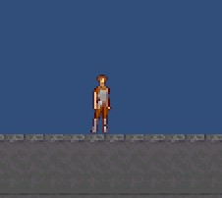 Fig1: Start of Game, Player in Frame

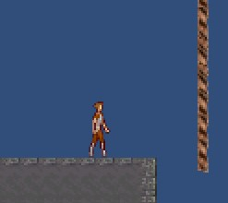 Fig2: Player Walking on platform

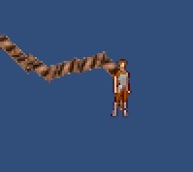 Fig3: Player attaching to rope

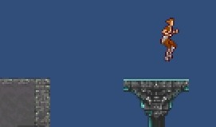 Fig4: Player jumping on platform

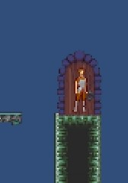 Fig5: Player Reaches end of Level