Foundation of AI Coursework Part 1

# Introduction

This report mentions my approach to the implementation of four tree search methods (depth-first search, breadth-first search, iterative deepening search, and a* search) for the “Blocksworld Tile Puzzle”. The rules of the puzzle are introduced in [1]. Evidence will be provided to show that the implementation works as intended. On the other hand, there is an analysis of the scalability of the four methods and the limitations of the implementation.

# Approach

## Depth-First Search

There are two approaches for the depth first search. In the first approach, the agent moves randomly to prevent the search from stuck. The agent will move indefinitely until it reaches the goal state. Then, it will return the solution.

In the second approach, a depth limit is defined to prevent the search from going endlessly. First, a node stack will be constructed. After putting the root into the stack, it will pop the node on the top of the stack. If the node is not in the goal state and it has not reached the depth limit, it will be expanded and the expanded nodes will be put on the top of the stack. Because the stack is “last-in, first-out”, the most recently expanded nodes, which are also the deepest nodes will be popped first. If the node has reached the depth limit already, it will not be expanded. It repeats all the steps above until it finds a node in the goal state, or there is no more node in the stack. Then, it will return the solution or none if no solution is found.

## Breath-First Search

First, it constructs a node queue then put the root into the queue. After that, it will visit all the nodes in the queue. If it finds a node in the goal state, it will stop and return the solution. If there is no node in the goal state, pop all the nodes in the queue and expand them. This will continue until all nodes in the queue are popped and expanded. The expanded nodes will then be put into the queue. Since the all the nodes are popped, the expanded nodes will all have the same depth. Therefore, the search will visit all the nodes with the same depth first, then expand all the nodes and then visit the expanded nodes in the deeper depth. It repeats all the steps above until it finds a node in the goal state, or there is no more node in the queue. Then, it will return the solution or none if no solution is found.

## Iterative-Deepening Search

It is similar to the depth first search but the depth limit will increase if no solution is found after all the nodes are popped. After putting the root into the stack, it will pop the node on the top of the stack. If the node is not in the goal state and it has not reached the depth limit, it will be expanded and the expanded nodes will be put on the top of the stack. Because the stack is “last-in, first-out”, the most recently expanded nodes, which are also the deepest nodes will be popped first. If the node has reached the depth limit already, it will not be expanded. If it finds a node in the goal state, it will return the solution. If there is no more node, it will increase the depth limit by 1, put the root into the stack and restart searching.

## A* Search

For the A* Search, the heuristic algorithm will calculate the Manhattan distance between the position of A, B, C in the current state and the position of A, B, C in the goal state respectively. After that, it will sum up the Manhattan distance of A, B, and C and the depth of the node as the estimated cost. Like other searching algorithms, it constructs a node queue then put the root into the queue. Then, it will pop the node with the lowest estimated cost. If the popped node is not in the goal state, it will expand the popped node. The expanded node will then be put into the node queue. It keeps popping and expanding until it finds the solution or there is no more node.

# Evidence

## Solution Check

There is a function to check whether the solution found by the search is correct. The function checks whether it can reach the goal state from the start state by applying the solution.

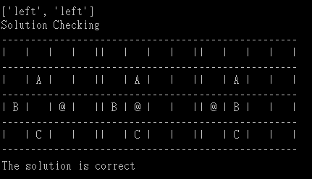

Figure 1. Solution Check Output

## Visiting Order

The visiting order is recorded during the search to make sure it is performing the search wanted. Example output is provided below.

### Randomized Depth-first Search

The search always visits the deepest node first and the moves are selected randomly.

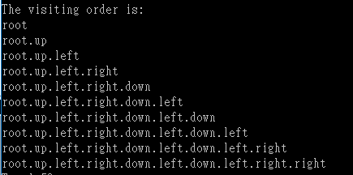

Figure 2. Visiting order of Randomized Depth-first Search

### Depth-first Search with Depth Limit

The search visits the deepest node first. After it reaches the depth limit, it will stop expanding nodes and visit other nodes in the stack.



Figure 3. Visiting order of Depth-first Search with Depth Limit

### Breadth-first search

The search visits all the nodes with the same depth first, then visits the deeper nodes.

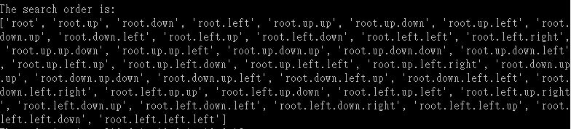

Figure 4. Visiting order of Breadth-first Search

### Iterative Deepening Search

The search visits the deepest node first. If it reaches the depth limit, it will stop expanding nodes. If there is no more node in the stack, it will revisit the root again and the depth limit is also increased by 1.

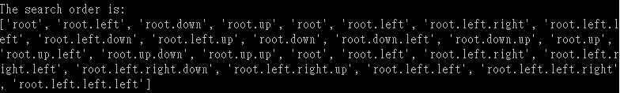

Figure 5. Visiting order of Iterative Deepening Search

### A* Search

The search visits the node with the least estimated cost first.



Figure 6. Visiting order of A* Search

## Example Output

See Appendix.

# Computational Time Scalability Study

To measure the scalability of computational time (the number of nodes expanded) of the tree search algorithms, 5 different start states will be used for the search. Each start state has different minimal distance (3 to 14) to the goal state. The longer the distance, the more moves are needed to solve the puzzle. Since the difficulty of the search will increase as the distance to the goal state increases, we can find the scalability by comparing the results.

## Randomized Depth-first Search (RDFS)

Since the moves are randomized, this algorithm obtains different result each time. Therefore, an average of 100 results is used for the study. This algorithm expands the most nodes when the distance to the goal state is short. However, this algorithm scales very well, even when the distance to the goal state is 14, the number of nodes expanded is not increased by much.

## Depth-first Search with Depth Limit (DFSw/DL)

The depth limit is set to 20 for the searches. It should be sufficient to solve from the start states chosen. This search algorithm does not scale well since often it expands the most nodes. However, the result depends on the depth limit selected. If the depth limit chosen is closer to the minimum depth required, the number of nodes expanded can be greatly reduced.

## Breath-first Search (BFS)

The scalability of breath-first search is slightly better than depth-first search with depth limit and iterative deepening search since it expands slightly fewer nodes overall. However, it fails to find a solution when the distance to the goal state is 14. The program will raise memory error because it takes too much space.

## Iterative Deepening Search

The scalability of this algorithm is similar to that of Breadth-first Search but it expands slightly more nodes since it revisits the whole tree again every time the node stack is empty. However, it succeeds to find a solution when the distance to the goal state is 14 because the space complexity of it is lower.

## A* Search

The scalability of A* Search is the best overall. The slope of the line is clearly less than that of other algorithms apart from RDFS. As the distance to the goal state increases, the number of nodes expanded is more significantly fewer than other algorithms apart from RDFS.

# 

Figure 6. Scalability of Tree Search Algorithms

# Limitations

## Randomized Depth-first Search

This algorithm only works for puzzles with a bottomless tree. If there is a bottom in the tree, it will be stuck because it is not able to go back and visit other nodes. On the other hand, memory error will be raised if the search depth is too large since it takes too much space to save the visiting order.

## Breath-first Search

Memory error will be raised if the search depth is too large since breadth-first search takes so much space to save the nodes.

# References

[1] Anon, (2017). Blocksworld Tile Puzzle. [online] Available at: https://secure.ecs.soton.ac.uk/notes/comp6231/blocksworld_tile_puzzle.pdf [Accessed 6 Jan. 2017].

# Appendix

## Code

### code.py

**import** random

**from** operator **import** attrgetter

"""

This code solves the "Blocksworld Tiles Puzzle"

Goal State

-----------------

| | | | |

-----------------

| | A | | |

-----------------

| | B | | |

-----------------

| | C | | | (agent can be anywhere)

-----------------

"""

**class** **Node:**

**def** __init__**(**self**,** name**,** state**,** parent**,** move**,** depth**,** heuristic**):**

self**.**name **=** name

self**.**state **=** state

self**.**parent **=** parent

self**.**move **=** move

self**.**depth **=** depth

self**.**heuristic **=** heuristic # Estimated cost

**def** __repr__**(**self**):**

**return** repr**((**self**.**name**,** self**.**state**,** self**.**parent**,** self**.**move**,** self**.**depth**,** self**.**heuristic**))**

**def** expand**(**node**,** goal**):**

expanded_nodes **=** **[]**

up **=** move**(**node**.**state**,** 'up'**)**

down **=** move**(**node**.**state**,** 'down'**)**

left **=** move**(**node**.**state**,** 'left'**)**

right **=** move**(**node**.**state**,** 'right'**)**

new_depth **=** node**.**depth **+** 1

new_name **=** node**.**name

**if** up**:**

expanded_nodes**.**append**(**Node**(**new_name**+**'.up'**,** up**,** node**,** "up"**,** new_depth**,** new_depth **+** heuristic**(** up**,** goal**)))**

**if** down**:**

expanded_nodes**.**append**(**Node**(**new_name**+**'.down'**,** down**,** node**,** "down"**,** new_depth**,** new_depth **+** heuristic**(** down**,** goal**)))**

**if** left**:**

expanded_nodes**.**append**(**Node**(**new_name**+**'.left'**,** left**,** node**,** "left"**,** new_depth**,** new_depth **+** heuristic**(** left**,** goal**)))**

**if** right**:**

expanded_nodes**.**append**(**Node**(**new_name**+**'.right'**,** right**,** node**,** "right"**,** new_depth**,** new_depth **+** heuristic**(** right**,** goal**)))**

**return** expanded_nodes

**def** display**(**state**):**

**print** "-----------------"

**print** "| {} | {} | {} | {} |"**.**format**(**state**[**0**],** state**[**1**],** state**[**2**],** state**[**3**])**

**print** "-----------------"

**print** "| {} | {} | {} | {} |"**.**format**(**state**[**4**],** state**[**5**],** state**[**6**],** state**[**7**])**

**print** "-----------------"

**print** "| {} | {} | {} | {} |"**.**format**(**state**[**8**],** state**[**9**],** state**[**10**],** state**[**11**])**

**print** "-----------------"

**print** "| {} | {} | {} | {} |"**.**format**(**state**[**12**],** state**[**13**],** state**[**14**],** state**[**15**])**

**print** "-----------------"

**return** **True**

**def** getNextMove**(**agent**):**

moves**={**0**:**"up"**,**1**:**"down"**,**2**:**"left"**,**3**:**"right"**}**

rng**=**random**.**randint**(**0**,**3**)**

**while** **(**rng**==**0 **and** **(**agent **in** **[**0**,** 1**,** 2**,** 3**]))** **or** **(**rng**==**1 **and** **(**agent **in** **[**12**,** 13**,** 14**,** 15**]))** **or** **(**rng**==**2 **and** **(**agent **in** **[**0**,** 4**,** 8**,** 12**]))** **or** **(**rng**==**3 **and** **(**agent **in** **[**3**,** 7**,** 11**,** 15**]))** **:**#Only moves within the boundaries

rng**=**random**.**randint**(**0**,**3**)**

**return(**moves**[**rng**])**

**def** move**(**state**,** direction**):**

new_state **=** state**[:]**

index **=** new_state**.**index**(** '@' **)**

**if** direction **==** 'up'**:**

**if** index **not** **in** **[**0**,** 1**,** 2**,** 3**]:** # Can't go up

temp **=** new_state**[**index **-** 4**]**

new_state**[**index **-** 4**]** **=** new_state**[**index**]**

new_state**[**index**]** **=** temp

**return** new_state

**else:**

**return** **None**

**if** direction **==** 'down'**:**

**if** index **not** **in** **[**12**,** 13**,** 14**,** 15**]:** # Can't go down

temp **=** new_state**[**index **+** 4**]**

new_state**[**index **+** 4**]** **=** new_state**[**index**]**

new_state**[**index**]** **=** temp

**return** new_state

**else:**

**return** **None**

**if** direction **==** 'left'**:**

**if** index **not** **in** **[**0**,** 4**,** 8**,** 12**]:** # Can't go left

temp **=** new_state**[**index **-** 1**]**

new_state**[**index **-** 1**]** **=** new_state**[**index**]**

new_state**[**index**]** **=** temp

**return** new_state

**else:**

**return** **None**

**if** direction **==** 'right'**:**

**if** index **not** **in** **[**3**,** 7**,** 11**,** 15**]:** # Can't go right

temp **=** new_state**[**index **+** 1**]**

new_state**[**index **+** 1**]** **=** new_state**[**index**]**

new_state**[**index**]** **=** temp

**return** new_state

**else:**

**return** **None**

**def** is_goal**(**state**,** goal**):**

**if** state**[**goal**[**'A'**]]==**'A' **and** state**[**goal**[**'B'**]]==**'B' **and** state**[**goal**[**'C'**]]==**'C'**:**

**return** **True**

**else:**

**return** **False**

**def** solution**(**node**):**

moves **=** **[]**

temp **=** node

**while** temp**.**move**:**

moves**.**insert**(**0**,** temp**.**move**)**

**if** temp**.**depth **==** 1**:**

**break**

temp **=** temp**.**parent

**return** moves

**def** dfs_random**(**start**,** goal**,** show_board**,** show_order**):**

state **=** start

count **=** 0

moveList **=** list**()**

**print** 'start'

**if** show_board**:**

display**(**state**)**

order **=** **[**'root'**]** # visiting order

**while** **not** is_goal**(**state**,**goal**):**

nextMove**=**getNextMove**(**state**.**index**(**'@'**))**

**if** show_order**:**

order**.**append**(**order**[**len**(**order**)-**1**]+**'.'**+**nextMove**)**

moveList**.**append**(**nextMove**)**

state**=**move**(**state**,**nextMove**)**

count**+=**1

**print(**'End'**)**

**if** show_board**:**

display**(**state**)**

**print** **(**'Goal! The search Depth is: '**+**str**(**count**))**

**print(**'Total '**+**str**(**count**)+**' steps'**)**

**print(**'Nodes expanded: '**+**str**(**count**))**

**print** **(**'Solution Checking'**)**

**if** solution_check**(**start**,** goal**,** moveList**,** show_board**):**

**if** show_order**:**

**print(**'The first 10 visiting order is: '**)**

**for** i **in** xrange**(**10**):**

**print(**order**[**i**])**

**return** count # Return the number of nodes expanded

**def** dfs_limit**(**start**,**goal**,** depth_limit**,** show_board**,** show_order**):**

nodes **=** **[]** # Node stack

count **=** 0 # Number of nodes expanded

visited **=** 0 # Number of nodes visited

order **=** **[]** # pop order

nodes**.**append**(**Node**(**'root'**,** start**,** **None,** **None,** 0**,** heuristic**(**start**,** goal**)))** # Root

**print** 'Start'

**if** show_board**:**

display**(**start**)**

**while** **True:**

**if** len**(**nodes**)** **==** 0**:**

**print(**'No solution! The search depth is '**+**str**(**node**.**depth**))**

**print(**'Nodes expanded:' **+** str**(**count**))**

**print(**'Nodes visited: ' **+** str**(**visited**))**

**if** show_order**:**

**print(**'The search order is:'**)**

**print(**order**)**

**return** **None** #No solution

node **=** nodes**.**pop**()** #Pop the top node

**if** show_order**:**

order**.**append**(**node**.**name**)** # Record the visiting order

visited **+=** 1

**if** is_goal**(**node**.**state**,** goal**):**

**print(**'End'**)**

**if** show_board**:**

display**(**node**.**state**)**

**print(**'Goal! The search depth is '**+**str**(**node**.**depth**))**

**print(**'Nodes expanded:' **+** str**(**count**))**

**print(**'Nodes visited: ' **+** str**(**visited**))**

**if** show_order**:**

**print(**'The search order is:'**)**

**print(**order**)**

moves**=**solution**(**node**)**

**print** **(**'Solution Checking'**)**

**if** solution_check**(**start**,** goal**,** moves**,** show_board**):**

**return** moves

expanded_nodes **=** **[]**

**if** node**.**depth **<** depth_limit**:** #Expand only if the node is less than the depth limit

expanded_nodes **=** **(**expand**(**node**,** goal**))**# expand

nodes**.**extend**(**expanded_nodes**)** #put the expanded node at the top of the stack

count **+=** len**(**expanded_nodes**)**

**def** bfs**(**start**,** goal**,** show_board**,** show_order**):**

nodes **=** **[]** # Node queue

count **=** 0 # Number of nodes expanded

visited **=** 0 # Number of nodes visited

order **=** **[]** # pop order

nodes**.**append**(**Node**(**'root'**,** start**,** **None,** **None,** 0**,** heuristic**(**start**,** goal**)))** # Root

**print** 'Start'

**if** show_board**:**

display**(**start**)**

**while** **True:**

**if** len**(**nodes**)** **==** 0**:**

**print(**'No solution! The search depth is '**+**str**(**node**.**depth**))**

**print(**'Nodes expanded:' **+** str**(**count**))**

**print(**'Nodes visited: ' **+** str**(**visited**))**

**print(**'The search order is:'**)**

**if** show_order**:**

**print(**order**)**

**return** **None** #No solution

**for** i **in** xrange**(**len**(**nodes**)):** # Check if there is solution in the nodes

**if** show_order**:**

order**.**append**(**nodes**[**i**].**name**)** # Record the visiting order

visited **+=** 1

**if** is_goal**(**nodes**[**i**].**state**,** goal**):**

**print(**'End'**)**

**if** show_board**:**

display**(**nodes**[**i**].**state**)**

**print(**'Goal! The search depth is '**+**str**(**nodes**[**i**].**depth**))**

**print(**'Nodes expanded:' **+** str**(**count**))**

**print(**'Nodes visited: ' **+** str**(**visited**))**

**if** show_order**:**

**print(**'The search order is:'**)**

**print(**order**)**

moves**=**solution**(**nodes**[**i**])**

**print** **(**'Solution Checking'**)**

**if** solution_check**(**start**,** goal**,** moves**,** show_board**):**

**return** moves

expanded_nodes **=** **[]**

**while** len**(**nodes**)** **>** 0**:** # Pop and expand until there is no nodes

node **=** nodes**.**pop**(**0**)**

expanded_nodes**.**extend**(**expand**(** node**,** goal **))**

count **+=** len**(**expanded_nodes**)**

nodes**.**extend**(** expanded_nodes **)**

**def** ids**(**start**,** goal**,** show_board**,** show_order**):**

nodes **=** **[]** # Node stack

count **=** 0 # Number of nodes expanded

visited **=** 0 # Number of nodes visited

depth_limit **=** 1

order **=** **[]** # pop order

nodes**.**append**(**Node**(**'root'**,** start**,** **None,** **None,** 0**,** heuristic**(**start**,** goal**)))** # Root

**print** 'Start'

**if** show_board**:**

display**(**start**)**

**while** **True:**

node **=** nodes**.**pop**()** #Pop the top node

**if** show_order**:**

order**.**append**(**node**.**name**)** # Record the visiting order

visited **+=** 1

**if** is_goal**(**node**.**state**,** goal**):**

**print(**'End'**)**

**if** show_board**:**

display**(**node**.**state**)**

**print(**'Goal! The search depth is '**+**str**(**node**.**depth**))**

**print(**'Nodes expanded:' **+** str**(**count**))**

**print(**'Nodes visited: ' **+** str**(**visited**))**

**if** show_order**:**

**print(**'The search order is:'**)**

**print(**order**)**

moves**=**solution**(**node**)**

**print** **(**'Solution Checking'**)**

**if** solution_check**(**start**,** goal**,** moves**,** show_board**):**

**return** moves

expanded_nodes **=** **[]**

**if** node**.**depth **<** depth_limit**:** #Expand only if the node is less than the depth limit

expanded_nodes **=** **(**expand**(**node**,** goal**))**# expand

nodes**.**extend**(**expanded_nodes**)** #put the expanded node at the top of the stack

count **+=** len**(**expanded_nodes**)**

**if** len**(**nodes**)** **==** 0**:** # No solution. Increse depth_limit

depth_limit **+=** 1

nodes**.**append**(**Node**(**'root'**,** start**,** **None,** **None,** 0**,** heuristic**(**start**,** goal**)))** # Root

**def** astar**(**start**,** goal**,** show_board**,** show_order**):**

nodes **=** **[]** # Node queue

count **=** 0 # Number of nodes expanded

visited **=** 0 # Number of nodes visited

order **=** **[]** # pop order

nodes**.**append**(**Node**(**'root'**,** start**,** **None,** **None,** 0**,** heuristic**(**start**,** goal**)))** # Root

**print** 'Start'

**if** show_board**:**

display**(**start**)**

**while** **True:**

**if** len**(**nodes**)** **==** 0**:**

**print(**'No solution! The search depth is '**+**str**(**node**.**depth**))**

**print(**'Nodes expanded:' **+** str**(**count**))**

**print(**'Nodes visited: ' **+** str**(**visited**))**

**if** show_order**:**

**print(**'The search order is:'**)**

**print(**order**)**

**return** **None** #No solution

node **=** nodes**.**pop**(**nodes**.**index**(**min**(**nodes**,** key **=** attrgetter**(**'heuristic'**))))** # Pop and expand the node with the least estimated cost

**if** show_order**:**

order**.**append**(**node**.**heuristic**)** # Record the visiting order

visited **+=** 1

**if** is_goal**(**node**.**state**,** goal**):** #check if the node poped is the goal

**print(**'End'**)**

**if** show_board**:**

display**(**node**.**state**)**

**print(**'Goal! The search depth is '**+**str**(**node**.**depth**))**

**print(**'Nodes expanded:' **+** str**(**count**))**

**print(**'Nodes visited: ' **+** str**(**visited**))**

**if** show_order**:**

**print(**'The order of the estimated cost of the nodes visited is:'**)**

**print(**order**)**

moves**=**solution**(**node**)**

**print** **(**'Solution Checking'**)**

**if** solution_check**(**start**,** goal**,** moves**,** show_board**):**

**return** moves

expanded_nodes **=** **[]**

expanded_nodes**.**extend**(**expand**(**node**,** goal**))** #expand

count **+=** len**(**expanded_nodes**)**

nodes**.**extend**(**expanded_nodes**)**# Add the expanded node at the back of the queue

**def** heuristic**(**state**,** goal**):** #Sum of the Manhattan Distance between A B C in the current state and that in the goal state

**if** state**:**

A **=** state**.**index**(**'A'**)**

B **=** state**.**index**(**'B'**)**

C **=** state**.**index**(**'C'**)**

dist **=** abs**(**A**%**4**-**goal**[**'A'**]%**4**)+**abs**(**A**/**4**-**goal**[**'A'**]/**4**)+**abs**(**B**%**4**-**goal**[**'B'**]%**4**)+**abs**(**B**/**4**-**goal**[**'B'**]/**4**)+**abs**(**C**%**4**-**goal**[**'C'**]%**4**)+**abs**(**C**/**4**-**goal**[**'C'**]/**4**)**

**return** dist

**else:**

**return** **None**

**def** solution_check**(**start**,** goal**,** solution**,** show_board**):**

**if** is_goal**(**start**,**goal**):**

**print** **(**'The solution is correct'**)**

**return** **True**

**if** solution**:**

state **=** start

**if** show_board**:**

display**(**state**)**

**for** i **in** xrange**(**len**(**solution**)):**

state **=** move**(**state**,** solution**[**i**])**

**if** show_board**:**

display**(**state**)**

**if** is_goal**(**state**,**goal**):**

**print** **(**'The solution is correct'**)**

**return** **True**

**else:**

**print** **(**'The solution is wrong'**)**

**return** **False**

**else:**

**print(**'No solution'**)**

**return** **False**

**def** avg**(**start**,**goal**,** times**,** show_board**,** show_order**):**

count **=** 0

**for** i **in** xrange**(**times**):**

count**+=**dfs_random**(**start**,**goal**,** show_board**,** show_order**)**

avg **=** count**//**times

**return** avg

**def** main**():**

start **=** **[**' '**,**' '**,**' '**,**' '**,**' '**,**'A'**,**' '**,**' '**,**'B'**,**' '**,**' '**,**'@'**,**' '**,**'C'**,**' '**,**' '**]** # Distance from goal is 3

#start = [' ',' ',' ','@',' ','A',' ',' ','B',' ',' ',' ',' ','C',' ',' '] # Distance from goal is 5

#start = [' ',' ','A',' ',' ',' ','@',' ','B',' ',' ',' ',' ','C',' ',' '] # Distance from goal is 7

#start = [' ',' ','A',' ',' ',' ',' ',' ','B',' ',' ',' ',' ','C','@',' '] # Distance from goal is 9

#start = [' ',' ','A',' ',' ',' ',' ',' ',' ',' ','B',' ',' ','C',' ','@'] # Distance from goal is 11

#start = [' ',' ',' ',' ',' ',' ',' ',' ',' ',' ',' ',' ','A','B','C','@'] # Distance from goal is 14

#start = ['A','B','C',' ',' ',' ',' ',' ',' ',' ',' ',' ',' ',' ',' ','@'] # Distance from goal is 14

goal **=** **{**'A'**:**5**,** 'B'**:**9**,** 'C'**:**13**}**

show_board **=** **False** # display the board if True

show_order **=** **False** # show the visiting order if True

**print** **(**'Randomized depth first search'**)**

average**=(**avg**(**start**,** goal**,** 100**,** show_board**,** show_order**))**

**print** 'The average is'**,**

**print(**average**)**

**print(**'\n'**)**

**print** **(**'Depth-first search with depth limit'**)**

solution**=(**dfs_limit**(**start**,** goal**,** 20**,** show_board**,** show_order**))**

**print** 'The solution is: '**,**

**print** solution

**print(**'\n'**)**

**print** **(**'Performing breadth first search'**)**

solution**=(**bfs**(**start**,** goal**,** show_board**,** show_order**))**

**print** 'The solution is: '**,**

**print** solution

**print(**'\n'**)**

**print** **(**'Iterative deepening search'**)**

solution**=(**ids**(**start**,** goal**,** show_board**,** show_order**))**

**print** 'The solution is: '**,**

**print** solution

**print(**'\n'**)**

**print** **(**'A* search'**)**

solution**=(**astar**(**start**,** goal**,** show_board**,** show_order**))**

**print** 'The solution is: '**,**

**print** solution

**print(**'\n'**)**

**if** __name__ **==** "__main__"**:**

main**();**

## Example Output

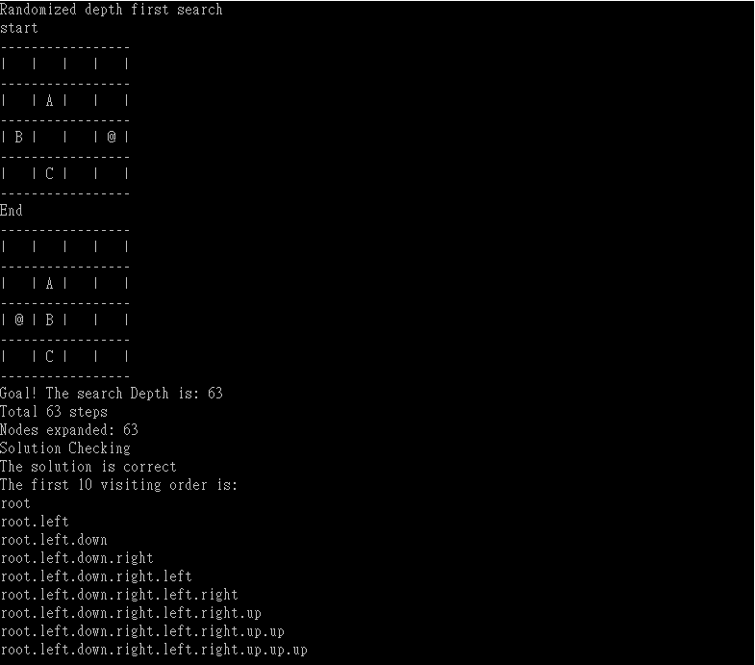

Figure 7. Example Output of Randomized Depth-first Search

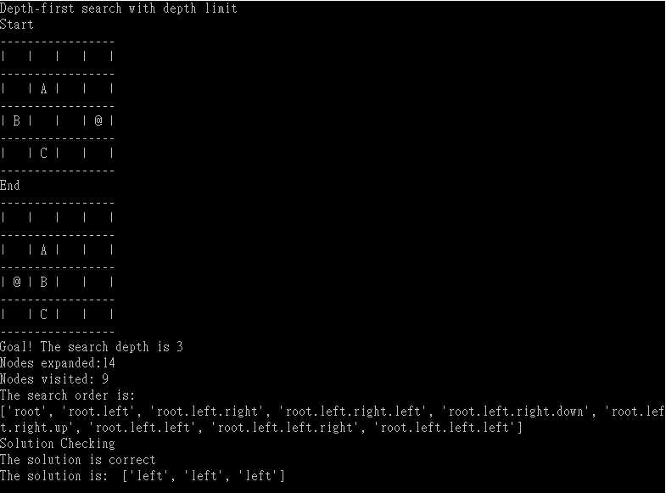

Figure 8. Example Output of Depth-first Search with Depth Limit

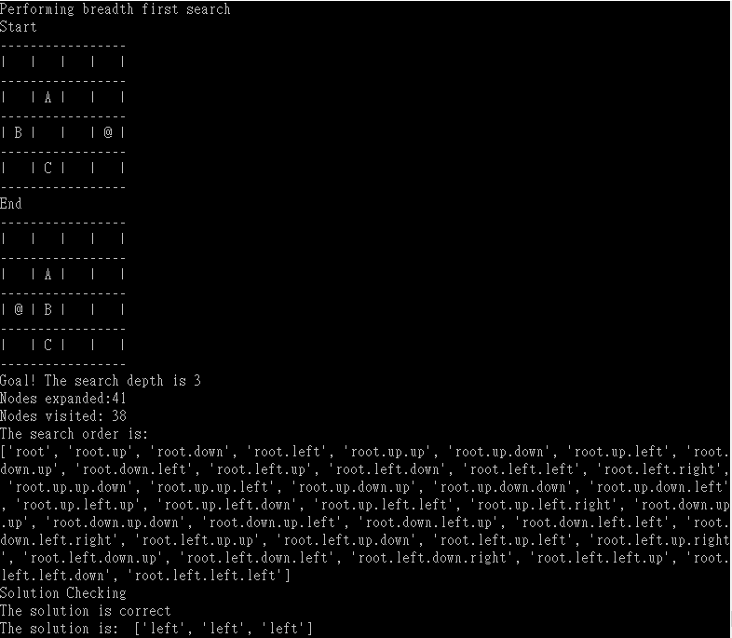

Figure 9. Example Output of Breadth-first Search

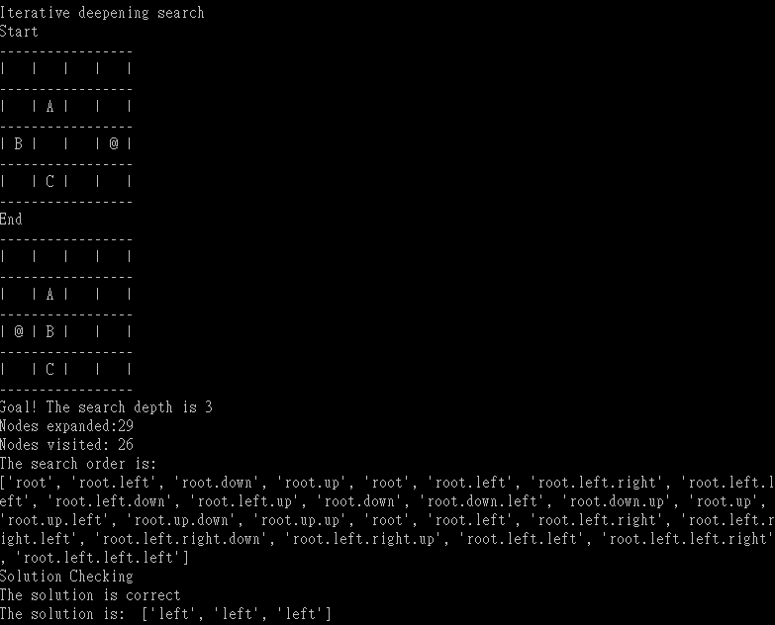

Figure 10. Example Output of Randomized Iterative Deepening Search

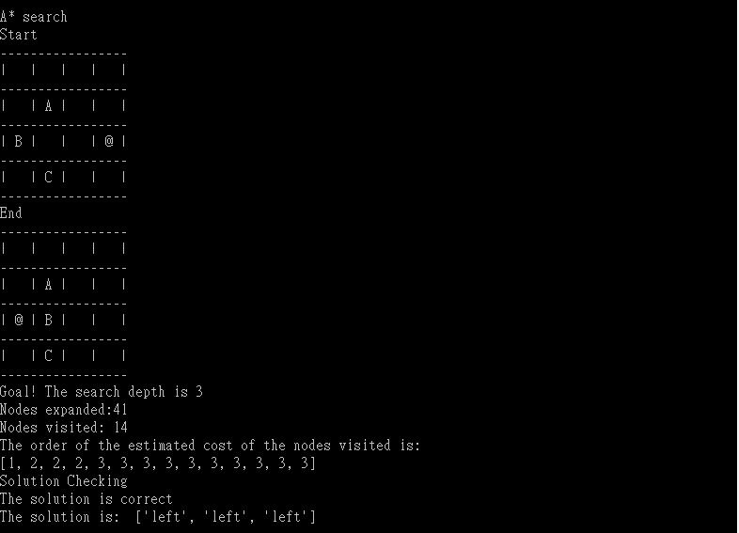

Figure 11. Example Output of A* Search

Foundation of AI Coursework Part 2